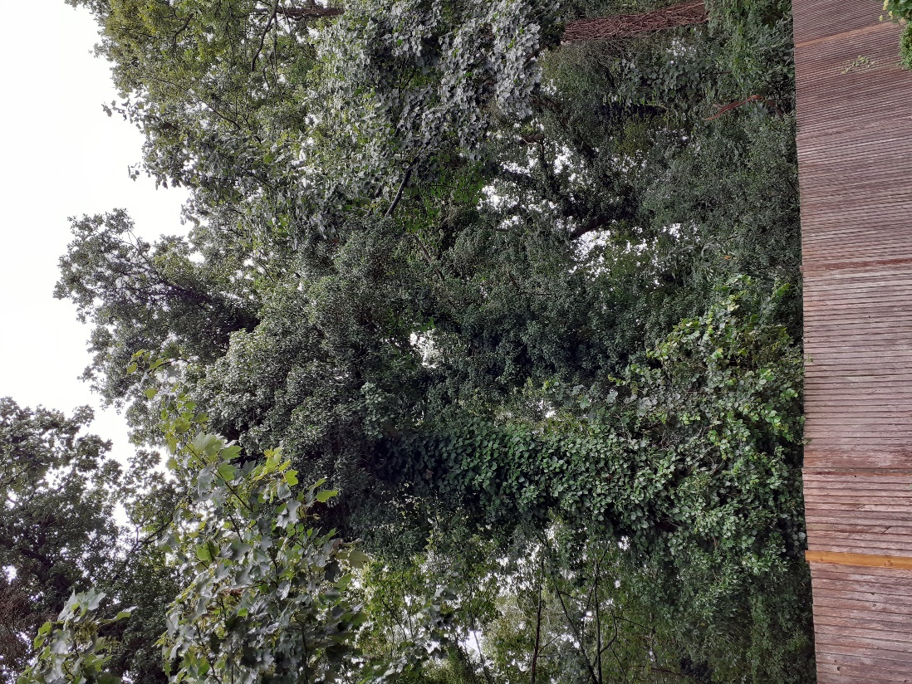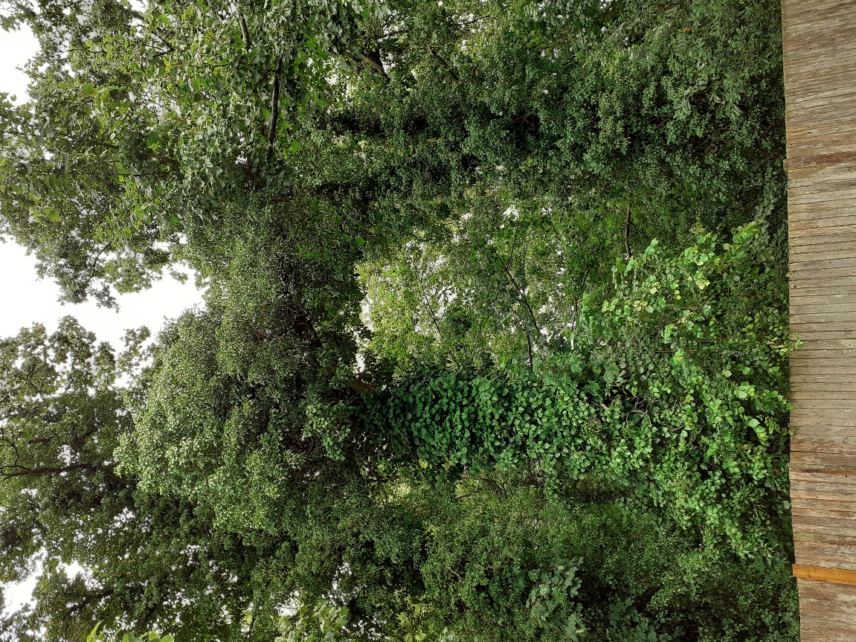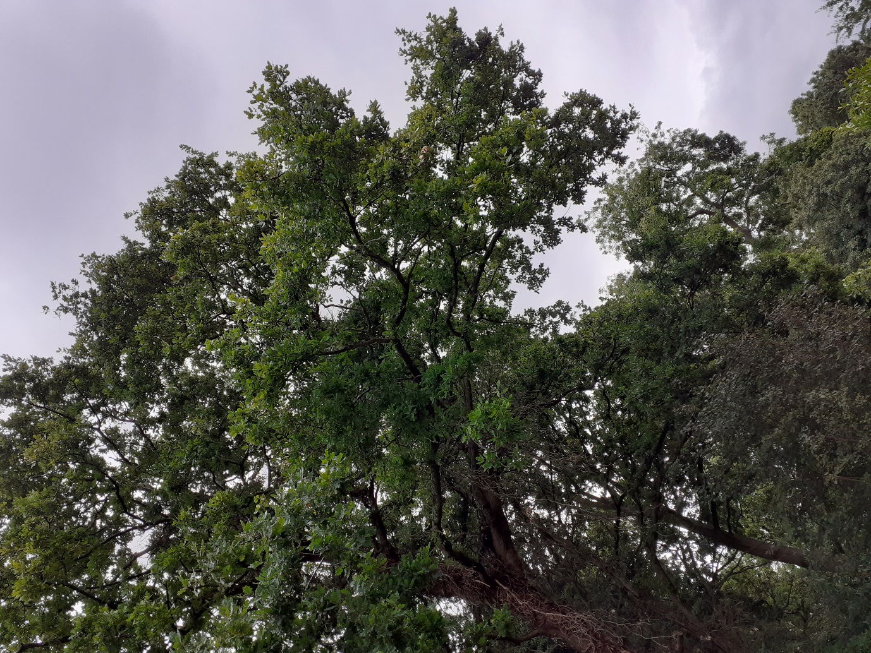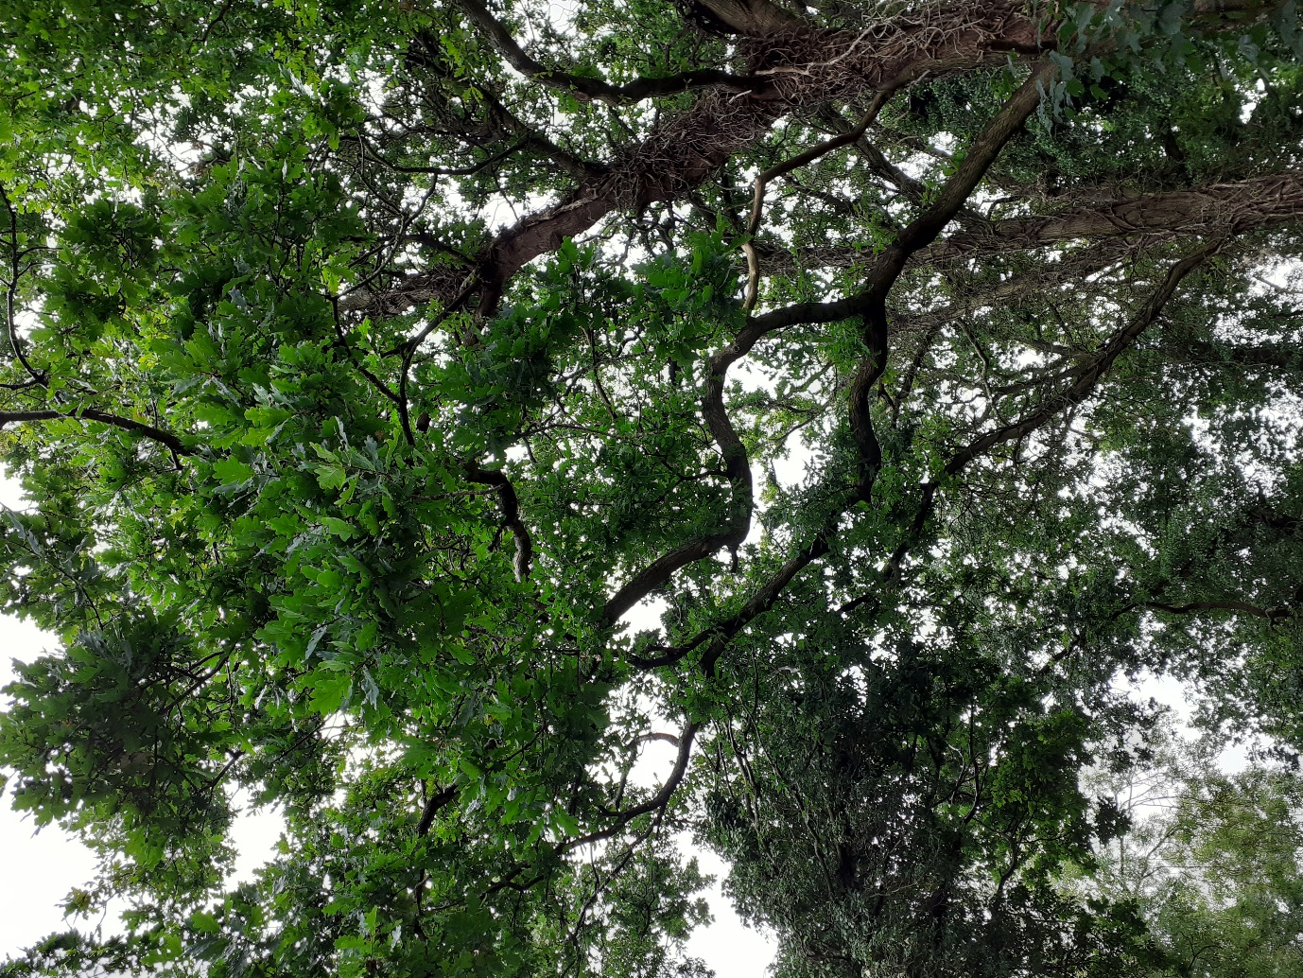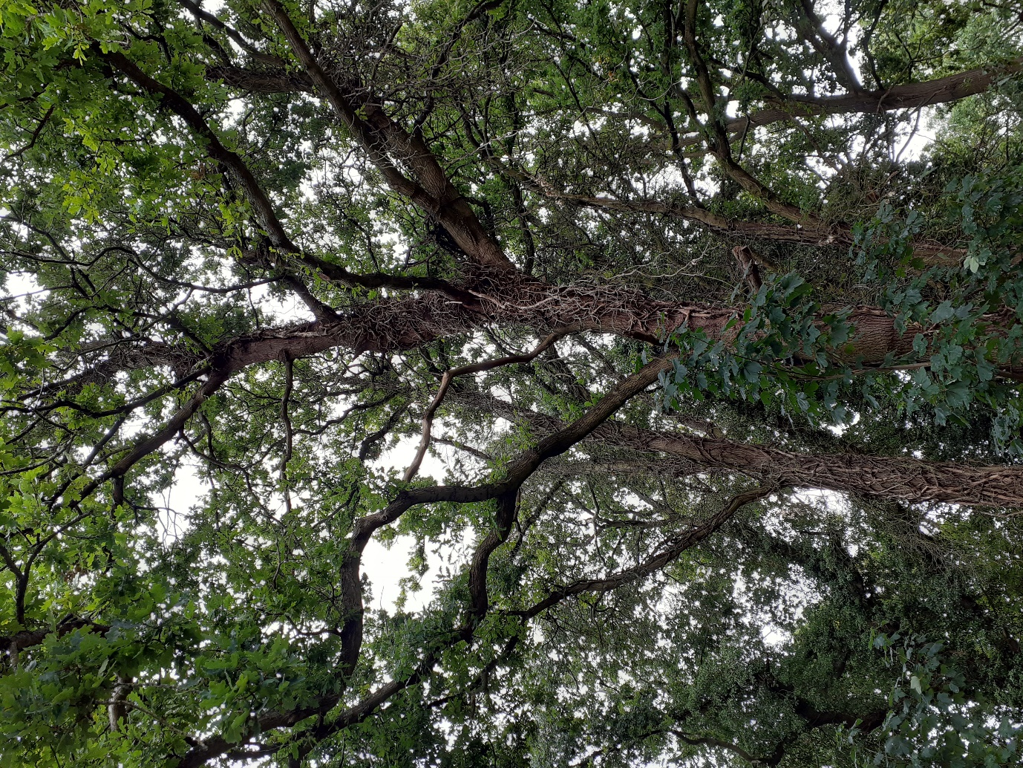
Ivy covered Sycamore
Branch from Sycamore to be removed
Oak - Branches to be reduced
Oak – forked branch to be reduced, as indicatively shown
Oak – forked branch to be reduced

Oak and Sycamore overhanging 4 Bluebell Gardens from 26 Tower Close
TPO 33/02
Application ref: 200761/TPO
1/7/20

