Delegated Application Report Target Date: 24/07/20
Address: 7b Cambridge Street
Application No: 200735/CLE
Proposal: Use of basement as self-contained flat (Class C3)
Case Officer: Tom Hughes
Site Description
The application site comprises a three storey mid-terraced property. 7b Cambridge Street, the subject of this application, occupies the basement level with its own independent access from the street. 7 Cambridge Street occupies the ground and first floors of the building. The surrounding area is predominantly residential.
Description of Use or Development
A Lawful Development Certificate for an existing use is sought for the use of the basement as a self-contained flat. The relevant time period is 29/05/16 to 29/05/20.
Relevant Planning History
None.
Relevant Planning Policy and Guidance
Section 10 of the Planning and Compensation Act 1991 established a procedure that enables anyone who wishes to do so, to apply to the local planning authority to determine whether a proposed use or operation, or an existing operational development or an existing use of land, or any other matter constituting a failure to comply with any condition or limitation subject to which planning permission has been granted, is lawful, and is so, be granted a certificate to that effect.
A Lawful Development Certificate is a legal document stating the lawfulness of past, present or future development. If granted by the local planning authority, the certificate means that enforcement action cannot be carried out to the development referred to in the certificate. However, the certificate will not protect from enforcement action by the planning authority if the specified use or development is then changed ‘materially’ without a planning application for it.
The certificate is not planning permission. The planning merits of use, operation or activity in the application are not relevant. The issue of a certificate depends entirely on factual evidence about the history and planning status of the building or other land and the interpretation of any relevant planning law or judicial authority. The responsibility is on the applicant to provide evidence to support the application.
The NPPG states that ‘The applicant is responsible for providing sufficient information to support an application. In the case of applications for existing use (section 191 of the Town and Country Planning Act 1990), if a local planning authority has no evidence itself, nor any from others, to contradict or otherwise make the applicants version of events less than probable, there is no good reason to refuse the application, provided the applicants evidence alone is sufficiently precise and unambiguous to justify the grant of a certificate on the balance of probability’.
Consultations
No response received to consultations.
Submitted Evidence
The agent supplied the following, received on 01/06/20:
Supporting Letter
Drawing No: LDC/B/1999/1 – Site Location and Site Plan
Drawing No: LDC/B/1999/2 – Basement Floor Plan
Statutory Declaration by Mrs Kaye Helsen, current legal owner of 7 Cambridge Street, dated 20/05/20, witnessed by a solicitor
Statutory Declaration by Mr Antoine Luc Anne-Marie, current legal owner of 7 Cambridge Street, dated 20/05/20, witnessed by a solicitor
Statutory Declaration by Mrs Janis Fletcher, former legal owner and vendor of 7 Cambridge Street, dated 20/05/20, witnessed by a solicitor
Haslams Estate Agent Sales Marketing Information
Energy Performance Certificate for 7b Cambridge Street, dated 13/09/19
Energy Performance Certificate for 7 Cambridge Street, dated 11/09/19
Email with meter readings, dated 12/12/19
Electricity bill for 7b Cambridge Street, dated 24/01/20
Electricity bill for 7 Cambridge Street, dated 31/01/20, for period 18/12/19 to 29/01/20
Electricity bill for 7b Cambridge Street, dated 07/01/20, for period 15/11/19 to 01/12/19
Council Tax band details for 7b Cambridge Street, dated 08/12/19, for period from 13/01/99
Council Tax band details for 7 Cambridge Street, dated 08/12/19, for period from 13/01/99
Internal and external photographs of 7 and 7b Cambridge Street, dated 20/05/20
Subsequently the agent supplied the following, received 11/08/20:
Email, dated 11/08/20, with details of recent use of property, and explanation for lack of more detailed tenancy information
Analysis of Evidence
An Application for a Lawful Development Certificate for an existing use has been made, to establish that the use of the basement of 7 Cambridge Street as a self-contained flat, known as 7b Cambridge Street, has been ongoing for more than four years.
The relevant time period is 29/05/16 to 29/05/20.
The agent has supplied evidence dating to 1999 that the basement has been in use a self contained flat. The basement has been unoccupied since September 2019, when the property (7 and 7b Cambridge Street) was listed for sale. The sale of the property was completed in November 2019, and refurbishment works to both no.7 and no.7b commenced immediately. Due to COVID-19 the refurbishment works were halted, but had recommenced at the time of the application submission.
The Local Planning Authority has evidence of its own to show that the use of the basement as a self-contained flat has been ongoing since 1999. The information supplied with the application is sufficient to corroborate the information contained within the Statutory Declarations from the current and previous owners of the property, that the basement has been used as a self-contained flat for more than four years. Officers are satisfied that the vacancy of the flat since September 2019 was for renovation and refurbishment of the property, delayed due to the onset of COVID-19.
Having regard to the foregoing, it is considered on the balance of probability, the property known as 7b Cambridge Street, Reading, RG1 7PA has been in use as a self-contained flat for a period in excess of four years. In the circumstance it is considered appropriate to grant a Certificate of Lawfulness to that effect.
Recommendation
Grant Certificate
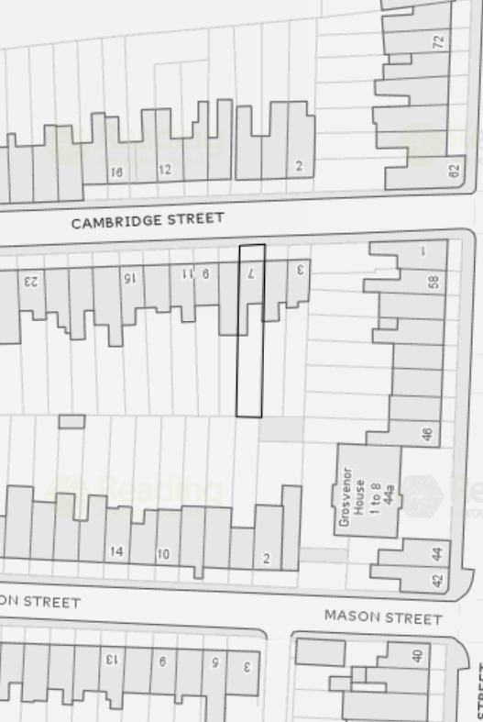
Site Location

