DELEGATED APPLICATION REPORT - Application Nos.: 200886/ADV
Address: Phase 6A Green Park Village, Longwater Avenue
Proposal: Advertisement consent for the erection of a building wrap advertisement on the western elevation of Block 4, in Phase 6 of the Green Park Village development.
Case officer: Alison Amoah

Site Description and Surrounding Area:
Phase 6 is currently under construction and is a predominantly residential phase of Green Park Village, sited to the north of the established Green Park Business Park.

Proposal:
One building wrap on the end elevation (marked blue) of one of the blocks, as part of phase 6A, which faces the railway line, and the proposed Green Park Village Station. The sign would be 16m wide by 24m high, and 12m from ground level to underside, and would be in place during construction.

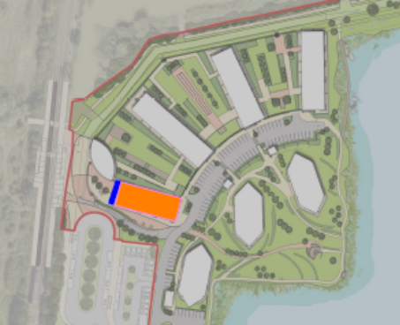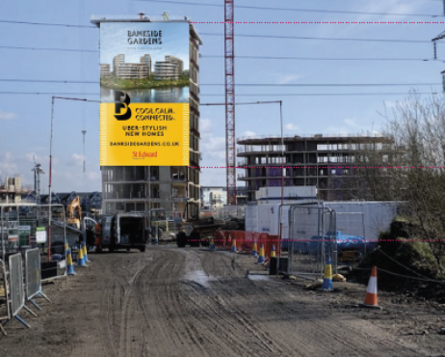

Plans considered:
- Proposed Advert Location Plan, received 25th June 2020
- Bankside Gardens Building Wrap Planning Document, June 2020, prepared by Hunter Solves, received 25th June 2020

Relevant Planning History:
151069/ADV – Billboard sign – wayfinding -Consented 27/11/2015
200886/ADV - Wayfinding and block signage at the entrance to Phases 3A & 3B, to
include parking, direction, marketing suite, banner and one backlit sign – Consented 28/9/2020.

Numerous signage within Green Park Business park – to the south of the application site.

Consultation Responses: No internal or external consultation was undertaken.

Equality Act 2010:
In determining this application the Council is required to have regard to its obligations under the Equality Act 2010. However, there is no indication or evidence (including from consultation on the application) that the protected groups identified by the Act have or will have different needs, experiences, issues and priorities in relation to this particular planning application. Therefore in terms of the key equalities protected characteristics it is considered there would be no significant adverse impacts as a result of the development.

Relevant Planning Policy and Guidance and Legal Context
Regulation 3 of the Town and Country Planning (Control of Advertisements) (England) Regulations 2007 requires the Local Planning Authority to exercise its powers under these regulations in the interests of amenity and public safety taking into account the provisions of the development plan, so far as they are material; and any other relevant factors. Regulation 3 states that factors relevant to amenity include the general characteristics of the locality, including the presence of any feature of historic, architectural, cultural, or similar interest.

Factors relevant to public safety include highway safety and whether the advert would hinder security or surveillance devices, including speed cameras.

Section 38(6) of the Planning and Compulsory Purchase Act 2004 requires that proposals be determined in accordance with the development plan unless material considerations indicate otherwise. Material considerations include relevant policies in the National Planning Policy framework (NPPF) - among them the 'presumption in favour of sustainable development'.

The following local and national planning policy and guidance is relevant to these applications:

Adopted Reading Borough Local Plan (2019):
CC7 (Design and the Public Realm)
CC8 (Safeguarding Amenity)
TR3: Access, Traffic and Highway-Related Matters
OU4: (Advertisements)

Appraisal:
Main Issues: The main issues are considered to be:

(a) Amenity
- Safety

(a) Amenity
The sign would be set high up on the building and would be highly visible, but it would be temporary for the purpose of advertising the phase of residential development. It would be visible from the west, from open fields and the railway line and forthcoming Green Park Village Station. It would not be illuminated, and it is not considered that it would have a significant detrimental effect on visual amenity.

On the above basis, the proposed sign is considered to comply with Adopted Reading Borough Local Plan Policies CC7, CC8, TR3 and OU4.

(b) Safety
The NPPG (in particular in this instance Paragraph: 068 Reference ID: 18b-068-20140306 & Paragraph: 078 Reference ID: 18b-078-20140306) provides guidance as to the considerations affecting public safety. Having reviewed the guidance with respect to the type of advertisements which may cause danger to road users, the officer concludes that there would be no detrimental effect with regard to highway safety.

The positioning of the signage is unlikely to have any effect on road users; there will be no illumination, it would not obscure existing signs, nor reduce visibility for road users, or impact on the sight lines of CCTV cameras. The signage is therefore, considered to accord with Adopted Reading Borough Local Plan Policies TR3 and OU4.

RECOMMENDATION:

GRANT

Proposed conditions:

- Standard advert conditions
- Approved plans

Informatives:
T&Cs
Positive and proactive

