Caversham Weir Reading
Hydroelectric Project
Construction Materials

Document Control

Version | Date of Issue | Author(s) | Reviewed by
01 |  | Matt Lomax | Rich Spurr
0.2 | August 2020 | Simon Lewis | Tony Cowling
0.3 | September 2020 | Simon Lewis | Tony Cowling
0.4 | November 2020 | Simon Lewis | Tony Cowling

Contents
1 Introduction 2
2 Materials 2
Reinforced concrete 2
Intake screens 2
Archimedes Screw turbine 3
Generator Hut 3
Fencing 5
Eel tiles and fish brushes 5
Bat Boxes 6
3 Example of twin Archimedes Screw project in Pershore, Gloucestershire 7

Introduction
- This document outlines the proposed materials to be used in the construction of the Caversham Weir Hydro project.

Materials

Reinforced concrete
- The main structure is made of reinforced concrete – similar to shown below:
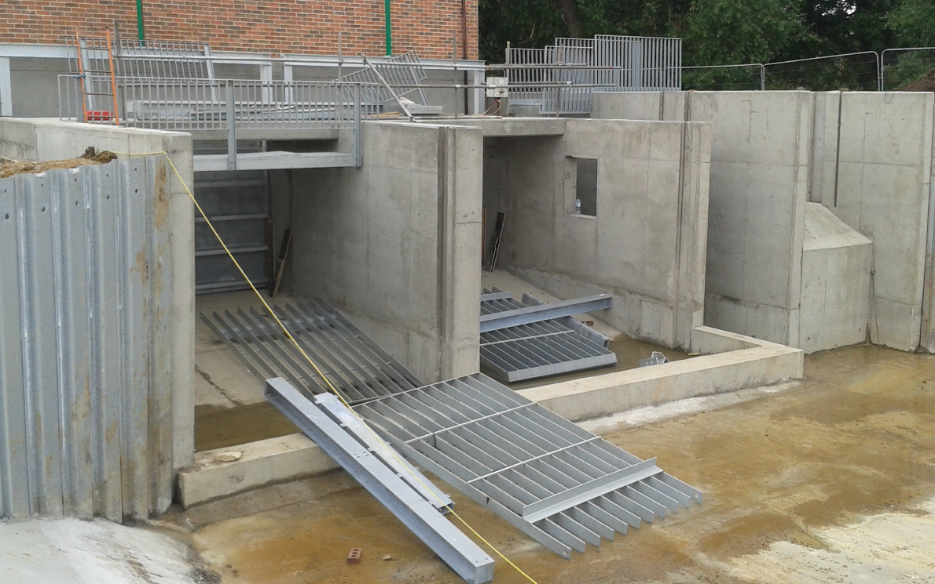

Intake screens
- Stainless steel intake bars – similar to shown below.
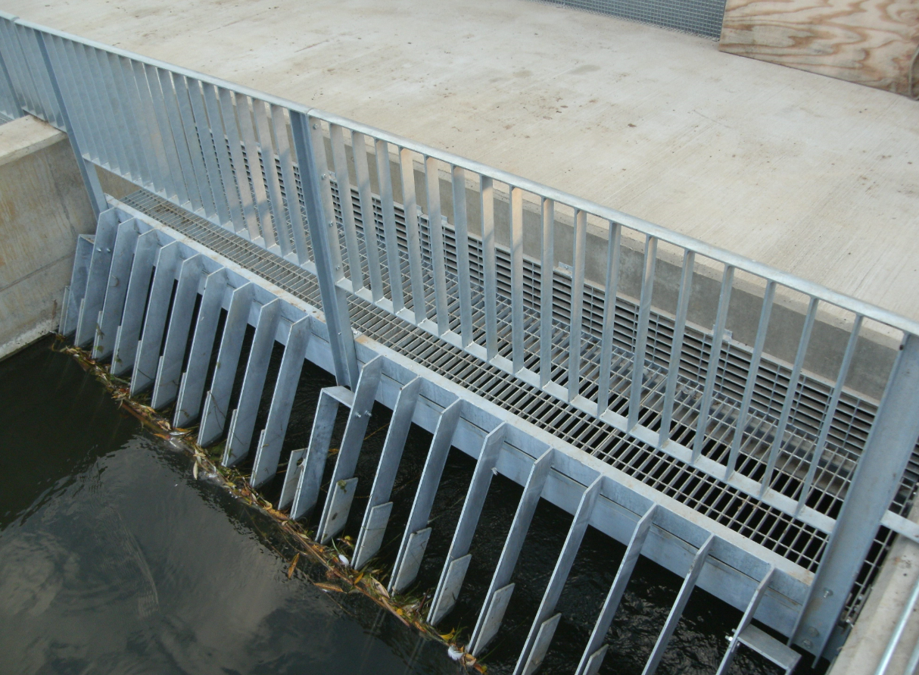

Archimedes Screw turbine
- Archimedes Screw turbines are powder coated metal usually in black or dark green.
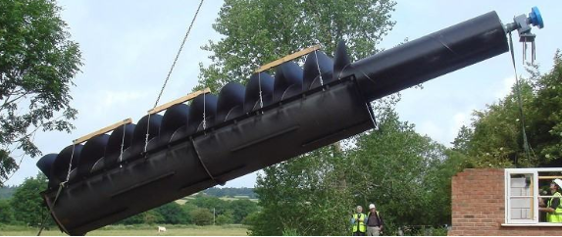

Generator Hut
- The building structure will be fair faced concrete blocks, painted white.
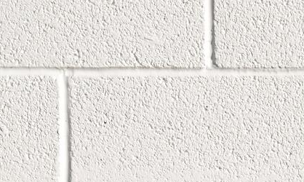

- The roof will be box profile roofing sheets in green (RAL 6005 or similar):
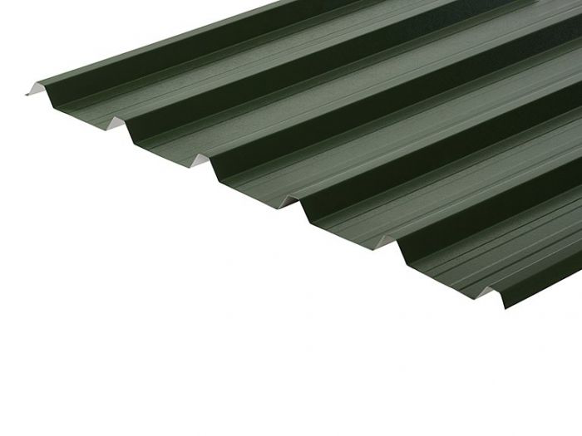
- Door – double personnel access door powder coated.
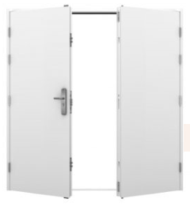

Fencing
- Palisade fencing.1.8m tall in Green RAL6005 or similar. Security fans at open ends.
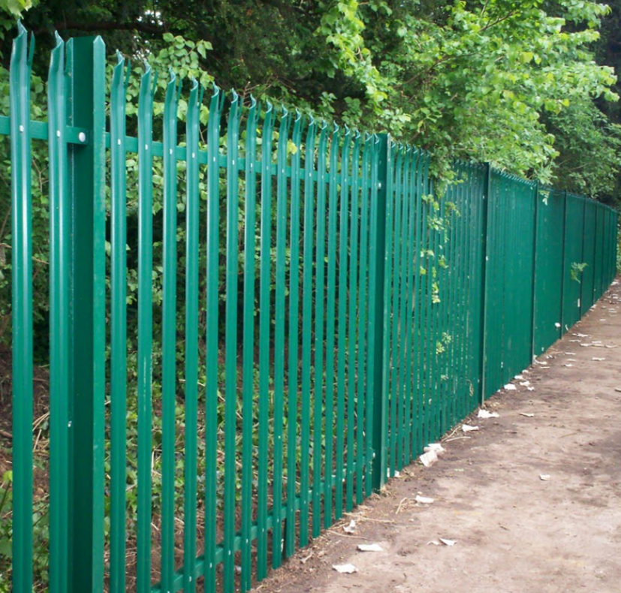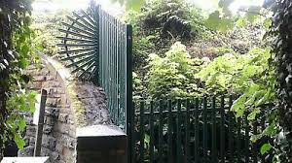
- Key Clamp style railing (with infill panels on public footpath), galvanized steel.
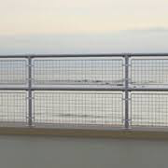

Eel tiles and fish brushes
- The eel tiles and fish pass brushes will look similar to the below:
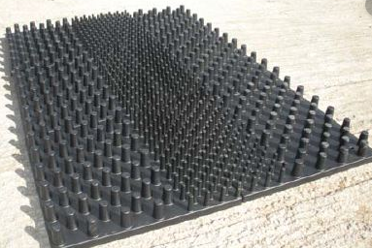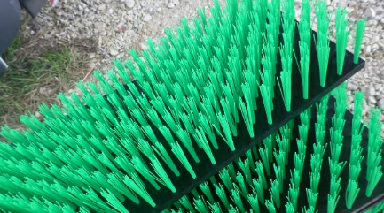

Bat Boxes
- 2 bat boxes will be built into the gable end of the generator hut as shown by the arrows on the plan below. The design for these has been provided separately.
- 5 wooden bat boxes have already been fitted to nearby trees on View Island as shown on the plan below. These were built to RSBP specification (example below).
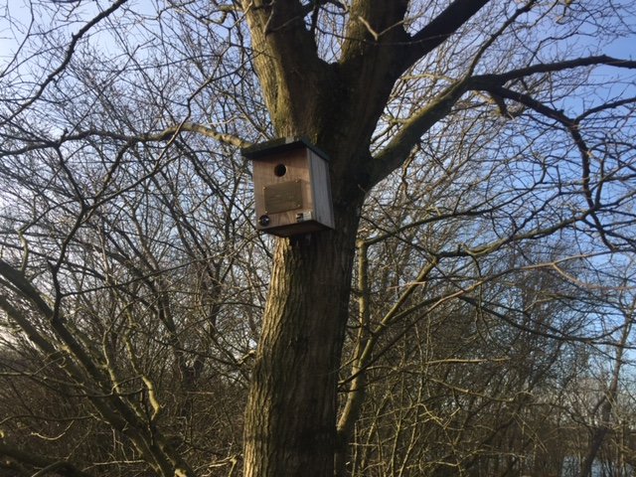

- Location of bat boxes
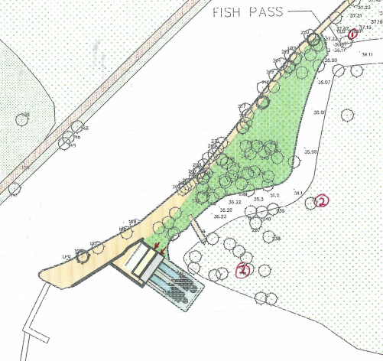

Example of twin Archimedes Screw project in Pershore, Gloucestershire
