DELEGATED HOUSEHOLDER APPLICATION REPORT
Ward: Peppard
App Ref: 210733 / HOU
Address: 1 Netley Close, Caversham, Reading, RG4 6SR
Proposals: Proposed single storey front infill extension plus internal alterations
Case Officer: Beatrice Malama
Date received (valid from): 10th May 2021 Target date: 5th July 2021

SITE DESCRIPTION
The site is a two story semi-detached house located at the junction of Netley Close and Kingsway in a predominantly residential area. The area comprises of detached and semi detached properties with similar design, style and age. The property is not listed and does not fall within a conservation area.
PROPOSED DEVELOPMENT
The proposed development is a single-story front extension to create additional kitchen space. The proposed extension measures approximately 2.2m deep and 2.6m wide respectively. Proposed exterior finishes including the roof would match that of the existing house. The roof would be pitched to match the existing house.
Plans considered;
Drawing No: 21047.B.PP-01 – Existing Ground Floor Plan
Drawing No: 21047.B.PP-02 – Existing Elevations
Drawing No: 21047.B.PP-03 – Proposed Ground Floor Plan
Drawing No: 21047.B.PP-04 – Proposed Elevations
Drawing No: 21047.B.PP-05 – Location Plan
Drawing No: 21047.B.PP-06 – Block Plan
As received on 10th May 2021

RELEVANT PLANNING HISTORY
No Planning History

CONSULTATIONS
Confirmation that the site notice was displayed on 13th May 2021 was received from the agent and the following addresses were consulted by letter.
57 Kingsway, Caversham, Reading, RG4 6RH
2 Netley Close, Caversham, Reading, RG4 6SR
One letter of representation has been received from the neighbour at 2 Netley Close raising concerns about potential loss of light. This concern is addressed later in the report under residential amenity.

Equality Act 2010:
In determining this application the Council is required to have regard to its obligations under the Equality Act 2010. However, there is no indication or evidence (including from consultation on the application) that the protected groups identified by the Act have or will have different needs, experiences, issues and priorities in relation to this particular planning application. Therefore, in terms of the key equalities protected characteristics it is considered there would be no significant adverse impacts as a result of the development.

Relevant Planning Policy and Guidance
Section 38(6) of the Planning and Compulsory Purchase Act 2004 requires that proposals be determined in accordance with policies in the development plan unless material considerations indicate otherwise. Material considerations include relevant policies in the National Planning Policy framework (NPPF) - among them the 'presumption in favour of sustainable development'.

National Planning Policy
National Planning Policy Framework (2019)
National Planning Practice Guidance

Reading Borough Local Plan (2019)
CC7 (Design and the Public Realm)
CC8 (Safeguarding Amenity)
H9 (House Extensions and Ancillary Accommodation)
SPG/SPD
A Design Guide to House Extensions SPG

Assessment
Character and appearance
Policy CC7 (Design and the Public Realm) requires that all developments be of high design quality, whilst Policy H9 (House Extensions and Ancillary Accommodation) requires that an extension “respects the character and appearance of the house in terms of scale, location, materials and design and should not harm the character and pattern of neighbouring houses and the appearance of the street scene”.
The proposed development retains the design and style of the existing house with exterior finishing materials to match. Since the proposal would retain the character of the existing house and would not extend beyond the existing building line to the front elevations, it would be considered unlikely to cause harm to the character and pattern of neighbouring houses and the appearance of the street scene. In addition, although the proposed extension would cause a break in the existing pattern of the street scene and reduce the gap between the site and the neighbouring house at No. 2 Netley Close, the impact on the appearance of the neighbour’s house and the street scene would not be detrimental. The proposal therefore does not harm the character or appearance of the existing house nor have a detrimental impact on the wider area.
Residential Amenity
CC8 (Safeguarding Amenity) seeks to prevent development causing detrimental impact on the neighbouring properties; policy H9 (House Extensions and Ancillary Accommodation) provides that extensions should not cause an overbearing impact on neighbours”.
As the proposal is single-story there would be no overlooking of neighbouring houses therefore the extension is unlikely to cause loss of privacy to the neighbour. With regard to the relationship with the attached neighbour at 2 Netley Close, this property has a front facing kitchen window. The primary living space is located to the rear of the house. As the property is north facing, this kitchen window is largely shaded by the existing house (as shown in figure 1 - aerial photo), therefore the proposal is not considered to make the living conditions of the neighbouring house at No. 2 significantly worse. The proposed single-story front extension is unlikely to cause any harmful loss of sunlight, daylight or overshadowing to the neighbouring house. Furthermore, the proposal would be considered unlikely to cause harmful overbearing impact on the neighbouring houses and the street scene as the proposal would retain the style and design of the existing frontage.
Figure 1: Arial Photo Showing the existing frontage at No. 1 & 2 Netley Close
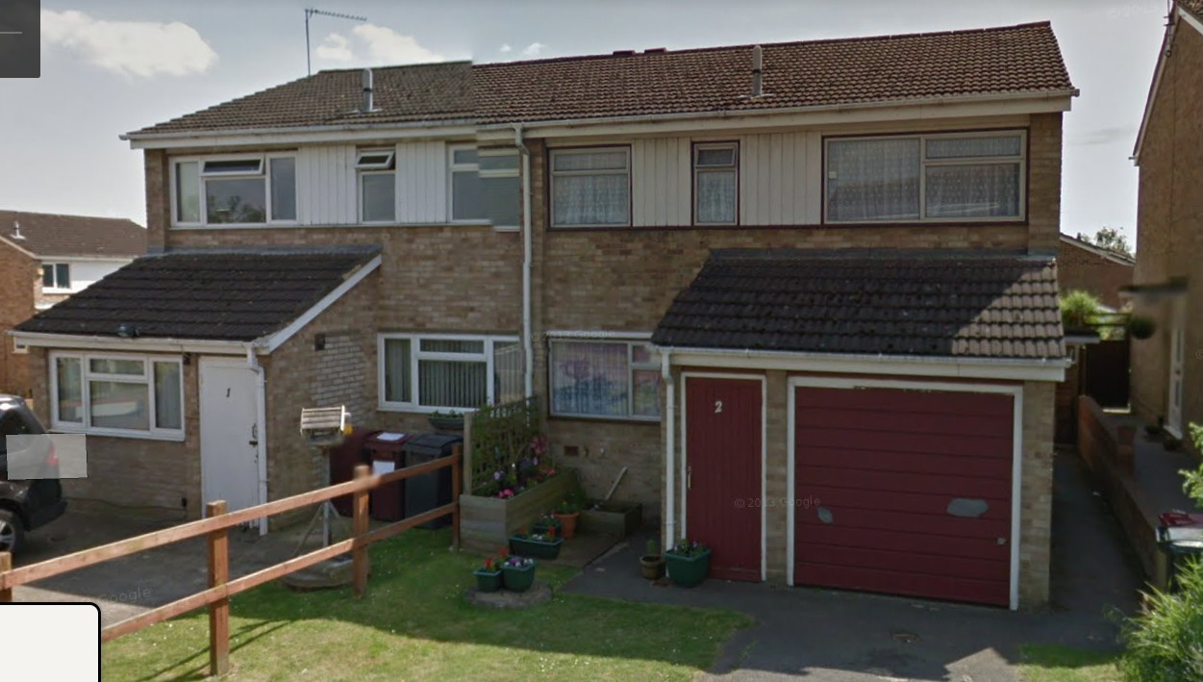
Conclusion
The proposed extension is considered to be in accordance with the Reading Borough Local Plan (2019) and the Design Guide to House extensions (2021) and therefore the application is recommended for approval subject to conditions.

Recommendation:
Grant
CONDITIONS
- Time Limit (Standard) TL1
- Approved Plans Ap1
- Materials (To Match) M1

