DELEGATED HOUSEHOLDER APPLICATION REPORT

App Ref: 201785
Address: 22 Corwen Road
Proposal: Erection of a self-contained single-storey log cabin at rear of garden
Case Officer: Mr Brian Conlon
Applicant: Mrs Hayley Webb
Date received (valid from): 13 Jan 2021
Target Decision date: 1st April 2021

1. SITE DESCRIPTION
The application site relates to a post-war end terraced house. The property benefits from a driveway and side access to a large rear garden which until recently contained a detached single garage (now demolished). The site is not within a conservation area nor contains any protected trees.

2. PROPOSED DEVELOPMENT
The application seeks permission for the erection of a self-contained single storey log cabin to the back of the rear garden.

3. RELEVANT PLANNING HISTORY
None relevant.

4. CONSULTATIONS

Neighbours

A site notice was displayed on the 14th January 2021 for the requisite period and both adjoining neighbours were consulted by letter. The statutory publicity requirements of the Council were fulfilled.

No letters of representation were received.

5. EQUALITY ACT 2010:

In determining this application, the Council is required to have regard to its obligations under the Equality Act 2010. However, there is no indication or evidence (including from consultation on the application) that the protected groups identified by the Act have or will have different needs, experiences, issues and priorities in relation to this particular planning application. Therefore, in terms of the key equalities protected characteristics it is considered there would be no significant adverse impacts as a result of the development.

6. LEGAL AND PLANNING POLICY CONTEXT

Section 38(6) of the Planning and Compulsory Purchase Act 2004 requires that proposals be determined in accordance with the development plan unless material considerations indicate otherwise. Material considerations include relevant policies in the National Planning Policy framework (NPPF) - among them the 'presumption in favour of sustainable development'. The following local and national planning policy and guidance is relevant to this application:

National Planning Policy

National Planning Policy Framework (2019)
National Planning Practice Guidance

Reading Borough Local Plan (adopted 2019)

CC7: Design and the Public Realm
CC8: Safeguarding Amenity
EN12: Biodiversity and the Green Network
H9: House Extensions and Ancillary Accommodation

SPG/SPD

A Design Guide to House Extensions SPD (2021)

7. APPRAISAL

7.1 Principle of development

The proposal seeks permission for the erection of a self-contained single-storey log cabin at the back of the rear garden. It is understood the cabin would be occupied by an elderly relative. As such, the cabin is therefore considered on the basis that it is for ancillary residential purposes.
Residential alterations including the construction of outbuildings are supported in principle by Policy H9 (House Extensions and Ancillary Accommodation) of the Local Plan (2019. In addition to general design and amenity objectives that are covered later in this report, Policy H9 specifically supports ancillary accommodation such as granny annexes, where they would not be capable of operating as a separate dwelling which could be let or sold separately.
The supporting text to Policy H9 identifies the need to ensure that any such ancillary accommodation should not be a way of introducing new dwellings by stealth. The supporting text goes on to outline a number of factors which could lead ancillary accommodation to be considered a separate dwelling. These are:
- Self-sufficiency in terms of facilities e.g. kitchens and bathrooms;
- Independent access e.g. front door without internal links to the main house; and/or
- Independent external facilities for self-contained living, e.g. access, drive, garden; or has scope for these external facilities to be easily created.
In addition to the physical characteristics listed above, it is necessary to consider the overall size and relationship of the outbuilding in relation to the main dwelling. This includes the available plot, its siting and its location. Alongside these physical characteristics, the LPA must also consider the characteristics of how the cabin will be used. This includes the nature of the use, by whom and their relationship to occupants of the main dwelling. Based on case law, none of these factors listed are overriding and must all be read in combination. The weight given to each is relative to the nature of the proposal and is a matter of fact and degree. However, any use must fundamentally meet the Policy H9 test which requires such proposals to “not be capable of operating as a separate dwelling which could be let or sold separately”.
The plans show that the cabin would be 7m x 3m and have an internal floorspace of 21sqm. The internal layout of the cabin is divided into three rooms, two small and one larger room. No facilities or internal arrangements are shown on the submitted plans. The cabin is proposed to be located to the back of the rear garden, behind the single garage which is now demolised (See below).
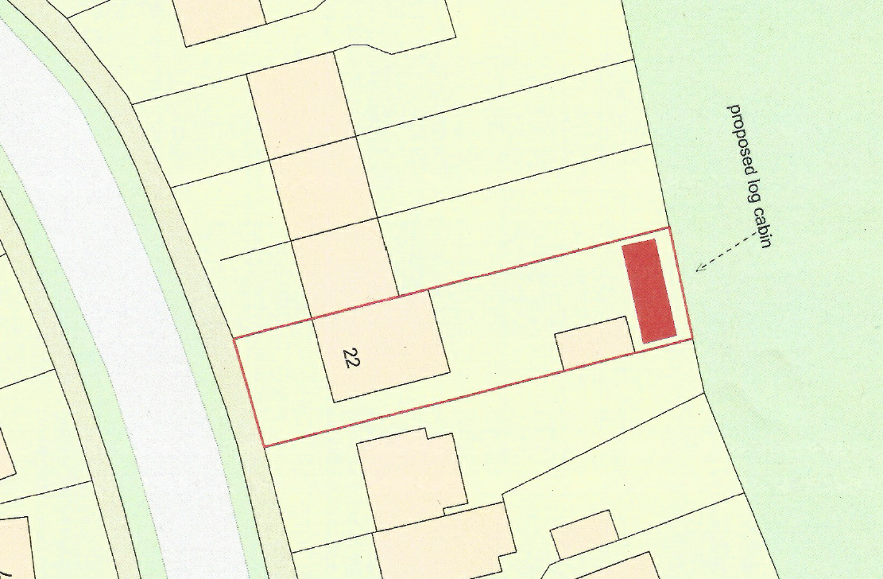
Extract from block plan (Not to scale)
In considering the proposal against the above criteria, the description of development states the cabin is to be ‘self-contained’ and whilst not shown on the plans or able to be monitored by the Council, it can be assumed via the description that it is the intention for the cabin to contain all facilities reasonably required for independent occupation. The cabin is only accessible by entering the rear garden of 22 Corwen Road down the side of the main house. Furthermore, the cabin would not be provided with separate outdoor space of its own and would share the same address and front door as the main dwelling.
Given its proposed location adjacent to the rear boundary of the site and physical relationship to the main dwelling, any occupier of the cabin would have to utilise the outdoor space and access associated with the main dwelling. Whilst there always remains the scope for such measures to be provided separately in the future, this would constitute a subdivision of the main planning unit in connection with the use of the outbuilding and require planning permission in itself.
In considering the physical characteristics of the proposed outbuilding and its relationship to the main dwelling, the cabin is considered modest in size and is clearly ancillary in scale to the main house. Secondly, it is considered comparative is size and siting to other outbuildings that are used for any such ancillary purposes. In considering the intended use of the cabin by an elderly relative of the occupant of main dwelling, the nature of which (assisted living of an elderly relative) and provision of accommodation for an aging population is specifically supported by national policy and Policy H9 of the Local Plan, subject to restrictions preventing severance from the main planning unit.
Whilst it is accepted that the proposed cabin could contain all the facilities required for independent occupation, its overall size is modest and the level of facilities it would provide would be basic. This would be expected for such accommodation ancillary to the main dwelling.
Whilst unlikely, it is recognised that any grant of planning permission could result in pressure for the building to be used as a separate dwelling at some point in the future once the cabin is no longer required by an elderly relative of the occupant. National guidance and Policy H9 recognise that a condition can be attached to any permission ensuring that the occupation of this unit remains ancillary. The fact that such a condition is included in national guidance and local policy is an indication that it is capable of being enforced and there is no reason why the Council is not able to investigate and take any action should any breach of condition occur.
Overall, it is concluded that the proposed development would constitute an appropriate ancillary use to the main house rather than constituting the harmful creation of new dwelling simply because has all facilities for independent living as identified by Policy H9. Furthermore, Policy H9 allows for its continued ancillary use to be reasonably secured via condition, which would prevent any change in the nature of its occupation with the main dwelling without planning permission.
Therefore, in summary, in responding to the main test of Policy H9, specifically whether the accommodation would “be capable of operating as a separate dwelling which could be let or sold separately”, the physical characteristics of the cabin and imposition of a condition is considered to prevent any such occurrence. As such the development is therefore considered acceptable in principle and accords with policies contained within the Local Plan and NPPF.

7.2 Character and scale
Policy CC7 of the Local Plan states that, development must be of a high design quality that maintains and enhances the character and appearance of the area in Reading in which it is located. Policy H9 states that such development will be acceptable where it respects the character of the house, and surrounding area.

The proposed outbuilding is of modest scale, single storey and of timber construction. It cannot be seen from the public realm. Therefore, it is not considered to have any harm on the character or appearance of the main dwelling or wider character of the adjoining rear gardens. As such, the proposal accords with the aims of Policy CC7 and the design considerations of Policy H9.

7.3 Amenity

Policy CC8 requires development to refrain from causing a detrimental impact on the living environment of existing residential properties or unacceptable living conditions for residents.

The outbuilding is not considered to cause any detrimental impact on neighbour’s privacy, sunlight or overbearingness by virtue of siting and design; with no views into adjacent neighbour’s private outdoor amenity space being created. The site would not result in any harmful reduction in private amenity space available for 22 Corwen Road.

The proposed development is therefore deemed to accord with Policy CC8.

7.4 Biodiversity and sustainability

Part ‘b’ of Policy EN12 indicates that all development sites should not result in a net loss of biodiversity or geodiversity and should provide a net gain for biodiversity wherever possible through new tree planting, wildlife friendly landscaping and other ecological enhancements. These aims are supported by Policy H9 which states that an extension will only be acceptable where it does not result in the loss of biodiversity within gardens.

The outbuilding will be located on garden land that does not contain any protected trees of feature of biodiversity value. As such there is not considered to be a net loss of biodiversity or geodiversity. As such the proposal is considered to accord with the biodiversity and sustainability considerations of Policies H9 and EN12 of the Local Plan.

8. CONCLUSION
In light of the above assessment the proposal is considered to accord with the requirements of the development plan. As such, the proposed development is recommended for approval subject to conditions.

9. RECOMMENDATION
GRANT

10. CONDITIONS

- TL1 Time Limit
- AP1 Approved Plans
- M3 Materials as specified
- Ancillary use restriction

Site Photos
