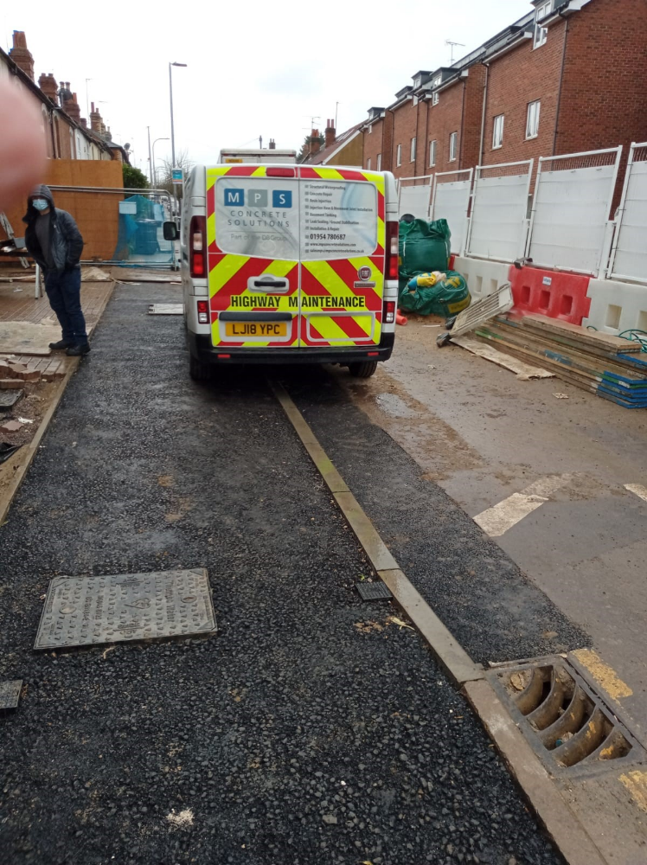

Photo of access works – 201324 – cd 6 received 20th November 2020

