Schedule of External Wall Materials
This schedule should be read in conjunction with the General Arrangement Floor Plans, Elevations and Window & Door schedule along with the Construction Specification
Samples availabe on site.

Item | Proposed Specification | Comments | Image SAMPLE
External Wall – Main Construction Build-Up
Brickwork (main) | Forterra – Wentworth Mixture Brick  Standard Grey Mortor |  | 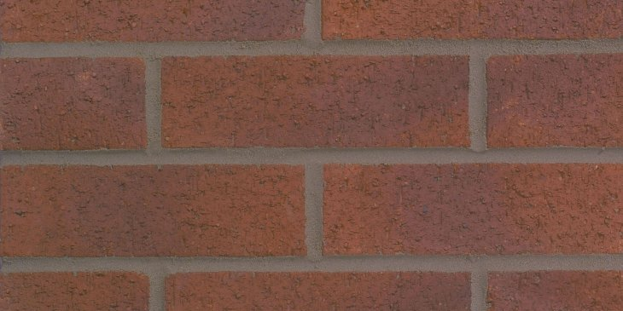
Brickwork (Textured area) | Forterra – Wentworth Mixture Brick  20mm indend and protrusion  Standard Grey Mortor |  | 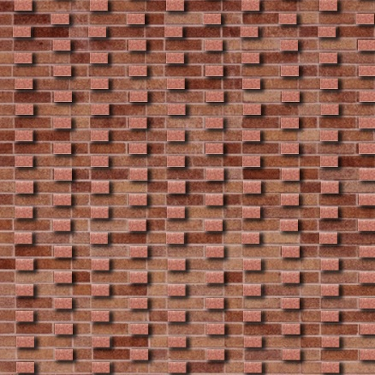
Brickwork (core entrances) | Synthesis S17 From MBH PLC  Standard Grey Mortor |  | 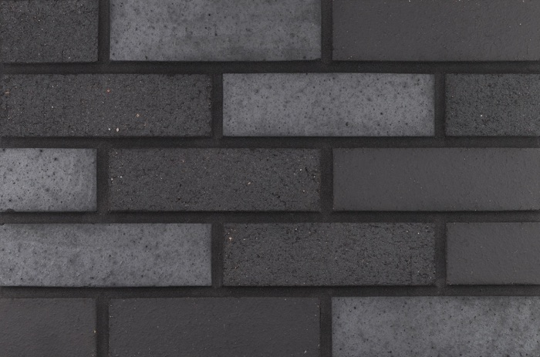
Timber Boarding (to community building) | Kebony Cladding |  | 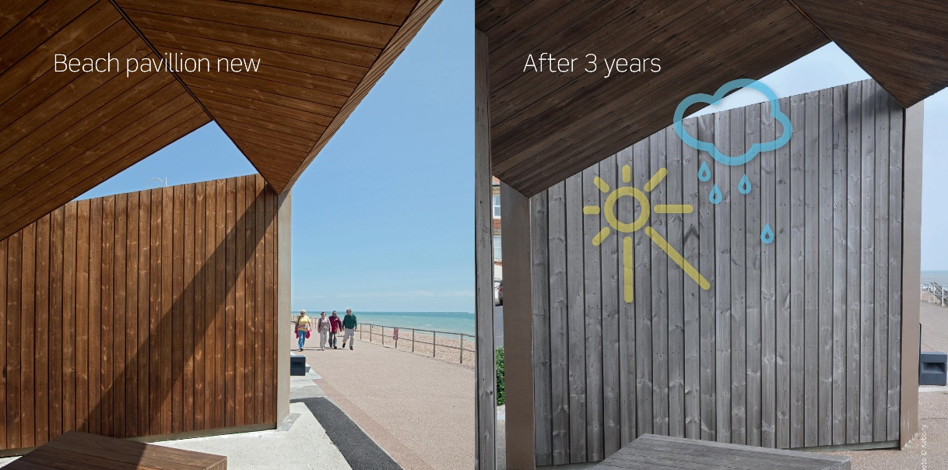
Balcony feature fins | Keybony Timber Fins  Balcony rails (cira. RAL7016) |  | 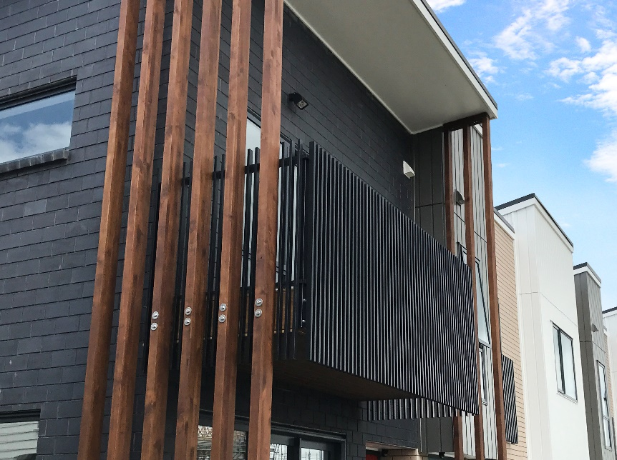
Entrance doors | Profile 22 or IG  Dark Grey or Black (cira. RAL7016) Composite GRP doors or similar  SBD/Part Q Ironmongary  Cira. RAL 7016
Windows & Patio doors | Dark Grey or Black (cira. RAL7016) uPVC  Profile 22 or Rehau  SBD/Part Q Ironmongary |  | 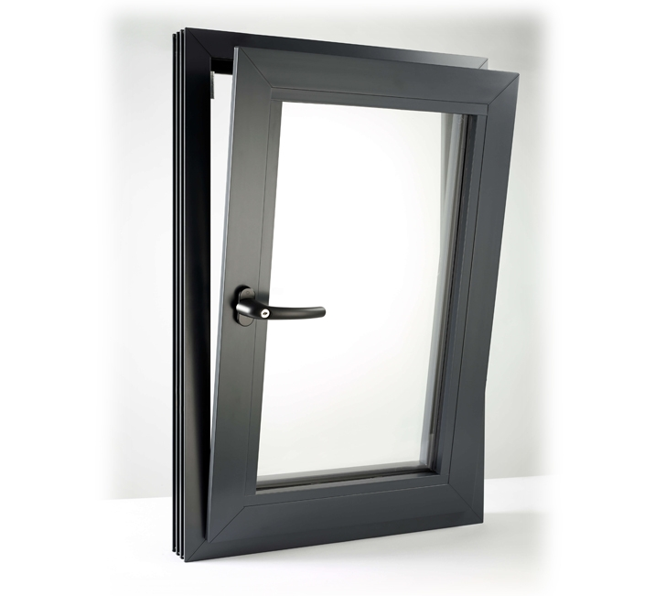
Parapet and balcony flashing  & Roof covering | Axter Edge Flashing or Similar  Dark Grey (cira. RAL7016)  Axter SinglePly Membrane or Similar (Grey) (roof covering dependant on suppliers designs)
rainwater goods | Axter Black Hopper & uPVC downpipes |  | 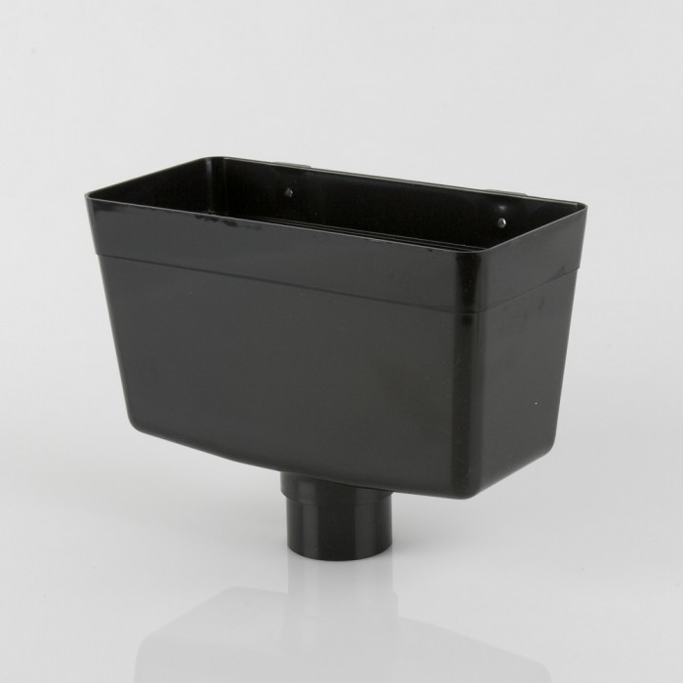

Revision | Status | Date | Notes | by | chk
P01 | Preliminary issue | 02/09/2020 | For review | AK | BW
P02 | Materials Updated | 10/09/2020 | For Planning Condition | AK | BW

