Delegated Application Report Target Date: 10/8/20 (extended)

Address: Green Park Village
Application No: 200898/NMA
Proposal: Non-Material Amendment to permitted application 171019 - To replace the external balcony guarding from glass to vertical metal balustrade.
Case Officer: Alison Amoah

Proposal: To change the balcony guards from glass to metal. the reason for the proposed change, as set out by the applicant, is a result of new and emerging policy on fire safety. recent legislative changes to building regulations has effectively banned the use of laminated glass in balustrades due to flammable material in the interlayer.

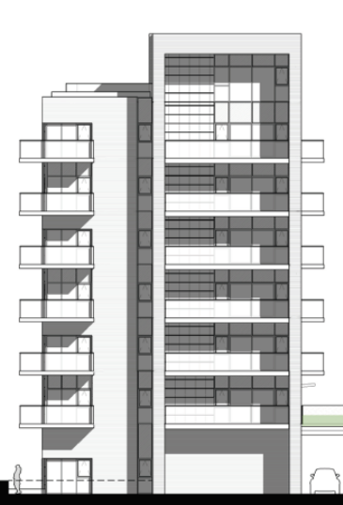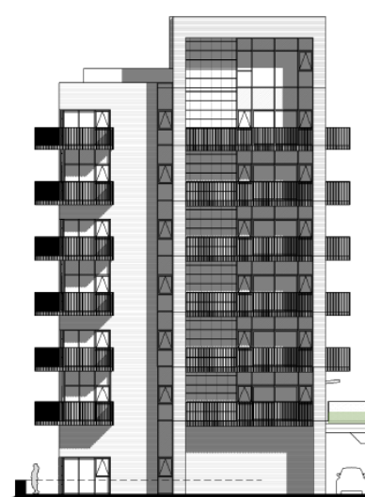
Approved Proposed

Original Plan approved under 171019/FUL | Proposed Amended Plan under 200284/NMA
GA Sections Blocks F-H – Drawing no: A-P6-04-002 Rev P5, received 31st October 2017 | GA Sections Blocks F-H – Drawing no: A-P6-04-002 Rev P7, received 26th June 2020
GA Sections Block D - Drawing no: A-P6-04-004 Rev P1, 21st May 2018 | GA Sections Block D - Drawing no: A-P6-04-004 Rev P3, received 26th June 2020
Bay Study – Typical Radial Blocks D-H Side A – Drawing no: A-P6-04-010 Rev P5, received 21st May 2018 | Bay Study Typical Radial Block D-H Side A – Drawing no: A-P6-04-010 Rev P6, received 26th June 2020
Bay Study - Typical Radial Blocks D-H Side B – Drawing no: A-P6-04-011 Rev P5, received 21st May 2018 | Bay Study - Typical Radial Block D-H Side B – Drawing no: A-P6-04-011 Rev P6, received 26th June 2020
Site Sections AA, BB - Drawing no: A-P6-04-014 Rev P3, received 21st May 2018 | Site Sections AA, BB – Drawing no: A-P6-04-014 Rev P4, received 26th June 2020
Site Sections Blocks CC,DD – Drawing no: A-P6-04-015 Rev P3, received 21st May 2018 | Site Sections Blocks CC, DD – Drawing no: A-P6-04-015 Rev P4, received 26th June 2020
Site Sections Blocks EE – Drawing no: A-P6-04-016 Rev P3, received 21st May 2018 | Site Sections Blocks EE – Drawing no: A-P6-04-016 Rev P4, received 26th June 2020
GA Elevations Block D – Drawing no: A-P6-05-002 Rev P8, received 21st May 2018 | GA Elevations Block D – Drawing no: A-PP6-05-002 Rev P9, received 26th June 2020
GA Elevations Block F – Drawing no: A-P6-05-003 Rev P8, received 21st May 2018 | GA Elevations Block F – Drawing no: A-P6-05-003 Rev P9, received 26th June 2020
GA Elevations Block G – Drawing no: A-P6-05-004 Rev P8, received 21st May 2018 | GA Elevations Block G – Drawing no: A-P6-05-004 Rev P9, received 26th June 2020
GA Elevations Block H – Drawing no: A-P6-05-005 Rev P9, received 21st May 2018 | GA Elevations Block H – Drawing no: A-P6-05-005 Rev P10, received 26th June 2020

Objections Received (Summary):
Applications under S96A are not applications for planning permission, so are not covered by the publicity requirements as set out in the DMPO.

Relevant Planning History:
10/01461/OUT (102172) – A planning application for mixed-use development comprising: Phase 1 (submitted in full with no matters reserved and as defined in area on Plan Ref. PL-P1-001) for the construction of housing (Class C3), local retail (Use Classes A1, A2, A3, A4, A5), management suite, village hall, engineering and infrastructure works including reconfiguration of the lake, lakeside access, car parking, pedestrian and cycle routes, services & infrastructure, landscaping and other associated works; and Subsequent phases (submitted in outline with all matters reserved except for details of the main access proposals) for the construction of housing (Class C3), extra care housing with ancillary community uses (Class C2), offices (Class B1), one-form entry primary school Class (Class D1), health surgery (Class D1), Nursery (Class D1), sports pitches, children's play facilities, engineering and infrastructure works including reconfiguration of the lake and vehicular access, lakeside access, car parking, pedestrian and cycle routes, services & infrastructure, landscaping and other associated works – Approved 1/7/11

171019/FUL – A planning application for residential led mixed-use development comprising the construction of 339 residential apartments (Class C3), 556 sqm (GIA) local retail units (Use Classes A1, A2, A3, A4, A5), residents’ gym and associated car parking, pedestrian and cycle routes, services and infrastructure, landscaping and other associated works (Phase 6A) (amended) – Approved subject to S106 21st December 2018

Appraisal:
Although the proposed scheme would change the appearance of the balconies, it is not considered that this would have a detrimental effect on the overall appearance of the blocks of flats compared to what was originally approved, nor a detrimental impact on the amenity of future residents. It is considered that the proposed vertical metal balconies would blend effectively with the remaining materials and would retain a high-quality design scheme according with Policy CC7. It is clear, that as a result of events at Grenfell and resulting changes to Building Regulations that options for balcony materials is more limited than previously for this scale of building.

Conclusion:
The changes as proposed are considered to be acceptable non-material alterations to the approved scheme.

Recommendation:
Approve non-material amendment subject to conditions. Although Section 96(A) of the Act does not allow for the original decision to be re-issued, it does allow the modification of, or imposition of, conditions. In this respect it is considered appropriate to impose an additional condition:

Condition
The plans hereby approved by this Non-Material Amendment (under Section 96A of the Town and Country Planning Act 1990) are as follows:

• GA Sections Blocks F-H – Drawing no: A-P6-04-002 Rev P7, received 26th June 2020
• GA Sections Block D - Drawing no: A-P6-04-004 Rev P3, received 26th June 2020
• Bay Study Typical Radial Block D-H Side A – Drawing no: A-P6-04-010 Rev P6, received 26th June 2020
• Bay Study - Typical Radial Block D-H Side B – Drawing no: A-P6-04-011 Rev P6, received 26th June 2020
• Site Sections AA, BB – Drawing no: A-P6-04-014 Rev P4, received 26th June 2020
• Site Sections Blocks CC, DD – Drawing no: A-P6-04-015 Rev P4, received 26th June 2020
• Site Sections Blocks EE – Drawing no: A-P6-04-016 Rev P4, received 26th June 2020
• GA Elevations Block D – Drawing no: A-PP6-05-002 Rev P9, received 26th June 2020
• GA Elevations Block F – Drawing no: A-P6-05-003 Rev P9, received 26th June 2020
• GA Elevations Block G – Drawing no: A-P6-05-004 Rev P9, received 26th June 2020
• GA Elevations Block H – Drawing no: A-P6-05-005 Rev P10, received 26th June 2020

Reason: to clarify which plans are approved by this Non-Material Amendment.

INFORMATIVES
- This notice relates only to the changes to the plans as approved under condition 2 of the planning permission 171019 and is bound by all the other conditions and obligations attached to that permission. That permission still stands and this notice (and any other notices issued under section 96a for this development) should be read together.
2. In reaching this decision, the local planning authority is satisfied that the changes proposed by this application do not constitute a material change to the approved planning permission.

