Delegated Application Report Target Date: 04/01/21
Address: 5 Hilcot Road
Application No: 201565/CLP
Proposal: Single storey rear extension
Case Officer: Tom Hughes
Introduction and Proposal
The application site comprises a two storey mid-terraced dwelling. The dwelling benefits from a two storey rear gable. The surrounding area is predominantly residential.
The proposal is for a short single storey rear extension, extending across the width of the existing gable. The extension would project to a depth of 2.1m, and would have a mono-pitch roof with a maximum height of 3.2m and a height to eaves of 2.2m. A window would be located to the rear elevation.
Plans Submitted
The agent supplied the following, received on 06/11/20:
Drawing No: M03520-SP01 – Site Location
Drawing No: M03520-01 – Existing Ground Floor Plan (part)
Drawing No: M03520-03 – Proposed Ground Floor Plan (part)
Drawing No: M03520-02 – Existing Elevations
Drawing No: M03520-04 – Proposed Elevations
Subsequently the agent supplied the following, received on 09/11/20:
Drawing No: M03520-BP01 – Block Plan
Relevant Planning History
980784/FUL – Conversion to two flat – Refused 24/03/98
Summary of Consultations
No consultations were undertaken as it is not required for an application of this type.
Relevant Planning Policy and Guidance
National Planning Practice Guidance
The Town and Country Planning (General Permitted Development) (England) Order 2015 (GPDO) (as amended)
Permitted development rights for householders – Technical Guidance April 2017
Assessment
A Certificate of Lawfulness for a proposed development has been submitted as the applicant considers the proposal falls within the permitted development rights of the property.
The proposed single storey rear extension must be assessed to ensure that it complies with the conditions of Class A, Part 1, Schedule 2 of the Town and Country Planning (General Permitted Development) (England) Order 2015, which relates to ‘enlargement, improvement or other alteration of a dwellinghouse’.
The relevant conditions of the GPDO for a single storey rear extension, which is not listed or in a conservation area, are as follows:
A.1 Development is not permitted by Class A if:
A.1 (a) permission to use the dwellinghouse as a dwellinghouse has been granted only by virtue of Class M, N, P or Q of Part 3 of this Schedule (changes of use); complies
A.1 (b) as a result of the works, the total area of ground covered by buildings within the curtilage of the dwellinghouse (other than the original dwellinghouse) would exceed 50% of the total area of the curtilage (excluding the ground area of the original dwellinghouse); complies
A.1 (c) the height of the part of the dwellinghouse enlarged, improved or altered would exceed the height of the highest part of the roof of the existing dwellinghouse; complies
A.1 (d) the height of the eaves of the part of the dwellinghouse enlarged, improved or altered would exceed the height of the eaves of the existing dwellinghouse; complies
A.1 (e) the enlarged part of the dwellinghouse would extend beyond a wall which (i) forms the principle elevation of the original dwellinghouse; complies or (ii) fronts a highway and forms a side elevation of the original dwellinghouse; complies
A.1 (f) subject to paragraph (g), the enlarged part of the dwellinghouse would have a single storey and – (i) extend beyond the rear wall of the original dwellinghouse by more than 4 metres in the case of a detached dwellinghouse, or 3 metres in the case of any other dwellinghouse, complies or (ii) exceed 4 metres in height; complies
A.1 (g) until 30th May 2019, for a dwellinghouse not on article 2(3) land nor on a site of special scientific interest, the enlarged part of the dwellinghouse would have a single storey and – (i) extend beyond the rear wall of the original dwellinghouse by more than 8 metres in the case of a detached dwellinghouse, or 6 metres in the case of any other dwellinghouse, complies or (ii) exceed 4 metres in height; complies
A.1 (h) the enlarged part of the dwellinghouse would have more than a single storey and – (i) extend beyond the rear wall of the original dwellinghouse by more than 3 metres, complies or (ii) be within 7 metres of any boundary of the curtilage of the dwellinghouse opposite the rear wall of the dwellinghouse; complies
A.1 (i) the enlarged part of the dwellinghouse would be within 2 metres of the boundary of the curtilage of the dwellinghouse, and the height of the eaves of the enlarged part would exceed 3 metres; complies
A.1 (j) the enlarged part of the dwellinghouse would extend beyond a wall forming a side elevation of the original dwellinghouse, and would – (i) exceed 4 metres in height, complies (ii) have more than a single storey, complies or (iii) have a width greater than half the width of the original dwellinghouse; complies
A.1 (ja) any total enlargement (being the enlarged part together with any existing enlargement of the original dwellinghouse to which it will be joined) exceeds or would exceed the limits set out in sub-paragraphs (e) to (j); complies
A.1 (k) it would consist of or include – (i) the construction or provision of a verandah, balcony or raised platform, complies (ii) the installation, alteration or replacement of a microwave antenna, complies (iii) the installation, alteration or replacement of a chimney, flue or soil and vent pipe, complies or (iv) an alteration to any part of the roof of the dwellinghouse. complies
A.2 In the case of a dwellinghouse on article 2(3) land, development is not permitted by Class A if:
A.2 (a) it would consist of or include the cladding of any part of the exterior of the dwellinghouse with stone, artificial stone, pebble dash, render, timber, plastic or tiles; n/a
A.2 (b) the enlarged part of the dwellinghouse would extend beyond a wall forming a side elevation of the original dwellinghouse; n/a
A.2 (c) the enlarged part of the dwellinghouse would have more than a single storey and extend beyond the rear wall of the original dwellinghouse; n/a
A.2 (d) any total enlargement (being the enlarged part together with any existing enlargement of the original dwellinghouse to which it will be joined) exceeds or would exceed the limits set out in sub-paragraphs (b) and (c). n/a
Conditions
Development is permitted by Class A subject to the following conditions:
A.3 (a) the materials used in any exterior work (other than materials used in the construction of a conservatory) must be of a similar appearance to those used in the construction of the exterior of the dwellinghouse; complies
A.3 (b) any upper-floor window located in a wall or roof slope forming a side elevation of the dwellinghouse must be (i) obscure-glazed, n/a and (ii) non-opening unless the parts of the window which can be opened are more than 1.7 metres above the floor of the room in which the window is installed; n/a and
A.3 (c) where the enlarged part of the dwellinghouse has more than a single storey, or forms an upper storey on an existing enlargement of the original dwellinghouse, the roof pitch of the enlarged part must, so far as practicable, be the same as the roof pitch of the original dwellinghouse. n/a
Recommendation
The proposal has been assessed against the Town and Country Planning Act 1990 (as amended) and Class A, Part 1, Schedule 2 of the Town and Country Planning (General Permitted Development) (England) Order 2015.
It can be confirmed that the proposed operation would be lawful for planning purposes on the basis of the drawings received on 06/11/20:
Drawing No: M03520-03 – Proposed Ground Floor Plan (part)
Drawing No: M03520-04 – Proposed Elevations
Drawing No: M03520-BP01 – Block Plan (received 09/11/20)
Sufficient evidence has been provided to demonstrate that a Certificate of Lawfulness should be granted for the proposed single storey rear extension.
Informatives
Building Regulations
Encroachment and Party Wall Act
Construction and Demolition
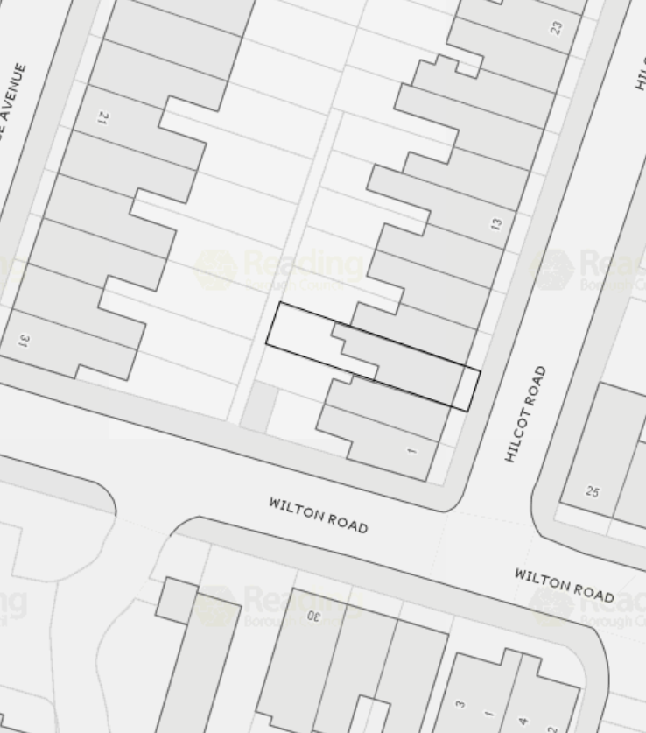
Site Location

