Material Alteration
Flat 9, 28 London, Reading, Berkshire, RG1 5AG
Relating to the Proposal for a Fireplace Installation
Following the approval of listing building consent to install a fireplace Flat 9, 28 London Road (Application number 190963) a survey was completed to determine the location of the original fire chamber within the chimney breast. The cavity was found to be off centre and to narrow to accommodate the size of register suitable for the proposed fire surround, this application seeks approval for material alternation following this discovery. The material removed during the survey was found to be modern breeze block, likely from a more recently attempted to block the chamber, no original build material/fabric was impacted by this survey. Figure 1. & Picture 1. Illustrate the location of the original cavity shaded in grey in relation to the chimney breast and the dimensions of the proposed fire surround. Given the chimneys masonry structure and the likelihood of compromising other pre-existing flues for lower levels, it is not advisable to expand the chamber further.
As it is preferred to have a fireplace installed centrally within the chimney breast, this cavity will be resealed and an alternative fire register sourced that can be recessed within the limited depth of the pre-existing drywall which will be further extended (approximately 10cm out from the original breast) and the thickness of the fire surround. This installation therefore will be purely decorative and no further works will be completed to unblock or reline the chimney flue. Work extend out the drywall further should not affect any original structures although the marble surround will still require structural pinning into the masonry chimney breast. Some packing material (either breeze block or a wooden stud structure) might be utilised to pack the gap between the original masonry wall and the extended dry partition all, this will provide a secure backing for the surround, these materials will not be permanently bonded to the original masonry structure.
Picture 2. to 5. show the design of an alternative fire register which meets the requirement for reduced depth together with the internal dimensions of the fire surround. This is through to be an original Georgian period fire register, the foundry marking to the rear (No 227 16R) suggest this was produced by a Falkirk foundry likely the Carron Company ironworks established in 1759. The depth of this register will be reduced by restoration experts, the cardboard cut-out is shown in picture 3. show the depth amendment required to ensure this register will fit the limited depth measurements. A new metal backplate will be installed to close the opening, this will be finished in the same black paint to ensure a seamless finish.
Picture 6. shows the surround (recently found to be manufactured by Jamb, London a emanate purveyor off high-quality period replica surrounds) together with the proposed fire register.


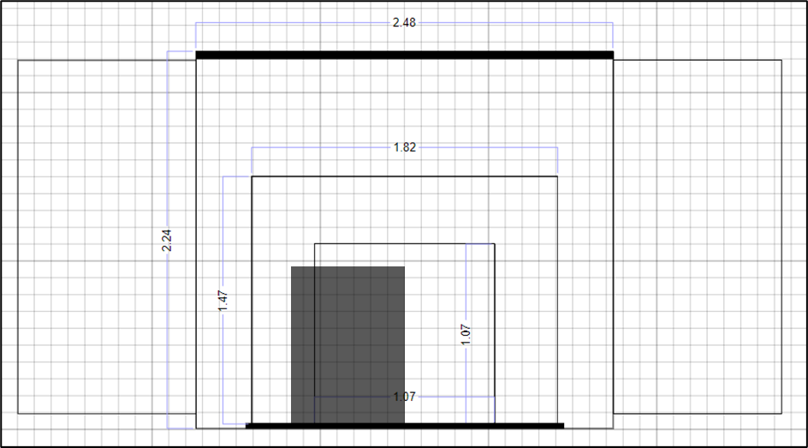

Figure 1. Scale drawing of proposed fire surround within the application chimney breast, dimensions listed in metres. the location of the orginal cavity shaded in grey, the ceiling beam and slate hearth shaded black.
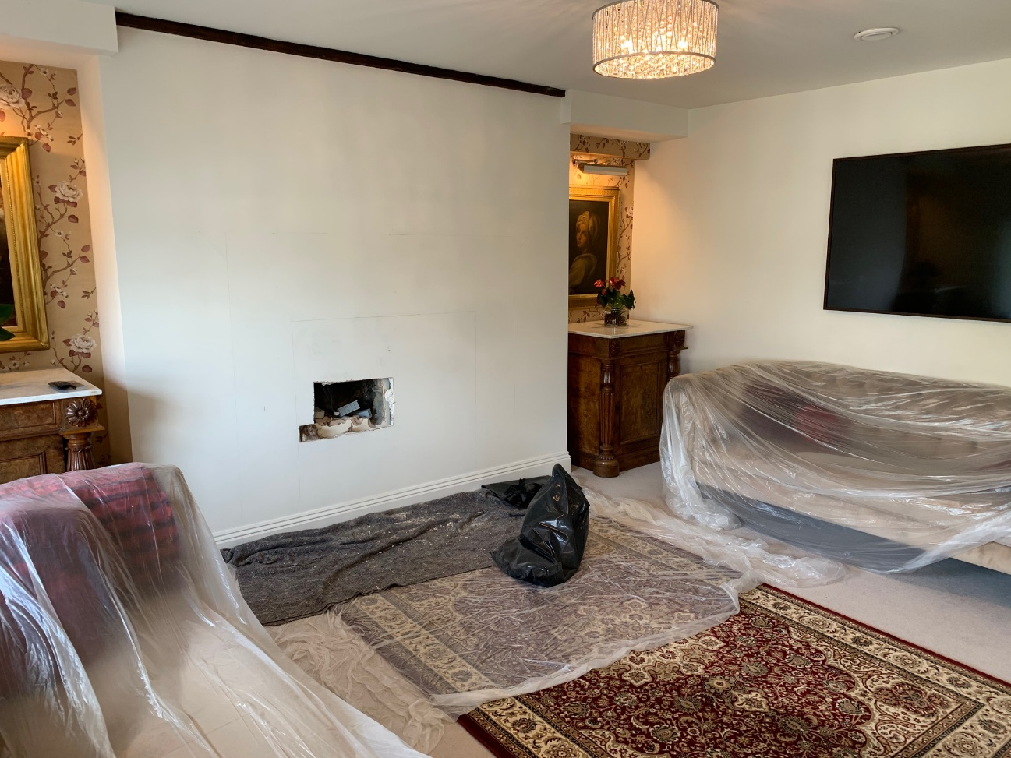
Picture 1. Chimney breast following initial survey to locate the cavity
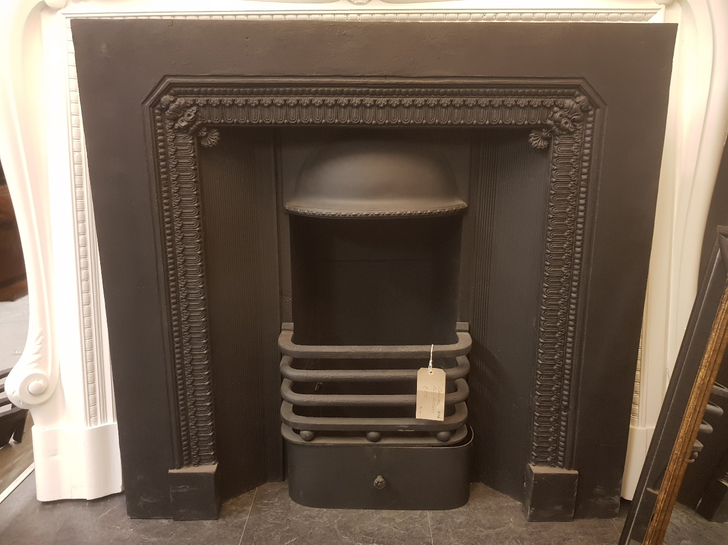
Picture 2. The Proposed fire register.
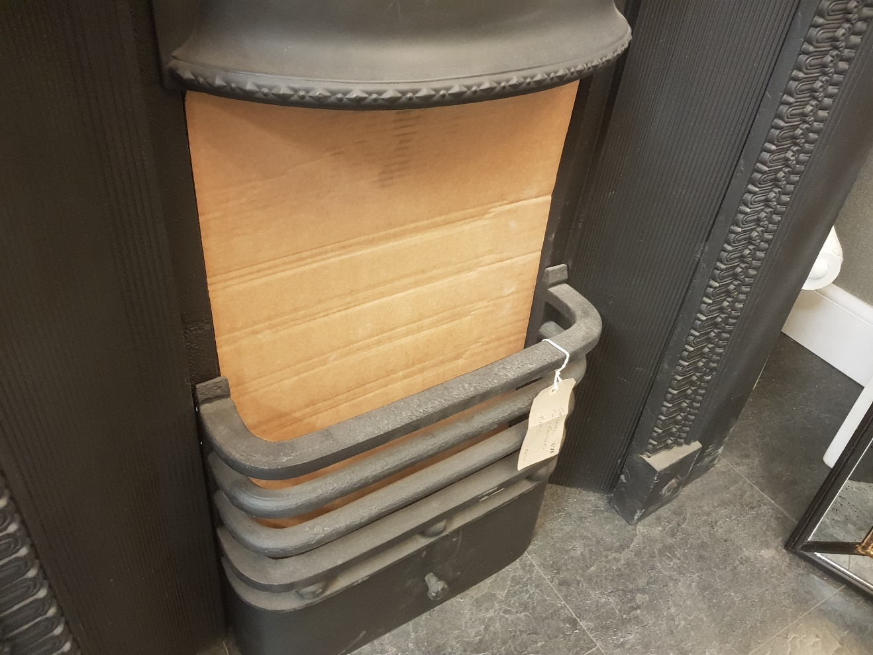Picture 3. The Proposed fire register, a cardboard insert to show amendment to backing.
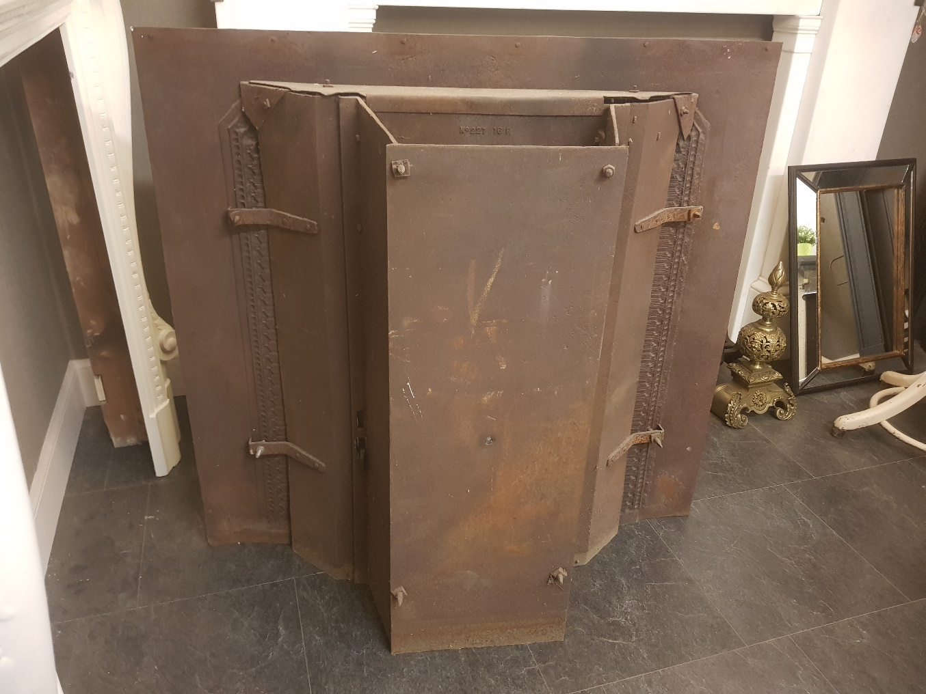
Picture 4. The rear of the proposed fire register.
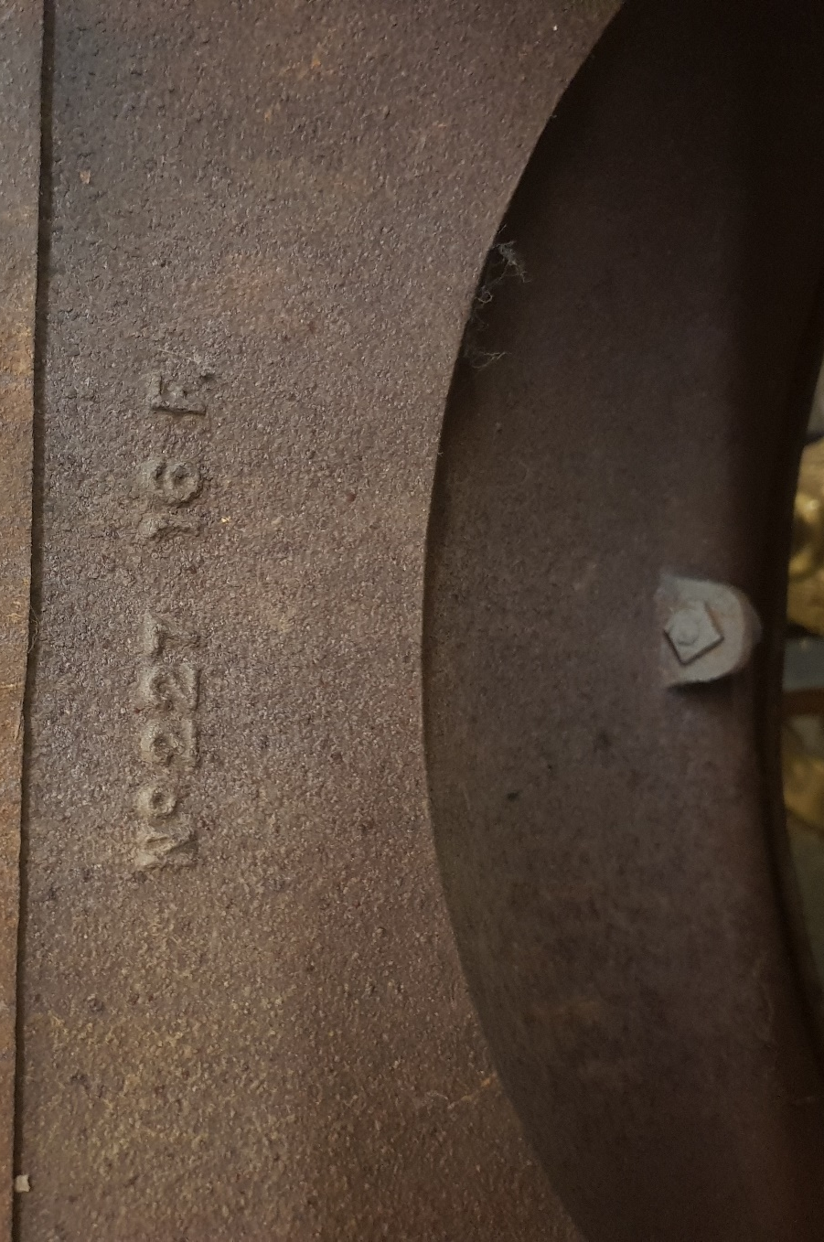
Picture 5. Foundry marking to the rear (No 227 16R).
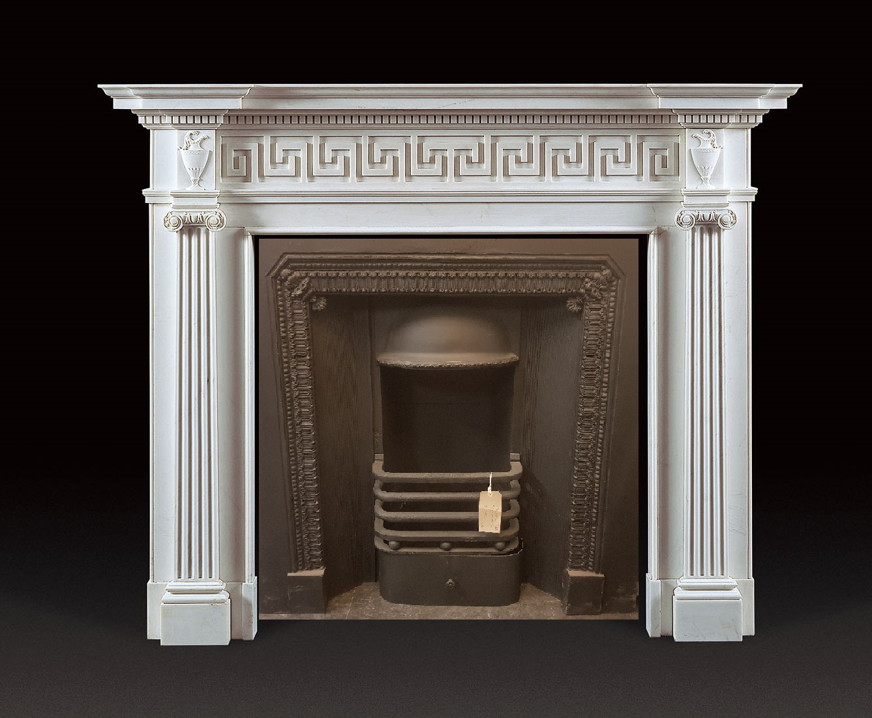
Picture 6. Visual representation of the proposed fire register together with the proposed surround. Based on the best available images, the prospective of the register is not square therefore the angles are distorted.

