Phoenix School
Construction Management Plan
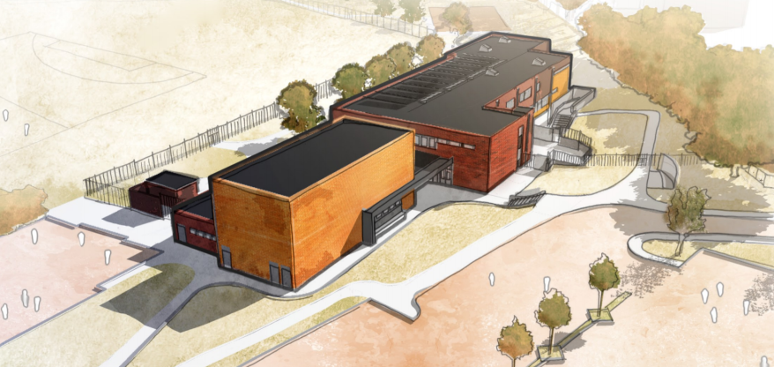

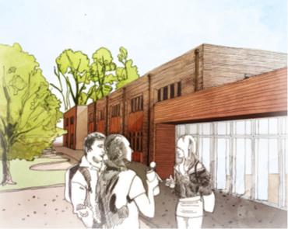




Issue – For Construction
Revision - B
30/11/2020
1.0 Contents
- Contents
- Introduction
- Project Description
- Site Operations
  - Site Management
  - Communication of the works
  - Noise and Vibration
  - Dust Suppression / Air Quality
  - Site Security
  - Working Hours
  - Scaffolding
  - Temporary Services
  - Phasing and Programme
- Environmental Management
  - Ecological Protection
  - Local Nuisance
  - Hazardous Substances
  - Tree Protection
- Public Safety
- Drainage and Dewatering
- Waste Management
- Traffic Management & Highways Work
  - General Measures
  - Deliveries
  - Parking
  - Public Transport
  - Plant Selection / Emissions
- Key Contacts
Appendices

2.0 Introduction
This document sets out the site control measures and strategies which will be employed to, as far as is reasonably practicable, minimise the impacts of construction operations on traffic and the local environment.
This plan has been developed to support the planning application for the construction of the new Phoenix School in Reading. The Construction Management Plan will be a ‘live’ document that will be monitored and reviewed throughout the duration of the project to ensure that it reflects the current site activities and hazards. The plan will be distributed to all key stakeholders and sub-contractors involved with the project, to ensure that the measures set out are always followed.
ISG has developed this plan as the principle contractor for the project and it should be read in conjunction with the Construction Phase Health and Safety plan.
3.0 Project Description
The Phoenix School project is the construction of a new SEN school for Reading Borough Council. The school is currently based in existing buildings in Reading Town Centre. The proposal for this new School would see a complete relocation of facilities from the existing site, to the new site off Hamilton Road. It is proposed that the current vacant building contained within the new site (1,800m2), will be refurbished, together with a new 500m2 extension.
- Provision of a new build extension comprising main hall, dining hall, kitchen and other ancillary accommodation.
- Asbestos removal and complete strip out of the building.
- Heavy re-fit of the existing building including re-roofing, re-glazing, over-cladding external walls, new walls, partitions, soffits, etc., to form new general arrangement.
- Total renewal of the building mechanical and electrical services.
- Fit-out of the new building including IT and FF&E
- Associated drainage, landscaping and external works including the formation of a new sports pitch, external seating, paving and planting.
- Improvements/alterations to the existing roads and car parking and the formation of a new car park.
Security measures including CCTV, access control and perimeter fencing.
The School is located off Hamilton Rd in Reading. Hamilton Rd is a 20mph road and within the immediate vicinity of the project has houses occupying the opposite side of the road, a retirement home to the South West Boundary, and the open space of school playing fields to the North West. The main access to the site both during construction and permanently will be via Hamilton Rd with the existing entrance being widened. There is very limited public parking available in the immediate area around the School site.
There are reasonable public transport links with the nearest bus stop from Reading Station being a 5 min walk away on Wokingham Rd, served by buses 17, 4 and X4:

Figure 1 - Location of Phoenix School site on Hamilton Rd Lane, and proximity to Reading Station
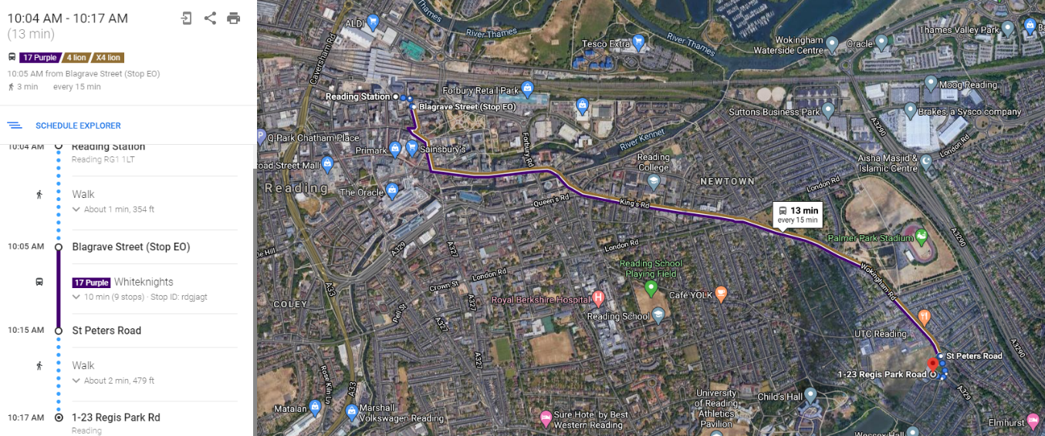
Buses 17, 4 and X4 all stop at the St Peters Road stop. This is then a 5 min walk to site via the access route across the playing fields.

The main access for the project will be via the Hamilton Rd entrance. This will be enlarged and will have a permanent gateman to manage deliveries etc. at the site boundary in the car park.
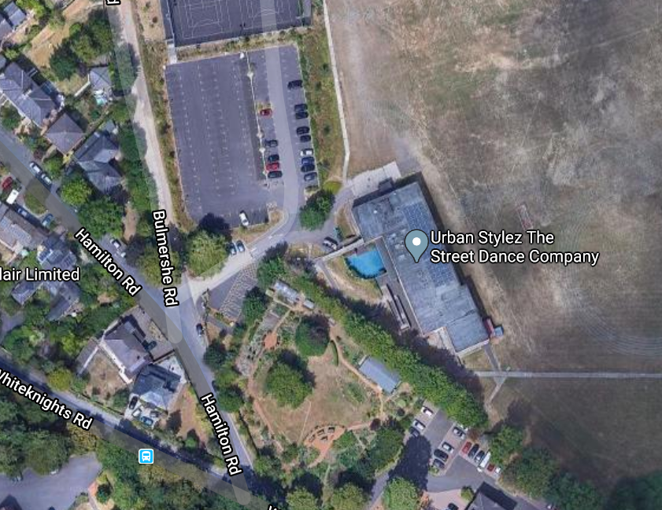
Figure 2 - Aerial Photo of the site location
4.0 Site Operations
This section details the control measures ISG will employ on this project to ensure construction activities are always safely controlled and that the impact of these operations is minimised on all stakeholders to as great an extent as reasonably practicable. Appendix A illustrates the proposed location of the construction site fencing, compound and work areas and should be read in conjunction with the following sections.
4.1 Site Management
As principal contractor, ISG will have responsibility for health, safety and environmental aspects of all construction operations on site. Control of operations will be coordinated by the site management team on site which includes a Project Manager who will be the main point of contact for all site related issues and other Site Management personnel for day to day running of the site.
The site team will be supported and assisted by our regional office based staff including environmental, planning, temporary works and health and safety managers. Services installation co-ordination and management will be achieved by the appointment of a services manager to the project.
Prior to any sub-contracted works commencing on site, strict controls are used to ensure that suitable method statements, risk assessments and environmental control plans are in place. These documents are all reviewed prior to works commencing and are monitored and updated as works progress. A general risk assessment of the works has been undertaken by ISG management and is included in Appendix B of this document. Safety of the Public, School staff & Pupils and Site operatives is of paramount importance to ISG.
4.2 Communication
To ensure that all stakeholders of the project are all made fully aware of any disruption to the local area caused by construction activities it will be important to provide effective communication in advance of works. ISG will work closely with Reading Borough Council, Hampshire County Council, Phoenix School and the local community to identify the stakeholders and ensure they are consulted and updated throughout the construction process.
ISG is an associate member of the Considerate Constructors Scheme and takes its responsibilities to the local community and environment very seriously. Some of the measures that will be implemented on the project include;
• Contact details for the Project Manager posted on the site hoarding and construction area fencing, who will be available 24/7 to deal with any queries or issues.
• Information / Community notice board erected at the site entrance and in other suitable locations to inform local residents and stakeholders of upcoming works
• ISG will feed into the existing school’s communication system to make parents and staff aware of any potential disruption
• Periodic letter drops to residents throughout the project to update them
• Where appropriate ISG will utilise social media to assist with the communication of the works to enable interested parties to stay updated with upcoming works.
• Communication will be reviewed and approved by relevant parties prior to its general release.
4.3 Noise and Vibration
ISG will endeavour to minimise noise and vibration disturbance throughout the project by employing appropriate measures during the different stages of project delivery. ISG will create Local Impact & Nuisance Management Plans for some of the sub-contract packages to tailor measures specific to each element of work and will use guidance from BS 5228 ‘Noise Control on Construction and Demolition Sites’ as the best practice guideline. Some of the control measures which we will utilise on this project include;
• Tool Box Talks In accordance with BS5228 will be provided to operatives on noise and vibration to ensure the whole workforce is aware of best practice for reducing noise and vibration.
• Within task specific method statements, noise advisory levels and noise action levels will be identified to ensure safe control over the works.
• Plant and equipment will be powered down when not in use to avoid unnecessary noise and vibration.
• All plant and equipment will be properly maintained in accordance with manufacturer’s instructions.
• Plant will be selected with the task in mind to ensure appropriate size plant and equipment is used in accordance with task requirements.

4.4 Air Quality
Construction operations can have a detrimental impact on air quality when not managed properly. Given the construction site is located next to the existing school where children will be playing outdoors and public housing nearby. It is of additional importance to ensure that air pollution is kept to a minimum. Specific control measures to reduce pollution will be detailed in the Local Impact & Nuisance Management Plans outlined in section 4.3. The following measures will be used to minimise the impacts of construction work;
• When possible materials will be ordered so as they do not require cutting on site to eliminate the need for cutting operations, this is particularly important due to limited space available on site
• Cutting activities will always be damped down with water
• No burning of materials or bonfires will be permitted on the site at any time
• All non-road mobile machinery (NRMM) to be compliant to NRMM stage IIIB. This includes excavators, cranes, dumpers, rollers, generators, etc…

• All loads entering and leaving site will be covered
• Any temporary site roads stoned up areas will be damped down during dry periods to prevent dust from spreading
• The requirements for dust suppression generally will be monitored daily and called in as and when required
• Demolition works will always be damped down to minimise dust
4.5 Site Security
ISG will establish a secure compound around the construction area of the project for each phase as per Appendix A – Logistics Plan. The ISG compound will be securely hoarded with initially the use of Heras fence for the enabling works, before additional timber hoardings are established in the main school car park area. There will be a vehicles access gates off from within the car park which will be closed when not in use and locked securely at night. The gates will be installed such that they will open into the site so as not to obstruct the pedestrian footpaths/car park routes outside of the site.
Any plant left on site will have immobilisers fitted and the keys will be secured away from the plant in a safe location. Construction work areas will be fenced off where any interaction with the general public is expected. No plant or materials will ever be stored on the public highways.
CCTV security to be installed around site hoarding to ensure site security.
Emergency contact details for the Project Manager will be clearly visible on the site perimeter at the site gates if any emergency requires it. Daily fence checks will be undertaken by the site team to ensure that the site perimeter is secure to prevent unauthorised access. ISG will hold assemblies/briefings within the existing school to communicate the dangers of construction sites to the secondary school children to reduce the risk of pupils trying to access the site.
4.6 Working Hours
Core working hours for the site are proposed to be;
Mon – Fri: 08.00 – 18.00 and Sat: 0800 – 1300
ISG personnel will always be present whenever any work is taking place on site.
Any local lighting for the scheme will only be in use during these periods and will be turned off out of hours. Consideration will be given to the direction of lighting to not affect surrounding stakeholders / residents, and the use of LED lights for energy efficiency where possible.
If for any reason work is required to be undertaken outside of these hours, this will be communicated to all relevant parties for prior agreement.
Delivery times will be strictly enforced by ISG. Deliveries will be co-ordinated to avoid school pick up and drop off times. As such we will ensure no deliveries between 08:00-9.00am and 3.00-400pm. Further information on the controlling of deliveries can be found in section 9.2.
4.7 Scaffolding
Conventional scaffolding, where required, will be independent with boarded lifts to suit the nature, location and type of the operations being carried out. All scaffolding will be securely tied to the structure and will include suitable access.
Scaffolding will be provided, erected and maintained in accordance with all current statutory regulations and brick guards will be to used to serves as guarding.
Suitable guard railing will be utilised to prevent falling from unprotected edges of the excavations, upper floors and staircases as applicable.
No person other than certified competent scaffolders will be permitted to erect, alter, adapt or dismantle any conventional scaffolding.
4.8 Temporary Services
• Power supply will be provided by a connection from the existing supply to the school – which will be disconnected to allow the demolition works and used for a temporary building site supply.
• 110v power will be utilised throughout the building.
• Water will be provided direct from the mains system for use in the welfare facilities.
• Temporary drainage will be connected into the existing onsite foul drainage

4.9 Programme
Planned Programme Duration
Our construction programme for the entire project has an overall period of 63 weeks with a contract completion in November 2022. The planned start on site is Aug 2020, which will commence with the setting up of site, and then demolition / asbestos works to the existing building.
Mobilisation
Immediately prior to starting on site we will undertake a letter drop to all local residents providing contact telephone numbers for our on-site management should any issues arise during the build relating to the community. Liaison with school and community will continue throughout the project.
The site establishment works will commence with the erection of the perimeter fencing to segregate the construction working area from the surrounding car park and external areas. All the suppliers and supply chain contractors will be issued a traffic management plan which will confirm the vehicle restrictions. There will be a daily logistic meeting on site with the contractors and schedule will be produced to coordinate the timed deliveries.
Construction Access
Construction deliveries will be directed onto Hamilton Road to where the construction entrance Is located, from the M4 to the South
The construction traffic will be controlled by a dedicated gateman / banksman, thus preventing any unauthorised access to the construction works. The entry to the site will be controlled at the gatehouse, where all personnel will report to the gateman. An electronic turnstile will control and monitor access for construction operatives, site visitors and ISG management
All deliveries will be controlled at the site entrance and directed to the unloading area. The deliveries will turn around within the site boundary to mitigate the need for vehicles reversing within the school car park / surrounding roads.
The construction itself is broken down into 3 key areas:
- Refurbishment of Existing Building
Initially the work revolves around removal of all the existing furniture / carpets ceiling s in the building to allow a 6 week asbestos clearance period to begin. This will then allow the building frame to be exposed. This element includes the stripping back of much of the external skin of the building to allow new external cladding to be installed. This will then follow to internal fit out / M and E and then final finishing works such as flooring and decoration
- New Timber Frame Extension

Adjoining the existing building is the new timber frame extension. This follows on from the initial demolition phase of the building, and will form the new kitchen, dining hall and main hall. Clad in the same system as the existing building, it will follow the same construction sequence.

- External Areas

Initially the external works focuses on the new car park access from the existing, to create hard standing for the construction period, and room for site welfare / storage. Additionally, the new MUGA will be progressed for additional storage space. In the later stages of the project, soft landscaping will commence, and final tarmac install around the building.

Materials Management

Space has been allocated for storage of materials on the new MUGA pitch to the South of the scheme. Materials will be delivered into the new car park, and then distributed to site directly, or held in the storage area until required. The area will be prepared to base course level to keep the storage area clean, tidy and dust free:
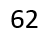
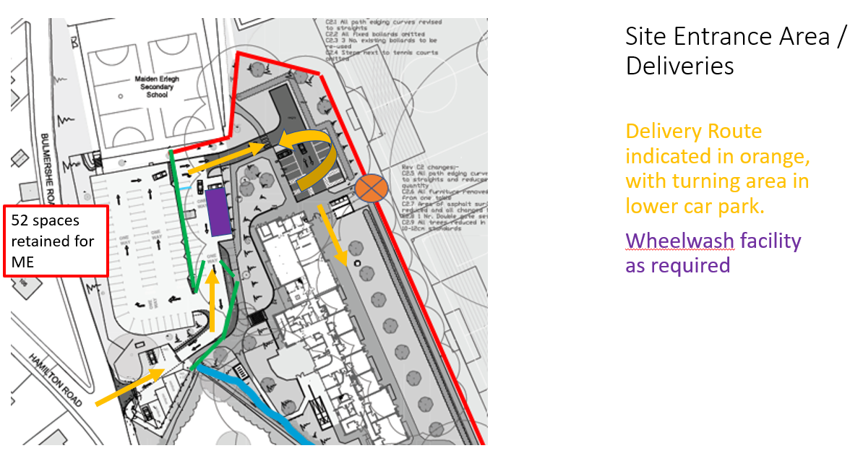

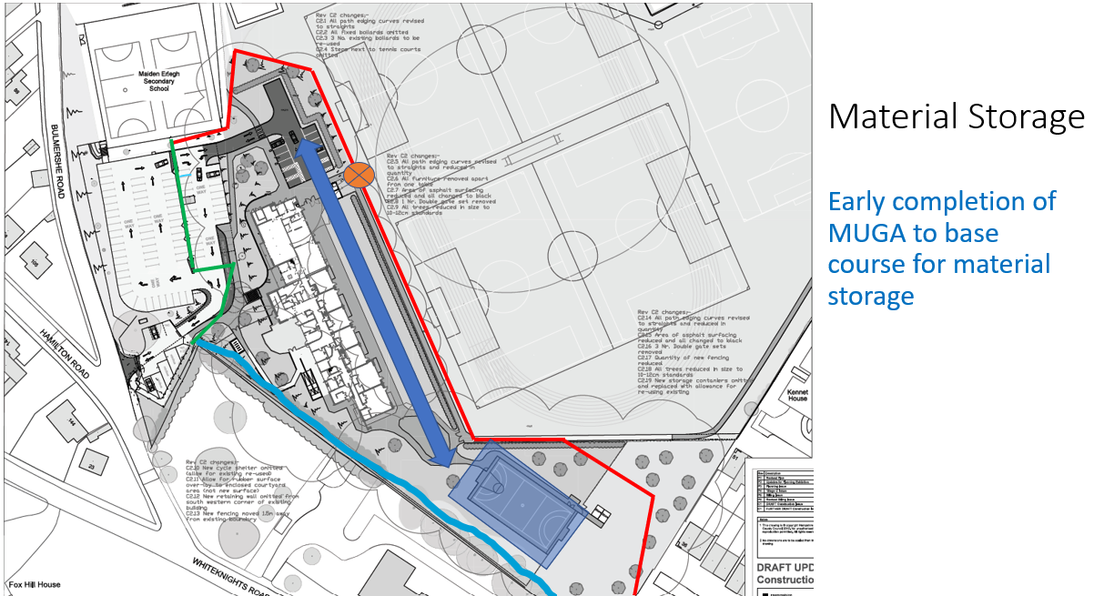

5.0 Environmental Management
5.1 Ecology
Ecological protection measures will be implemented as required in accordance with the ecological assessments and approved mitigation strategies.
5.2 Local Nuisance
The Construction Liaison Representative for the project shall be Tony Sedgwick (contact details can be found in the Key Contacts section 10.0)
The project shall be registered with the Considerate Constructors Scheme and measures will be implemented to reduce all elements of nuisance caused by the construction of the works.
Contact details for the public to use to make any complaints or query regarding the project shall be posted on the fencing for the work areas. ISG will also supply a number of update notice boards and online systems to enable people to comment via the internet. The Construction Liaison Rep will feed any comments/complaints back to the relevant individuals within the school and council upon receipt. Letter drops will also be undertaken in advance of works starting, with periodic updates on progress with information on any aspect of the project which may impact the local residents.
To reduce the visual impact of construction activities from public areas, a solid timber hoarding shall be installed in the existing playground to screen off the construction activities for the build elements of the project. The hoarding will be kept in good condition and the verges will be kept tidy and where appropriate landscaped. Heras fencing will be used on the playing field facing side.
Wheel washing facilities will be provided on site as necessary during relevant periods of the project to ensure that no debris is carried onto the local highways. Road-sweepers will also be available on call in the event of any accidental debris spill on to the road.
Very limited parking will be available on site during the initial construction phases, but as the frame develops and space becomes less available on site, there will be no Parking available within the site area. ISG will provide additional parking via the hard standing area off Regis Park Road to prevent any issues to local residents, with a footpath access via the playing fields:
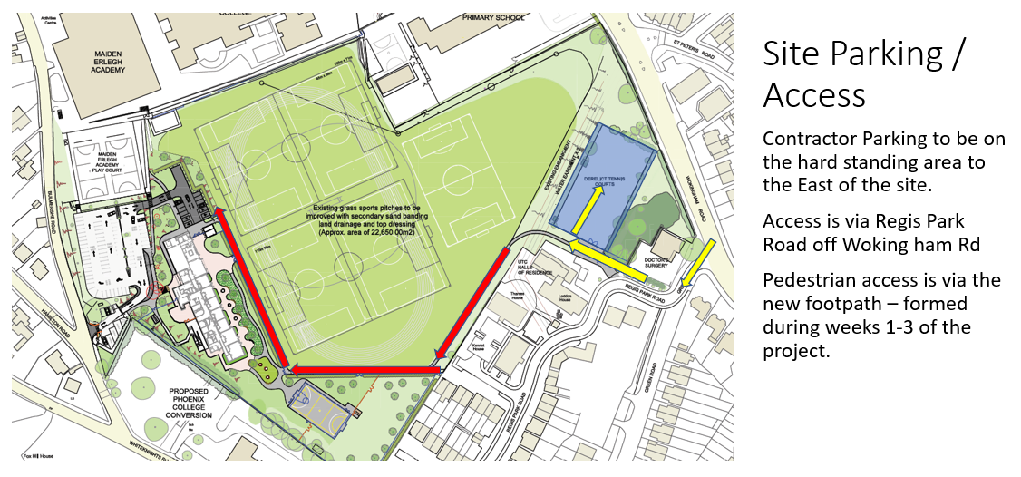

5.3 Hazardous Substances
Any materials which fall under the COSHH regulations shall be stored in a suitable container in accordance with the COSHH sheet and manufacturer’s instructions. These materials will be stored in a locked enclosure, with appropriate bunding to ensure that no discharge into the local environment is possible.
A spill kit will be available for all storage areas and an action plan will be in place to deal with any accidental discharges such as spillages, along with emergency plans for relevant activities.
5.4 Tree Protection
Tree Protection will be installed in accordance with approved arboriculture method statements and plans to ensure that relevant trees are suitably protected from damage during construction activities. Relevant signage will also be installed, and a strict permit to enter will be incorporated. This is mainly to the trees between the site and the residential home on the SW boundary.
6.0 Public Safety
The safety of the public and the workforce is paramount to ISG during all construction operations.
Consideration of the public, school staff and pupils will be the first consideration during all activity planning. Robust and secure fencing will border the site to ensure that access is not possible for pupils or other members of the general public. The construction site will have its own dedicated access to avoid interface and conflict with the existing school access points. Adequate warning signage will be placed on all fencing to ensure the hazards are clearly visible to all passing pedestrians.
When construction vehicles or deliveries are approaching the site, they will be met by the site banksman / traffic marshall, who will manage the safe access and egress of construction related vehicles.
There is suitable space within the site boundary to act as a holding area for deliveries as per the logistics plan in Appendix A to ensure that deliveries are not blocking the main road and/or footpath.
ISG will ensure sufficient control of all sub-contracted works to ensure that no risks are placed on the general public.
During the construction phase of the project, fire assembly points will be clearly shown on site traffic management plans and agreed with the school. Fire drills will be held to ensure that all parties understand the fire routes and assembly points. Additional fire drills will be held in the event of significant changes in the fire safety plans due to different phasing of the project.
7.0 Drainage and Dewatering
7.1 Proposed Surface Water
Surface water drainage will ultimately connect into the existing storm water drains that served the existing building. Localised diversions will be implemented to allow the construction of the new extension.
An additional 135m3 storm water attenuation tank will be constructed under the car park area, with a Hydrobrake connection on the outfall manhole to limit the discharge to 15l/s.
7.2 Proposed Foul Water.
As with the Storm, the foul drainage will ultimately connect into the existing foul water drains that served the existing building. Localised diversions will be implemented to allow the construction of the new extension.
7.3 Pest Control Considerations
As noted above, there are some works to the existing drainage system, and due consideration will be given to the risk of pests from open drainage. When new connections are to be made, these will be capped off at the end of any working day to maintain a sealed system. This will be monitored at site level by the project management team. Additional measure will be taken if required.
8.0 Waste Management
Skips for construction waste will be located within the ISG secure compound and all construction waste will be placed within these skips. Under no circumstance will any construction waste be placed within school or public bins.
Waste segregation will take place on site with Asbestos, Timber, Inert, Plasterboard, Metal and General waste skips located in the compound at suitable points during construction.
All waste which leaves site is recorded and statistics are provided to ISG on a monthly basis on waste recovery/recycling and waste to landfill. A Site Waste Management Plan will be created and used throughout the project.
Waste carriers licences and Tip licences will always be checked prior to any waste removal off site. A designated individual will be responsible for checking all tickets, licences.
Pollution mitigation measures will be active throughout the construction process in accordance with the Pollution Prevention Guidelines produced by the Environment Agency. Spill Kits will be available adjacent to any fuel storage areas and these will always be in securely locked containers with suitable bunding to prevent any uncontrolled releases.
9.0 Traffic Management
The mitigation measures detailed below will be provided to all sub-contractors and suppliers who visit the site. ISG will include the measures within its on-site Local Impact & Nuisance Management Plans and Project Environmental Management Plans.
9.1 General Measures
Directional Signage will be placed near to the site to assist delivery drivers in finding the site to avoid them taking the incorrect route and causing further congestion. Warning signage will be placed near to the site entrance to warn motorists and pedestrians/cyclists of the location of the site entrance and the hazards from it i.e. large vehicles.
Letter drops to local residents will be sent out prior to the project starting and in advance of any change in the access strategy to ensure they are well informed and have the opportunity to offer comments to the construction team. Residents will also be encouraged to inform ISG management of any contractor parking which takes place within the residential areas, to assist with the management of construction traffic.
A speed limit of 5mph will be enforced for site vehicles and deliveries and will be signed on all access and egress points. This will assist in reducing the noise impact of plant and deliveries.
9.2 Deliveries
The construction traffic will be controlled by a dedicated gateman / banksman, thus preventing any unauthorised access to the construction works. The entry to the site will be controlled at the gatehouse, where all personnel will report to the gateman. An electronic turnstile will control and monitor access for construction operatives, site visitors and ISG management.
All deliveries will be controlled at the site entrance and directed to the unloading area. The deliveries will turn around within the site boundary to mitigate the need for vehicles reversing onto Hamilton Rd.
All deliveries will be subject to the ISG delivery induction which covers a basic site induction and ensures the competence of the driver and all deliveries on site will be recorded. The key elements of this Construction Management Plan will be included within this induction.
ISG site management will coordinate daily deliveries to stagger arrival times and avoid congestion. All loads entering and exiting the site will where practicable be covered.
All vehicles will be checked prior to leaving the site for muck on wheels to ensure no debris is taken off site onto local roads. If required wheels will be washed down to remove excess debris.
No deliveries will be undertaken on the public highway at any time.
9.3 Parking
To minimise disruption to the local residents, contractor parking will be available in the hard standing area located off Regis Park Rd, via Wokingham Rd. There is then a pedestrian access across to the site.
Under no circumstance will operatives be allowed to park along Hamilton Lane or in the local residential areas. This will be communicated to all sub-contractors in advance of beginning on site and at site inductions.
Sub-contractors will be encouraged to use public transport where practicable. ISG will provide a safe area for the storage of bicycles to encourage site operatives to cycle to work.
Periodic reviews of parking arrangements will take place throughout the project to ensure that the construction project it not having an adverse effect on the local residents.
Local residents will be encouraged to assist in the enforcement of the no contractor parking on residential streets by alerting site management to any occurrences so they can be dealt with immediately.

9.4 Public Transport
ISG will include a section on public transport within the site induction to inform all operatives of the access via local buses, train and cycling. The school is located just a 5min walk to nearby bus connections, and 20 mins by public transport to Reading Station. Details of the methods of public transport will be posted up within site canteens and welfare areas with times and costs to encourage personnel to use these methods.
9.5 Plant Selection / Emissions
ISG has a comprehensive environmental management recording system to capture all emissions which are produced due to construction activities. Each month the data collated from the signing in register, delivery induction and records and other construction information is collated into a report to calculate total emissions. These are monitored and then targets are set for reducing these emissions. This is an important management tool and helps ISG understand trends and set improvement targets.
To help reduce emissions all vehicles and plant will be turned off when not in use and not left idling. All vehicles will be properly maintained and serviced. Where possible silenced plant will be used to reduce the noise impact of construction operations. Where these items are unavailable or economically unsuitable and works are taking place close to residential properties, noise monitoring will be employed to ensure noise limits are within acceptable levels.
10.0 Key Contacts
This project will be managed from ISG’s regional office in Reading and a site office will be established at the school for site management to oversee the day to day running of the site. The personnel listed below will be involved throughout the duration of the project and can be contacted regarding any query or concern in relation to the project.
Wayne Burfield – Operations Director – wayne.burfiled@isgltd.com
Jen Mullaney – Health, Safety & Environmental advisor – Jennifer.Mullaney@isgltd.com
Tony Sedgwick – Project Manager – Tony.Sedgwick@isgltd.com

Reading Office – 0118 909 0070
Contact details will be posted on the site hoarding along with specific details of the site management team

Appendix A – Site Logistics Diagrams

