Proposed work to 8 Eldon Road, Reading, RG14DH
Contractor Ben Hubert
Hubert restoration and Conservation
hubertrestoration@gmail.com
07736779001

I am not certain that the work we would like to carry out requires listed buildings consent but felt it is better to be safe than sorry as the building is both listed as grade ii and is in the Eldon Square conservation area.
The porch area has gone through some bad restoration at some stage with extensive use of gypsum that is causing issues of delamination on the softer limestone and discolouration. There is repairs to the Bottom plinth area.

Steps
At present there is delamination and wear to the nose of the steps. There has been cement repair on the lower step and the whole of the top step has had a cement skim.
The driveway has been raised at some stage, thus covering the lower step. See Diag 1
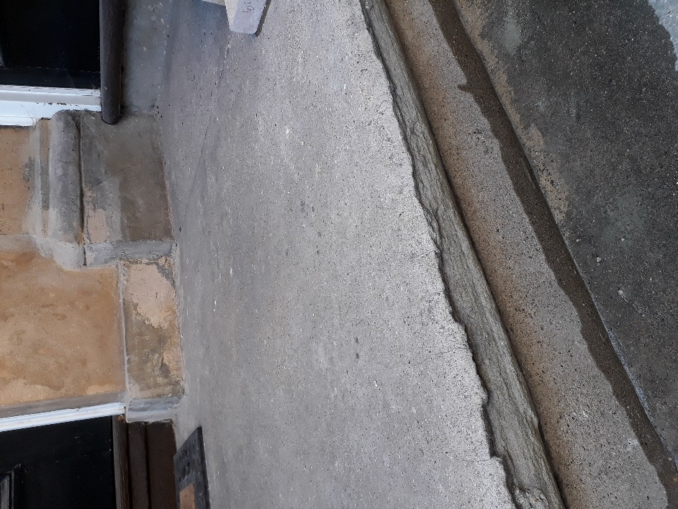
Diag 1
Proposal
Tile the top step porch area in a beige limestone which is the closest match to Bath stone.
https://artisansofdevizes.com/product-collections/stone-porcelain-paving/wychwood-limestone-etched-finish-2/
https://artisansofdevizes.com/product-category/stone-porcelain-paving/page/5/
Put a bullnose on to the step.
See Diag 2
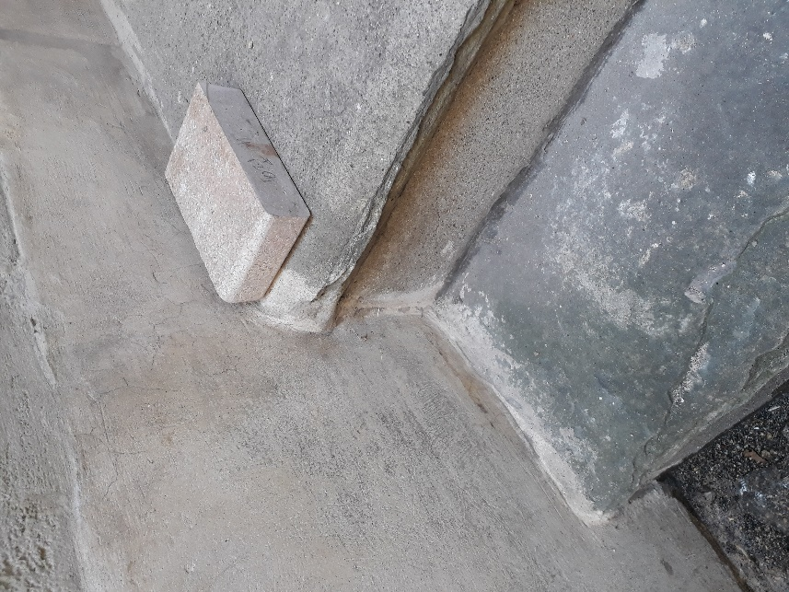
Diag 2

Porch area
At some stage, the porch area has been repaired using cement and a thin, hard cement render has been applied to most of this area.
This is causing severe de-lamination to the extent that areas have detached, and other areas are dangerous and a risk of falling off.
See Diagram 3
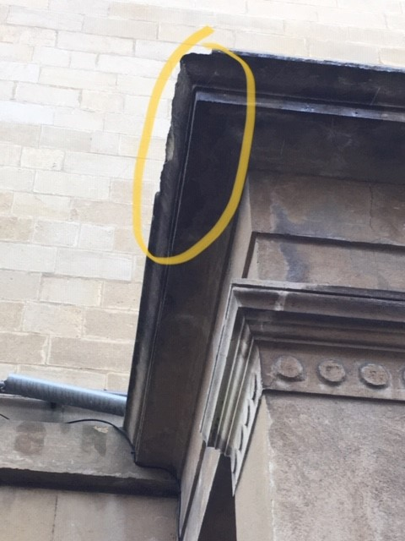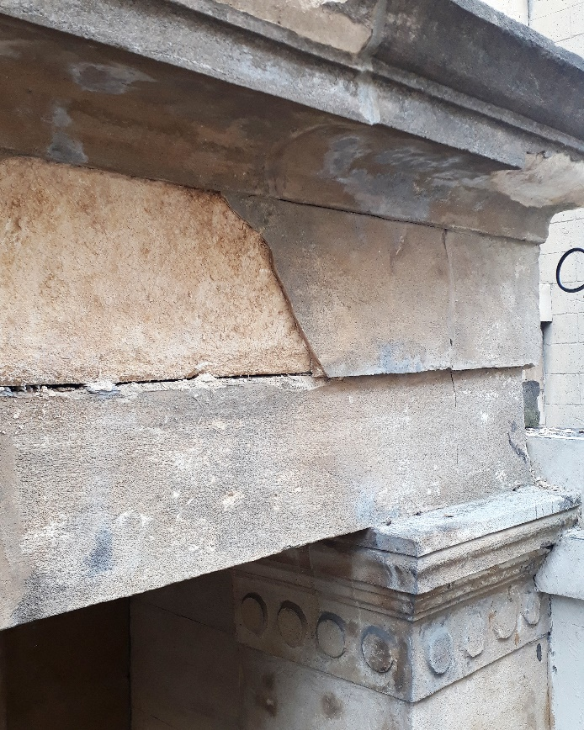
Diag 3
The Cement in many areas has gone a very dark grey colour and is blotchy. See diagram 4
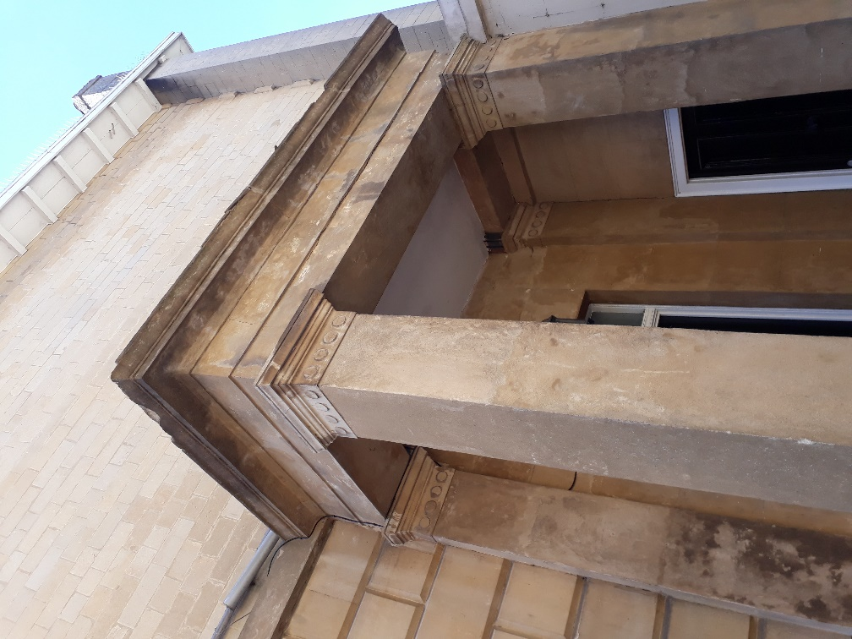
Diag 4
We have tried various techniques to clean the staining with no success.

Proposal.

Remove all areas where the cement has blown.
Treat the soft exposed stonework with limewater to consolidate then repair using lime putty, stone dust and aggregate mix. Build up to match existing.
Instead of matching to the dark cement, tone the surrounding areas to match to the existing lighter limestone and wash over the darker staining using a casein limewash. This will colour but not alter the texture See Diag 4 sample.
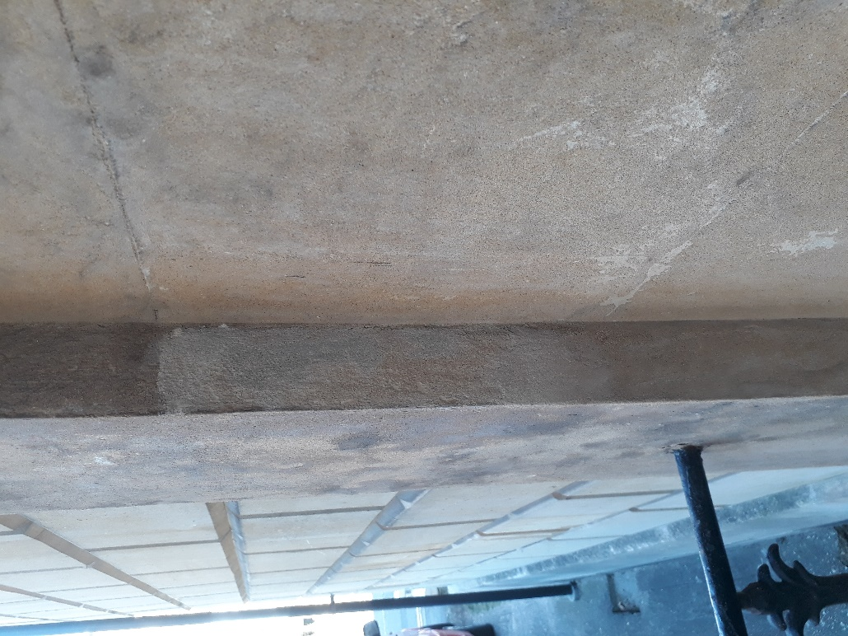
Finish by capping the stone for protection with a lead cap the same as the front bay area.

