5 Osbert House, Notley Place, Reading RG4 8PW
Design and Access Statement
July 2020

This is the design and access statement for the request for planning permission for the replacement of steel framed windows in a bay window at the property of flat 5 Osbert House.
Please note that the content in this statement may also be used to support the application for planning permission for the replacement of the bay windows in the flat below flat 5: flat 2 Osbert House.

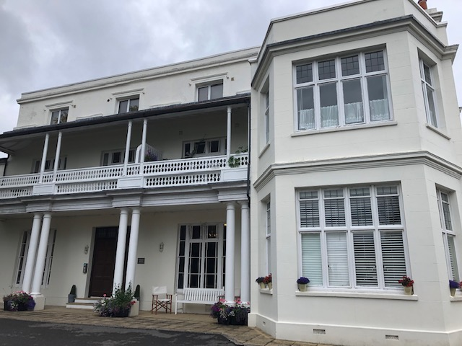

Features on the existing site: Osbert House is a grade ii listed building. It was redeveloped in 2006 and changed from a single residence/nurses home to a block of 6 apartments all of which have different layouts and formats. The precise age of the building is not known but believed to be approximately 150 years old. And is central to the development now called Notley Place but formally called ’91 Peppard Road’. The development itself consists of two blocks of 7 terraced town houses and stands back from the main Peppard Road behind one of the terrace of houses.

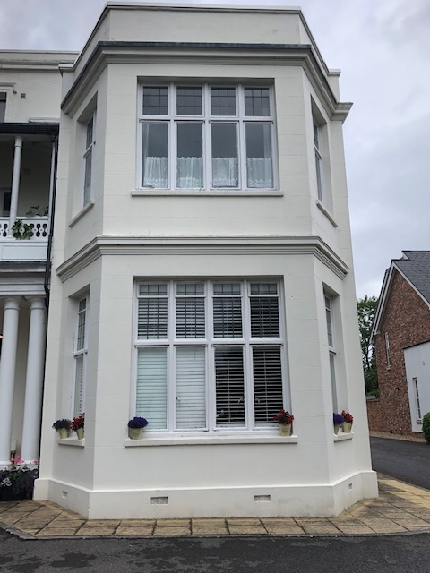

Details of the proposed works: Flat 5 is a first floor flat and is situated over the ground floor Flat 2, both flats share similar ‘mirrored’ features on both floors, including the bay window.
It is not known when the current windows were fitted in the bay windows. They are steel framed, crittal style and painted white.
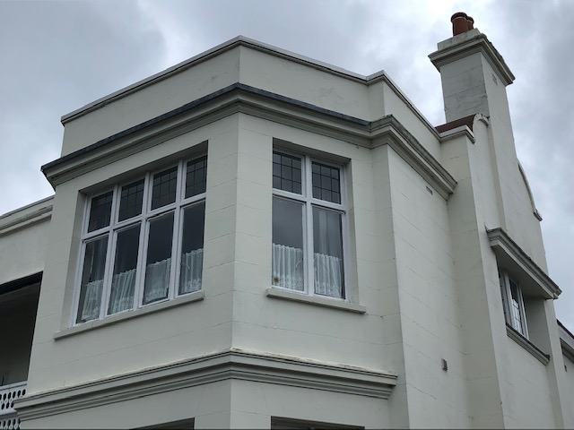

There are two ‘layers’ of windows in the bay, in eight panels.
The bottom ‘layer’ comprises eight single glazed windows measuring approx. eight 48 cm x 119 cm.

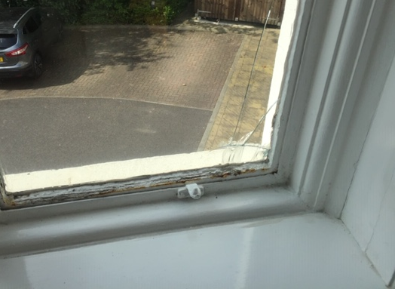

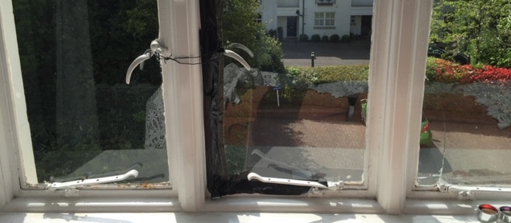

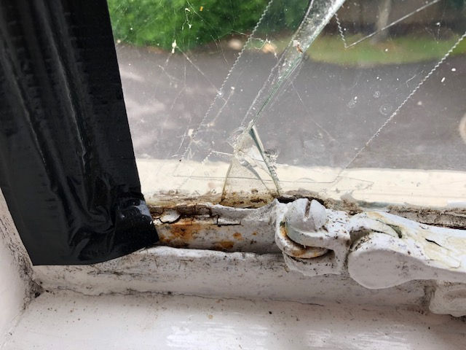

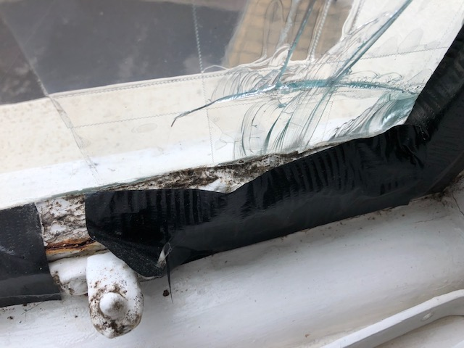

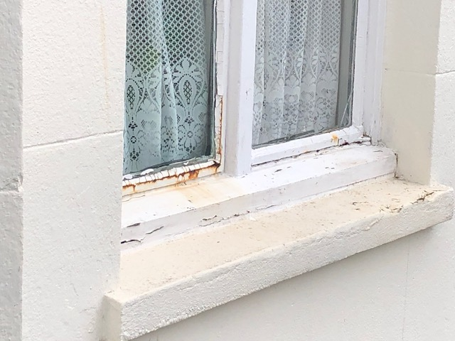

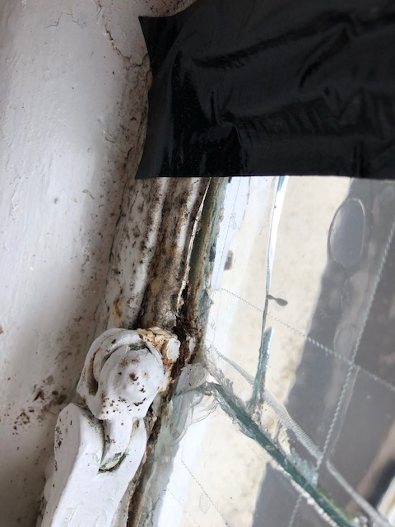

Referring to Flat 5, most of these panes of glass are now cracked and some panes have holes due to deterioration and breakage. Much of the steel has rotted and deteriorated to the point that most of the windows cannot be opened and are now sealed with duct tape.
The planning permission applied for is the replacement of these eight windows with new treated steel frame windows with double glazing. Which will be in keeping with the existing format of the windows, will maintain the external appearance, will provide added insulation and safety features inherent in modern double glazing.

The upper ‘layer’ of windows consists of eight panels of smaller leaded light, steel framed windows. The overall state of these windows (again referring to flat 5) is better than the lower windows and these can be retained in their current form with the addition of internal secondary glassing, to improve insulation and again maintain the external appearance of the bay window feature.

The proposed work would be carried out by a local supplier (Henley Glass, Henley on Thames) who has confirmed that they are familiar with carrying out this type of work in this style of building. They have stated that the most effective means to approach the project from the outside of the building will be to use a cherry picker and have estimated that this should be done in 1 -3 days and can be carried out with minimal impact on the neighbours in both Notley Place and Osbert House.

The contractors would be on site in Flat 5 which would be accessed by the communal hall and measures such as floor and balustrade coverings would ensure that the fabric of the building was safe guarded and disruption to the other neighbours would be minimal.

It is hoped that the owner of Flat 2 will shortly be completing planning permission for the bay in Flat 2 and that this work will be completed on or close to the same date as the replacement of the windows for Flat 5, thus making absolutely sure that the overall look and feel of the bay window structure is unified by both having a fresh and consistent appearance.

Please provide details of how access issues have been addressed

Not applicable – this work will not impact access to Osbert House or the surrounding development

Please provide details of the layout of proposed development

Not applicable – this work will not impact the layout of Osbert House or the surrounding development

