Design and Access Statement

Conversion of an existing terraced house to include a ground floor extension along with a second storey loft conversion

63 de Beauvoir Road, Reading RG1 5NR

Site

Eastings 473134
Northings 172930

Brief

To build an extension and loft conversion, to allow two further bedrooms and an extra bathroom. The design is to allow for more light and create a more efficient space plan.

Consideration

The proposal is to remove the existing internal arrangement which has been developed over the years and has resulted in a poor circulationary plan with some of the spaces with poor or no natural lighting.
By removing the existing ground floor extension will enable a new extension to create better floor arrangement for the kitchen and diner with more natural light as briefed by the client.
The ground floor extension will also remove the existing ‘steps’ onto the back garden space to be replaced with a flush drainage threshold to remove unnecessary obstacles where possible.

The proposal is also to create a new access point via a new stairwell to the loft to provide a further two bedrooms and a bathroom to reduce a ‘choke point’ on the existing bathroom / bedrooms. More natural lighting can be given by use of extra windows including skylights. The proposed change would mean a four bedroomed / two bathrooms including a ground floor ‘Wetroom’. The ground floor extension and Wetroom will have skylights incorporated to improve natural lighting throughout.

The proposed design of an added extension and loft is by no means unique and is indeed quite a common feature of ‘De Beauvoir Road’ and as also seen in many residential streets in surrounding areas.

Plan layout

The new extended extension will be 2.2m further to line up (handed) with next door to the right. The new wetroom will be 1.2m longer.
The loft extension would be 4.6m longer and 2.8m wide on the existing first floor structure giving a further 12.8 sqm in addition to existing loft space to allow for two extra bedrooms and a bathroom.

Appearance

As there are similarly built loft conversions and extensions, the material use will remain along the lines of traditional brick and slate appearance. The cladding where applicable will be charcoal black to blend in with surrounding houses.

Access

There will be no alteration required to the normal access arrangements to the building.
The small change would be to remove step and enable a non trip access point to the back of the extension into the garden.

Photographs as shown overleaf

Front elevation as seen from the street of De Beauvoir Road.

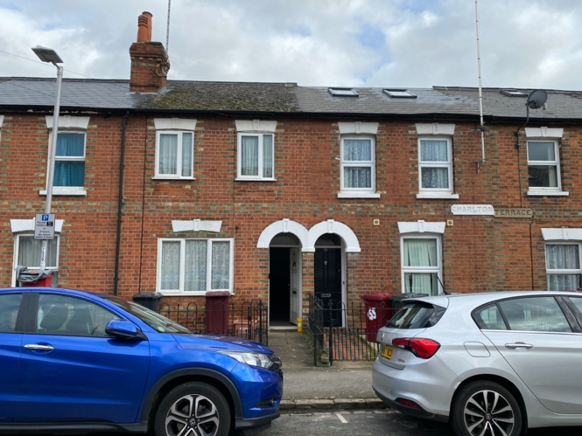

Back elevation seen from the garden

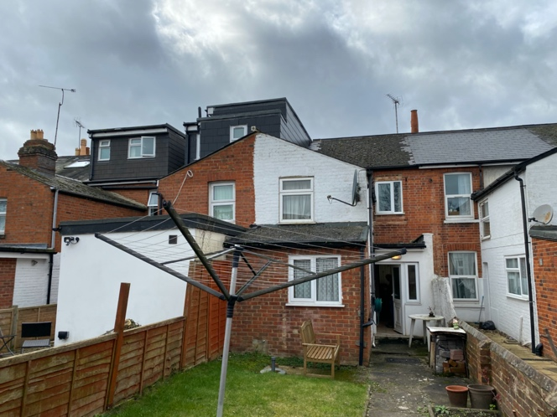

Rear elevation seen from the garden to the right

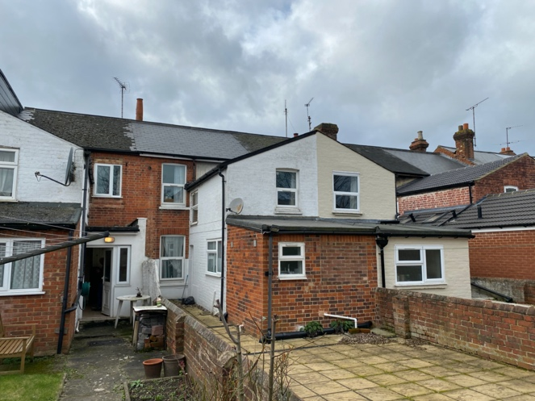
Rear elevation seen from the garden to the left

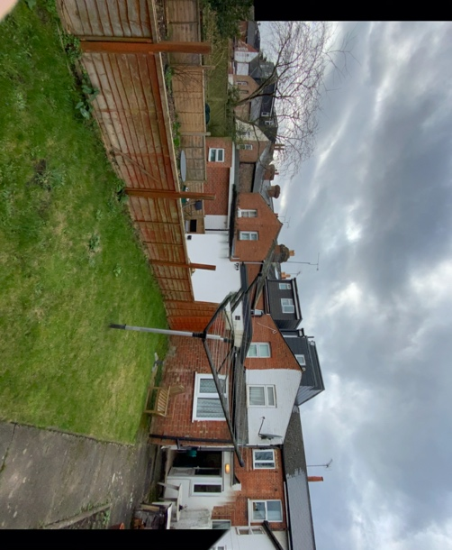

Typical appearances to lofts and walls maintaining similar finishes

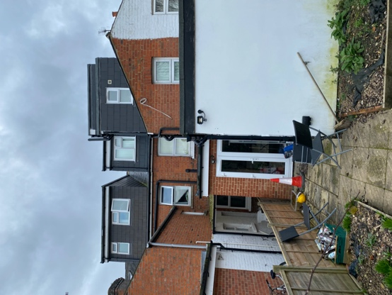

Juxtaposition of various extensions and lofts seen along the street

