Mr Dave Cole
Permafix

24/02/2020
Our Ref. SS240220

166 Castle Hill
Reading

Dear Dave

Further to meeting at the above property, please find detailed below our report.

If I have misunderstood your instructions or missed any points at this early stage, please contact me immediately to discuss.

Background
166 Castle Hill is a mid Terrace property with a large basement level. with potential living accommodation. To the front elevation a there is a light well, to the rear is also a light well, access to the basement it down timber stairs from the middle of the property.

Water ingress was not noted a the time of the visit. Some walls had damp issue and small areas of ground salts suggesting internal walls have issues with rising damp.

Investigation
1 A site survey was conducted by Simon Smith
2 No site investigation information has been provided at this stage regarding ground gas or ground contaminants.

Discussion
From a visual inspection a structural waterproofing system is required to provide a habitable environment in accordance with BS8102 (2009).

The grade of waterproofing required as per Table 2 “Grades of Waterproofing Protection” of
BS8102:2009 would be Grade 3 where the performance level is that “no water penetration acceptable.

Ventilation, dehumidification or air conditioning necessary, appropriate to intended use”.

Best advice would be to provide a Type C cavity drain waterproof system in conjunction with BS8102 2009.

The floor slab is believed to be a mix of brick and concrete with floors slightly uneven.

Internal Type C cavity drain system.

Wall membrane.
Install the Wykamol CM8 Mesh full height to all the retaining walls, Wykamol sealed fixings should be installed at approx. 250mm centres when used in conjunction with dry wall adhesive for plasterboards dry lining systems

Perimeter channel.
Install the Wykamol perimeter drainage channel to a chased channel around the perimeter wall area, flushing points should be installed for future maintenance and in accordance with BS8102 2009, maintainable Type C systems. These can be hidden behind blank electrical points for example.

Perimeter channel.

The Wykamol perimeter channel should be drained out to the rear elevation, as the basement has no natural drainage a sump chamber is required. I would suggest a twin pump system so if moisture ever gets in and the primary system fails, there is a secondary pump to move water. Each pump should be on its own fused spur. I would also suggest a mains high level alarm to alert if the primary pump has failed.

Floor membrane.
Install the Wykamol CM20 membrane to the floor. The floor membrane should be sealed to the wall membrane using corner tape.

NOTE.
The waterproof systems should be installed to the manufacturer’s instructions including all joints, seals and overlaps.
The internal Type C cavity drain system should be fully tested and commissioned before handing over to the client.

Wall & floor finishes can be installed once the internal system has been commissioned.

Please note this design is only applicable to Wykamol products and assumes a specialist contractor, who has been trained by Wykamol, installs the system.
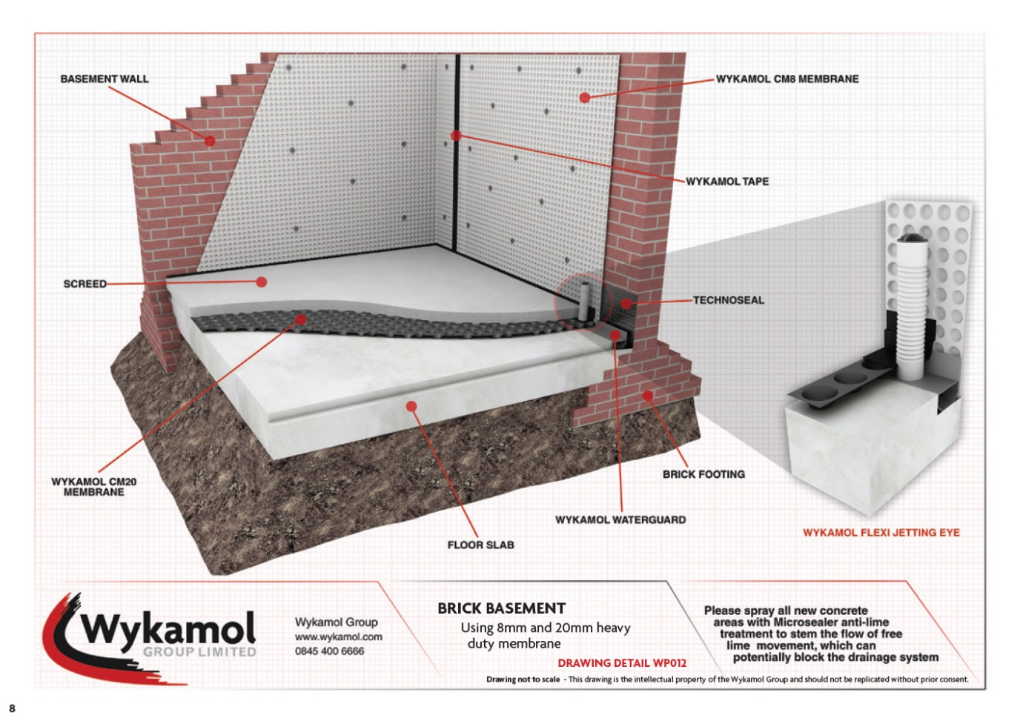
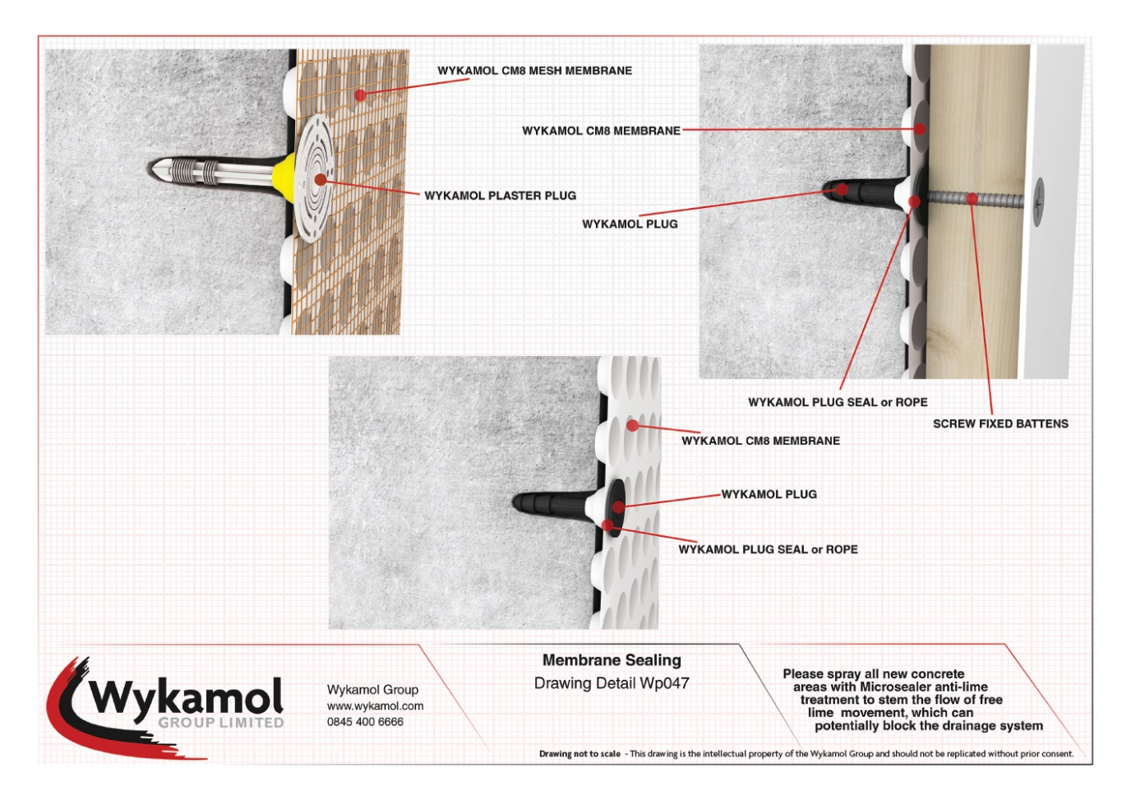
Guidance & Recommendations if/as required.

Where pipes penetrate through the floor slab or wall membrane, seal using Wykamol sealing rope and overseal tape to prevent water ingress.

Prior to carrying out structural waterproofing works check the structure to ensure that there is no significant water ingress through the building fabric since it should act as the primary resistance as detailed in BS8102:2009. If there is significant water ingress this may be reduced by applying Wykamol products but will require an additional visit to advise on a suitable course of action.

We trust you find this report informative. Please do not hesitate to contact me on 07795 821101 with any questions or queries you may have.

Yours sincerely,
For and on behalf of Wykamol Group Ltd

Simon Smith
CSSW CSRT
Technical Sales Manager

