DELEGATED APPLICATION REPORT - Application Nos.: 200887/ADV
Address: Green Park Village, Longwater Avenue
Proposal: Wayfinding and block signage at the entrance to Phases 3A & 3B, to include parking, direction, marketing suite, banner and one backlit sign.
Case officer: Alison Amoah

Site Description and Surrounding Area:
Phases 3A and 3B are under construction and are residential phases of Green Park Village, sited to the north of the established Green Park Business Park.

Proposal:

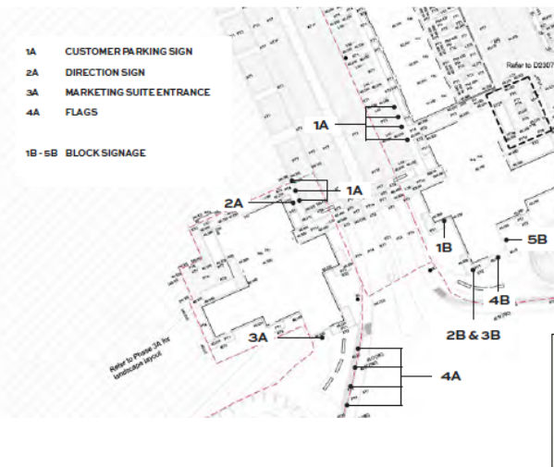

- 7 no. Customer Parking Sign (1A)– 0.406m wide, 0.406m wide, 0.1m deep. Printed di-bond, freestanding sign. Non-illuminated.
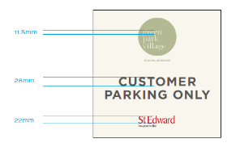

- 1 no. Marketing Suite Entrance (Directional) (2A) – 0.7m wide, 1.3m high. Printed di-bond freestanding sign. Non-illuminated.
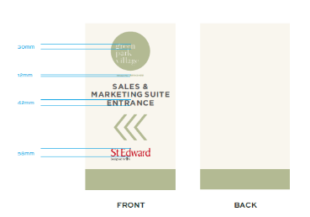

- 1 no. Marketing Suite Entrance (3A) - 1.2m wide, 3 m high. Printed di-bond. Halo effect backlit lettering at 270cd per linear m.

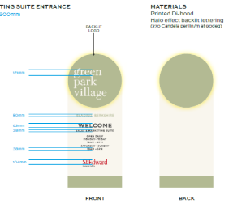

- 4 no. Fixed Banner Flags (4A) – 0.65m wide, 2m high.

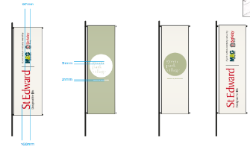
- (1B-5B) 1 no. Building Banner – 9.62m high 1.88m wide – vinyl – 2.5m above ground; 1 no. Building Banner – 12.75m high, 2.495m wide – vinyl; 2 no. Balcony Signs – 4.92m wide, 1.18 m high, 9.6m above ground level – vinyl; 2 no. Balcony Signs - 4.92m wide, 1.18m high, 3.4m above ground level - vinyl
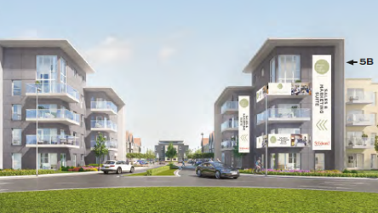

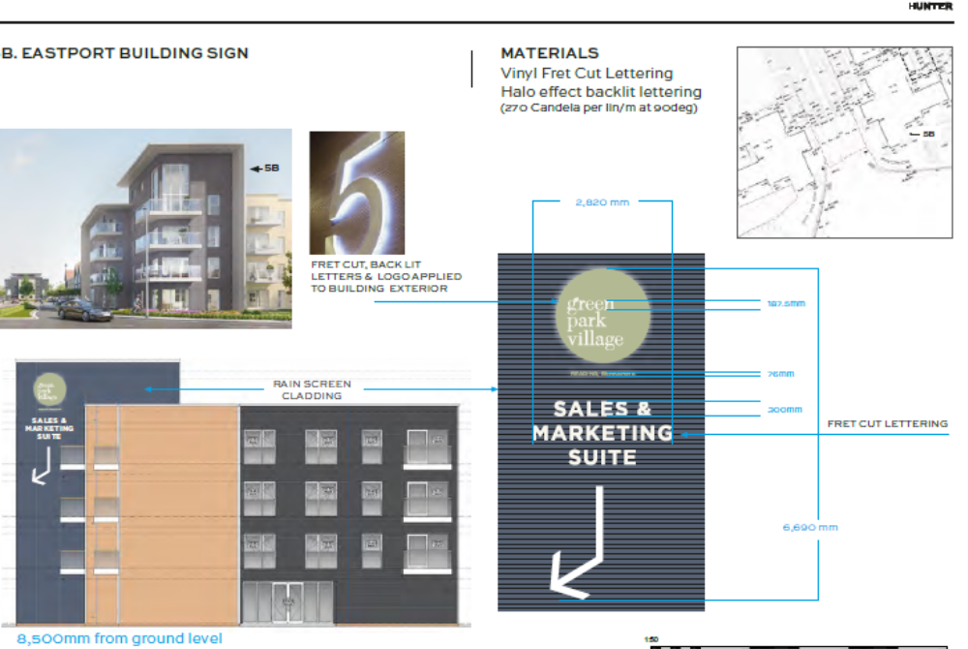

- Signage to Side of Block (imagery above) – No letters will be illuminated only the circle around the ‘ Green Park Village’ will be lit at 270 candelas per linear m. The arrow to be aluminium (rain screen cladding is the approved material and does not form part of the application).

Plans considered:
- Green Park Village Westport Marketing Suite Signage (for July 2020) Planning Pack, July 2020, prepared by Hunter Solves, received 2nd July 2020

Relevant Planning History:
151069/ADV – Billboard sign – wayfinding -Consented 27/11/2015

Numerous signage within Green Park Business park – to the south of the application site.

Consultation Responses: As the properties are under construction there were no residents to consult nor adjacent properties considered to be affected by the proposed signage.

RBC Transport and Natural Environment Teams were consulted.

Transport: There are no transport objections to the proposed location or illumination of the wayfinding and block signage, subject to the following condition.

AD1 ADVERT LUMINANCE
The maximum luminance from the sign hereby consented shall not exceed 300 cd/m2.
REASON: To protect the visual amenity and avoid excessive glare that could lead to a danger to highway users in accordance with Policy CC7 and OU4 of the Reading Borough Local Plan 2019.

Natural Environment (Trees):
I note the position and type of signs as detailed in the covering letter and Planning Pack document dated July 2020. I have no objections as the signs are either attached to buildings or avoid landscape beds with trees (particularly important re the flag signs) and in any case I assume they are all temporary for the purposes of advertising Phases 3A and 3B and will be removed on completion and occupation of that phase.

Equality Act 2010:
In determining this application the Council is required to have regard to its obligations under the Equality Act 2010. However, there is no indication or evidence (including from consultation on the application) that the protected groups identified by the Act have or will have different needs, experiences, issues and priorities in relation to this particular planning application. Therefore in terms of the key equalities protected characteristics it is considered there would be no significant adverse impacts as a result of the development.

Relevant Planning Policy and Guidance and Legal Context
Regulation 3 of the Town and Country Planning (Control of Advertisements) (England) Regulations 2007 requires the Local Planning Authority to exercise its powers under these regulations in the interests of amenity and public safety taking into account the provisions of the development plan, so far as they are material; and any other relevant factors. Regulation 3 states that factors relevant to amenity include the general characteristics of the locality, including the presence of any feature of historic, architectural, cultural, or similar interest.

Factors relevant to public safety include highway safety and whether the advert would hinder security or surveillance devices, including speed cameras.

Section 38(6) of the Planning and Compulsory Purchase Act 2004 requires that proposals be determined in accordance with the development plan unless material considerations indicate otherwise. Material considerations include relevant policies in the National Planning Policy framework (NPPF) - among them the 'presumption in favour of sustainable development'.

The following local and national planning policy and guidance is relevant to these applications:

Adopted Reading Borough Local Plan (2019):
CC7 (Design and the Public Realm)
CC8 (Safeguarding Amenity)
TR3: Access, Traffic and Highway-Related Matters
OU4: (Advertisements)

Appraisal:
Main Issues: The main issues are considered to be:

(a) Amenity
- Safety

(a) Amenity
Although some of the signage is relatively large the proposed signs are temporary for the purpose of advertising the phases of residential development. It is considered that the material, colour and luminance would not be harmful to the wider area, and would not have significant detrimental effects on visual amenity. The overall area which would be illuminated would be very limited; a halo effect. A condition is recommended which restricts the level of lux to max of 300 cd/m2.

On the above basis, the proposed sign is considered to comply with Adopted reading Borough Local Plan Policies CC7, CC8, TR3 and OU4.

(b) Safety
The NPPG (in particular in this instance Paragraph: 068 Reference ID: 18b-068-20140306 & Paragraph: 078 Reference ID: 18b-078-20140306) provides guidance as to the considerations affecting public safety. Having reviewed the guidance with respect to the type of advertisements which may cause danger to road users, the officer concludes that there would be no detrimental effect with regard to highway safety.

Although the signage would be visible to road users, and in particular the arrow and banner signs on the side of the building (Visible from Longwater Avenue from the east) the signs would be set back from the highway and would be of an illuminance level that would not distract drivers so as to have an effect on safety. The signage would not obscure existing signs, reduce visibility for road users, or sight lines of CCTV cameras. The signage is therefore, considered to accord with Adopted Reading Borough Local Plan Policies TR3 and OU4.

RECOMMENDATION:

GRANT

Proposed conditions:

- Standard advert conditions
- Approved plans
- Maximum luminance should not exceed 300 cd/m2.

Informatives:
T&Cs
Positive and proactive

