DELEGATED HOUSEHOLDER APPLICATION REPORT
Ward: Whitley
App Ref: 211250 / HOU
Address: 541 Basingstoke Road, Reading, RG2 0SH
Proposals: Revised proposals for part single and part double storey side and rear extensions with a front dormer.
Case Officer: Beatrice Malama
Date received (valid from): 30th July 2021 Agreed Target date: 4th October 2021

SITE DESCRIPTION
The application site is a two-story end terrace dwelling house located at 541 Basingstoke Road in a predominantly residential area. The area is characterised by semi-detached and terraced properties of similar design and style with large back gardens. Many properties in the area have rear and/or side extensions. The property is not listed and does not fall within a conservation area.
PROPOSED DEVELOPMENT
The proposed development involves demolition of the existing side attached garage in order to construct a part single and part double story side extension with a footprint slightly less than the existing garage. The proposed ground floor side extension measures approximately 2.2m deep and approximately 7.6m along the side whereas the proposed first floor side extension measures approximately 2.2m deep and 5.6m wide. The proposed first floor extension would be setback from the front by 2m.
Following the recent grant of prior approval for a single-story rear extension measuring 6m deep and 7m wide, this proposal would include the single storey extension plus an additional first floor rear extension measuring 3m deep and 5m wide. The first-floor rear extension would be set away from the boundary shared with No. 539 Basingstoke road by at least 0.9m.
In addition, the proposed development would have a front dormer to the existing loft floor. The existing loft floor was extended under permitted development rights to include a dormer to the rear roof slope and a change in the roof design from hip to gable.
The proposed side extension would have a pitched roof whereas the proposed rear extension would have a flat roof. Exterior wall, roof, door and window finishing materials would match that on the original house.

Plans considered;
Drawing No: BR541:102 Rev – Location Plan
Drawing No: BR541:101 Rev – Block Plan
Drawing No: BR541:103 Rev– Pre-Existing Floor Plans
Drawing No: BR541:104 – Pre-Existing Loft Plan
Drawing No: BR541:105 Rev – Existing Loft Plan
Drawing No: BR541:108 Rev – Pre - Existing Elevations
Drawing No: BR541:020 Rev – Existing Elevations
Drawing No: BR541:110 Rev – Proposed Elevations
Drawing No: BR541:106 Rev – Proposed Plans
Drawing No: BR541:107 Rev – Proposed Loft Plan
As received on 30th July 2021

RELEVANT PLANNING HISTORY
210857/HPA - Rear extension measuring 6.00m in depth, with a maximum height of
2.95m, and 2.87m in height to eaves level – Prior Approval Given on 2nd July 2021.

CONSULTATIONS
External Consultations
A site notice was sent to the agent on 4th August 2021 and the following addresses were consulted by letter.
Flats 1, 2,3,4,5 Tiverton House, 83a Ambrook Road, RG2 8SN
79 Ambrook Road, RG2 8SN
543 & 539 Basingstoke Road, RG2 0SH
A letter of objection was received from 543 Basingstoke Road. The following are objections raised by the occupants.
- Overlooking and loss of privacy.
- Loss of natural light.
Planning Officer Comment: Please refer to ‘Residential Amenity Section’ to see assessment of the proposed development in relation to the above concerns.

Equality Act 2010:
In determining this application the Council is required to have regard to its obligations under the Equality Act 2010. However, there is no indication or evidence (including from consultation on the application) that the protected groups identified by the Act have or will have different needs, experiences, issues and priorities in relation to this particular planning application. Therefore, in terms of the key equalities protected characteristics it is considered there would be no significant adverse impacts as a result of the development.
Relevant Planning Policy and Guidance
Section 38(6) of the Planning and Compulsory Purchase Act 2004 requires that proposals be determined in accordance with policies in the development plan unless material considerations indicate otherwise. Material considerations include relevant policies in the National Planning Policy framework (NPPF) - among them the 'presumption in favour of sustainable development'.
National Planning Policy
National Planning Policy Framework (2021)
National Planning Practice Guidance
Reading Borough Local Plan (2019)
CC7- Design and the Public Realm
CC8 - Safeguarding Amenity
H9 - House Extensions and Ancillary Accommodation
SPG/SPD
A Design Guide to House Extensions SPG (2021)
Assessment
Character and appearance
Policy CC7 (Design and the Public Realm) requires that all developments be of high design quality, whilst Policy H9(House Extensions and Ancillary Accommodation) requires that an extension “respects the character and appearance of the house in terms of scale, location, materials and design, and that it should not harm the character and pattern of neighbouring houses and the appearance of the street scene”.
The proposed development includes a part single and part two story side extension with an increase in the gap between the extension and the boundary fencing to the south from a maximum of 0.5m to at least 0.9m. The proposed side extension would have a pitched roof whereas the rear extension would have a flat roof. Whilst the rear extension would have a flat roof it would be considered unlikely to have a detrimental impact on the appearance of the existing house. The extension would be setback from the front and away from the boundary and thus allowing the existing house to retain its primary character and appearance. In addition, the design and the setting back of the proposed first floor side extension would prevent any terracing effect and therefore the proposed extension would be considered unlikely to harm the character and appearance of the existing house and the neighbouring houses. Furthermore, although the proposed extension would change the established pattern of the existing terrace, the stepped profile of the proposed side and rear extensions and the overall design would reduce any potential harm to the character and appearance of the original house, the neighbouring houses and the wider street.
Residential Amenity
CC8 (Safeguarding Amenity) seeks to prevent development causing detrimental impact on the neighbouring properties; policy H9 (House Extensions and Ancillary Accommodation) provides that extensions should not cause an overbearing impact on neighbours”.
Privacy and overlooking: The proposed ground floor rear extension would have a window to the southern side elevation facing part of the neighbour’s front garden however the existing gap and boundary fencing between the site and the neighbouring house would limit any potential loss of privacy to the occupants of 543 Basingstoke Road. There are no side facing windows proposed at first floor level and as such it is considered that there would be no overlooking of neighbouring properties and the extension is unlikely to cause any harmful loss of privacy to the neighbours.
Access to sunlight and daylight: Although the proposed side extension would be part two story, it would be set away from the boundary fencing by at least 0.9m and would have a pitched roof and thus any harmful impact to the living conditions of the neighbouring occupants would be reduced. There is an existing window to the side elevation of the neighbour’s house at 543 Basingstoke Road however the window does not appear to serve a primary habitable room. In addition, due to the orientation of the existing buildings, the proposed extension is unlikely to cause a significant loss of sunlight and daylight to the neighbouring houses.
With regard to overshadowing, the existing northern side elevation of the neighbouring house currently receives its own shadow and therefore it is considered unlikely that the proposed extension would result in or create an unacceptable level of overshadowing to the neighbouring occupants.
Visual dominance and overbearing effects of a development: Although the proposed development would result in a notable increase in the size of the existing house, it would not be visually dominant or overbearing as the design and exterior finishes fit in with the existing house. In addition, the design of the proposed development would allow the character and primacy of the existing house to be retained.
Conclusion
The proposed extension is considered to be in accordance with the Reading Borough Local Plan (2019) and the Design Guide to House extensions (2021) and therefore the application is recommended for approval subject to conditions.
Recommendation:
Grant

CONDITIONS
- Time Limit (Standard) TL1
- Approved Plans Ap1
- Materials (To Match) M1
- No new windows shall be introduced to the southern side elevation.
Appendix i: Photos of the site
Photo 1: Aerial View of the site and neighbouring properties
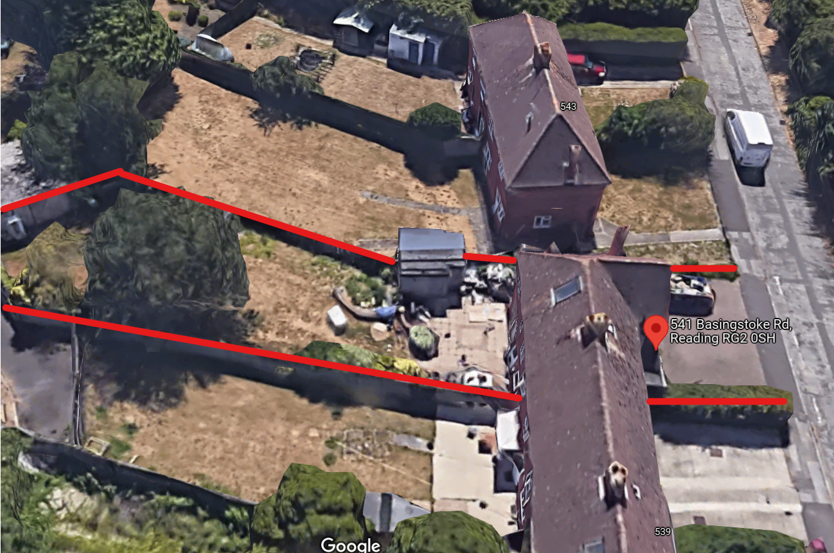
Photos 2 & 3: Existing front elevations - 541 and 543 Basingstoke Road
