Delegated Application Report Target Date: 09/09/20
Address: 45 Watlington Street
Application No: 201010/CLP
Proposal: Single storey rear extension
Case Officer: Tom Hughes
Introduction and Proposal
45 Watlington Street is a mid-terraced property located within Eldon Square Conservation Area. The property benefits from a loft conversion, with front and rear dormers. The dormers combine to exceed the original ridge height. The dormers are unauthorised but have been in situ for in excess of ten years, so are immune from enforcement action due to the passing of time. Beyond the rear garden is located a parking court for Barkham Mews.
The Eldon Square Conservation Area appraisal notes that the character of the area is predominantly residential, with Watlington Street being the primary street within the area:
“Its street frontage of short rows of two and three storey houses is punctuated by two significant places of worship and Watlington House, a 17th Century clothier’s mansion, now offices”.
45 Watlington Street is identified as a Building of Townscape Merit, as are all the unlisted buildings along Watlington Street. The adjoining properties at 47 and 49 Watlington Street are a storey taller, and benefit from rearward gables and further extensions. The adjoining property at 43 Watlington Street is of the same original form, and has not been extended to the rear.
The proposal is for the erection of a single storey rear extension. The extension would project to a depth of 2.134m, set 0.2m from the sideward boundaries. The extension would have a pitched roof with a maximum height of 3.573m and a height to eaves of 2.208m. The extension would be constructed of brickwork, to match the existing property. Bi-fold doors would be located to the rear elevation, with roof lights set within each roof slope.
Plans Submitted
The agent supplied the following, received on 15/07/20:
Drawing No: 218-A2-01-A – Site Location, Block Plan, Existing Floor and Roof Plans, Elevations and 3D Views
Drawing No: 218-A1-10 – Site Location, Block Plan, Proposed Floor and Roof Plans, Elevations and 3D Views
Relevant Planning History
171787/HOU – Single storey rear extension and replacement of existing front and rear dormers – Withdrawn 18/12/17
191353/PRE – Various external works including single storey rear extension, elevational alterations and reconstruction of dormers – Observations sent 08/10/19
192052/HOU - Single storey rear extension, alterations to fenestration and provision of roof light to forward roof slope – Refused 10/06/20
Summary of Consultations
No consultations were undertaken as it is not required for an application of this type.
Relevant Planning Policy and Guidance
National Planning Practice Guidance
The Town and Country Planning (General Permitted Development) (England) Order 2015 (GPDO)
Permitted development rights for householders – Technical Guidance April 2017
A Lawful Development Certificate is a legal document stating the lawfulness of past, present or future development. If granted by the Local Planning Authority, the certificate means that enforcement action cannot be carried out to the development referred to in the certificate. However, the certificate will not protect from enforcement action by the Local Planning Authority if the specified use or development is then changed ‘materially’ without a planning application for it. The certificate is not a planning permission. The planning merits of the use, operation or activity in the application are not relevant.
Assessment
A Certificate of Lawfulness for a proposed development has been submitted as the applicant considers the proposal falls within the permitted development rights of the property.
The proposed single storey rear extension must be assessed to ensure that it complies with the conditions of Class A, Part 1, Schedule 2 of the Town and Country Planning (General Permitted Development) (England) Order 2015, which relates to the ‘enlargement, improvement or other alteration of a dwellinghouse’.
The relevant conditions of the GPDO for a single storey rear extension, and the installation of a window, which is not listed or in a conservation area, are as follows:
A.1 Development is not permitted by Class A if:
A.1 (a) permission to use the dwellinghouse as a dwellinghouse has been granted only by virtue of Class M, N, P or Q of Part 3 of this Schedule (changes of use); complies
A.1 (b) as a result of the works, the total area of ground covered by buildings within the curtilage of the dwellinghouse (other than the original dwellinghouse) would exceed 50% of the total area of the curtilage (excluding the ground area of the original dwellinghouse); complies
A.1 (c) the height of the part of the dwellinghouse enlarged, improved or altered would exceed the height of the highest part of the roof of the existing dwellinghouse; complies
A.1 (d) the height of the eaves of the part of the dwellinghouse enlarged, improved or altered would exceed the height of the eaves of the existing dwellinghouse; complies
A.1 (e) the enlarged part of the dwellinghouse would extend beyond a wall which (i) forms the principle elevation of the original dwellinghouse; complies or (ii) fronts a highway and forms a side elevation of the original dwellinghouse; complies
A.1 (f) subject to paragraph (g), the enlarged part of the dwellinghouse would have a single storey and – (i) extend beyond the rear wall of the original dwellinghouse by more than 4 metres in the case of a detached dwellinghouse, or 3 metres in the case of any other dwellinghouse, complies or (ii) exceed 4 metres in height; complies
A.1 (g) until 30th May 2019, for a dwellinghouse not on article 2(3) land nor on a site of special scientific interest, the enlarged part of the dwellinghouse would have a single storey and – (i) extend beyond the rear wall of the original dwellinghouse by more than 8 metres in the case of a detached dwellinghouse, or 6 metres in the case of any other dwellinghouse, complies or (ii) exceed 4 metres in height; complies
A.1 (h) the enlarged part of the dwellinghouse would have more than a single storey and – (i) extend beyond the rear wall of the original dwellinghouse by more than 3 metres, complies or (ii) be within 7 metres of any boundary of the curtilage of the dwellinghouse opposite the rear wall of the dwellinghouse; complies
A.1 (i) the enlarged part of the dwellinghouse would be within 2 metres of the boundary of the curtilage of the dwellinghouse, and the height of the eaves of the enlarged part would exceed 3 metres; complies
A.1 (j) the enlarged part of the dwellinghouse would extend beyond a wall forming a side elevation of the original dwellinghouse, and would – (i) exceed 4 metres in height, complies (ii) have more than a single storey, complies or (iii) have a width greater than half the width of the original dwellinghouse; complies
A.1 (ja) any total enlargement (being the enlarged part together with any existing enlargement of the original dwellinghouse to which it will be joined) exceeds or would exceed the limits set out in sub-paragraphs (e) to (j);
A.1 (k) it would consist of or include – (i) the construction or provision of a verandah, balcony or raised platform, complies (ii) the installation, alteration or replacement of a microwave antenna, complies (iii) the installation, alteration or replacement of a chimney, flue or soil and vent pipe, complies or (iv) an alteration to any part of the roof of the dwellinghouse. complies
A.2 In the case of a dwellinghouse on article 2(3) land, development is not permitted by Class A if:
A.2 (a) it would consist of or include the cladding of any part of the exterior of the dwellinghouse with stone, artificial stone, pebble dash, render, timber, plastic or tiles; complies
A.2 (b) the enlarged part of the dwellinghouse would extend beyond a wall forming a side elevation of the original dwellinghouse; complies
A.2 (c) the enlarged part of the dwellinghouse would have more than a single storey and extend beyond the rear wall of the original dwellinghouse; complies
A.2 (d) any total enlargement (being the enlarged part together with any existing enlargement of the original dwellinghouse to which it will be joined) exceeds or would exceed the limits set out in sub-paragraphs (b) and (c). complies
Conditions
Development is permitted by Class A subject to the following conditions:
A.3 (a) the materials used in any exterior work (other than materials used in the construction of a conservatory) must be of a similar appearance to those used in the construction of the exterior of the dwellinghouse; complies
A.3 (b) any upper-floor window located in a wall or roof slope forming a side elevation of the dwellinghouse must be (i) obscure-glazed, n/a and (ii) non-opening unless the parts of the window which can be opened are more than 1.7 metres above the floor of the room in which the window is installed; n/a and
A.3 (c) where the enlarged part of the dwellinghouse has more than a single storey, or forms an upper storey on an existing enlargement of the original dwellinghouse, the roof pitch of the enlarged part must, so far as practicable, be the same as the roof pitch of the original dwellinghouse. n/a
Recommendation
The proposal has been assessed against the Town and Country Planning Act 1990 (as amended) and Class A, Part 1, Schedule 2 of the Town and Country Planning (General Permitted Development) (England) Order 2015.
It can be confirmed that the proposed operation would be lawful for planning purposes on the basis of the drawings received on 15/07/20:
Drawing No: 218-A1-10 – Site Location, Block Plan, Proposed Floor and Roof Plans, Elevations and 3D Views
Sufficient evidence has been provided to demonstrate that a Certificate of Lawfulness should be granted for the proposed single storey rear extension.
Informatives
Building Regulations
Encroachment and Party Wall Act
Construction and Demolition
Bats
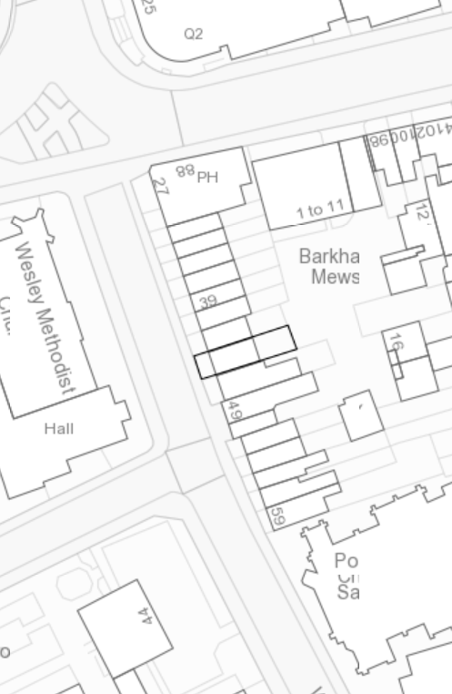

Site Location Plan

