DELEGATED APPLICATION REPORT - Application No.: 201504/VARIAT
Address: 689 Oxford Road
Proposal: Change of use from D1 (Day Care Facility for People with Learning Difficulties) at ground floor and C3 flat at first floor, to part ground floor for B1 office and C3 residential for the remainder of the building without complying with condition 2 of Planning permission 190413 to amend the plan to omit the proposed rear single storey extension
Case officer: Alison Amoah
Target Date: 26/2/2021 (extended)

Site Description, Surrounding Area and Background:
The application site is the end of terrace property on the corner of Oxford Road and Grovelands Road, granted permission under 190413 to change its use from a former D1 use to a part B1 office and part C3 residential unit. This included a rear ground floor extension. The development has commenced (the change of use), and the rear extension has not been implemented nor the originally approved internal changes.

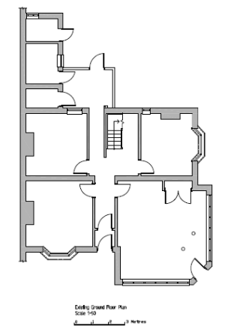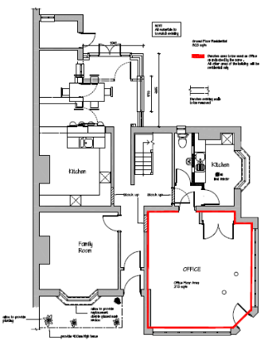
Existing Plan submitted under 190413 Approved Plan under 190413

Proposal:
The applicant seeks to vary the relevant plans condition (2) to replace the approved plan:

- Proposed Plans & Elevations – Drawing no: 02 Rev E, received 3rd June 2019

With: Site Survey & Elevations - Drawing no: 05, received 27th October 2020, which shows the retained existing rear projection (conservatory) and the internal layout at both ground and first floors as originally submitted under 190413.

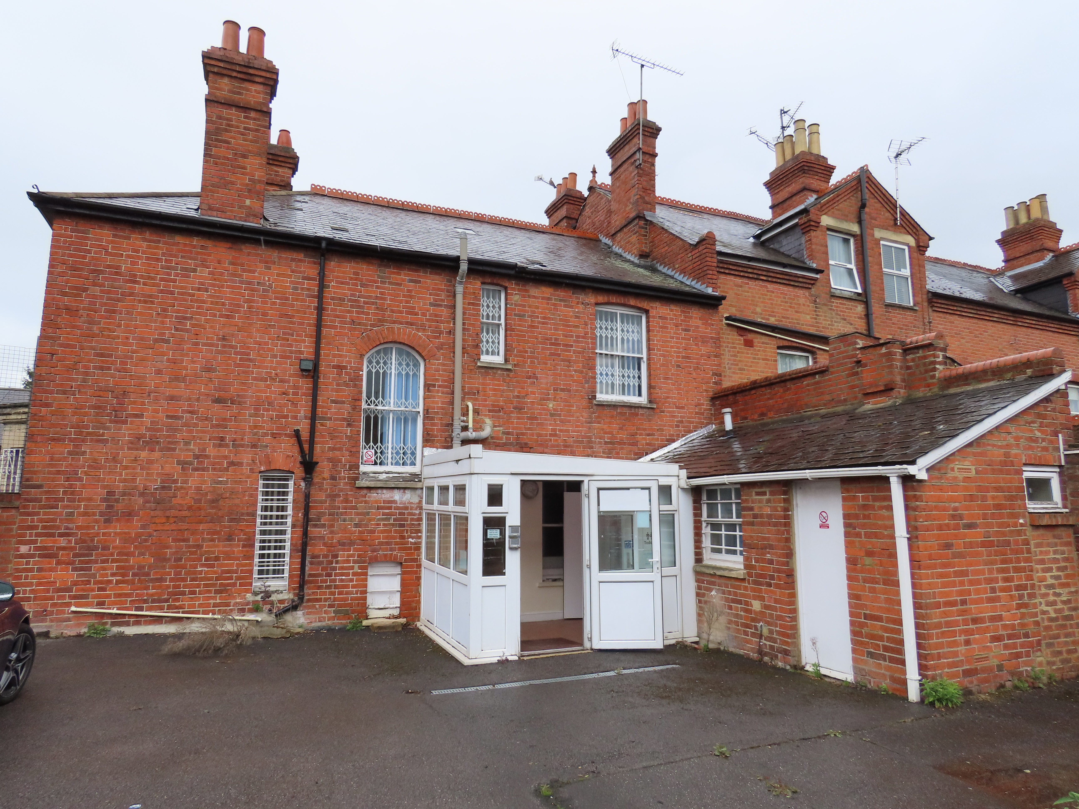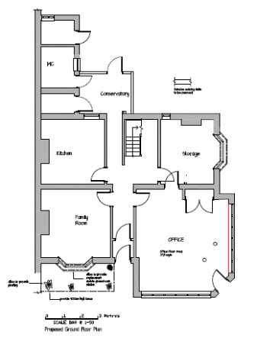
Proposed Plan under 201504

Plans considered:
- Site Survey & Elevations - Drawing no: 05, received 27th October 2020

Other Documents:
- Covering Letter from ET Planning, dated 16th October 2020, received 27th October 2020

Relevant Planning History:

TP5964 – Use of first floor as offices and stores – Approved 6/10/1967

77/273 – Shopfront modernisation – Approved 7/4/77

99/0580 - Change of use from Class B1 to Class D1 (Offices to Day Care Facility for People with Learning Difficulties) – Approved 19/11/99 (committee decision)

190413 - Change of use from D1 (Day Care Facility for People with Learning Difficulties) at ground floor and C3 flat at first floor, to part ground floor for B1 office and C3 residential for the remainder of the building – Approved 3/6/2019

Consultation Responses:
No consultation undertaken.

Equality Act 2010:
In determining this application the Council is required to have regard to its obligations under the Equality Act 2010. However, there is no indication or evidence (including from consultation on the application) that the protected groups identified by the Act have or will have different needs, experiences, issues and priorities in relation to this particular planning application. Therefore in terms of the key equalities protected characteristics it is considered there would be no significant adverse impacts as a result of the development.

Relevant Planning Policy and Guidance:
Section 38(6) of the Planning and Compulsory Purchase Act 2004 requires that proposals be determined in accordance with the development plan unless material considerations indicate otherwise. Material considerations include relevant policies in the National Planning Policy framework (NPPF) - among them the 'presumption in favour of sustainable development'.

The following local and national planning policy and guidance is relevant to this application:
National Planning Policy Framework
National Planning Guidance

Reading Borough Local Plan 2019
Policy CC7: Design

APPRAISAL:
The proposed change to the approved plan essentially retains the building as it existed when the original permission was granted. There are therefore, no implications on the amenities of surrounding residents or the design of the building. The variation would no cause a change in the description of development under the original 190413, which did not include reference to the rear extension. Therefore, the variation in condition 2, to amend the plan, is considered to be acceptable.

RECOMMENDATION:

Approve

