Delegated Application Report
Application No: 201232/VAR
Address: 29 Cumberland Road
Proposal: Replacement of existing rear single storey extension with a two storey extension, and introduction of two dormer windows within the main rear roof slope, and associated internal works, to allow for community uses ancillary to the ongoing use of the building (comprising Nos. 29 & 31) as a Mosque with ancillary residential accommodation (Partly retrospective)as approved by application reference 170365 with a variation of Condition 2 (Approved Plans) relating to changes to the North elevation and provision of an emergency escape staircase on the south elevation and associated conditions.
Case Officer: Mr James Overall
Applicant: Mr Asif Hussaini
Date Received (valid from): 8 October 2020
Extended Target Date: 19 February 2021
Site Description
The application site contains Nos 29 and 31 Cumberland Road, mid and end terrace properties at the junction of Cumberland Road and Norwood Road. The surrounding area is largely residential in nature, although there is an existing Gurdwara (Sikh temple) almost opposite the site and various commercial and community uses to the south west of the site fronting Kings Road. No 31 is used as a mosque and community and cultural centre. No 29 was formally a residential dwelling that now forms part of the mosque. These properties front Cumberland Road, with an existing single storey rear extension to No 31 orientated towards Norwood Road, which is where the main entrance to the building is located.

Relevant Planning History
111308 | Replacement of existing rear single storey extension with a two-storey extension, introduction of two dormer windows within the main rear roof slope, and associated internal works, to allow for community uses ancillary to the ongoing use of the building (comprising Nos. 29 & 31) as a Mosque (partly retrospective). Ancillary residential accommodation. | Planning Permission Granted on 15th December 2011
170365 | Replacement of existing rear single storey extension with a two-storey extension, and introduction of two dormer windows within the main rear roof slope, and associated internal works, to allow for community uses ancillary to the ongoing use of the building (comprising Nos. 29 & 31) as a Mosque with ancillary residential accommodation (Partly retrospective). Amendment to permission 11/00583/FUL to alter the roof design and associated internal changes. | Planning Permission Granted on 28 June 2017

The planning permission 170365 was granted to alter the originally permitted scheme (111308) by design alterations to the two-storey rear extension by the replacement of the originally permitted curved ‘green’ roof and the erection of a pitched roof with two pitches (9 degrees then 47 degrees) to maintain the originally permitted (111308) ridge and eaves heights. The roof was proposed to be constructed of dark grey Sarnafil, with 6 additional rooflights to provide increased internal light which resulted in 12 in total.

The originally permitted scheme (111308) had a recessed two-storey element that ‘linked’ the main 3 storey building to the two-storey extension. To seek to create visual relief on the elevation fronting Norwood Road, patterned block work cladding was proposed at first floor on the new build element.

As for the internal layout the applicant had set out that the originally permitted scheme (111308) did not provide any designated storage space as required for the building to function as a mosque. Therefore, the previous proposal (170365) sought to excavate a new basement under the footprint of the originally permitted rear extension (115 sqm). This area was to be used solely for storage, W/C and sinks.

Other internal alterations to the layout were sought under 170365 to allow the building to function more effectively and reduce the floor area for prayer from 246 sqm to 188sqm.

The previous permissions saw the following revised uses for the permitted floor area:

Originally permitted (111308)
Total prayer area: 246.6 sqm
Basement total prayer area: 36.1 sqm
Ground floor total prayer area: 95.5 sqm
First floor total prayer area: 115.0 sqm
Second floor total prayer area: 0 sqm

Previously permitted (170365)
Total prayer area: 188.5 sqm
Basement total prayer area: 0 sqm
Ground floor total prayer area: 89.9 sqm
First floor total prayer area: 98.6 sqm
Second floor total prayer area: 0 sqm

Submitted drawings:
Original superseded plans received on 3rd September 2020.

As received on 1st February 2021:
JAH 100 Rev B Location & Block Plan
WD-01 - Proposed Ground Floor Plan
WD-02 - Proposed First Floor Plan
PL-2B Rev B - Proposed Site Plan

As received on 2nd February 2021:
PL-1A - Proposed Elevations

Consultations
The following neighbouring households were consulted as part of this application on 8th October 2020 and then re-consulted on 3rd February 2021 to confirm change to description with addition of fire escape staircase:
2 Norwood Road, Reading, Berkshire, RG1 3LD
30A Cumberland Road, Reading, Berkshire, RG1 3LB
23 Cumberland Road, Reading, Berkshire, RG1 3LB
1 Norwood Road, Reading, Berkshire, RG1 3LD
30 Cumberland Road, Reading, Berkshire, RG1 3LB
19 Cumberland Road, Reading, RG1 3LB
28 Cumberland Road, Reading, RG1 3LB
5 Norwood Road, Reading, RG1 3LD
25 Cumberland Road, Reading, RG1 3LB
32 Cumberland Road, Reading, RG1 3LB

No representations have been received.

There was no need for internal consultations on the changes proposed by this application.

Legal and Planning Policy Context
Section 38(6) of the Planning and Compulsory Purchase Act 2004 requires that proposals be determined in accordance with the development plan unless material considerations indicate otherwise. Material considerations include relevant policies in the National Planning Policy framework (NPPF) - among them the 'presumption in favour of sustainable development'.
The following local and national planning policy and guidance is relevant to this application:

National Policy
National Planning Policy Framework
National Planning Practice Guidance

Reading Borough Local Plan (2019)
CC7: Design & the Public Realm
CC8: Safeguarding Amenity

Appraisal
This current application (201232) for a variance of condition is applying to change the north facing elevation as well as the ground and first floor plans and to introduce an escape staircase on the south elevation.

Permitted under 170365: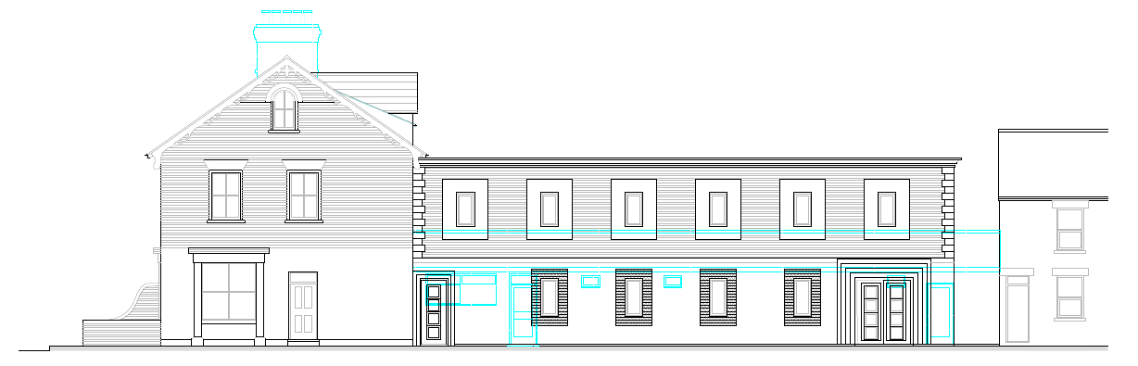

Amended plans applied for under 201232:
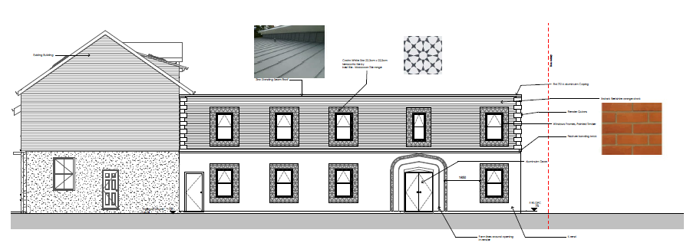
The changes to the North facing elevation involve the removal and changes to windows on the existing building:

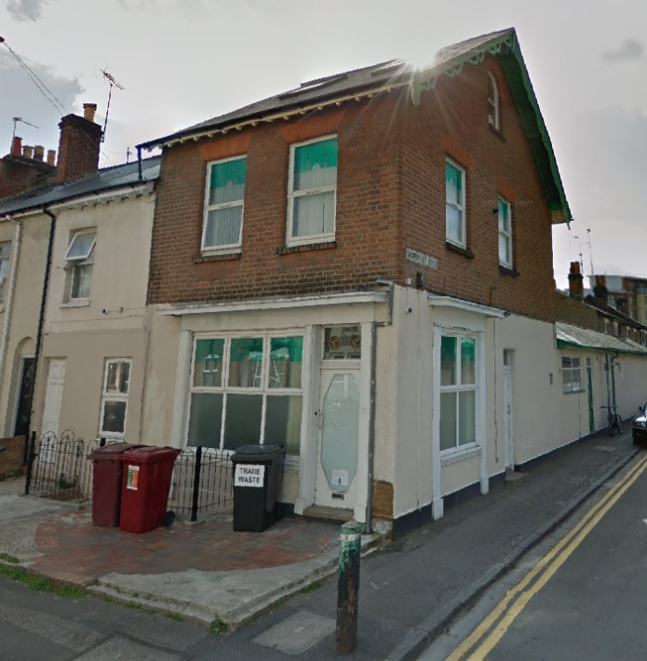
To be altered.
To be removed.

as well as a variety of amendments to the previously permitted windows and doors on the extension.

Decorative Surrounds & Brickwork
The previous report (111308) states “Whilst the existing extension is of no particular merit and the proposed replacement has been designed with its function in mind, and there are elements of Islamic architecture which add interest to the building. One entrance off Norwood Road would be recessed with decorative brick surrounds, and the ground floor windows would be set within decorative terracotta surrounds…The design of the extension is considered to be appropriate in this context”.

The scheme applied for under this variation sees a considerable alteration to the previously permitted doors, which were large and had a large decorative surround. The proposed variation seeks permission to allow a simple set of aluminium doors, with minimal decorative surround titled “Moroccan Encaustic Cement Pattern”.

Officers expressed their concerns and acceptable amended plans were provided.

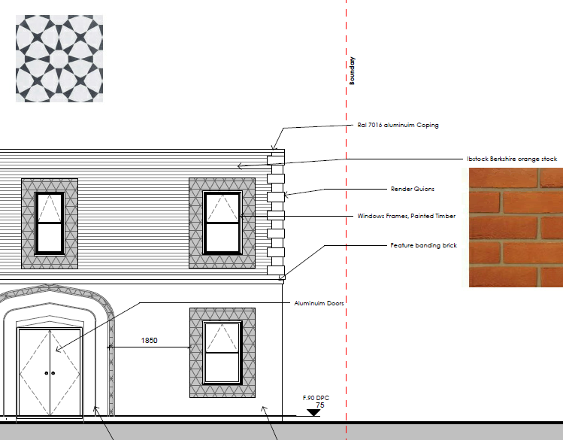 Extract showing materials

While a simpler design the main entrance is identified and is an attractive design. The proposed tiling surrounds of the windows and the confirmation that these windows will be timber framed is also welcomed. Subject to the proposed materials being of a good quality this is now considered to be an acceptable alteration. Retaining the bricks on the original building is also an improvement.

The proposed changes are possibly be a step back from the appearance and quality of what was previously proposed but not to the extent that the proposed development would fail against Policy CC7.

Floor Plan Alterations & Neighbour amenity
Internal stair cases have been relocated to allow larger areas for prayer, and the originally permitted (170365) 1st floor office is to be changed to a bathroom. Further to the above, the ground floor sees the addition of a bathroom area and the removal of bike storage. Bike stands are now to be provided on the forecourt area on Cumberland Road.

An external metal fire escape is further proposed under this variation. It was this element that also required amended plans to ensure that neighbours would be screened from being over looked or disturbed by visitors to the mosque using the stairs for anything other than an emergency access and required re-consultations.

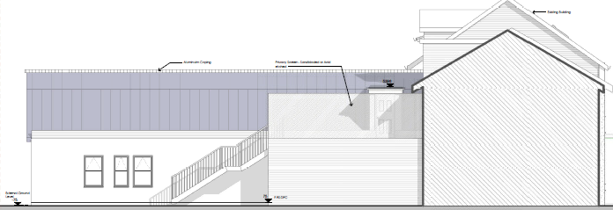South elevation

No objections have been received and officers are satisfied that conditions can be added to ensure that the neighbours remain protected. As such the proposed amendments are considered to be acceptable and the changes comply with Policy CC8.

Conclusion
The amended elevation, floor plans and external emergency staircase proposed within this application to replace those originally permitted under application reference 170365 are considered to comply with the relevant Policies CC7 & CC8 set out within the Local Development Framework, and as such the application is recommended for approval.

Officer’s Recommendation
Application Permitted

Time to implement changes should be given 1 year.
Informative to explain other changes to conditions

