DELEGATED APPLICATION REPORT

Application No: 210004/FUL  Address: 81 Broad Street, Reading, RG1 2AP  Proposal: Alterations to shop front  Case Officer: David Brett  Applicant: Bee World UK Ltd t/a Jollibee Restaurant  Received on (valid from): 04/01/2021  Target Date: 01/03/2021 | Application No: 210005/ADV  Address: 81 Broad Street, Reading, RG1 2AP  Proposal: Internally illuminated Fascia Sign, Internally illuminated Projecting Sign.  Case Officer: David Brett  Applicant: Bee World UK Ltd t/a Jollibee Restaurant  Received on (valid from): 04/01/2021  Target Date: 01/03/2021

Site Description and Surrounding Area

The proposal site is a three-storey building that is part of a terraced row on Broad Street. The vacant ground floor unit was previously a café, the plans within this application would allow the ground floor to be used as a restaurant. The ground floor is currently classified as A3, permitting the use of the space as a restaurant or café. The surrounding area comprises of a retail high street, with 81 Broad Street fronting on to a pedestrianised area of Broad Street.

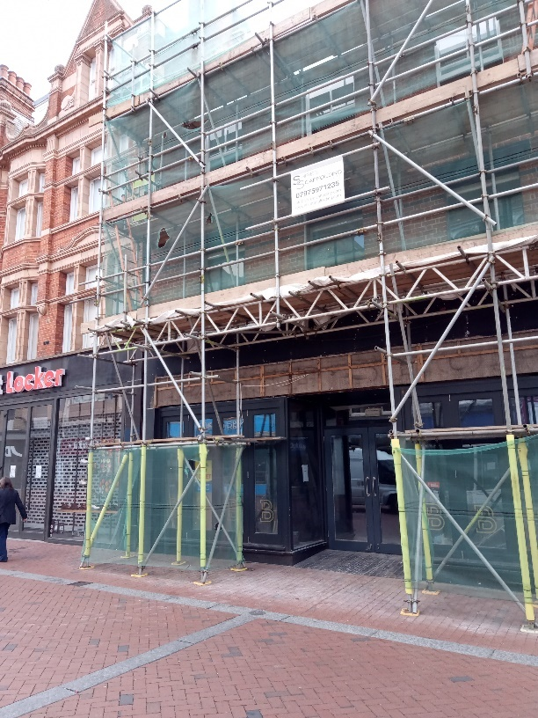 | 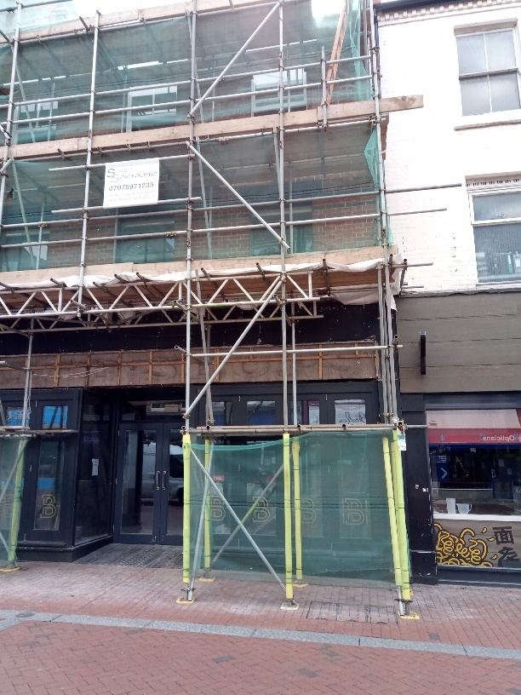
1. Existing Elevations. Photo taken on 12/05/2020. | 2. Existing Elevations. Photo taken on 12/05/2020.

Proposal

The proposal seeks the following:
- Minor alterations to shop front together with advertisement consent for new signage - illuminating and projecting signage proposed to the shopfront.

Internal Consultations

Reading Borough Council, Transport (application 210005 only) – Response received on 27/01/2021
- There are no transport objections to the proposed a signage.

External Consultees

- 80 Broad Street, Reading, RG1 2AP – No response received.
- 83 Broad Street, Reading, RG1 2AP – No response received.
- 83b Broad Street, Reading, RG1 2AP – No response received.
- 65-67 Broad Street, Reading, RG1 2AF – No response received.
- 68 Broad Street, Reading, RG1 2AF – No response received.

No further consultation response have been received for applications 210004 and 210005.

Plans/Documents Considered

The agent supplied the following plans for applications 210004 and 210005:

- Location Plan – 416.LP.01
- Existing Elevations – Front – 20009-011
- Proposed Elevations Rear – 20009-012
- Proposed Front Elevation – 20009-P201
- Planning Signage A – 20009-P202
These plans were received on 4th January 2021

Relevant Planning History

141887 - Change of use from A1 to A3 (retrospective) – Application permitted on 21/01/2015

200547 - Siting of ventilation/extraction equipment to flat roof to rear. – Application Permitted on 04/06/2020

200548 - Internally illuminated Fascia Sign, Internally illuminated Projecting Sign. – Application Permitted on 04/06/2020

Equality Act 2010
In determining this application, the Council is required to have regard to its obligations under the Equality Act 2010. However, there is no indication or evidence (including from consultation on the application) that the protected groups identified by the Act have or will have different needs, experiences, issues and priorities in relation to this particular planning application. Therefore in terms of the key equalities protected characteristics it is considered there would be no significant adverse impacts as a result of the development.

Relevant Planning Policy and Guidance

Application 210004

- Section 38(6) of the Planning and Compulsory Purchase Act 2004 requires that proposals be determined in accordance with the development plan unless material considerations indicate otherwise. The Development Plan for Reading relevant to the application site comprises the Reading Borough Local Plan (adopted November 2019).

- The ‘National Planning Policy framework’ (‘’NPPF’’) 2019 states clearly that its content is to be a material consideration in the determination of applications. The ‘NPPF’ states that due weight should be given to the adopted policies of the Local Plan according to their degree of consistency with the ‘NPPF’ (the closer the policies in the plan to the policies in the ‘NPPF’, the greater the weight that may be given).

Application 210005

- Regulation 3 of the Town and Country Planning (Control of Advertisements) (England) Regulations 2007 requires the Local Planning Authority to exercise its powers under these regulations in the interests of amenity and public safety taking into account the provisions of the development plan, so far as they are material; and any other relevant factors. Regulation 3 states that factors relevant to amenity include the general characteristics of the locality, including the presence of any feature of historic, architectural, cultural, or similar interest.
- Factors relevant to public safety include highway safety and whether the advert would hinder security or surveillance devices, including speed cameras.

Relevant Policies
The application has been assessed against the following policies:

National
National Planning Policy Framework 2019;
National Planning Policy Guidance 2014 onwards;
NPPG: Advertisements;

Reading Borough Local Plan (November 2019)
- CC7: Design and the Public Realm
- CC8: Safeguarding Amenity
- OU4: Advertisements (Application 210005 only)
- EN1: Protection and Enhancement of the Historic Environment
- EN15: Air Quality
- TR3: Access, Traffic and Highway related matters

Appraisal
The main issues considered for these two separate applications are as follows:

Application 210004 Appraisal – New roller shutter doors and canopy
- Principle of Design and Development
- Safeguarding Amenity
- Air Quality
- Protection and Enhancement of the Historic Environment

Application 210005 Appraisal - Display of signage
- Advertisements (Application 210005 only)

Application 210004 Appraisal - New roller shutter doors and canopy

- Principle of Design and Development

The proposed alterations to the existing shopfront of 81 Broad Street consist of minor alterations to the fenestration of the shopfront. The proposed alteration is considered only to alter the character and appearance of the shopfront to a small degree, that does not detrimentally impact 81 Broad Street or the surrounding area. The existing shopfront is to be stripped out and replaced with a new metal frame, glazed shopfront. The shopfront will retain its central double door entrance, while the existing access ramp to the entrance is retained to maintain accessibility. The materials and finish of the proposed shopfront is considered characteristic of other nearby shopfronts along Broad Street.

Overall the proposed development is considered characteristic of the surrounding area and appropriate given the use the of the premises. Therefore, the proposed development is considered in accordance with policy CC7 of the Reading Borough Local plan.

- Safeguarding Amenity
This proposal has also been assessed against Reading Borough Local Plan policy CC8: Safeguarding Amenity, which states that proposals are acceptable where they will not cause a detrimental impact on the living environment of existing residential properties with regard to:
- Privacy and overlooking
- Access to sunlight and daylight
- Harm to outlook
- Crime and safety
The proposal is not considered to detrimentally impact the amenity to the surrounding area and is considered compliant with policy CC8: Safeguarding Amenity of the Reading Borough Local Plan (Adopted November 2019). This is mainly due to the size, scale and nature of the works proposed.

- Air Quality
This proposal has been considered against Reading Borough Local Plan policy EN15, as the proposal site is within an Air Quality Management Area (AQMA). As demonstrated in the policy, this proposal does not meet the requirements for an Air Quality Assessment (AQA) and is considered not enough of a detrimental impact air quality to warrant such an assessment due to the size and scale of the proposal.

- Protection and Enhancement of the Historic Environment
The proposal site is opposite 67 and 68 Broad Street, a Grade II listed building. The listing describes 67 and 68 Broad Street as:
“Nos 67 and 68 SU 7173 SW 2/412 II 2. 1890s or circa 1900. In a Norman Shaw manner. 3 storeys and attic. Grey brick with red brick quoins and terracotta decorative band with dentil strips over 2nd floor. 2 storey recessed bay of 5-lights to left with stucco decoration, small pane upper windows and pediment to centre windows. Similar treatment to right, 2nd floor only (1st floor lopped off for slightly later shop window with carved pairs of fascia brackets). Carved stucco scroll brackets to cornice, entablature with stucco acanthus decoration. Central rainwater head. Mansard tile roof with dentil purlin and 2 corniced dormers of 2 lights (glazing bar sashes) flanking panel. Crested ridge, end chimneys, coped verge. Modern ground floor shops. Included as interesting examples of the Norman Shaw style.”
The proposed development at 81 Broad Street is not considered to harm the character and appearance or setting of the nearby listed building. Therefore, the proposal is considered in accordance with policy EN1 of the Reading Borough Local Plan.

Application 210005 Appraisal - Display of fascia signage

- Advertisements (Application 210005 only)
The Reading Borough Local Plan advertisements policy (OU4) states that all adverts need to comply with the following criteria in order to be approved:
Advertisements will not obstruct windows, any other sign already located on the building, or cut across significant architectural features such as historic fascias, windows, pilasters, cornices or scrolls. | Complies
Where a shop or business occupies more than one adjacent unit, the advertisement will not run between the shopfronts. | Complies
Advertisements on listed buildings or in Conservation Areas will respect or enhance the building or area, and will respect the key features of the special historic interest. | Complies
Advertisements will not reduce visibility for users of the highway or accesses onto the highway. | Complies
Illumination should not detract from the amenity of the area or pose a safety hazard to users of the highway. | Complies
Advertisements should not obscure the sight lines of cameras installed for public safety. | Complies

NPPG: Advertisements – Considerations affecting public safety
The NPPG (in particular in this instance Paragraph: 068 Reference ID: 18b-068-20140306 & Paragraph: 078 Reference ID: 18b-078-20140306) provides guidance as to the considerations affecting public safety. These are detailed below (in italics), together with officer responses in relation to the proposal (in bold):
The main types of advertisement which may cause danger to road users are:
(a) | those which obstruct or impair sight-lines at corners, bends or at a junction, or at any point of access to a highway | Complies
(b) | those which, because of their size or siting, would obstruct or confuse a road-user’s view, or reduce the clarity or effectiveness of a traffic sign or signal, or would be likely to distract road-users because of their unusual nature | Complies
(c) | those which effectively leave insufficient clearance above any part of a highway, or insufficient lateral clearance for vehicles on the carriageway (due allowance being made for the camber of the road-surface) | Complies
(d) | those externally or internally illuminated signs (incorporating either flashing or static lights) including those utilising light emitting diode technology
 | - where the means of illumination is directly visible from any part of the road | Complies
 | - which, because of their colour, could be mistaken for, or confused with, traffic lights or any other authorised signals | Complies
 | - which, because of their size or brightness, could result in glare and dazzle, or distract road-users, particularly in misty or wet weather | Complies
 | - which are subject to frequent changes of the display | Complies
(e) | those which incorporate moving or apparently moving elements in their display, or successive individual advertisements which do not display the whole message | Complies
(f) | those requiring close study (such as Public Information Panels), which are situated so that people looking at them would be insufficiently protected from passing vehicles; or those advertisements sited on narrow footpaths where they may interfere with safe passage by causing pedestrians to step into the road | Complies
(g) | those which resemble traffic signs, as defined in section 64 of the Road Traffic Regulation Act 1984, and may therefore be subject to removal by the traffic authority under section 69 of that Act, for example
 | - those embodying red circles, crosses or triangles, or any traffic sign symbol; or those in combinations of colours which might otherwise be mistaken for traffic signs; or | Complies
 | - those incorporating large arrows or chevrons with only the arrow or chevron made of retroflective material or illuminated, causing confusion with similar signs in use at, or approaching roundabouts | Complies
(h) | those which embody directional or other traffic elements and which need special scrutiny because of possible resemblance to, or confusion with, traffic signs, for example, advertisements which
 | - contain a large arrow or chevron (or have a pointed end and have only a few words of message) | Complies
 | - invite drivers to turn right on a main road, or where there is fast moving traffic | Complies
 | - invite drivers to turn, but are sited so close to the turning that there is not enough time to signal and turn safely | Complies
 | - are so close to similar advertisements, or official traffic signs, that road-users might be confused in the vicinity of a road junction or other traffic hazard | Complies
 | The prevention of crime is a public safety consideration and local planning authorities should consider whether granting express consent could block the view of CCTV cameras, or whether illumination from an advertisement would cause glare on such cameras. | Complies

The application form states that the illuminance levels for the proposed illuminated signage as 250cd/m². In order to protect the visual amenity of the surrounding area, and avoid excessive glare which could pose a danger to vehicles, Reading Borough Council Transport have suggested restricting the illuminance levels to no more than 600cd/m² in accordance with policy OU4 of the Reading Borough Local Plan. The illuminance levels as recommended by Reading Borough Council Transport will be secured via a planning condition to this application.

Conclusion

The development has been assessed and the works are considered to be in accordance with the above relevant policies and planning permission and Advertisement Consent can be granted.

210004 Recommendation

GRANT

210004 Conditions

TL1: Time Limit (Standard)

The development hereby permitted shall begin no later than three years from the date of this planning permission.

REASON: In pursuance of Section 91 of the Town and Country Planning Act 1990 (as amended by Section 51 of the Planning and Compulsory Purchase Act 2004) in order to prevent an accumulation of unimplemented planning permissions.

AP1: Approved Plans (Application 210004 only)
The development hereby permitted shall ONLY be carried out in accordance with the following approved plans:

- Location Plan – 416.LP.01
- Proposed Front Elevation – 20009-P201
- Planning Signage A – 20009-P202
These plans were received on 4th January 2021

REASON: For the avoidance of doubt and to ensure that the development is carried out and adhered to in accordance with the application form and associated details hereby approved.

M3: Materials (As Specified)
The materials to be used in the construction of the external surfaces of this development shall be as specified on the plans and application form unless otherwise agreed in writing with the Local Planning Authority.

REASON: In the interests of visual amenity and ensuring the new development responds positively to the local context and character in accordance with Policy CC7 of the Reading Borough Local Plan 2019.

210004 Informatives

IF1: Positive and Proactive Working - approval
The Local Planning Authority has worked positively and proactively with the applicant to resolve relevant matters to allow permission to be granted within the agreed extended timescale for the decision to be issued.

IF5: Terms
Your attention is drawn to the terms and conditions of this permission. Any development which is carried out but which differs materially from the approved plans and details, or does not comply with any condition(s) or planning obligation(s) attached to the permission may result in the Council taking action to remedy the breach of planning control. If you are in any doubt please contact the Council.

IF6: Building Control
Your attention is drawn to the possible requirement for submission of a Building Regulations application for the proposed development. Please contact Building Control on 0118 937 2449 for advice.

IF7: Complaints about construction
Complaints are commonly received about noise and dust caused by construction and demolition works, particularly working outside reasonable hours and smoke from bonfires associated with the burning of waste on site. The developer is reminded that construction and demolition associated with the approved development will be subject to environmental health law.

Land Gas
You are advised that the development could potentially increase the risk of land gas within the main building, due to the proposal site to a nearby land fill site. You may wish to satisfy yourself that the details of the construction proposals take the necessary account of the possibility of land gas from that source. Should any external alterations be required to allow for the possibility of land gas, such as additional ventilation and/or extraction, a further planning application may be required.

210005 Recommendation

GRANT

210005 Conditions

A1: STANDARD ADVERT REQUIREMENTS
No advertisement is to be displayed without the permission of the owner of the site or any other person with an interest in the site entitled to grant permission.
- No advertisement shall be sited or displayed so as to:
- endanger persons using any highway, railway, waterway, dock, harbour or aerodrome (civil or military);
- obscure, or hinder the ready interpretation of, any traffic sign, railway signal or aid to navigation by water or air; or
- hinder the operation of any device used for the purpose of security or surveillance or for measuring the speed of any vehicle.
- Any advertisement displayed, and any site used for the display of advertisements, shall be maintained in a condition that does not impair the visual amenity of the site.
- Any structure or hoarding erected or used principally for the purpose of displaying advertisements shall be maintained in a condition that does not endanger the public.
- Where an advertisement is required under these Regulations to be removed, the site shall be left in a condition that does not endanger the public or impair visual amenity.
REASON: In accordance with Schedule 2, Regulation 2(1) of the Town and Country Planning (Control of Advertisements) (England) Regulations 2007.

AD1: Advert Luminance
The maximum luminance from the internally illuminated signs hereby consented shall not exceed 600 cd/m2.
REASON: To protect the visual amenity and avoid excessive glare that could lead to a danger to highway users in accordance with Policy CC7 and OU4 of the Reading Borough Local Plan 2019.

AD2: APPROVED PLANS (ADVERTS)
The advertisements hereby consented shall be carried out in accordance with the following approved plans:

- Location Plan – 416.LP.01
- Proposed Front Elevation – 20009-P201
- Planning Signage A – 20009-P202
These plans were received on 4th January 2021

REASON: For the avoidance of doubt and to ensure that the advertisement is carried out in accordance the details hereby approved in accordance with Policy OU4 of the Reading Borough Local Plan 2019.

210005 Informatives

IF1: Positive and Proactive Working - approval
The Local Planning Authority has worked positively and proactively with the applicant to resolve relevant matters to allow permission to be consent within the statutory timescale for the decision to be issued.

