Discharge of Planning Condition No 6 For Green Park Station Building – RBC Application Number 190858

The small station building (30m x 8m) is part of a much larger construction site to build a new station on the existing Reading to Basingstoke railway line. There are two 150m long platforms connected by a pedestrian over bridge. There is also an Interchange for buses, taxi ranks, drop off area, accessible car parking and car parking.

6. No development shall take place, including any works of demolition, until a
Construction Method Statement has been submitted to and been approved in writing by the local planning authority to provide for:
• space on site where vehicles of site operatives and visitors can be parked with details of how site operatives and visitors will be required to make use of the parking area provided.
See attached sketch showing the existing site offices and existing car parking area already in place for the rest of the car park. These will be used for the station building construction.

• location on site for storage of plant and materials used in constructing the
Development.
All materials and plant will be stored in the interchange area which is part of the rest of the contract. The roads and car parks will be tarmacked up to underside of wearing course at the time when the station building is built. See sketch attached.

• the erection and maintenance (including removal of any graffiti or fly posters) of
security hoarding around the site.
The new station building is within an existing construction site and has an existing hoarding along the perimeter with the St Edwards site.

• any footpath closures or road closures needed during construction
There are no footpath or road closures required during the construction.

• wheel washing facilities on site
The construction of the building once out of the ground will not produce mud on the internal tarmac road. During foundation works any mud on the road will be removed with a mechanical road brush and / or jet wash.

• a scheme for recycling waste resulting from the construction works
Balfour Beatty use a firm called Reconomy for removing all waste from all sites. All the different types of skips from site are sent to the waste transfer station where they are sorted further and a very high percentage of the waste is recycled

• a scheme which specifies the provisions to be made for the control of noise and dust emanating from the site, and the protection of culverts during the demolition and construction phases.
There is no demolition on the site. Dust suppression measure have been employed during the dry summer months on the existing site and these will continue through the winter months when the below ground works will be carried out. The bottom driven piling is one of the quietest methods of driven piling as the impact is below ground. The nearest culvert under the railway is about 60m away so will not be affected by the construction of the station building.

The CMS shall confirm that the hours of noisy construction, demolition and associated deliveries shall be restricted to the hours of 08:00hrs to 18:00hrs Mondays to Fridays, and 09:00hrs to 13:00hrs on Saturdays, and not at any time on Sundays and Bank or Statutory Holidays without prior approval from the Local Planning Authority.
We will comply with the restricted hours stated above for any noisy construction and associated deliveries.

See sketch below.
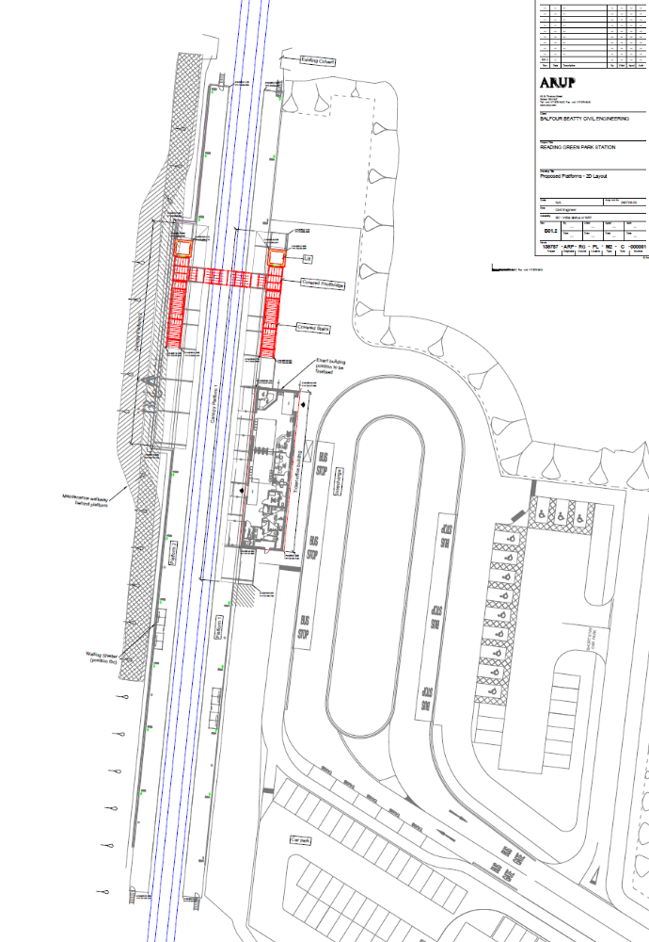
Area of Tarmac for Access and Storage
Existing Car Parking
Existing Site Offices
Station Building
Green Park Station Site Layout

