DESIGN AND ACCESS STATEMENT
UNIT-5 61 MERICK HOUSE RG2 0GX
THE PROCESS
- Assessment
- Conversion of Gym into A1 Grocery Shop
- The structure of the building will not affect development of the planning policy.

- Involvement
- This is not applicable for this development work.

- Evaluation
- There are no conflict issues with this proposed work.

- Design
- The proposed is to convert the Gym into Class E retail shop.
- The proposed work does not have any external alterations.
- There are no changes on the character of the building due to the change of use.
USE
- The proposed ground floor is use as commercial and above as residential.
- There are no changes after the development
AMOUNT
- The commercial area is doesn’t change due to the development
LAYOUT
- The proposed site accessible for the workers and the public.
- Space is safe and convenient.
- The class E use grocery shop. It’s very essential to the surrounding area.

SCALE
- The drawings prepared for this proposed site is with the scale of 1:100.

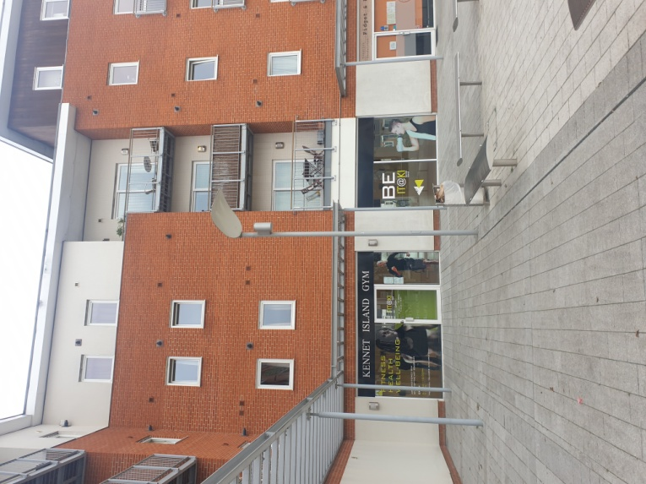
LANDSCAPING& APPEARANCE

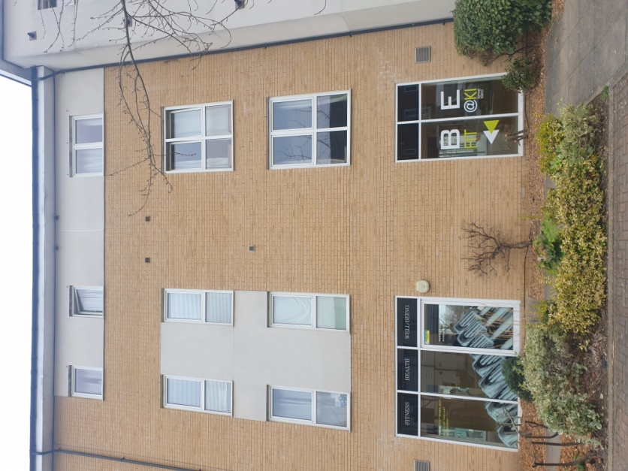

This shows the Front and rear of the store building.
ACCESS
- There is no vehicular and transport access to the proposed site.
OPENING TIME
The shop will be open Monday to Saturday 7:00 to 22:00. Sundays 08:00 to 21:00

