DELEGATED APPLICATION REPORT - Application Nos.: 201599/FUL & 201600/ADV
Address: Unit B Whiteknights Retail Park, 203-205 Shinfield Road,
Proposal:
201599: Proposed new Shopfront, Fascias and Projecting signage. New Air conditioning condensers and extract louvres.
201600: Proposal includes 3 no fascia signs and 1 no projecting sign all internally illuminated
Case officer: Alison Amoah
Target Expiry: 1st March 2021 (ext)

Site Description and Surrounding Area:
The site is the vacant former Car Phone Warehouse unit (former A1 retail use, now under Class E) within a small group of retail units on the eastern side of Shinfield Road, with a joint parking area to the front and servicing area to the rear. The unit has three main sections of shopfront, one facing north (adjacent to Specsavers) and two facing west (adjacent to Sue Ryder)

Adjacent to the rear boundary of the rear servicing yard, i.e. not immediately adjacent to the application unit itself, is a residential area (Westlands Avenue) and to the north is St. Barnabas Church and its grounds.

Whiteknights Retail Park is part of the wider Shinfield Road District Centre as defined in Policy RL1 of the Reading Borough Local Plan (RBLP).

The application site is part of the defined Key Frontage (Policy RL3) and within an Air Quality Management Area (Policy EN15).

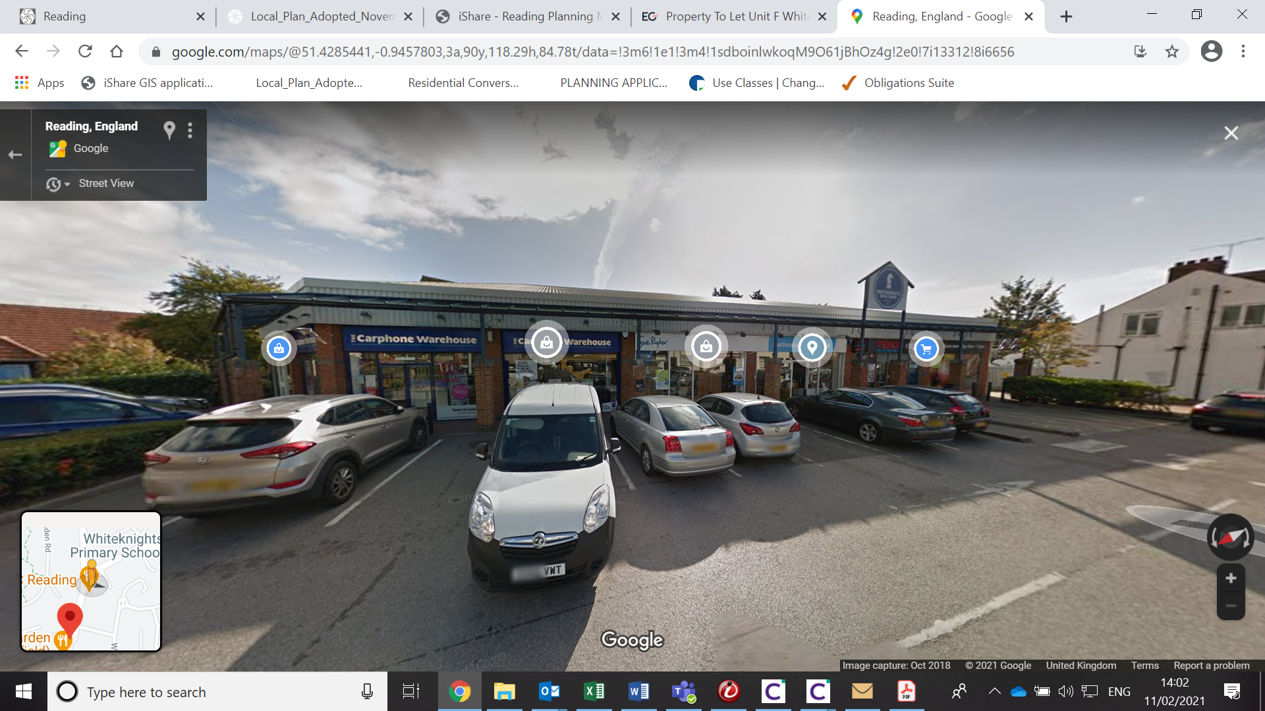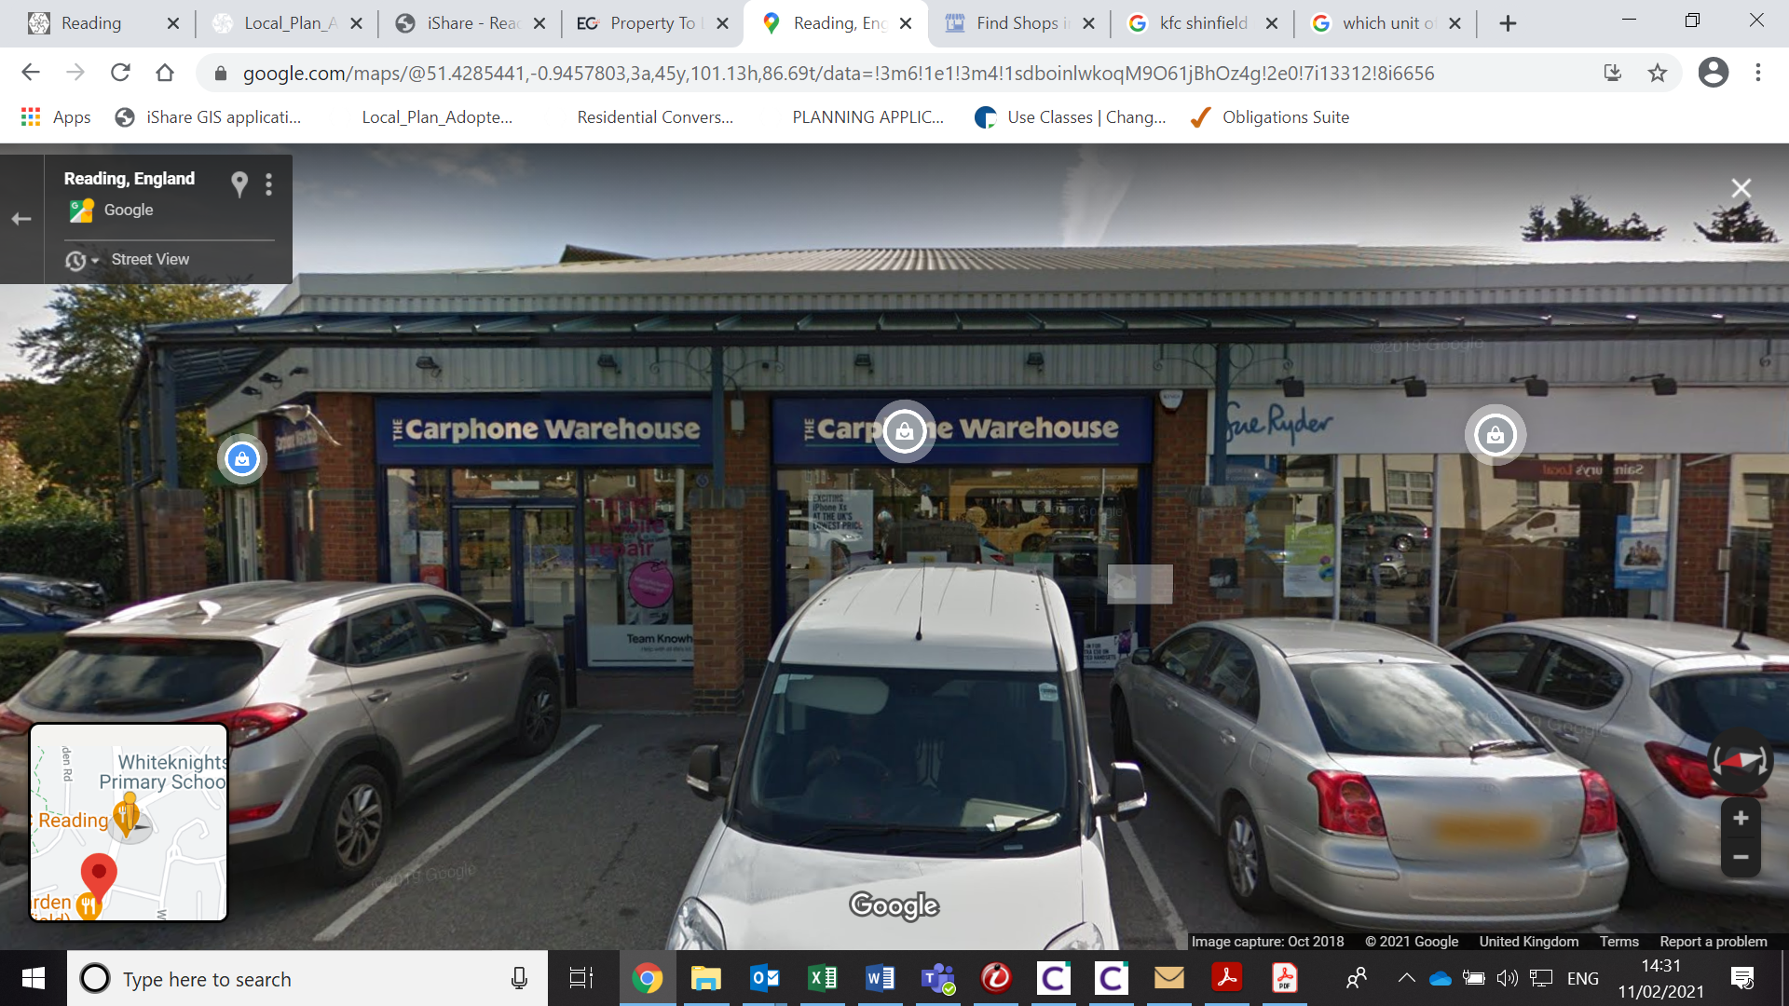

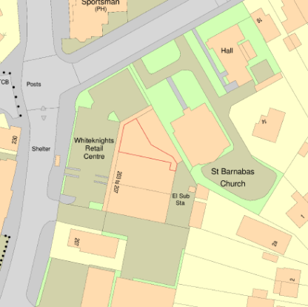
Proposal: Both applications for the site are included and assessed within this report

(201599) - Proposed new Shopfront, Fascias and Projecting signage. New Air conditioning condensers and extract louvres - Includes:

- Elevation A –
201599/FUL - Existing shopfront to be replaced with new powder coated aluminium shopfront finished grey RAL 7011 with new laminated glazing; new ceramic tiles to stall riser; relocated entrance doors.

201600/ADV – New aluminium fascia back panel finished grey RAL 7015; 2 no. internally illuminated ‘Greggs’ fascia badge box sign – 2.6m above ground to base; 0.6m high x 2.5m wide x 0.1m deep; aluminium blue; ‘Greggs’ lettering, in fret cut opal Perspex and quatro dots. Letters and dots internally illuminated to 300cd/m2; and 1 no, internally illuminated projecting sign – 2.6m above ground to base; 0.7m high x 0.7m width x 0.17m deep; aluminium grey; ‘Greggs’ lettering, in fret cut opal Perspex and quatro dots. Letters and dots internally illuminated to 300cd/m2.

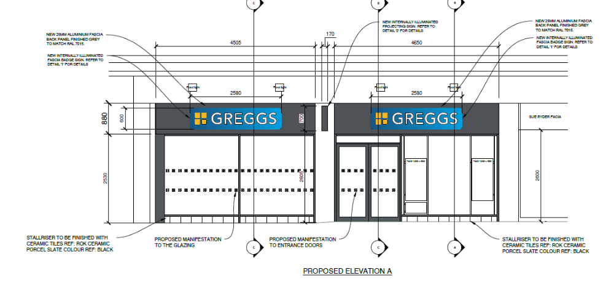

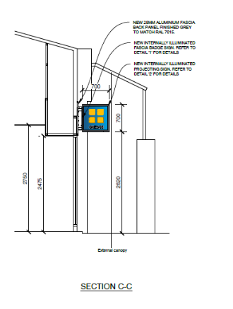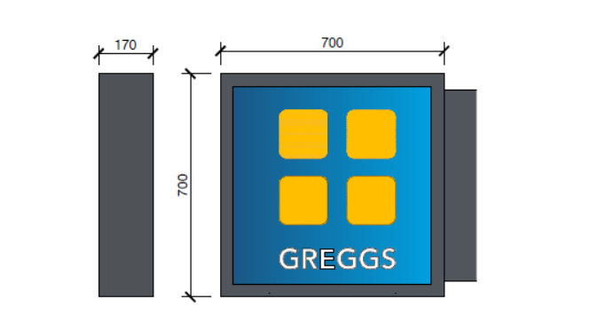

- Elevation B –

201599/FUL - Existing aluminium shopfront and glazing to be retained and spray painted with grey RAL 7011.

201600/ADV - New aluminium fascia back panel finished grey RAL 7015; 1 no. internally illuminated ‘Greggs’ fascia badge box sign – 2.6m above ground to base; 0.6m high x 2.5m wide x 0.1m deep; aluminium blue; ‘Greggs’ lettering, in fret cut opal Perspex and quatro dots. Letters and dots internally illuminated to 300cd/m2;

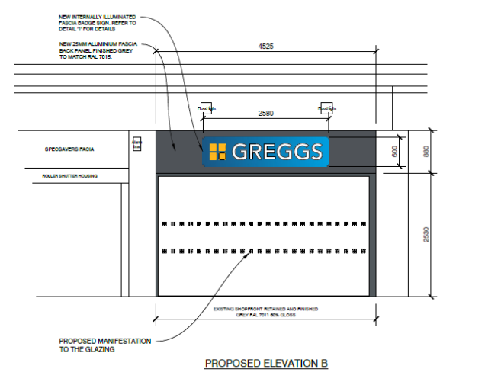

- Elevation C (to the rear facing service yard) – Two new air conditioning condensers (double and single) fixed on angled brackets, to replace existing double air condenser; new extract and toilet louvre to match the colour of the external cladding.
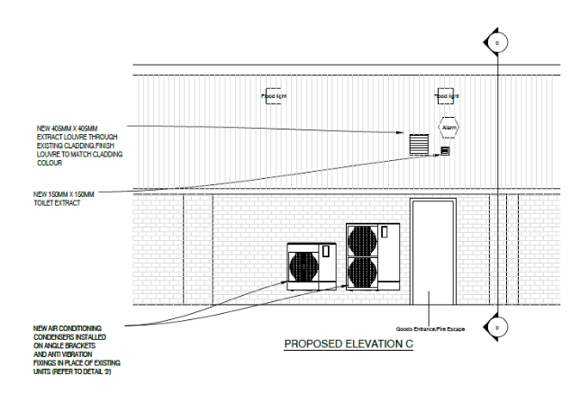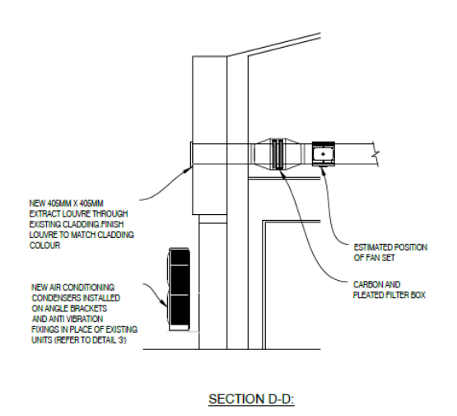

Plans and other information considered: As received 12th November 2020
- Location Plan – Drawing no:
- Existing Elevations – Drawing no: RSOE/S5623/02
- Proposed Plan & Detail – Drawing no: RSOE/S5623/02P
- Proposed External Elevations – Drawing no: RSOE/S5623/01P
- Odour Impact Assessment, dated 5/7/18, document ref: A3227/01A/002, prepared by Accon UK
- Pleated Panel Filter, datasheet, Dustop Ltd
- The Carbopleat Disposable Panel-Gas Phase Filtration – Product Datasheet, Westbury Filtermation Ltd
- PLA-ZM R32 4-Way Blow Ceiling Cassette System; Power Inverter Heat Pump (Single Phase) Air Conditioning Product Information, Mitsubishi Electric

Relevant Planning History:
Original Whiteknights Retail Park permission:
97/00611/FD – Demolition of existing buildings construction of new A1 retail units and replacement of unit at rear of the site for A1 or B8 use, parking & service areas. With new access to adj. church – Approved 18/12/1997

Units within Whiteknights Retail Park – Units A-E currently Specsavers, Former Car Phone Warehouse (application site) Sue Ryder and Tesco - Range of shopfront, signage, change of use from A1 to A3 and extraction system applications – approved.

Consultation Responses:
Unit A (Spec Savers), Unit C&D (Sue Ryder) and Unit E (Tesco), and 2a Westlands Avenue were consulted and a site notice was displayed for 21days from 17th December 2020. No comments were received.

Environmental Health (EH):
Odour - The odour assessment seems to suggest that the Greggs is already operational, is that true? If so, they already have a system in place and a ‘sniff’ test carried out as part of the assessment suggests it is working. The system has grease filters and carbon filters, which should be sufficient if cleaned and maintained properly, although the flue exits 1.8m below a flat above it which isn’t in line with guidance, this should be 1m above roof ridge height, unless there are planning reasons for this not being the case?

Planning Officer note: With respect to odour, it was confirmed with the EH officer that although the odour assessment submitted relates to other sites, it had been submitted because the system to be used at the application site would be the same as at these other sites. The EH officer confirmed that the general extraction system setup with filters and carbon filters from the generic odour assessment submitted with the application would be acceptable, but still required that addition of an extraction flue to 1m above roof ridge height in order to aim dispersion. However, the applicant subsequently confirmed, that the extraction system does not require an extraction flue. They have advised that the majority of the food served within the premises would be pre-prepared products baked off from frozen, such as frozen savouries, baguettes, croissants, pizza slices and breakfast product. These do not use cooking processes such as deep or shallow frying, grilling, griddling or any other more odorous kitchen processes. The proposed ductwork would run to the following areas: refrigeration equipment; ovens, and staff areas and the proposed use of the extract system would be: Refrigerated Equipment - Remove excess heat; Ovens - Remove excess heat and steam when the oven doors are opened. A polished stainless steel oven canopy complete with baffle filters will be fitted above the ovens connected to the extract system; and Staff areas - Provide ventilation as outlined in the building regulations.

Noise - Applications which include noise generating plant when there are nearby noise sensitive receptors should be accompanied by an acoustic assessment carried out in accordance with BS4142:2014 methodology. The rear garden boundary of the nearest residential property is 11.4m away and the back of the house is 32m away. Is a noise assessment still required in this instance?

A noise assessment has not been submitted with the application and therefore I cannot determine the likely noise impact of the proposal and whether the proposals are acceptable. I therefore recommend refusal unless a noise assessment can be submitted and considered by us before the application is determined.

Alternatively a condition could be attached to consent, however it is possible that the criteria would not be met with the plant specifications proposed in this application and a new application may need to be made at a later date for alternative plant / location.

Planning Officer note: The applicant has confirmed that there are no noise sensitive receptors within 20 m of the proposed plant and they believe the closest residential accommodation is some 30 m away. The proposal is to replace existing an air conditioning condenser unit with two new units, and the new Mitsubishi units are much quieter than the existing old Toshiba unit. There are numerous other air con condenser units in this service yard area and their view is that the installation would not add to the general level of background noise.

Transport: The site is located within the Shinfield District Centre which offers a range of shops. The site is located at the rear of the retail park and is accessed from Shinfield Road via a shared accessed. Parking is shared amongst the retail units.

There are no transport objections to the proposed new shopfront. The entrance door will be sited in a new location.

The proposed signage should be subject to the following condition: AD1 Advert Luminance

Equality Act 2010:
In determining this application the Council is required to have regard to its obligations under the Equality Act 2010. However, there is no indication or evidence (including from consultation on the application) that the protected groups identified by the Act have or will have different needs, experiences, issues and priorities in relation to this particular planning application. Therefore in terms of the key equalities protected characteristics it is considered there would be no significant adverse impacts as a result of the development.

Relevant Planning Policy and Guidance and Legal Context
Regulation 3 of the Town and Country Planning (Control of Advertisements) (England) Regulations 2007 requires the Local Planning Authority to exercise its powers under these regulations in the interests of amenity and public safety taking into account the provisions of the development plan, so far as they are material; and any other relevant factors. Regulation 3 states that factors relevant to amenity include the general characteristics of the locality, including the presence of any feature of historic, architectural, cultural, or similar interest.

Factors relevant to public safety include highway safety and whether the advert would hinder security or surveillance devices, including speed cameras.

Section 38(6) of the Planning and Compulsory Purchase Act 2004 requires that proposals be determined in accordance with the development plan unless material considerations indicate otherwise. Material considerations include relevant policies in the National Planning Policy framework (NPPF) - among them the 'presumption in favour of sustainable development'.

The following local and national planning policy and guidance is relevant to these applications:

Adopted Reading Borough Local Plan (2019):
CC7: Design and the Public Realm
CC8: Safeguarding Amenity
TR3: Access, Traffic and Highway-Related Matters
OU4: Advertisements
OU5: Shopfronts and Cash Machines
EN16: Pollution and Water Resources
EN17: Noise Generating Equipment

Appraisal:

201599/FUL
The main issues are considered to be:
- Principle
- Design and appearance
- Environmental matters – odour, noise

- Principle
The proposal is to retain the unit for retail (former A1 use) to operate as a Gregg’s bakery shop selling hot and cold food. The unit is within the Key Frontage under RBLP Policy RL3. The proposal would not involve the net loss of retail and therefore, would accord with this policy and would therefore, be acceptable in principle. It would, in any case, also be a permitted change under the new E use class.

The E use class covers a range of different development types and although it might be desirable to control future changes to this unit to ensure ongoing compliance with the requirements of Policy RL3, it is not considered that any restriction applied through condition would meet all the relevant tests. This is because, it would not be relevant to the development to be permitted, which relates to external changes only, not a change of use.

- Design and appearance
Policy CS7 is the overraching design policy, which requires all development “to be of a high design quality that maintains and enhances the character and appearance of the area..”.

Policy OU5 states that shopfronts, “……will respect the character of the building on which they are located and their surroundings, as well as the wider street, in terms of design, colours, materials, lighting, and location.”. The proposed shopfront will include minimal alterations to the existing shopfront through resisting of the doors, new colours, and window detailing. Due to the design of the group of buildings, the proposed fascia size and position would remain unaltered, and would therefore be consistent with the adjacent retail units. The frontage would remain active with no proposed security features nor opaque coverings to the windows.

The changes to the rear, facing the service yard, which include new air conditioning units and vents, would be minimal, would not have a detrimental effect on the character and appearance of the area and would be consistent with the appearance of adjacent units.

The scheme would therefore comply with Policies CS7 and OU5.

- Environmental Matters – Odour, Noise
Policy EN16 addresses pollution and EN17 specifically noise. Policy CC8 requires development to not cause detriment to residents including from noise and smell.

The submission included an Odour Assessment, and the Environmental Health Officer confirmed the general extraction system setup with filters and carbon filters would be acceptable. As the applicant confirmed that no extraction flue is required to support the proposed cooking activities then no amended plan would be required to show such.

With respect to the external air conditioning units, the EH officer requested the submission and approval of a noise assessment. However, given the specific location of the site from the nearest sensitive receptor, i.e. 10.7m from the rear boundary of no. 2 Westlands Road and 31.7m from the house itself, and in light of the fact that this would be a replacement of an existing unit with a better quality and quieter model, and the range of existing plant at the adjacent units, it is considered in this instance that a noise assessment would be unnecessary. This is because it is considered that there would be no significant detrimental effect with respect to existing background noise levels.

The proposal is considered acceptable subject to being installed in accordance with the details submitted and would comply with Policies EN16 and EN17 and CC8 of the RBLP.

201600/ADV
The main issues are considered to be:
- Amenity
- Safety
a) Amenity
The proposed signage is considered to be wholly appropriate within this retail location and replaces existing signage of a very similar nature. It is considered that the material, colour and luminance would not be harmful to the wider area, and would not have significant detrimental effects on visual amenity. The overall area which would be illuminated would be limited to the letters and the ‘dots’ of the Greggs logo, and a condition is included which restricts the level of lux to max of 300 cd/m2.

On the above basis, the proposed sign is considered to comply with Adopted Reading Borough Local Plan Policies CC7, CC8, TR3 and OU4.

b) Safety
The NPPG (in particular in this instance Paragraph: 068 Reference ID: 18b-068-20140306 & Paragraph: 078 Reference ID: 18b-078-20140306) provides guidance as to the considerations affecting public safety. The proposed hanging sign would overhang the pedestrian walkway, but would be at 2.6m to underside, therefore, not posing any hazard to pedestrians. The signage would be set well back from Shinfield Road and would have very limited illumination, which would not distract drivers so as to have an effect on safety. It would not obscure any existing road signs, or sight lines of CCTV cameras. Therefore, it is concluded that there would be no detrimental effect with regard to highway safety and the signage is therefore, considered to accord with Adopted Reading Borough Local Plan Policies TR3 and OU4.

RECOMMENDATIONS:
GRANT

201599/FUL
Proposed conditions:
- TL1 – Time 3 years
- Approved plans
- Odour control measures to be in accordance with the recommendations in the Odour Assessment.

Informatives:
T&Cs
Positive and proactive

201600/ADV
Proposed conditions:
- Standard advert conditions
- Approved plans
- Maximum luminance should not exceed 300 cd/m2.

Informatives:
T&Cs
Positive and proactive

