DELEGATED APPLICATION REPORT

App Ref: 211140 / LBC
Address: 28 Eldon Road, Reading
Proposal: Construction of new wall to garden - adjacent to parking area
Case Officer: Beatrice Malama
Date Received: 04/08/2021 Agreed Determination Date: 21/10/2021

Site Description

The application site is a three storey Grade II listed semi-detached building located within Eldon Square Conservation Area (ESCA). The property which is located west of Eldon road was constructed pre 1840. Characteristic in the street are properties of similar design, style and age. Many properties in the street are finished in bath stone ashlar with hipped slate roofs.

Proposal

Application is sought for listed building consent to construct a 1.8m wall and a gate across the rear garden advancement to existing car parking area. The proposed wall would be constructed of block with a rendered finish and would have double timber gates. The colour of the boundary wall would match that of the main building and the neighbouring properties. The proposed wall would be capped with a sawn stone coping to integrate with the stone of the dwelling on the application site.

Photo 1: Existing Rear Elevation
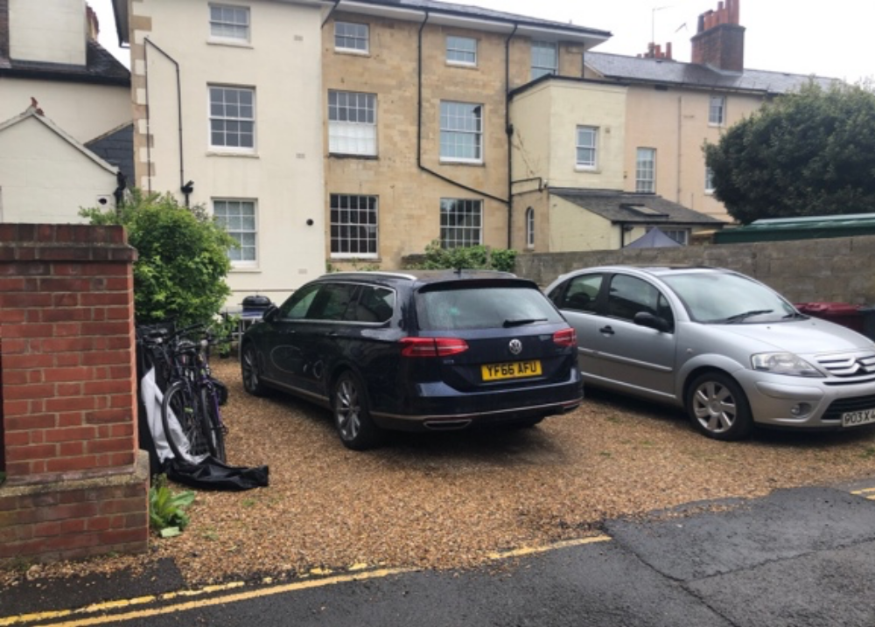

Photo 2 & 3: Style images - render detail around stone relief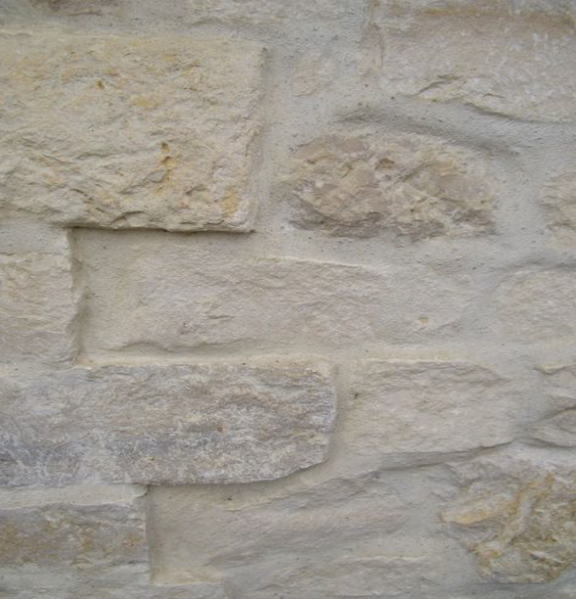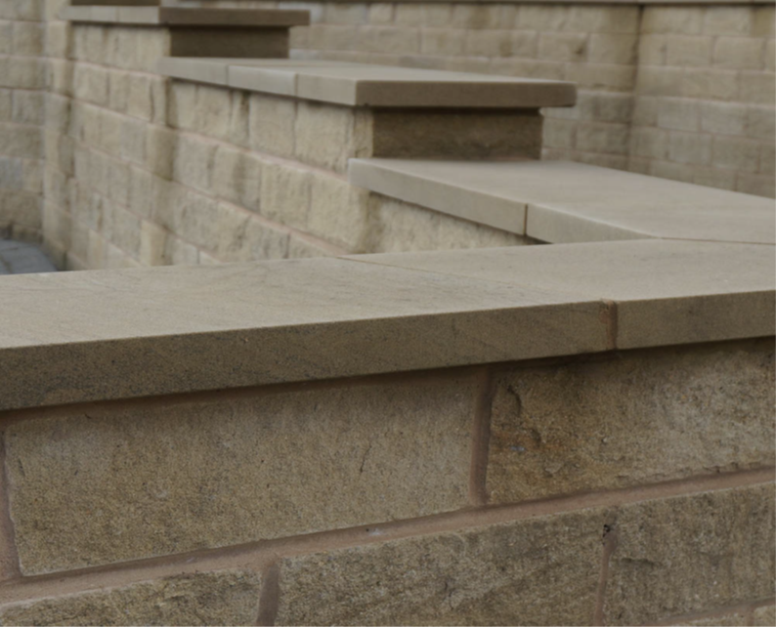

No other external changes are proposed to the building itself as part of this application.

Plans/Documents considered:

Location Plan- unnumbered
Drawing No: T 1129_15 – Plans and Elevations with materials detail
Drawing No: 1129_02.03 – Design layout with details
Design and Access Statement
Received on 8th July 2021

Heritage Statement
Received 2nd August 2021

Relevant Planning History

172122/PRE-APP - Pre-application advice for proposed lower ground floor extension, installation of en suite bathroom, addition of patio area, removal of 2 trees, replacement of front garden railings and partial surfacing of front garden.

180603/LBC - Replacement of railings and gate to the front of the property with wrought iron railings and gate, similar in design to those at the neighbouring property 30 Eldon Road, with the railing being fixed to the existing plinths using the holes left by the original railings – Permitted- 29/06/2019

CONSULTATIONS

Internal Consultees

Conservation and Heritage Officer – No comments received at the time of writing this report.

Reading Conservation Area Advisory Committee (RCAAC) – No comments received at the time of reporting.

Transport Development Control – No Objections to this application

External Consultation

Confirmation that the site notice was displayed on 11th August 2021 was received and neighbours at the following addresses were consulted by letter.
Flat 3, 28 Eldon Road, Reading, RG1 4DL
Flat 2, 28 Eldon Road, Reading, RG1 4DL
Flat 1, 28 Eldon Road, Reading, RG1 4DL
30 Eldon Road, Reading, RG1 4DL,
Maisonette, 30 Eldon Road, Reading, RG1 4DL
26 Eldon Road, Reading, RG1 4DL
26 Eldon Place, Reading, RG1 4ED
24 Eldon Place, Reading, RG1 4ED
No responses have been received.

Equality Act 2010:

In determining this application, the Council is required to have regard to its obligations under the Equality Act 2010. However, there is no indication or evidence (including from consultation on the application) that the protected groups identified by the Act have or will have different needs, experiences, issues and priorities in relation to this particular planning application. Therefore, in terms of the key equalities protected characteristics it is considered there would be no significant adverse impacts as a result of the development.

Legal and Planning Policy

Section 38(6) of the Planning and Compulsory Purchase Act 2004 requires that proposals be determined in accordance with the development plan unless material considerations indicate otherwise. Material considerations include relevant policies in the National Planning Policy framework (NPPF) - among them the 'presumption in favour of sustainable development'.

Section 66 of the Planning (Listed Buildings and Conservation Areas) Act 1990 requires the local planning authority to have special regard to the desirability of preserving a listed building or its setting or any features of special interest which it possesses.

Section 72(1) of the Planning (Listed Buildings and Conservation Areas) Act 1990 requires the Local Planning Authority in the exercise of its functions to pay special attention to the desirability of preserving or enhancing the character or appearance of a conservation area.

The following local and national planning policies and guidance are relevant to this application:

National Policy
National Planning Policy Framework (2021)
National Planning Practice Guidance

Reading Borough Local Plan 2019

CC7: Design and the Public Realm
CC8: Safeguarding Amenity
EN1: Protection and Enhancement of the Historic Environment

Appraisal

Heritage

Policy CC7 (Design and the Public Realm) requires that all developments be of high design quality:
Policy N1: Protection and Enhancement of the Historic Environment
The proposed works are limited to the rear garden wall across the rear garden adjacent to the parking area. The proposal would include piers to both the proposed and existing southern side boundary wall fencing. The proposed rear garden wall would be of clock rendered in a colour that matches the main building and would have stone capping and wooden gates in order retain character of the listed building and the wider area.
No other part of the building would be affected and thus no harm to the external appearance of the building itself and the surrounding properties would be expected. In addition, due to its location and proposed exterior materials that are in keeping with the character of the host property and that of the adjoining neighbours, the proposed garden wall would not be considered visually dominant nor would it cause an overbearing effect on the host property and that of the neighbours.
In light of the above, it is considered that the proposed works would not have detrimental impact on the setting or character of the listed building and conservation area within which it is located, and the proposal therefore complies with the requirements of Section 66 and 72 of the Town and Country (Listed Buildings and Conservation Areas) Act 1990 and the statutory duties of the Council in this regard have been discharged.
Impact on neighbouring properties
CC8 (Safeguarding Amenity) seeks to prevent development causing detrimental impact on the neighbouring properties.
The proposed rear garden wall would be located adjacent to the car parking area and would be parallel to a public road. The wall would be approximately 1.8m high. Due to the location and height of the proposed wall, the proposal would not be considered likely to have a detrimental impact on the living conditions of neighbouring occupants in terms of loss of sunlight, daylight or overshadowing neighbouring properties. The proposed wall therefore complies with Policy CC8.

CONCLUSION
The proposed works to the listed property which would involve construction of a garden wall with wooden double gate have been assessed and found to be acceptable as they comply with the identified policy and guidelines and therefore Listed Building Consent can be granted.

RECOMMENDATION
Grant Listed Building Consent
CONDITIONS
- Time Limit (Standard) TL1
- Listed Building (Works Specifications)
- Listed Building Materials (To Match)

INFORMATIVES
IF5: Terms
IF6: Building Control
IF7: Complaints about construction
IF8: Encroachment

