DELEGATED APPLICATION REPORT Target Date: 20/04/2021 (extended)
Application No: 201352/ADV
Address: Unit 6 Trade City Sentinel End, Reading
Ward: Whitley
Case Officer: James Schofield
Proposal: 7No fabricated dibond panels - non illuminated, 3No flex face box signs - internally illuminated, 1No free standing totem - non illuminated.
SITE DECSRIPTION AND CONTEXT
The development site relates to a commercial unit in recently built employment area off Basingstoke Road.
PROPOSALS
The application seeks advertisement consent as described above and see the application form for more details.
7No fabricated dibond panels - non illuminated
3No flex face box signs - internally illuminated
1No free standing totem - non illuminated – Height 4.8 metres high
The colour of text and background will be blue background, white text or orange background. white text

The box signs that will be illuminated will be Internally Illuminated to levels 240 cd/m2 with a static source.

Extract from plan
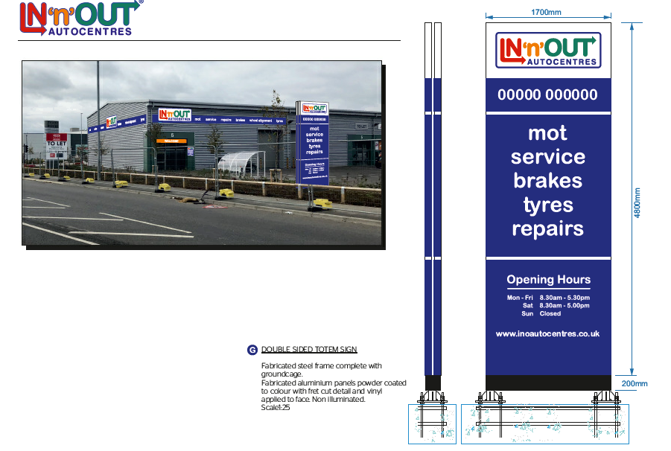

Plans considered;
Location plan and Drawing No: 14995, A & B received on 29 September 2020
Application Form
CONSULTEES
Neighbour consultations are not required for advertisement consent.
Transport
No objections subject to a condition restricting level of illumination to 600 cd/m2.
RELEVANT PLANNING HISTORY
None relevant.

LEGAL AND PLANNING POLICY CONTEXT

In determining this application, the Council is required to have regard to its obligations under the Equality Act 2010. However, there is no indication or evidence (including from consultation on the application) that the protected groups identified by the Act have or will have different needs, experiences, issues and priorities in relation to this particular planning application. Therefore, in terms of the key equalities protected characteristics it is considered there would be no significant adverse impacts as a result of the development.

Section 38(6) of the Planning and Compulsory Purchase Act 2004 requires that proposals be determined in accordance with the development plan unless material considerations indicate otherwise. The Development Plan for Reading relevant to the application site comprises the Reading Borough Local Plan (2019).

Accordingly, the ‘NPPF’ and the following development plan policies and supplementary planning guidance are relevant. Regulation 3 of the Town and Country Planning (Control of Advertisements) (England) Regulations 2007 requires the Local Planning Authority to exercise its powers under these regulations in the interests of amenity and public safety taking into account the provisions of the development plan, so far as they are material; and any other relevant factors. Regulation 3 states that factors relevant to amenity include the general characteristics of the locality, including the presence of any feature of historic, architectural, cultural, or similar interest. Factors relevant to public safety include highway safety and whether the advert would hinder security or surveillance devices, including speed cameras.

National Planning Policy
National Planning Policy Framework (2019)
National Planning Practice Guidance

Reading Borough Local Plan (adopted 2019):
CC7: Design and the Public Realm
TR3: Access, Traffic and Highway-Related Matters
OU4: Advertisements

APPRAISAL

Principle of development

The application seeks permission to install advertisements on this recently built commercial structure. Such works are supported in principle by policies of the Reading Borough Local Plan (2019) subject to a number of criteria ensuring the effects of the development are not harmful. This will be considered in more detail in the following sections.

Amenity

Policy CC7 of the Reading Borough Local Plan (2019) requires development to be of a high design quality that maintains and enhances the character and appearance of the area in Reading in which it is located.
The appearance of the proposed advertisements are considered to be in keeping with the established modern and commercial character of the building. No harm is considered likely to result as a consequence of the proposal to the site or nearby properties subject to a condition limiting the level of illumination is included. The Council’s Transportation Officer recommended 600/cd m2 as a limit for this area which could be described as being Zone E3, as cited by guidance note 4.7.29, of the Professional Lighting Guide 05: The Brightness of Illuminated Advertisements (Institute of Light Professionals, 2015). The applicant is proposing much less than this at 240/cd m2 so it is recommended in this case that a maximum level of illumination of 300 cd/m² is set. The proposal is considered to comply with Policies CC7 and OU4 of the Local Plan 2019 provided such a condition is included.

Public Safety

No works considered by this application could cause a physical obstruction to the public using a public highway, as the road has been pedestrianised. The proposal is deemed rather unlikely to serve as a meaningful distraction to users of public highways. The proposal is acceptable in terms of Policy TR3 of the Reading Borough Local Plan (2019).

9. CONCLUSION
In light of the above assessment the proposal is considered to accord with the requirements of the development plan and is therefore recommended for approval subject to conditions.

10. RECOMMENDATION
GRANT subject to conditions:
- A1 Standard Advert Condition
- Standard Advert Time Limit
- AD2 Approved Plans
- AD1 Advert luminance controls to 300cd/m2

