Delegated Report

Ward: Battle
App No.: 191987 VAR
Address: "Plot between Plot 4 and 8", 6 Norfolk Road, Reading
Proposal: Demolition of an existing store and construction of a new 3 bedroom dwelling but with a variation to condition 2 of 171407/FUL dated 02/07/18 to allow a 3m deep extension, internal alterations and the provision of a roof light
Applicant: Akshar Corporation Ltd
Target decision date: 29 April 2020 – Extended to: 14 August 2020
26 week date: 2 September 2020

1. INTRODUCTION

  - The application site as shown on the land registry plan below forms part of 8 Norfolk Road on a residential street, with a small store at the rear side. From the numbering, the site appears to constitute plot 6. Historical maps show the site as being part of 8 Norfolk Road.

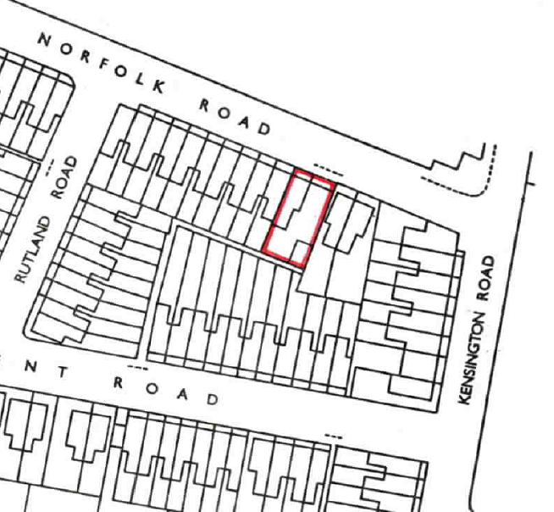
Location plan (not to scale)
  - The street is characterised by Victorian terraced dwellings and the adjoining houses at 4 and 8 Norfolk Road are not listed or in a conservation area

  - The site with vehicular access from Norfolk Road is currently being used for parking by existing number 8 Norfolk Road. However, the site is not allocated for parking and Council records show that number 8 has parking permits within this Controlled Parking Zone area.

- PLANNING HISTORY
  - Planning permission was granted for application 171407 for the development as described above by the Planning Application Committee on 11 October 2017. The decision was subject to a legal agreement being completed to secure an affordable housing contribution and a contribution towards creating a traffic order. That was completed and permission granted on 2 July 2018.

3. PROPOSAL
3.1 The current variation proposal seeks to change the approved plans to allow a single storey rear 3m deep x 1 metre wide rear extension with a flat roof in the gap adjacent to no.8. See comparison plans below.

The proposed changes are:
To infill side gap at ground floor with flat roofed single storey extension 3 metres deep as shown below.
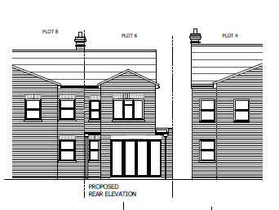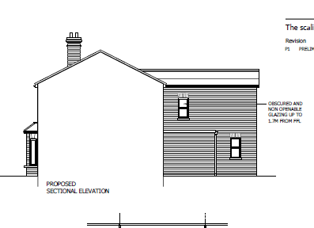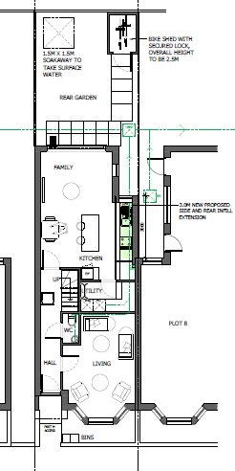
As approved by 171407
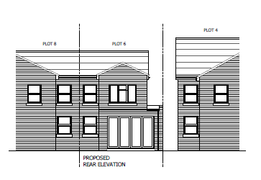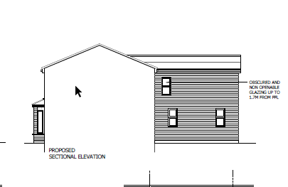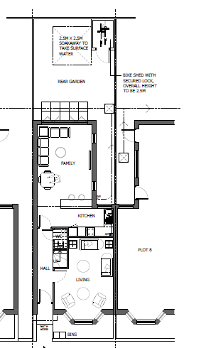

4. CONSULTATIONS
(i) Statutory
None.

(ii) Non-Statutory
No objections

As the original application was determined by Planning Applications committee (PAC) the Chair of PAC and ward councillors have been advised in accordance with delegation protocol about the application and no comments have been received or requests to call in the application for the decision to be taken by councillors.

(iii) Public Consultation

Neighbours as before have been consulted with one observation submitted regarding concerns not related to the proposed change.
5. RELEVANT PLANNING POLICY AND GUIDANCE

5.1 Section 38(6) of the Planning and Compulsory Purchase Act 2004 requires that proposals be determined in accordance with the development plan unless material considerations indicate otherwise. Material considerations include relevant policies in the National Planning Policy framework (NPPF) - among them the 'presumption in favour of sustainable development'.

Reading Borough Local Plan (2019)
Policy CC1 – Presumption in Favour of Sustainable Development
Policy CC2 – Sustainable Design and Construction
Policy CC3 – Adaption to Climate Change
Policy CC5 – Waste Minimisation and Storage
Policy CC6 – Accessibility and the Intensity of Development
Policy CC7 – Design and the Public Realm
Policy CC8 – Safeguarding Amenity
Policy CC9 – Securing Infrastructure
Policy EN16 - Pollution and Water Resources
Policy H1 - Provision of Housing
Policy H2 – Density and Mix
Policy H3 – Affordable Housing
Policy H5 – Standards for New Housing
Policy H10 - Private and Communal Outdoor Space
Policy TR3 – Access, Traffic and Highway-Related Matters
Policy TR5 – Car and Cycle Parking and Electric Vehicle Charging
Supplementary Planning Guidance/Documents
Revised Parking Standards and Design (2011)
Sustainable Design and Construction (2019)
Planning Obligations Under S106 (April 2015)
Affordable Housing (2013)

Other relevant documentation
DCLG Technical housing standards – nationally described space standard (2015)
6. APPRAISAL

- Principle of Development
6.1 The principle of the proposed development has already been established by the granting of the earlier planning permission. There is a new Local Plan but the relevant policies have broadly been rolled forward and the proposal as varied remains acceptable in principle. The only matter for consideration here is whether the extension to the new building is also acceptable and if there are any new policies to consider.

(ii) Design and appearance
6.2 The proposed 3metre deep extension is no greater in size than what might have been built as permitted development once the new dwelling had been completed under the earlier permission. Its appearance is acceptable in this regard. The proposed dwelling would therefore still comply with Policy CC7.

6.3 However, there are concerns due to relatively small site that is permitted development rights to extend or to build upwards were used the resulting building would appear as an overdevelopment of the site. Therefore it is recommended that PD rights to extend further are removed. The agent has been advised of this concern and has agreed that such a condition would be reasonable.

(iii) Residential amenity
6.4 Policy CC8 seeks to safeguard the amenities of neighbouring properties. The proposed additional part of the dwelling would extend into the gap with no.8 but no further than what could be built as permitted development and the flat roof minimises the visual impact. The rear of these properties face south so a good level of light should still reach the side facing ground floor windows of no.8. The conclusion is that the additional development will not significantly harm the amenities of these neighbours. The removal of PD rights to extend as mentioned above also provides a safeguard to neighbouring residents’ amenity in accordance with Policy CC8.

(vii)Other Considerations
The Community Infrastructure Levy
6.5 The proposal would be liable to pay the levy based on the additional 3m2 floor space created.

S106 Legal Agreement
6.6 The proposed development would need to accord with policy H3 in terms of making a financial contribution to affordable housing that will enable the provision of affordable housing elsewhere in the Borough. It will also need to contribute £5k to fund the necessary changes to the Controlled Parking Zone. A legal agreement was entered into with the previous planning permission and clause 15 of that agreement confirms that Variations to that permission will be bound by that agreement.

Equality Act 2010
6.7 In determining this application the Council is required to have regard to its obligations under the Equality Act 2010. However, there is no indication or evidence (including from consultation on the application) that the protected groups identified by the Act have or will have different needs, experiences, issues and priorities in relation to this particular planning application. Therefore in terms of the key equalities protected characteristics it is considered there would be no significant adverse impacts as a result of the development.

CONCLUSION
7. GRANT
Previous conditions plus one for policy H5 & PD rights to extend removes and the time period for implementation adjusted to be 3 years from 2 July 2018.

