DELEGATED APPLICATION REPORT

App Ref: 211275 / LBC
Address: 17 Castle Street, Reading, RG1 7SB
Proposal: Deconstruction of damaged boundary wall (amended description)
Case Officer: Beatrice Malama
Date Received: 04/08/2021 Determination Date: 29/09/2021

Site Description

The application site is a three storey Grade II listed building located on the southern side of Castle Street and it is within a conservation area. The boundary wall fence to the rear is not listed in its own right however as it is attached to a listed building it is considered to be curtilage listed.

Proposal

This proposal is for listed building consent involving the deconstruction to a safe height of part of the existing rear boundary wall fence located between 15 and 17 Castle Street. The wall varies in height along its length between 2m and 2.7m with the middle section being the shortest with a height of 1.3m as shown in figure 1.

Figure 1: Existing boundary wall fencing
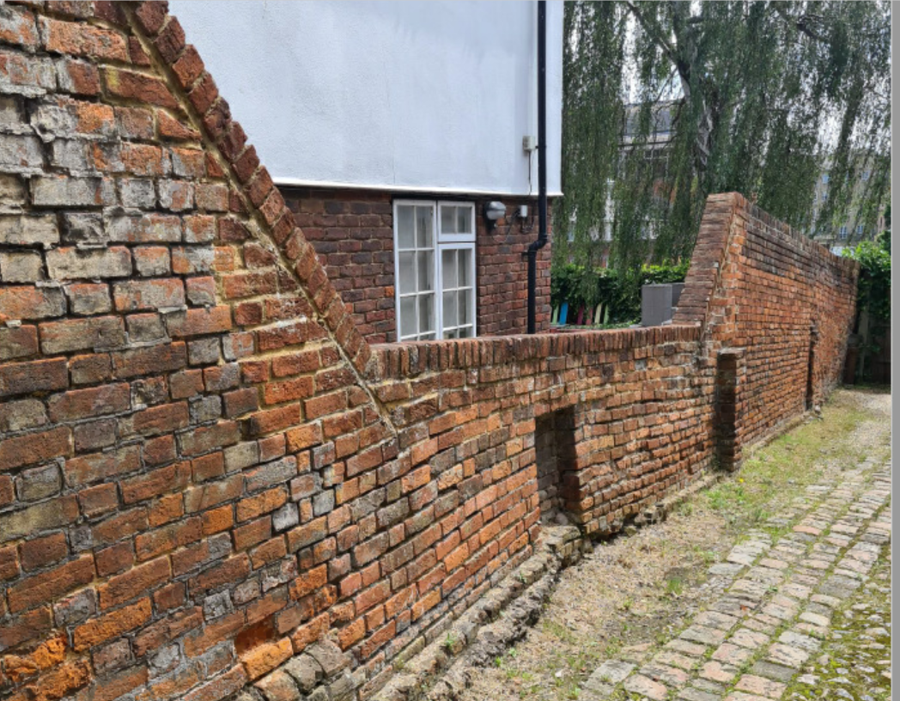

Part of the existing boundary wall fence is said to have structural defects. The worst affected part of the wall has visible cracks and is said to be leaning over to one side. This part of the wall is considered unstable and a risk to the public and hence the proposal to reduce the height of the affected wall to a safer point.

Figure 2 & 3: Parts of the affected wall with visible cracks
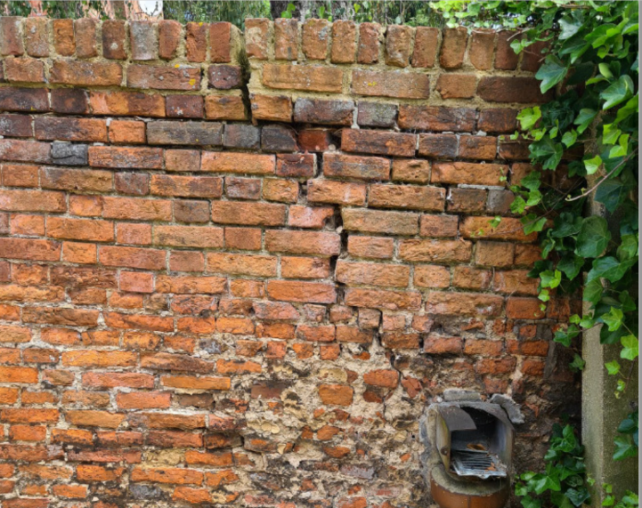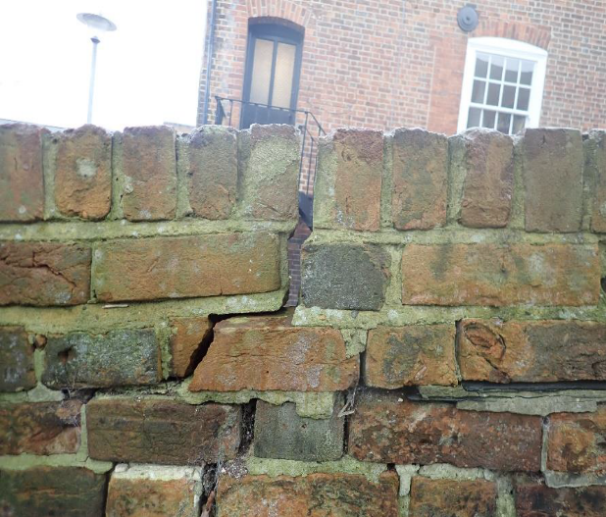

The proposal is to reduce the affected part of the wall which is 10m long by 1.1m as illustrated in Figure 4 (highlighted in yellow).

Figure 4: Part of the wall to be brought down
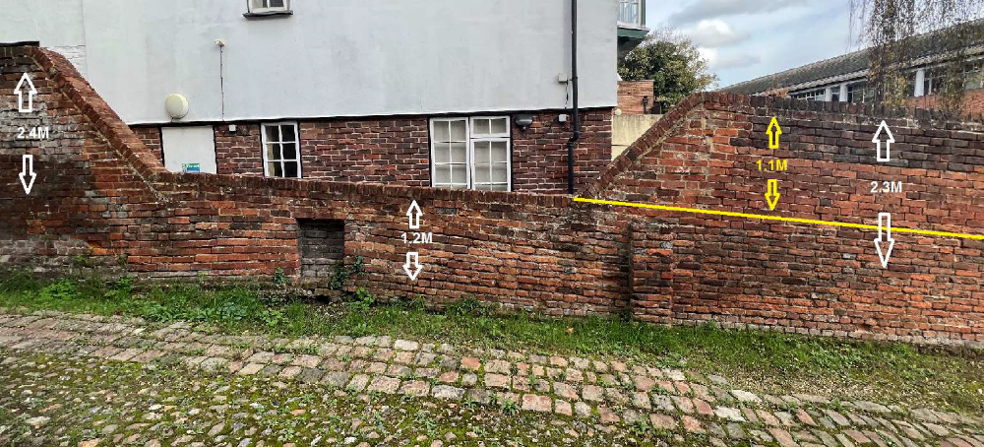

The proposal does not include reconstruction at this stage however it is stated in the proposal that the wall would be reconstructed in 2022 back to its original state as before it was deconstructed using bricks that would be salvaged during deconstruction and source additional ones to cover any missing bricks. It is proposed that reconstruction of the wall would take place between March and October 2022 which is lime mortar season.

No other external changes are proposed to the building itself as part of this application.

Plans considered:

Drawing No: TQRQM21214110258617 - Location Plan
Drawing No: TQRQM21214110121696 - Site Plan
Received 4th August 2021

Design and Access Statement
Structural Inspection dated 18th March 2021
Received 4th August 2021

Method Statement
Structural Inspection Report Ref: 216061
Received 4th November 2021

Heritage Statement Ref: 0673
Received 1st December 2021

Relevant Planning History

121430/PRE-APP - Pre-Application enquiry for works relating to fire risk assessment, works of repair to timber frame and other routine maintenance works

121658/LBC - Essential fire assessment works; escape stairs repairs/and or replacement; repairs to guttering, some window sills and flashings; other associated minor repairs; installing Emergency lighting system and works to timber beams in basement.

161841/LBC - New cabling to be installed for phone system. Cables to exit and re-enter the building at a number of points throughout the building although mainly restricted to newer (Nineteenth century) extension. Granted

190569/LBC - Install a ground floor disabled toilet to meet DDA, with a pull down
baby changing bench on the wall to make the toilet practical. Also, the addition of a small tea point, to serve two new accessible meeting rooms and reception, in the hallway next to the toilet. Granted

CONSULTATIONS

Internal Consultees

Conservation and Urban Design Officer – No objections to this application.
The Conservation and Urban Design Officer was consulted and he confirmed visiting the site twice and stated that the works are necessary due to safety concerns.

Additional information was requested and the applicant submitted the following documents:

- Method Statement
- Structural Inspection Report Ref: 216061
Received 4th November 2021

- Heritage Statement Ref: 0673
Received 1st December 2021

Reading Conservation Area Advisory Committee (RCAAC) – No comments received

External Consultation

A site notice was sent to the applicant on 31st August 2021and neighbours at the following addresses were consulted by letter.
19 Castle Street, Reading, RG1 7SB
15 Castle Street, Reading, RG1 7SB

No responses have been received.

Equality Act 2010:

In determining this application, the Council is required to have regard to its obligations under the Equality Act 2010. However, there is no indication or evidence (including from consultation on the application) that the protected groups identified by the Act have or will have different needs, experiences, issues and priorities in relation to this particular planning application. Therefore, in terms of the key equalities protected characteristics it is considered there would be no significant adverse impacts as a result of the development.

Legal and Planning Policy

Section 38(6) of the Planning and Compulsory Purchase Act 2004 requires that proposals be determined in accordance with the development plan unless material considerations indicate otherwise. Material considerations include relevant policies in the National Planning Policy framework (NPPF) - among them the 'presumption in favour of sustainable development'.

Section 16(2) of the Planning (Listed Buildings and Conservation Areas) Act 1990 requires the local planning authority to have special regard to the desirability of preserving a listed building or its setting or any features of special interest which it possesses.

Section 72(1) of the Planning (Listed Buildings and Conservation Areas) Act 1990 requires the Local Planning Authority in the exercise of its functions to pay special attention to the desirability of preserving or enhancing the character or appearance of a conservation area.

The following local and national planning policies and guidance are relevant to this application:

National Policy
National Planning Policy Framework (2021)
National Planning Practice Guidance

Reading Borough Local Plan 2019

CC7: Design and the Public Realm
CC8: Safeguarding Amenity
EN1: Protection and Enhancement of the Historic Environment

Appraisal

The application site is a redbrick boundary wall fence attached to a listed building and thus it is considered to be curtilage listed. A section of the existing wall measuring 10m long is said to have some structural defects including cracks and the wall leans to one side making it unsafe to the public.

The proposed works would only involve bringing down affected parts of the existing wall to a safe level recommended by the engineers. The affected part of the wall is 10m long and would be reduced in height by 1.1m. No other part of the listed building would be affected.
As the proposal involves only part of the boundary wall and no other part of the listed building would be affected, the works are not considered likely to have a detrimental impact on the setting of the listed building itself.
Whilst the proposed works to a listed boundary wall would be noticeable in terms of its height, the impact on the surrounding area is not considered detrimental. In addition, the benefits of reducing the height of the wall to a safe level at this stage outweigh any perceived harm to the wall and the character and appearance of the surrounding area.
The proposed works have been assessed by the case officer and the Conservation and Urban Design Officer and it is considered necessary that the affected wall be brought down to a safe height for the safety of the general public. As such it is considered that the proposed works are not in conflict with the relevant planning policies and guidance.

Proposed Reconstruction of the Wall
The applicant proposes to reconstruct the wall back to the state it was before it was deconstructed by using salvaged bricks. Construction works are proposed to take place between March and October 2022. The applicant is advised to make a separate planning application before any construction work commences.
Conclusion
The proposed works to the listed wall fence has been assessed and found to be acceptable as they comply with the identified policy and guidelines and therefore Listed Building Consent can be granted.

Recommendation
Grant Listed Building Consent

