ARTIFICIAL TURF CARPET & MAINTENANCE

AFTER CARE & MAINTENANCE NOTES FOR ARTIFICIAL GRASS SURFACES

IMPORTANT NOTICE
It is the responsibility of the Owners of the pitch to read and adhere to the Maintenance guidelines stated below. Failure to do so may affect the pitch warranty.
The pitch needs to be maintained on a regular basis for it to provide the best possible playing characteristics. The pitch will respond favourably provided it receives adequate maintenance.
There are some perceptions that artificial sports surfaces are maintenance-free, as opposed to natural turf pitches, which require intensive maintenance. The reality is that artificial pitches require less maintenance than natural surfaces.
This guide outlines the essential elements of maintaining the facility in good condition. A crucial tip for maintaining the pitch surface is to do a little often, rather than neglecting maintenance procedures for months and then facing large expenses attempting to restore the pitch to its optimum performance capabilities. Neglecting to maintain the pitch will affect its warranty, performance and test results.

EARLY MONTHS OF SETTLEMENT
It can take between 2-3 months for the playing surface to reach its optimum playing performance. The reason for this is to allow the infill materials to fully penetrate and settle into the turf structure.
During the installation, it is our responsibility to ensure an even distribution of infill materials over the entire pitch. Those made responsible for regular maintenance are advised that light grooming on a regular basis during this settlement period will aid the pitch in reaching its optimum performance. Heavy brushing must be avoided.

RECOMMENDED MAINTENANCE EQUIPMENT
When selecting the correct tools to maintain the pitch it is advised to purchase machines that are specifically designed for the task. It can be tempting to resort to a makeshift measure e.g. rigging something to an old tractor and dragging it around the pitch. However, using the wrong tools for the job will shorten the life of the pitch, damage seams and line markings, and may invalidate the pitch warranty.

The basic, regular maintenance tools are a triangular brush. This equipment is towed behind a lightweight vehicle, whose weight must not exceed 1 metric ton. The towing units must be fitted with wide, low ground pressure tyres. Vehicles such as a quad bike, mini tractor or ride-on mower (with grass cutting unit removed), are suitable. It is advised to ensure that the vehicle is clean before use on the pitch.

For a pitch located in an area with the problem of large amounts of debris such as leaves and pine needles, a mechanical brushing and collection system should be considered. The unit should be fitted with a medium bristle brush and set to lightly brush the pile only.
If the person responsible for maintenance either possesses a maintenance machine already or intends to purchase a machine that has not been recommended above, S&C Slatter must be consulted prior to use on the surface to ensure that it is appropriate.

BRUSHING THE PITCH
It is important to understand the turf structure is a medium dense pile and is designed to hold the infill materials in place. The structure is also designed to discourage the infill materials from compacting. Some infill may appear on the pile surface from time to time, but this only requires light brushing to restore it to the turf structure.
Brushing must take place on a regular basis. S&C Slatter recommends the brushing takes place at least once a week. The surface should be brushed in several directions alternating the direction in consecutive activities. Ensure that anyone operating the maintenance equipment has received full training.

CHECKING INFILL LEVELS
Following the initial settling in period sand infill levels will remain constant over most of the pitch area with regular brushing. However, areas of high usage such as penalty spots and football spots should be checked regularly. In these area infill may be dislodged and need replacing. Only use specified infill by S&C Slatter.

DEBRIS
Debris should be removed from the surface on a regular basis, i.e. once or twice a week. This is best accomplished by hand until the pitch has settled down.

DRAINAGE
Manhole / catchment pits and drainage pipes must be cleared out on a monthly basis.

MAINTENANCE OF PITCH SURROUNDS
The surrounds to the pitch must always be kept clean as debris on the perimeter of the pitch can be transferred on to the surface. No weeds, moss or algae should be present on the surrounds, and the base of the perimeter fence should always be free of all vegetation and debris.
In the autumn leaves and pine needles will fall onto the pitch. To prevent this organic matter from penetrating the turf structure this debris needs to be swept out of the surface. Failure to remove windblown debris will cause a failure in the pitch drainage, encourage growth of weeds and moss and present health and safety issues. If trees overhang the pitch surface, it is advised to have a programme of tree pruning. This will limit the amount of leaves and sap dropping on the surface.
Ensure that surrounding paths and gateways are clean. This will prevent dirt from being walked onto the pitch.

It is advised to have the following at all pitch entrances:
- A walk on, walk off mat
- A dirt lock with grids
- Footwear brushes
- A ban on players going on the pitch with muddy shoes.

VEGETATION ON THE PITCH
Moss / weed killing should take place two or three times a year to ensure that the pitch does not accumulate vegetation on the surface. The moss / weed killer agent must be a water-based systemic weed killer. Please also ensure that when the moss / weeds have died off, dead matter, including roots, is removed or in the case of moss swept out of the turf structure.

STAIN REMOVAL
Most stains can be removed quickly using hot tap water containing a solution of household detergent such as washing up liquid. Heavy oil marks can be removed using mineral spirits and a cloth.

VEHICLES ON THE SURFACE
No vehicles with narrow wheels or tyres should run over the surface. At all times, vehicles should be light and should not form grooves in the surface or over compaction of the base formation. When carrying out maintenance operations with a vehicle, the ground's person should slow down and turn in a wide circle ensuring that the wheels / tyres do not dig in. It is suggested that all turning circles are not less than 6 metres and no more than 10 metres, in diameter.

Furniture, toys and equipment on the pitch
Most surfaces will be indented and therefore damaged by heavy or sharp objects standing on the pitch.
Garden seats etc. should not be put directly onto the surface, but boards or pads should be placed under the legs to spread the load.
It is also essential to prohibit roller-skates, skateboards, bicycles, wheelbarrows full of sand and anything else that children may bring on the pitch and which could do damage to the surface. Family pets should also be excluded.
Machinery being used on the pitch surfaces such as compressors, water-pumps etc. should be stood at all times on a piece of plywood or similar.

THE PITCH PERIMETER
A strip of ground at least two feet wide outside the surround fence should always be kept clear of vegetation to form a barrier against plant and weed encroachment onto the playing surface. This may be done quite simply with an appropriate weed-killer. It follows from this that climbing plants such as roses or clematis should not be planted to grow up the surround fencing. Not only may their roots disturb the court surface and their leaves pollute it, but they may cause severe damage to the fencing during high winds.

Around the perimeter of the pitch the ground fixings should be checked at monthly intervals and appropriate actions taken when necessary to ensure the surface is firmly fixed or seated.

Shrubs, trees and hedges should be planted as far back from the court as possible, certainly allowing sufficient room between the surround fence and plants for maintenance to be carried out between them.

PROHIBITIONS
The following should not be allowed on the pitch, and a special sign near the gate should continually draw the attention of the users to these regulations:
- No glass, tin or ceramics
- No smoking or fireworks
- No dirty or muddy footwear
- No chewing gum
- No Vehicles, except maintenance vehicles
- No Animals

If mud or rubbish can be walked on to the pitch this will quickly affect the turf performance. The cost of cleaning the turf is expensive, therefore, observation and policing of these restrictions is advised.
A facility that has not put these restrictions into practice, or has failed to police them, must accept liability for any future failings of the turf surface.

CORRECT FOOTWEAR

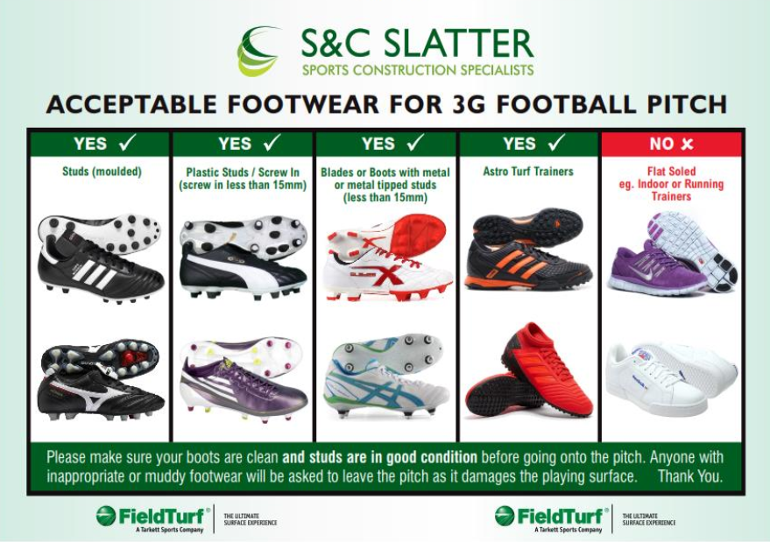


ADVERSE WEATHER
- Snow and ice is not harmful and can be permitted to melt naturally.
- The turf structure will freeze in conditions of lower than 0.5 c°. It is not advised to use the surface in these conditions. Under no circumstances should rock salt be used.
- The pitch can be played on if covered in a light dusting of snow (1/2cm depth) without having to remove the snow. It is recommended that players wear studded shoes in these conditions.
- Heavy fall of snow should be removed using wooden snow shovels, and sharp-edged metal or plastics shovels should be avoided at all costs.

Use of the pitch in adverse weather is a matter of common sense; if in doubt please consult S&C Slatter technical staff.

SPECIALIST MAINTENANCE
In addition to the items listed within this document, S&C Slatter encourages owners to embark on a specialist maintenance contract. This can be provided by S&C Slatter. This type of maintenance keeps the surface free of debris and contaminants for longer. Specialist maintenance can be tailored to suit individual facilities and can replace some recommended in-house activities if required.

Maintenance Training Guide – please use the O&M Manual as a supporting document to the following guide. This will include specific detail regarding the recommended maintenance regime which should be followed.

REDEXIM BRUSHING MACHINE (RTC)
- Fuel – unleaded – fill up off the pitch, ½ tank will enable around 70mins of brushing
- Oil- 10W-30
- Always clean the machine after use. Where possible blow any SBR infill back onto the pitch of the machine.
- Always clean the brushes/machine after use.
- Always check that the brushes are sitting evenly, just sitting into the top of the SBR infill.
- Adjust level of brushes as required, this may be required due to brushes wearing or the infill becoming compacted.
- Check the tyre pressure on a regular basis
- Rear pin silver underneath the back of the machine– if pulled out will disengage the gear box which will enable the machine to be pushed.

PITCH MAINTENANCE
- Always ensure litter and leaves are removed on a regular basis
- Blow any infill which migrates onto hard standing areas back onto the pitch. If the infill is mixed with other debris it should be swept up and disposed of in a bin.
- Spray fence line and mowing strip edging areas on a regular basis to prevent an ingress of weeds.
- Brushing –
  - Please refer to the guide to determine how often the pitch should be brushed. This is based on equivalent hours of use which is calculated based on the number of players using the pith per hour.
  - Ensure the direction of brushing is alternated
  - Always record maintenance completed on an official log sheet which includes date and who completed the maintenance. These records must be kept for warranty purposes.

EXTERNAL MAINTENANCE
- During the 1st year after completion the maintenance is completed by S&C Slatter. FieldTurf strongly recommend a quarterly maintenance programme with an external specialist maintenance division is continued. This will ensure the pitch is maintenance to a high standard which will help to prolong the life of the surface.

INFILL & LINES
- All lines should be checked on a regular basis, this can be done when brushing but should be inspected more carefully at least once per month.
- Infill levels should be check in high wear areas
  - Penalty spots
  - Corner kick arcs
  - Top of the penalty boxes
  - Goal lines
  - Popular teaching/training/warm up areas which may include the centre circle. If the infill levels are low, it is vital fresh SBR infill is added and brushes in, so the fibre is standing up. DO NOT just throw it on without brushing it in.

ENTRANCE AREAS, HARD STANDING AND SPECTATOR AREAS
- Ensure these areas are free from rubbish, including a build-up of SBR infill which may migrate. It is vital that mud from the boot cleaners is regularly removed
- Ensure entrance way mats are cleaned on a regular basis – it is recommended that they are jet washed at least once per year.

GOALS
- Always ensure the goals are not left up on the wheels
- The goals should not be dragged and should be moved by 2 people especially when moved by teenagers or the 11 aside goals.
- Always ensure the net clips are regular checked and the rope which runs from the corner arms to keep the nets from dragging on the ground.

