DELEGATED APPLICATION REPORT - Application No.: 191941/FUL
Address: Hartland Court, Hartland Road
Proposal: Two storey rear conversion and loft conversion with flat roof rear dormer to form a studio flat retrospective.
Officer: Alison Amoah
Target Expiry: 13th November 2020 (Ext)

Site Description, Proposal and Surrounding Area:
The application site is a semi-detached building within a wholly residential area, located on the southern side of Hartland Road in south Reading.

The building originally comprised 2 no. flats – one at ground floor and one at first floor. Works were undertaken in 2019, the subject of an enforcement case (found expedient to pursue), to convert the two-storey rear glazed projection (part of the floorspace of flats c&d) into a brick built structure (no additional floor space for flats c & d), internal alterations and the addition of a flat roof rear dormer to create a studio flat at second floor (roof level), and new rooflights to the front. This application is seeking to regularise that position.

At present they have garage space to the rear and use of the land to the side, however there is a current pending application for two flats on the adjacent land (ref: 200385).

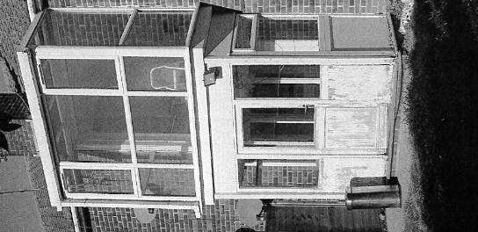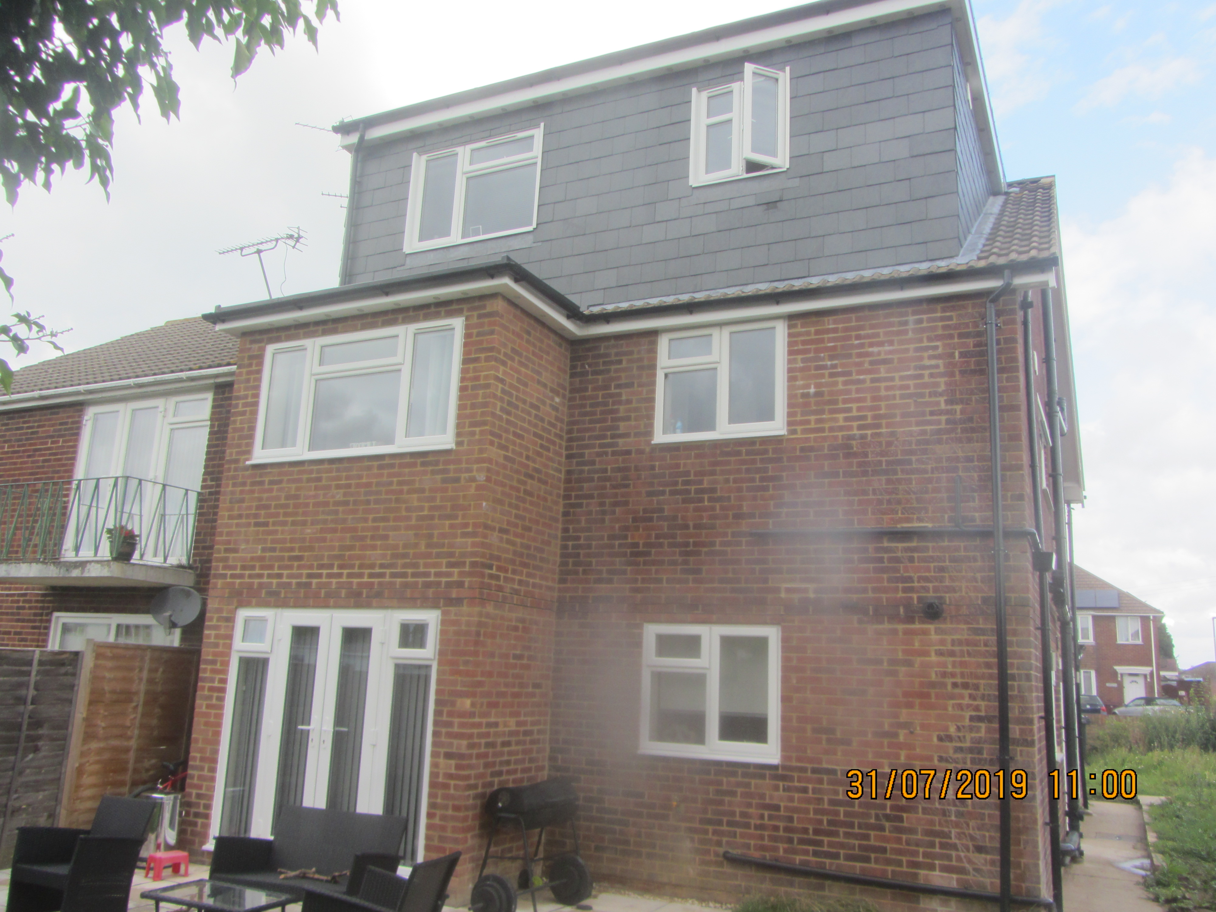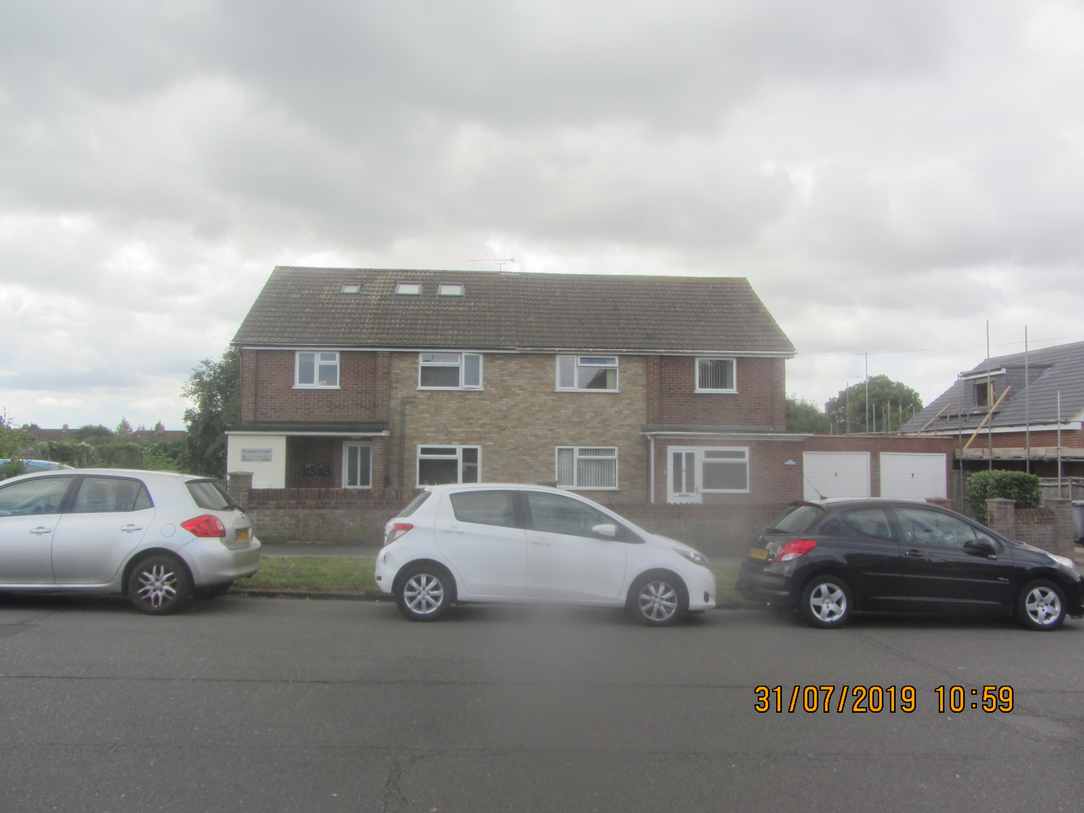
Previously (rear) Now (Rear) Now (Front)

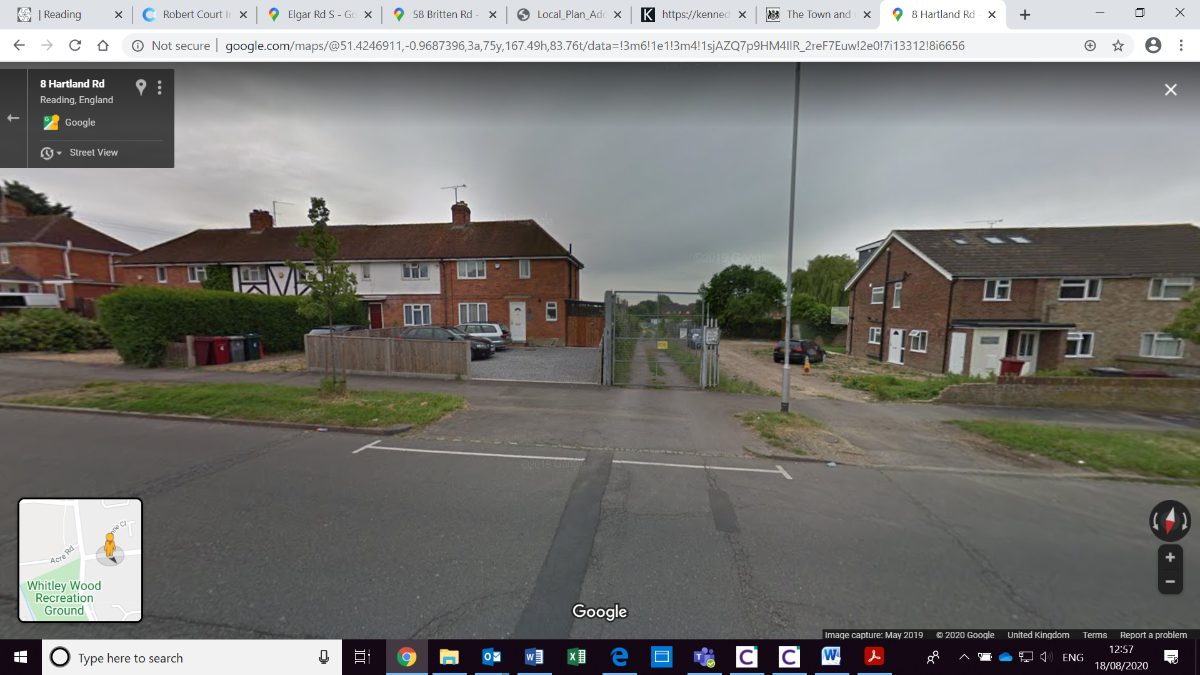
Land to side between Hartland Court and gated access to the allotments

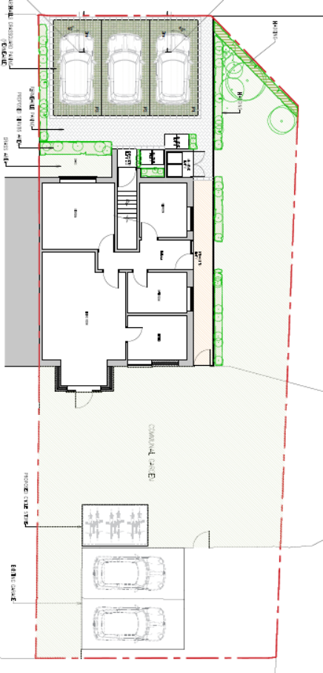
Proposed Block Plan

Plans Considered:
- Existing Elevations - Drawing no: 35718-04, received 9th December 2019
- Existing Ground Floor Plan - Drawing no: 35718-01, received 9th December 2019
- Existing First Floor Plan - Drawing no: 35718-02, received 9th December 2019
- Existing Roof Plan - Drawing no: 35718-03, received 9th December 2019
- Proposed Ground Floor Plan – Drawing no: 35718-05 Rev A, received 2nd February 2020
- Proposed First Floor Plan - Drawing no: 35718-06 Rev A, received 2nd February 2020
- Proposed Second Floor Plan – Drawing no: 35718-07 Rev B, received 16th April 2020
- Proposed Elevations - Drawing no: 35718-09 Rev A, received 16th April 2020
- Proposed Roof Plan - Drawing no: 35718-08, received 9th December 2019
- Proposed Bicycle Store - Drawing no: 35718-21, received 13th March 2020
- Proposed Site Plan – Drawing no: 35718-22 Rev A rec 9th September 2020

Relevant Planning History: Includes land to the side of the application site
9066/TP/3168 – 2 blocks maisonettes and 4 garages – Refused 10/11/1961
9175/3216 – Block 6 flats and garages – refused 21/12/1961
9248/3254 – 4 flats with garages – Approved 19/1/1962
9667/33379 – 4 maisonettes and garages – Approved 22/6/1962
182105 – 2 new attached dwellings – Withdrawn 11/2/2019

Consultation Responses: Flat A, and Flat B Hartland Road, 511 Basingstoke Road and 2 Hartland Road were consulted. No comments were received.

Transport
The site is located close to the junction of Basingstoke and Hartland Road and adjacent to the gated entrance of the allotments owned by RBC.

This application consists of 2 storey rear extension to provide more habitable accommodation for the 2 existing flats and to create an additional studio flat in the loft space.

Block Plan 35718-10 illustrates 3 off road parking spaces fronting Hartland Road, however the access has not been illustrated on plans. In order to facilitate the proposed parking layout, the existing access would need to be relocated and would require partial removal of the grass verge that is located outside the property. As previously advised in application 182105 the Loss of grass verge area up to 8m2 is acceptable anything more than this (up to 15m2) will require the use of permeable materials to reduce the impact of surfacing a verge area. Loss of a grass verge area more than 15m2 would not be supported. No part of the vehicle must overhang any part of the public highway and each parking space should be independently accessible and should be a minimum of 2.4m x 4.8m. Accesses that are not required will need to be reinstated and realigned with the footway.

All works carried out on the public highway will require a license from the Highways team.

Revised plans are required illustrating location and dimensions of access point and extent of the loss of the grass verge. Any new access will also require visibility splays to be illustrated in line with the Geometric Design and Guidance on Classified Roads.

Cycle provision for the new 1 bed unit has not been illustrated on submitted plans. Revised plans should be submitted illustrating proposed provision.

In order to fully determine this application please ask the applicants agent to address the points above.

Planning Officer Note: An amended plan was submitted and Transport commented further as follows:

“The loss of the grass verge is acceptable for the new access, however no visibility splays have been illustrated for the new access which was requested in the original Transport comments. There is a tree located on the grass verge, this should be illustrated on plans. Cycle storage is deemed acceptable.”

A final amended plan was submitted (Drawing no: 351718-1022 Rev A) which was deemed acceptable.

Equality Act 2010:
In determining this application the Council is required to have regard to its obligations under the Equality Act 2010. However, there is no indication or evidence (including from consultation on the application) that the protected groups identified by the Act have or will have different needs, experiences, issues and priorities in relation to this particular planning application. Therefore, in terms of the key equalities protected characteristics it is considered there would be no significant adverse impacts as a result of the development.

Relevant Planning Policy and Guidance
Section 38(6) of the Planning and Compulsory Purchase Act 2004 requires that proposals be determined in accordance with the development plan unless material considerations indicate otherwise. Material considerations include relevant policies in the National Planning Policy framework (NPPF) - among them the 'presumption in favour of sustainable development'.

The following local and national planning policy and guidance is relevant to this application:

Reading Borough Local Plan (2019)
Policy CC5: Waste Minimisation and Storage
Policy CC7: Design and the Public Realm
Policy CC8: Safeguarding Amenity
Policy CC9: Securing Infrastructure
Policy H1: Provision of Housing
Policy H3: Affordable Housing
Policy H5: Standards for New Housing
Policy H9: House Extensions and Ancillary Accommodation
Policy TR5: Car and Cycle Parking and Electric Vehicle Charging

Supplementary Planning Guidance/ Documents:
A Design Guide to House Extensions (2003)
Planning Obligations Under S106 (2015)
Affordable Housing (2013)

Appraisal

- Principle
- Design
- Residential Amenity
- Parking
- Landscaping
- S106 and Community Infrastructure Levy (CIL)
- Other Matters

1. Principle
The principle of residential use is considered acceptable as the provision of an additional residential unit would meet Policy H1 of the Reading Borough Local Plan (RBLP).

There are other material considerations which are assessed below.

2. Design
The overarching policy is CC7 which requires developments to “be of high design quality that maintains and enhances the character and appearance of the area of Reading in which it is located.”

The redevelopment of the original glazed projection to brick is considered acceptable as this uses matching materials to the host building.

The dormer, although large, is to the rear of the building and it is not considered that this has a detrimental effect on the overall character and appearance of the area. Although it is constructed of alternative materials to the existing building these in themselves are not considered harmful with respect to its appearance. If this was one C3 dwelling then a flat roofed dormer of this nature would likely be considered acceptable under permitted development.

With respect to the extensions themselves Policy H9 has been used as the basis of the assessment, albeit this is specific to a house extension, but the same principles are considered to apply in this case.

Policy H9 states that an extension to a house will be acceptable where it:

- Respects the character of the house in terms of scale, location, materials and design;

To assess this, the following has been considered – would the proposal:
- Detract from the appearance of the original building through the use of ill-matching materials and by not fitting in with the design, scale and proportions of the original building; No – the rebuilding of the original two storey rear projection in brick matches existing materials. The dormer, although in differing materials is not considered to be sufficiently harmful to warrant refusal on this basis.
- Reduce the amount of usable amenity space for the property to an unacceptable degree; No.
- Require the loss of trees in the garden or put significant trees at risk; No.

B. Respects the character and pattern of neighbouring properties and appearance of the street as a whole in terms of scale, location, materials and design, the arrangement of doors, windows and other principal architectural features and any important existing building line; & C. Does not present an overbearing impact on neighbours or a large blank façade to public areas

To assess this, the following has been considered – would the proposal:

- Significantly reduce the amount of daylight and sunlight enjoyed by neighbouring properties; No.
- Invade the privacy of neighbouring properties through overlooking from windows or balconies; No – The dormer introduces windows at the rear at a higher level than existing, but this is not considered to substantially impact on privacy of neighbouring gardens compared to the existing arrangement of rear windows at first floor level.
- Detract from the character of neighbouring properties through siting, excessive bulk, ill-matching materials or inconsistent design; No
- Detract from the appearance of the street or area by using ill-matched materials, glazing and detailing; No.

D. Does not result in a loss of biodiversity within garden – No.

E. Ancillary accommodation, such as granny annexes, will be acceptable where it would not be capable of operating as a separate dwelling which could be let or sold separately – N/A.

CC8: states: Development will not cause a detrimental impact on the living environment of existing residential properties or unacceptable living conditions for new residential properties, in terms of:

• Privacy and overlooking; No
• Access to sunlight and daylight; No
• Visual dominance and overbearing effects of a development; No
• Harm to outlook; No
• Noise and disturbance; No
• Artificial lighting; No
• Vibration; No
• Dust and fumes; No
• Smell; No
• Crime and safety; No or
• Wind, where the proposals involve new development of more than 8 storeys – N/A.

3. Residential Amenity
Policy H5 applies a number of standards for new housing. This includes that “a) All new build housing outside the Central Area as defined on the Proposals Map will comply with the nationally-described space standard.”

For a 1 bedroom 1 person flat the requirement is for the internal space to be a minimum of 37sqm. The proposed flat is 38sqm (excluding areas with the ceiling below 1.5 m high) so complies.

With respect to Policy H10 it states that “flats may be provided with communal outdoor space, balconies and/or roof gardens.” There is a private communal rear garden, which is of a sufficient size to serve the needs for the 3 flats within the building. In addition, there is public open space within walking distance, located on Basingstoke Road.

The studio flat is just within the space standard required. Any internal changes to create an additional bedroom would not be acceptable and therefore, a condition is included to ensure that the studio remains as such.

- Parking
The proposal includes three parking spaces to the front of the building and the retention of existing car parking spaces to the rear which meet parking requirements for the building in accordance with Policy TR5.

Six bicycle spaces within secure storage is proposed for the whole building (existing flats and new flat under this application) and accords with standards.

- Landscaping
The proposal includes some landscaping to the front and side boundaries. The parking is shown as within grasscrete. These measures are considered acceptable and accord with Policy CC7.

- S106 and Community Infrastructure Levy (CIL)
The creation of a dwelling is subject to policy H3 and the requirement for a contribution towards affordable housing. A section 106 will be prepared with a policy compliant affordable housing contribution of £6,125.

The development is not CIL liable as it involves a change of use with no new floor space.

- Other matters
At present bins are just placed in the front garden. The submitted scheme includes for enclosed bin storage areas to the front of the building. This accords with policy requirements under Policy CC5.

It should be noted that as the conversion was not a major refurbishment that BREEAM standards do not apply as required under Policy CC2. The more generic parts of the policy would have been met through Building regulations.

RECOMMENDATION:

APPROVE
3
- AP1 – Approved plans
- DC8 – Provided within 3 months in accordance with plans and retained thereafter.
- DC5 – Bicycle storage to be implemented within 3 months.
- Retention of studio as studio.
- Access

Informatives:

- IF5 - Terms and Conditions
- IF4 - S106
- IF3 - Highways
- IF1 – Positive and Proactive

