DELEGATED APPLICATION REPORT

App Ref: 211551 / LBC
Address: 23 Heritage Court, Castle Hill, Reading, RG1 7RP
Proposal: Listed Building Consent to replace the existing roof covering with single ply membrane (lead grey colour) and carry out associated works (amended description)
Case Officer: Beatrice Malama
Date Received: 17/09/2021 Agreed Determination Date: 03/12/2021

Site Description

The application site is located at Heritage Court a five-story block of flats which is a grade II listed building. The property is an early 19th century terraced building that was originally built of brick with slate pitched roof. The front of the terrace is rendered and painted cream. The property has a modern three-story rear extension and it is surrounded by high rise properties with similar characteristics. The property falls within a conservation area.

The application site is flat 23, one of the flats on a three-story rear extension at Heritage Court. The extension has rendered exterior walls and a bituminous felt flat roof. Figure 1 shows the rear elevation of the terrace including rear extensions

Figure 1: Existing rear elevation

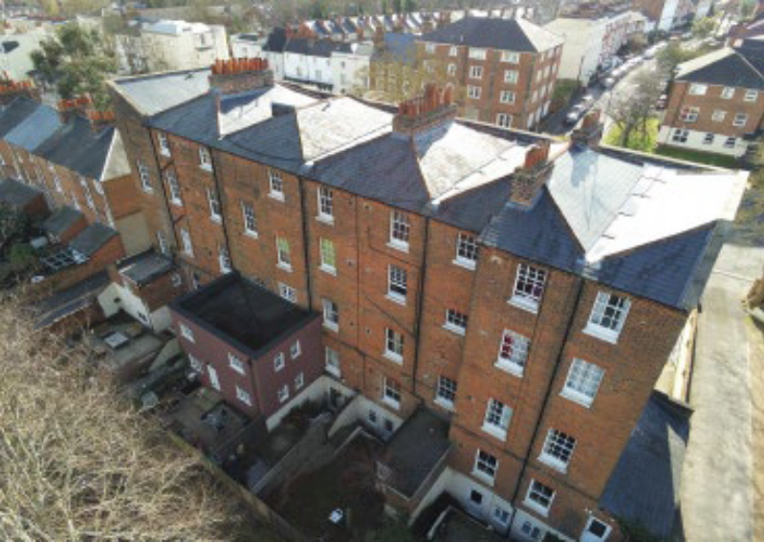
Flat 23 Heritage Court

Proposal

Application is sought for listed building consent to replace the existing defective bituminous felt roof with a single ply membrane (lead grey in colour) including associated works. The proposal includes additional roof insulation for energy efficiency. No other external alterations to the building are proposed as part of this application.
Plans/Documents considered:

Drawing No: AD/01 - Location and Block Plan
Design, Access and Heritage Statement
Received on 17th September 2021

Email - Minor changes to details
Received 8th November 2021

Relevant Planning History

None relevant to this application

CONSULTATIONS

Internal Consultees

Conservation and Urban Design Officer – Pictures of the proposed breather vents were requested and the applicant supplied this information via email and confirmed that the vents would not be visible as they would be concealed by the existing parapet wall around the roof.

Ecology – No Objections to this application

Natural Environment – No objections to this application however the applicant is advised to ensure that measures are put in place during implementation of the works to protect trees that are in close proximity to the application site.

External Consultation

A Listed Building Consent site notice was sent to the agent on 5th October 2021 and neighbours at the following addresses were consulted by letter.
6, 7, 8, 9, 10,11,12,13, 14, 15, 16, 17, 18,19, 20,21, 22 Heritage Court, Castle Hill, RG1 7RP

No responses have been received.

Equality Act 2010:

In determining this application, the Council is required to have regard to its obligations under the Equality Act 2010. However, there is no indication or evidence (including from consultation on the application) that the protected groups identified by the Act have or will have different needs, experiences, issues and priorities in relation to this particular planning application. Therefore, in terms of the key equalities protected characteristics it is considered there would be no significant adverse impacts as a result of the development.

Legal and Planning Policy

Section 38(6) of the Planning and Compulsory Purchase Act 2004 requires that proposals be determined in accordance with the development plan unless material considerations indicate otherwise. Material considerations include relevant policies in the National Planning Policy framework (NPPF) - among them the 'presumption in favour of sustainable development'.

Section 66 of the Planning (Listed Buildings and Conservation Areas) Act 1990 requires the local planning authority to have special regard to the desirability of preserving a listed building or its setting or any features of special interest which it possesses.

Section 72(1) of the Planning (Listed Buildings and Conservation Areas) Act 1990 requires the Local Planning Authority in the exercise of its functions to pay special attention to the desirability of preserving or enhancing the character or appearance of a conservation area.

The following local and national planning policies and guidance are relevant to this application:

National Policy
National Planning Policy Framework (2021)
National Planning Practice Guidance

Reading Borough Local Plan 2019

CC7: Design and the Public Realm
EN1: Protection and Enhancement of the Historic Environment

Other legislation

Planning (Listed Buildings and Conservation Areas) Act 1990

Appraisal

The proposal involves replacement of the existing bituminous felt flat roof with a single ply membrane (lead grey in colour) including associated works. The proposed maintenance works are limited to the roof structure. No other works to the building is proposed and therefore this proposal is assessed in terms of impact of the works on the fabric of a listed building.

Heritage

Policy CC7 (Design and the Public Realm) requires that all developments be of high design quality:
Policy N1: Protection and Enhancement of the Historic Environment
The building is a three-story rear extension with a bituminous flat roof. The existing roof is enclosed by a parapet wall.
The proposed maintenance works to the existing roof involves a complete removal of the existing roof finish and replacing it with Bond ICB Secutop or equivalent single ply membrane waterproofing system. The proposed colour of the roof is lead grey. Associated works include replacement of insulation materials, installation of mushroom breather vents between each pair of joists to opposing sides to ventilate the void above the insulation and reinstating downpipes from main roof among other things. The breather vents will be concealed by the parapet wall around the roof. The ridge height of the building would not change.
No other part of the building would be affected and thus no harm to the external appearance of the building itself and the surrounding properties would be expected. In addition, due to the height of the building and the presence of a parapet wall around the roof, the roof continues to be hidden and thus limits any potential harm to the wider area.
In light of the above, it is considered that the proposed works would not have detrimental impact on the setting or character of the listed building and conservation area within which it is located, and the proposal therefore complies with the requirements of Section 66 and 72 of the Town and Country (Listed Buildings and Conservation Areas) Act 1990 and the statutory duties of the Council in this regard have been discharged.
CONCLUSION
The proposed works to the listed property which would involve a replacement of the existing roof with a near enough like for like Bond ICB Secutop or equivalent single ply membrane waterproofing system (lead grey in colour) has been assessed and found to be acceptable as it complies with the identified policy and guidelines and therefore Listed Building Consent can be granted.

RECOMMENDATION
Grant Listed Building Consent
CONDITIONS
- Time Limit (Standard) TL1
- Listed Building (Works Specifications)
- Listed Building Materials (To Match)

INFORMATIVES
IF1: Positive and Proactive Working
IF5: Terms
IF6: Building Control
IF7: Complaints about construction
IF8: Encroachment

