Proposed external materials at 20 Belle Vue Road

External Brick
Reclaimed imperial red stock brick.
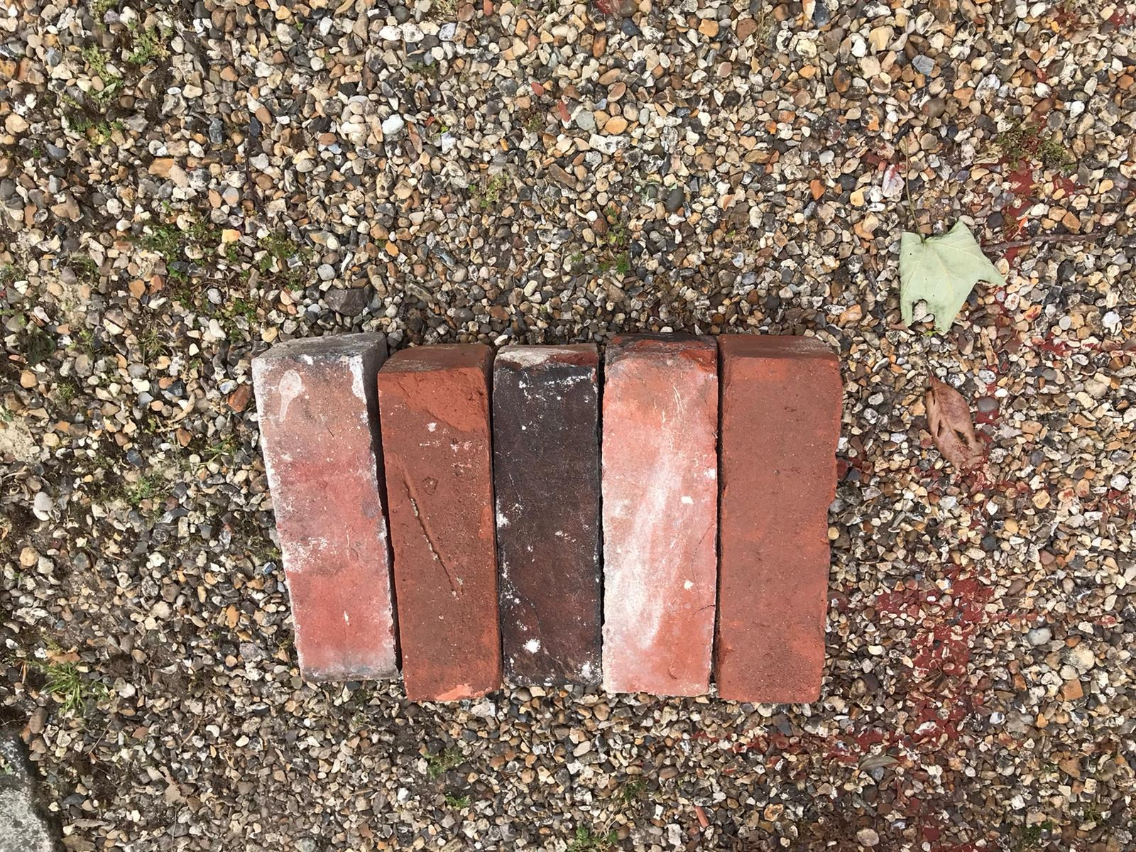
Windows
Anthracite (Ral 7016) Aluminium bi-fold doors and windows
Windows - https://www.smartsystems.co.uk/product/111/alitherm-300
Bi-fold Doors - https://www.smartsystems.co.uk/product/195/visofold-1000
Parapet Coping
Once Weathered Coping Stone – Grey/Slate
Slate - https://www.roofingsuperstore.co.uk/product/eurodec-50-75mm-once-weathered-coping-stone-600mm-x-350mm-slate.html

