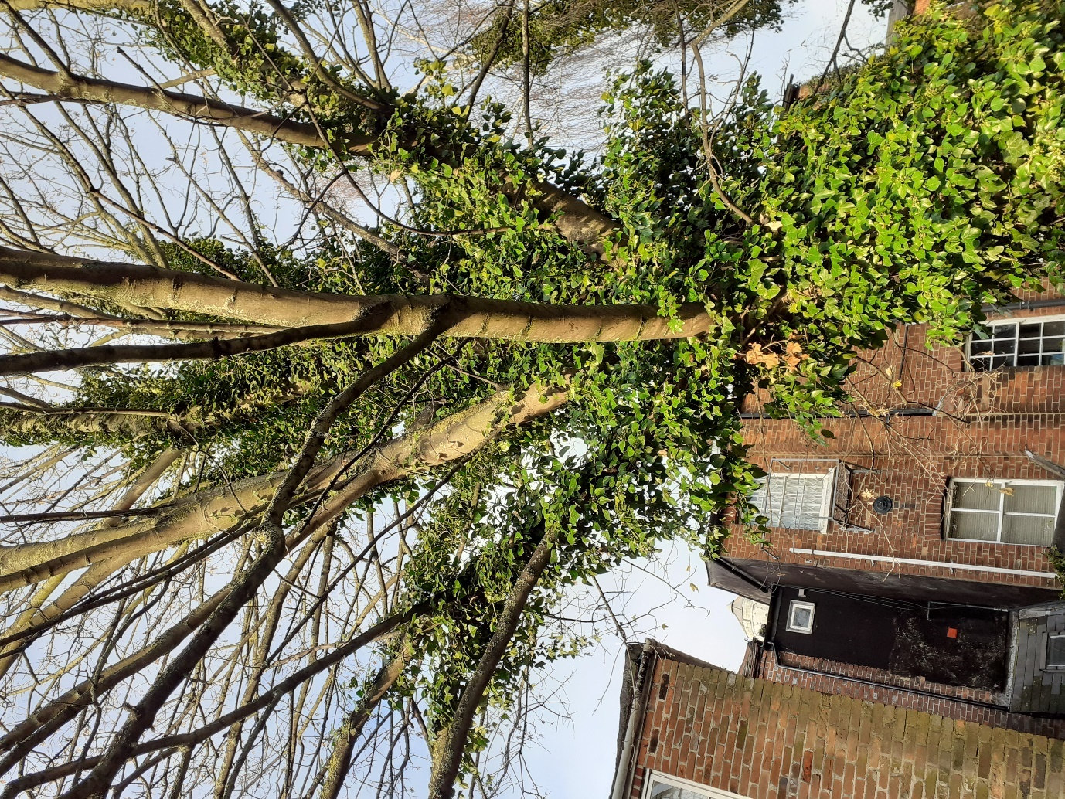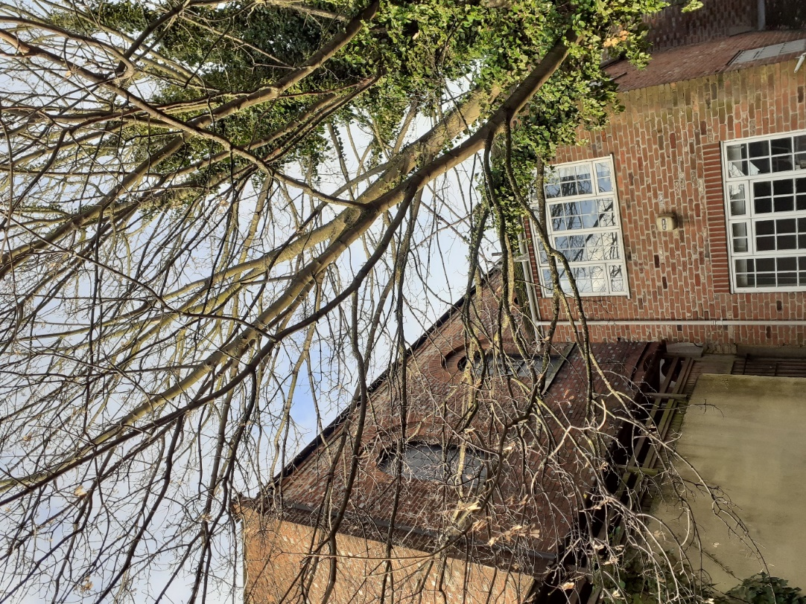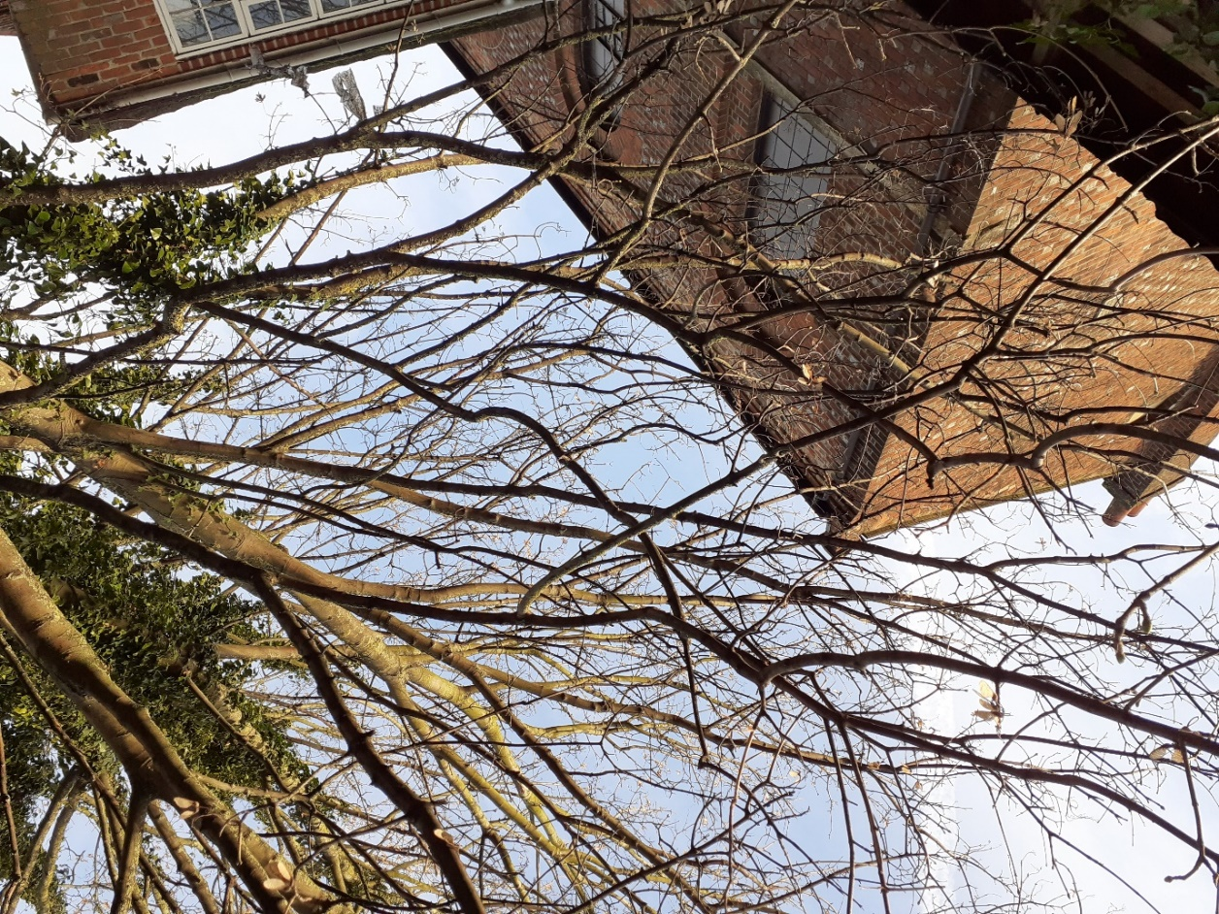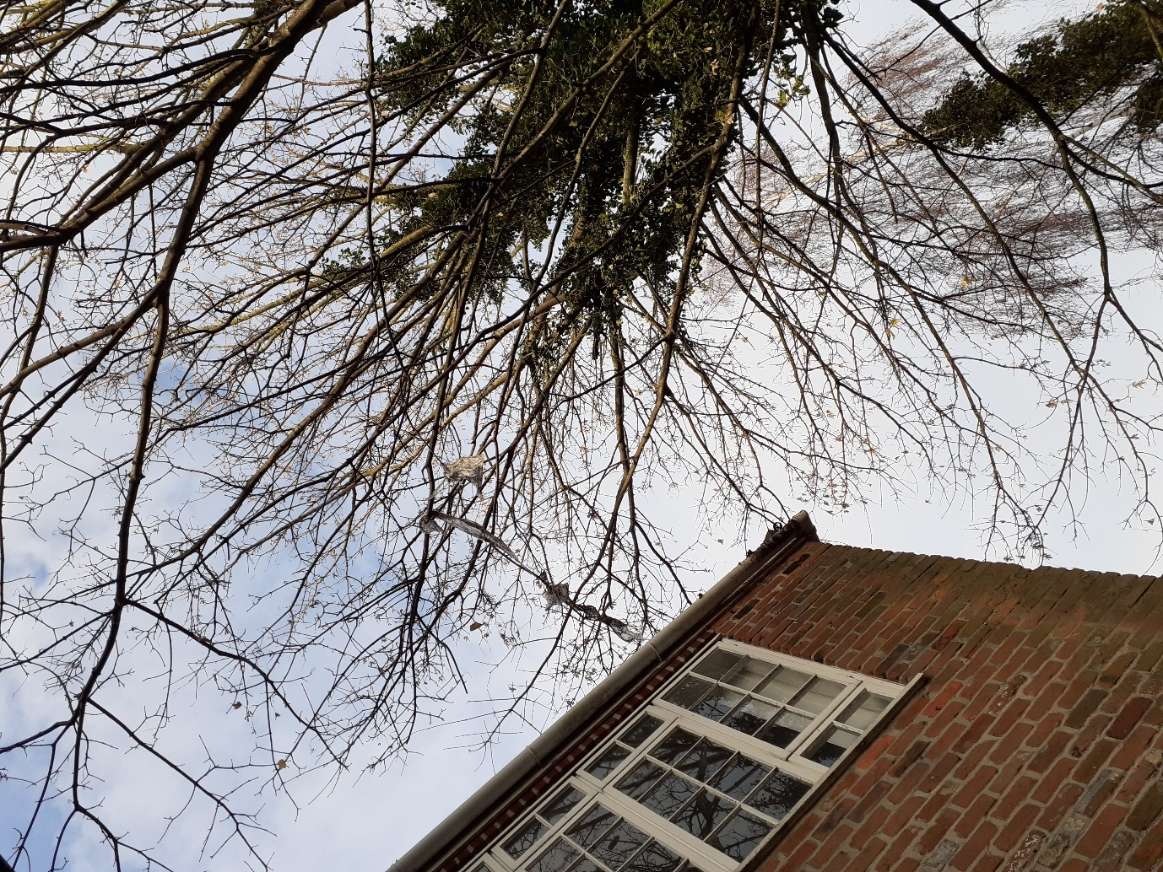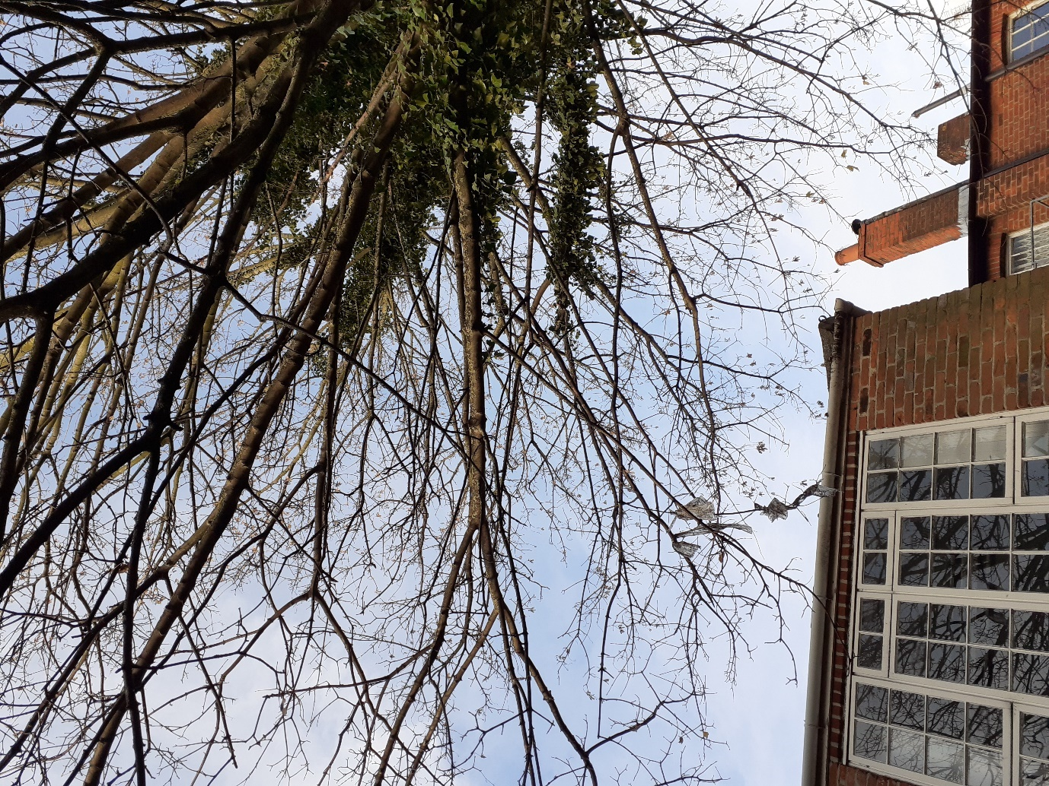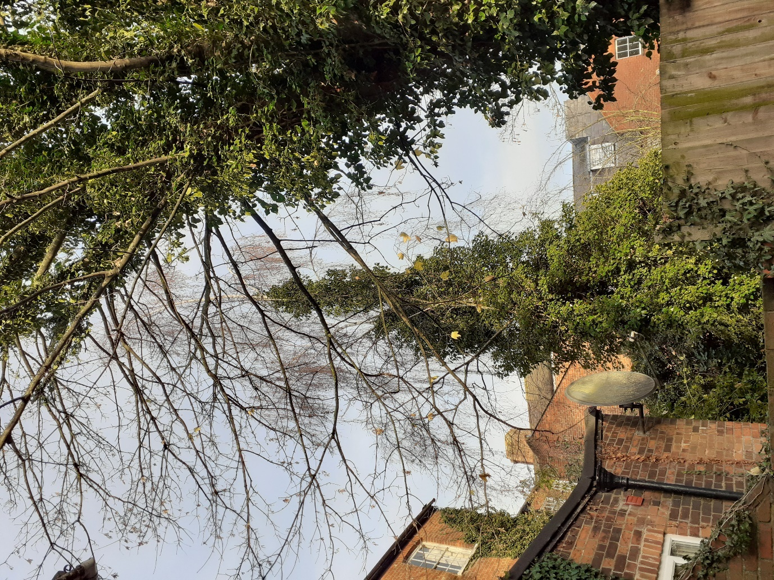
Twin branch over garden of No. 9 – both to be removed back to their individual point of original
Secondary branch growing towards No. 11’s roof to be removed
Lowest branch overhanging roof of No. 9 to be removed
Following removal of lowest branch; remaining canopy overhanging roof of No. 9 to be pruned to give 2m clearance above roof (branches will still overhang)
Small, low branches overhanging No. 7’s roof and garden to be removed

Ivy should be severed.
Sycamore at 7 Castle St – TPO 15/19

