Design and Access Statement
Site Address: 47 Norcot Rd, Reading RG30 6BP
Proposal: Single storey rear extension.

Application Site:
The application site is located at Norcot Road, Reading and comprises a two storey terraced dwelling finished with red brick and clay pantiles. The area is residential in character comprising a mix of housing styles and tenure. On the opposite side of the application site, the dwelling houses are predominantly large semi-detached residential properties with an open area in front. The application site is currently bounded by a low-level wooden fence. The dwellings are set back from the footway giving the area an open and verdant character.
The dwellinghouse is not a listed building and is not located in a conservation area. No trees will be affected by the proposal.
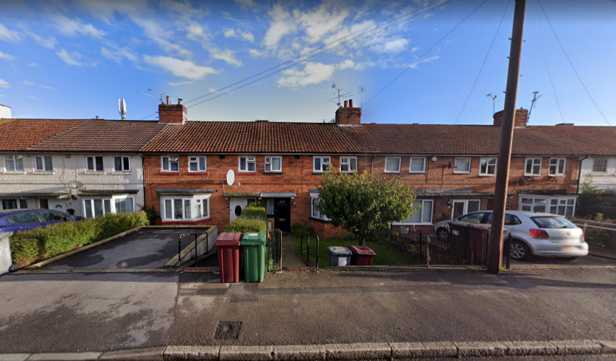
The application site, two storey attached dwelling alongside the side boundary of No.47 Norcot Rd

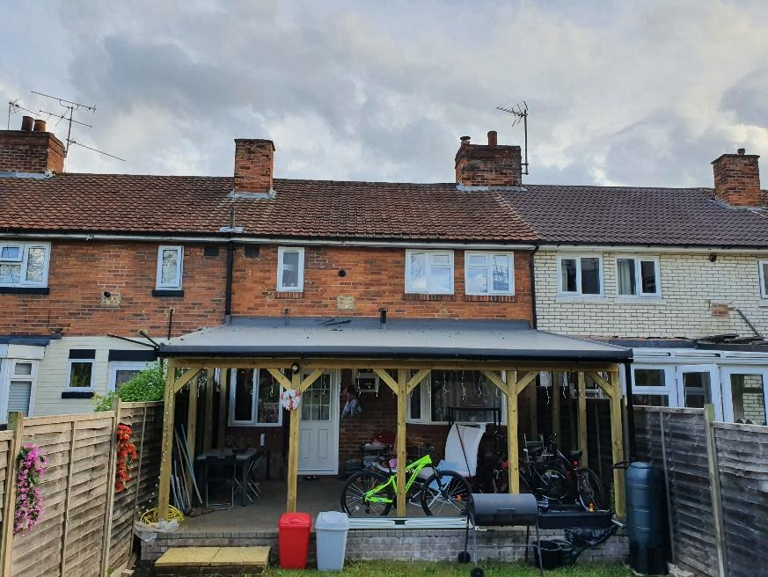
The existing canopy at the rear of the dwelling in the application site
Proposal:
The existing temporary structure (shown above) is to be replaced by a single storey rear extension using materials to match the existing dwelling. No further alterations are envisaged.

Design:
Compliance with the Design Guide To House Extensions Supplementary Planning Document, March 2021(as amended)
Policies 6 and 7 of the Design Guide To House Extension (March 2021) requires a development proposal to maintain or enhance the existing dwelling, neighbouring properties and the surrounding area. The extension is to be constructed of materials to match the existing house. The scale and design of the extension will respect the character and integrity of the host dwellinghouse and surrounding properties. The privacy of neighbouring occupiers will be significantly improved by this extension (from the existing arrangement). The proposal complies with the aims and objectives of the policies.
Access:
Access is via the main dwelling only. The driveway at the front of the property is unaffected.

