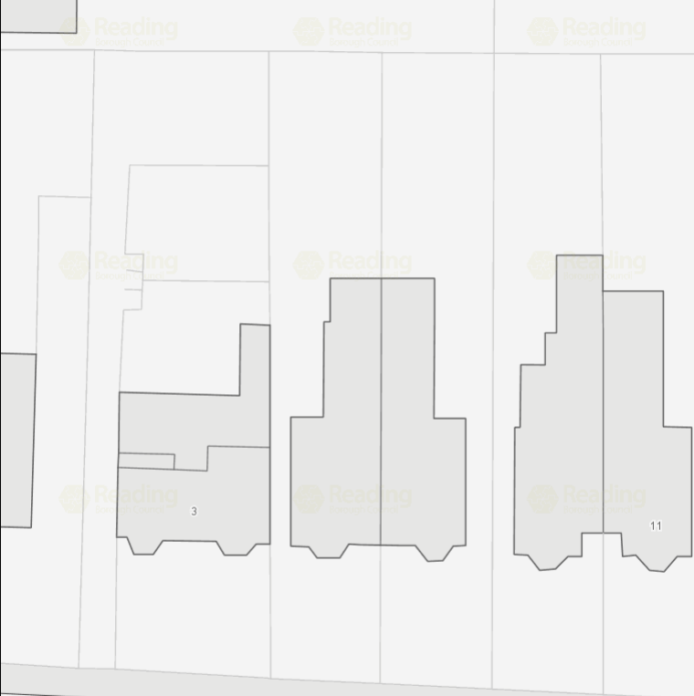
T7
T6
T5
T4
T3
T1 & T2
shed
Tree location plan (revised during visit of 23/6/21)
210826/TCA

