App No.: 210901/FUL
Address: Green Park Village Phase 6B
Proposal: Amendments to external balcony arrangements for Blocks 2 and 3 of Phase 6B as approved under 171017
Officer: Alison Amoah
Target Expiry (ext): 13th August 2021

1. SITE DESCRIPTION & BACKGROUND

  - The application site is part of the overall Green Park Village Development (GPV) and part of Phase 6B originally approved under the overall hybrid permission (10/01461/OUT), and the detail for the blocks (1, 2, 3 – originally referenced as A, B, C) under the reserved matters permission 171017.

1.2 The following is the location of the blocks and their appearance as approved.

Location Plan
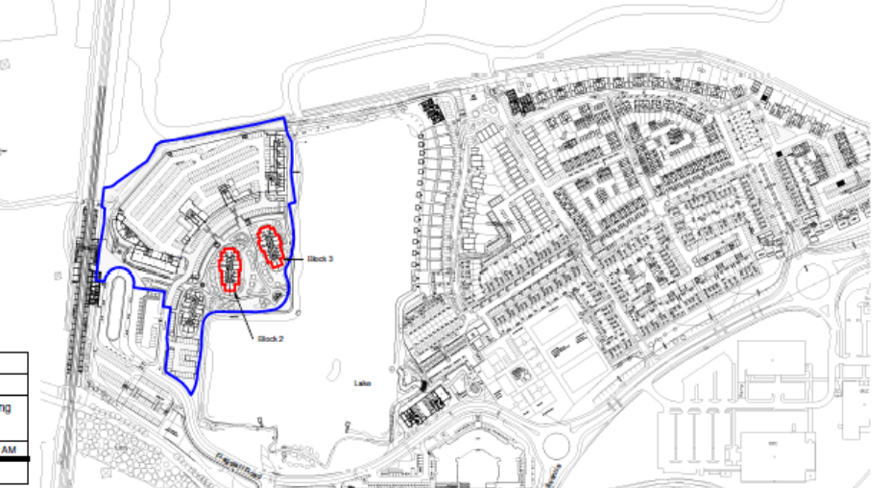

Existing approved appearance and floorplans of Blocks 2 & 3

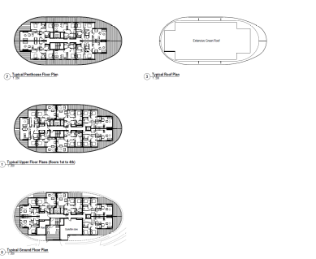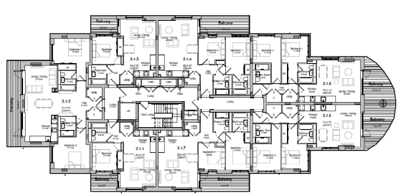

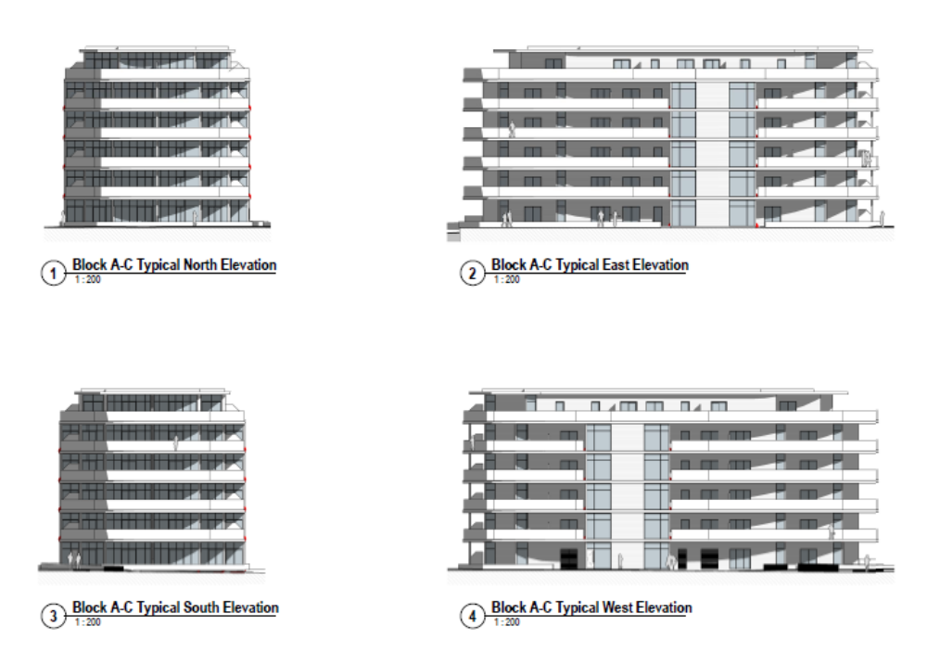

- PROPOSAL

2.1 To amend the external balconies of Blocks 2 and 3, as below, to remove the elliptical form to a largely rectangular form, consisting of bolt on balconies. The radius end terrace to each Block would be retained. Block 1, as part of the group of three, has already been completed and retains its elliptical form.

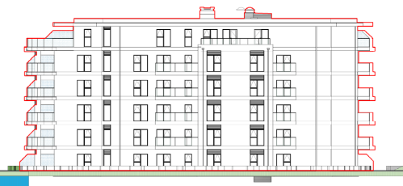

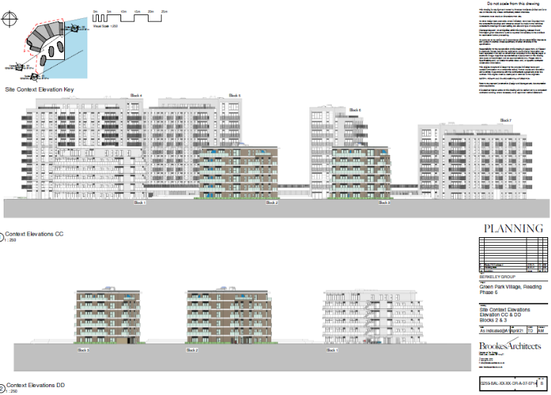

2.2 The proposal would result in amendments to the elevations and floor plans, and with respect to the latter only in relation to the external balconies; there would be no changes to the internal floorspace arrangements and the overall building proportions, and accommodation would remain the same. The reconfigured private amenity space would result in an associated reconfiguration of the windows and doors. The horizontal feature banding would be retained through the projecting balcony arrangement.

- RELEVANT PLANNING HISTORY

10/01461/OUT (102172) – A planning application for mixed-use development comprising: Phase 1 (submitted in full with no matters reserved and as defined in area on Plan Ref. PL-P1-001) for the construction of housing (Class C3), management suite, village hall, engineering and infrastructure works including reconfiguration of the lake, lakeside access, car parking, pedestrian and cycle routes, services & infrastructure, landscaping and other associated works; and Subsequent phases (submitted in outline with all matters reserved except for details of the main access proposals) for the construction of housing (Class C3), extra care housing with ancillary community uses (Class C2), offices (Class B1), local retail (Use Classes A1, A2, A3, A4, A5), one-form entry primary school Cl ass (Class D1), health surgery (Class D1), Nursery (Class D1), sports pitches, children's play facilities, engineering and infrastructure works including reconfiguration of the lake and vehicular access, lakeside access, car parking, pedestrian and cycle routes, services & infrastructure, landscaping and other associated works – Approved with S106 16/5/2011

171017/REM - Application for approval of reserved matters for Phase 6B for 120 dwellings following outline approval (10/01461/OUT) (amended) – Approved 19/7/2018

210667/APPCON – Cd17 – Materials – Discharged 3/5/2021

- PLANS CONSIDERED

Received 2nd June 2021:
- Site Plan Blocks 2 & 3 – Drawing no: G259-BAL-XX-XX-DR-A-07-0700 Rev B
- Block 2 and 3 Location Plan – Drawing no: G259-BAL-XX-XX-DR-A-07-0715 Rev A
- Site Context Elevations Elevations CC & DD Blocks 2&3 - Drawing no: G259-BAL-XX-XX-DR-A-07-0714 Rev B
- Site Context Elevations Elevations AA & BB Blocks 2&3 - Drawing no: G259-BAL-XX-XX-DR-A-07-0713 Rev B
- Building Elevations North & South Blocks 2 & 3 - Drawing no: G259-BAL-XX-XX-DR-A-07-0712 Rev B
- Typical Elevations East & West Blocks 2 & 3 – Drawing no: G259-BAL-XX-XX-DR-A-07-0711 Rev B
- Typical 1st & 4th & 5th Floors GA Plan Blocks 2 & 3 - Drawing no: G259-BAL-XX-XX-DR-A-07-0702 Rev C
- Typical Ground Floor GA Plan Blocks 2 & 3 - Drawing no: G259-BAL-XX-XX-DR-A-07-0701 Rev D

5. CONSULTATIONS

5.1 None undertaken. Site notices were displayed by the applicant on 25th June 2021.

6. RELEVANT PLANNING POLICY AND GUIDANCE

6.1 Section 38(6) of the Planning and Compulsory Purchase Act 2004 requires that proposals be determined in accordance with the development plan unless material considerations indicate otherwise. Material considerations include relevant policies in the National Planning Policy framework (NPPF) - among them the 'presumption in favour of sustainable development'.

6.2 The following national and local planning policy and guidance is relevant to this application:

National
National Planning Policy Framework (NPPF, 2021)
National Planning Policy Guidance

Adopted Reading Borough Local Plan (2019)
Policy CC7: Design and the Public Realm
Policy CC8: Safeguarding Amenity
Policy H5: Standards for New Housing

7. APPRAISAL

7.1 The relevant matters are considered to be as follows:
(i) Principle of Development
(ii) Design
(iii) Amenity

- Principle of Development
7.2 Blocks 2 & 3 have already been approved under permissions 10/01461/OUT and 171017 and therefore, the principle of residential development in this location has already been accepted. As the proposal only relates to the external appearance it is assessed, below, as to whether the design is acceptable.

(ii) Design
  - Design is a key element of national planning policy and para. 126 of the NPPF states that “The creation of high quality, beautiful and sustainable buildings and places is fundamental to what the planning and development process should achieve.”

  - At the local level the key policy is CC7 which states that “all developments must be of high design quality that maintains and enhances the character and appearance of the area of Reading in which it is located.”

  - The proposed amendments to the appearance of Blocks 2 & 3, through changes to the external balcony arrangements, would reflect the approved rectilinear design of the adjacent blocks in Phase 6A and would still retain the overall scale and alignment of horizontal banding emphasis and materiality of Block 1. When viewed in context with the overall Phase 6 buildings (Phases 6A and 6B) it is considered, therefore, that the changes to the scheme as originally approved under 171017 would not have a detrimental effect on the overall appearance of the wider development and would retain the principles of the approved Design and Access Statement for the site.

  - The siting of the blocks would not be changed so that the informal arrangement and orientation to maximise privacy and maintain views from and to the lake would be retained.

  - It is considered that the scheme accords with Policy CC7.

(iii) Amenity
7.8 Policy H10 details how dwellings should be provided with communal outdoor space, balconies and/ or roof gardens. There would be a change to the overall balcony space, however, the proposal would continue to provide private amenity space for each apartment in addition to the communal outdoor space provided between the blocks and within the wider Green Park Village development and therefore complies with policy.

(iv) Equality
7.9 In determining this application the Council is required to have regard to its obligations under the Equality Act 2010. There is no indication or evidence (including from consultation on the application) that the protected groups have or will have different needs, experiences, issues and priorities in relation to the particular planning application. Therefore, in terms of the key equalities protected characteristics it is considered there would be no significant adverse impacts as a result of the development.

RECOMMENDATION
Approve

Conditions
T1 - 3yr time limit
AP1 – Approved Plans
M1 – Materials as specified

Informatives
IF5 - Terms and conditions
IF6 - Building Regulations
IF7 - Construction noise
IF1 - Positive and proactive

