DELEGATED APPLICATION REPORT - Application No.: 210957
Address: 60 Christchurch Road
Proposal: Kitchen extract equipment on rear flat roof
Case officer: Alison Amoah
Target expiry: 8/10/2021 (ext)

Site Description and Surrounding Area:
The application site is a part 2 storey and 3 storey end of terrace building. At ground floor the commercial use will be ‘Slam Burger’ presented by the applicant as within the E use class, i.e. for consuming food and drink mostly on the premises. At first floor is a small HMO. It is within the Christchurch Road Local Centre (Policy RL1). The surrounding area is a mix of commercial and residential premises, with residential above the adjacent commercial premises.

The property was recently extended at the rear (permitted under 170254) and works internally to create the E use class are largely complete. The outside brickwork has been painted black.

Proposal: The proposal is for the rear extraction equipment only. As a change of use from the former A1 shop to former A3 café/ restaurant is now a permitted change, as both now fall under the E use class, the applicant has advised that the permission granted under 191755/FUL (change of use and extraction equipment), which included conditions to discharge, is no longer required. This application is therefore, just for the new extraction equipment, which does still require permission in its own right.

Plans and other information considered: Received 11th June 2021 (unless otherwise stated):
- Site Location Plan as Existing – Drawing no: 308-02-00 Rev P1
- Floor Plans as Existing [ground and first] - Drawing no: 308-01-00
- Extractor Fan Design Proposed Floor Plans – Drawing no: 308 03-30 Rev P, received 7th July 2021
- Extractor Fan Design Proposed Elevations – Drawing no: 308 03-31 Rev P, received 7th July 2021

Other information/documents:
- The Defra Guide
- Absolute (HEPA) Filters [technical sheet]
- Air Vents Technology Products in Line Mixed Flow Fans [technical sheet]
- Air Handling Vents Air Vent Technology [technical sheet]
- Splitter Silencers [technical sheet]
- Proposed Ventilation System, Aeris Engineering Ltd
- Odour Control Report, Aeris Engineering Ltd
- Passive Filtration [technical sheet], Purified Air
- Covering Letter, dated 10th June 2021, prepared by Walsingham Planning
- Acoustic Assessment of Proposed New Mechanical Services Equipment, dated 21st April 2021, prepared by ACA Acoustics

Relevant Planning History:
02/0217/FUL (020504) - Erection of single storey extension at the rear of existing building to form a storage area for laundry – Approved 17/4/02

170254 - Single storey rear extension to existing building, re-submission and alteration to expired consent 02/00217/FUL. Alteration comprises increase in length of extension of 6 metres – Approved 11/4/17

171491 - Change of use of building from Class A1 (shops) to A3 (restaurants). Prior Notification under Class C, Part 3 of Schedule 2 of the Town and Country Planning (General Permitted Development) Order 2015 – Withdrawn 6/10/17

181571/FUL - Change of use of ground floor to Class A3 café/restaurant, part single, part two-storey rear extension, changes to shopfront and kitchen extract equipment on rear flat roof – Refused 4/2/2019; Appeal Ref: APP/E0345/W/19/3228388 dismissed 27/8/19. Reasons for refusal as follows:

1. The proposed change of use would not maintain the vitality and viability of this local centre, due to the loss of an A1 shop unit, and would have a detrimental effect on the diversity of the centre contrary to Adopted Core Strategy Policy CS27 and Sites and Detailed Policies Document Policy DM13.
2
2. No assessment has been provided of the likelihood of odours and proposals to ensure that odour nuisance will be prevented. Therefore the proposed scheme could lead to odour nuisance which would have a detrimental effect on residential amenity contrary to Adopted Sites and Detailed Policies Document Policy DM4.
3
3. The proposed bin storage is considered to be insufficient in size to serve both the needs of the proposed mixed commercial and residential development and its layout is unsatisfactory with the storage for commercial and residential uses being combined. This would not comply with Adopted Core Strategy Policy CS2 and the Council’s Waste Management Guidelines. Insufficient space for waste is also likely to lead to detrimental effects on amenity with respect to odour, contrary to Adopted Sites and Detailed Policies Policy DM4.

181828/APPCON - Discharge of condition 4 of planning permission 170254 – Discharged 16/11/18

191755/FUL - Change of use of ground floor to Class A3 cafe/restaurant. Changes to shop front and kitchen extract equipment on rear flat roof – Approved 9/3/2020

Consultation Responses: Nos. 39, 56, 60A, 62, 62A, 74, 83, 83A Christchurch Road; Top Gear Tyres, Whitley Park Lane; 8, 18, 22 and 42 New Road; 10, 28, 62, 64, 80 and 83 Northcourt Avenue; 8 and 20 Cintra Close; 3 and 10 Whitley Park Lane; 6 Wellington Avenue; 27 Marlborough Avenue; 64 Redlands Road; 126 Caversham Road; and ward councillors were consulted. A site was displayed from 8th July 2021. One objection was received summarised as follows:

- No consideration has been given to the visual appearance of the rear of the shops. The rear of the building will be changed by the ventilation arrangements, kitchen ducting is large and will be contrary to Policy CC8.
- The rear aspect now looks like a light industrial estate. It is messy, uncoordinated and clearly visible from both Whitley Park Lane and Northcourt Avenue. That other premises have roof mounted vents is not a ground for permitting the addition of extraction equipment to this building. Two wrongs don’t make a right. The addition of the proposed kitchen ventilation equipment will make matters worse and harm the outlook.

Environmental Protection and Nuisance –

Noise generating development - The noise assessment submitted is satisfactory, and concludes that the specific noise level of the proposed plant will not exceed -10dB below the background noise and the rating level does not exceed the background noise so adverse impact on the local noise climate is unlikely. I therefore have no objections to the proposed plant subject to a condition restricting the hours of operation of the equipment (N16) and noise levels of plant (N8).

The applicant should ensure that they note the advice from the acoustic consultant, that further assessment will be required should refrigeration equipment be installed externally, and the advice about ensuring that the correct flue terminal is used to ensure a suitable airflow velocity to ensure that the noise levels are not increased.

Kitchen Extraction – odour - The odour risk assessment is satisfactory, therefore I recommend a condition requiring the system with associated mitigation (HEPA filters and carbon filters) to be installed as specified in the assessment, and maintained (N12).

Equality Act 2010:
In determining this application the Council is required to have regard to its obligations under the Equality Act 2010. However, there is no indication or evidence (including from consultation on the application) that the protected groups identified by the Act have or will have different needs, experiences, issues and priorities in relation to this particular planning application. Therefore in terms of the key equalities protected characteristics it is considered there would be no significant adverse impacts as a result of the development.

Relevant Planning Policy and Guidance
Section 38(6) of the Planning and Compulsory Purchase Act 2004 requires that proposals be determined in accordance with the development plan unless material considerations indicate otherwise. Material considerations include relevant policies in the National Planning Policy framework (NPPF) - among them the 'presumption in favour of sustainable development'.

The following local and national planning policy and guidance is relevant to this application:

NPPF
Section 7: Ensuring the Vitality of Town Centres

Reading Borough Local Plan 2019
CC7: Design and the Public Realm
CC8: Safeguarding Amenity
EN15: Air Quality
EN16: Pollution and Water Resources
EN17: Noise Generating Equipment
RL1: Network and Hierarchy of Centres

Assessment:
The main issues are considered to be:
- Principle
- Design
- Amenity of Residents

- Principle
The principle of kitchen extract equipment on the rear flat roof has already been considered acceptable under planning permission 191755. Indeed the proposed scheme is smaller than that previously approved. (see plan extracts below -approved on left and proposed on right).

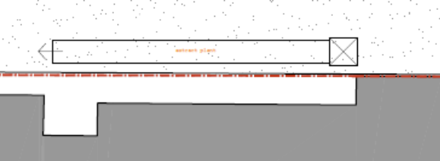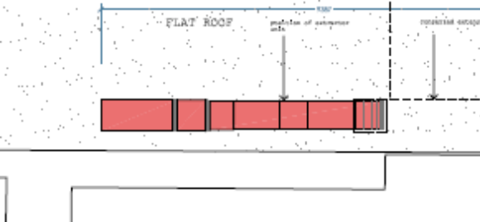

The change of use of the premises from a former launderette to a restaurant no longer requires planning permission as long as the food and drink sold is mostly consumed on the premises (Class E).

The principle of the scheme is therefore, acceptable.

- Design
The objector raises concern over the proposed appearance of the kitchen extract equipment. Whilst it is accepted that this is a relatively large unit, the addition of this extraction unit within the context of the existing rear of the shops, not considered to be visually attractive, is not considered so significantly harmful to warrant refusal on this basis. The fact that the extraction goes along the roof line, rather than vertically would minimise the effect when viewed from ground level. As the following photos demonstrate there would be limited views of the ducting on the ground floor rear extension.

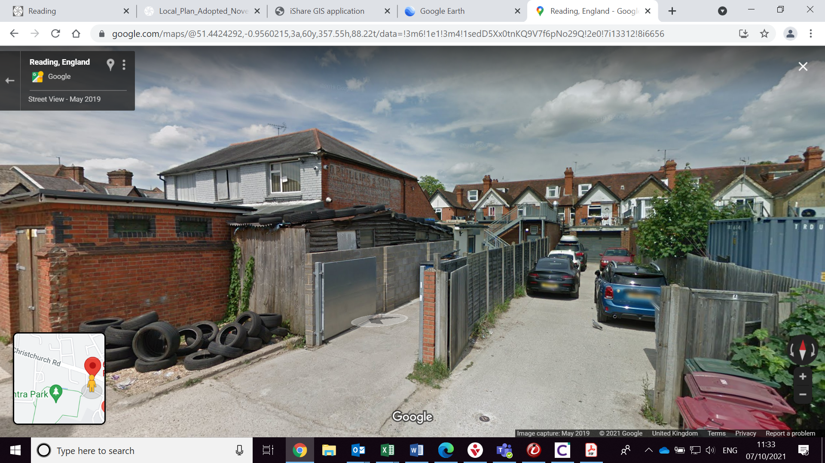
To the rear of the shops – application site is the far left gable ended property (behind Top Gear Tyres)

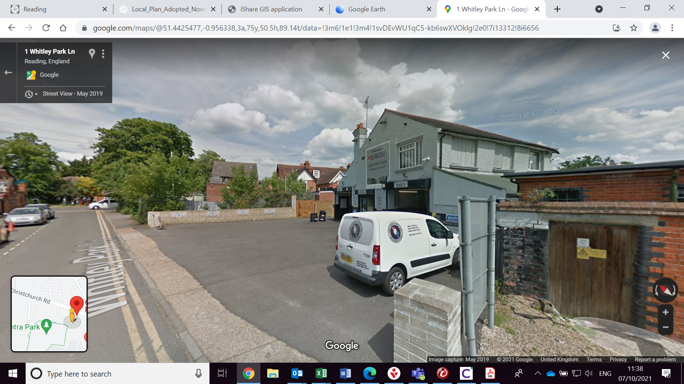
From Whitley Park Lane – limited views of the proposed location for the extraction equipment (first gable ended property from left)
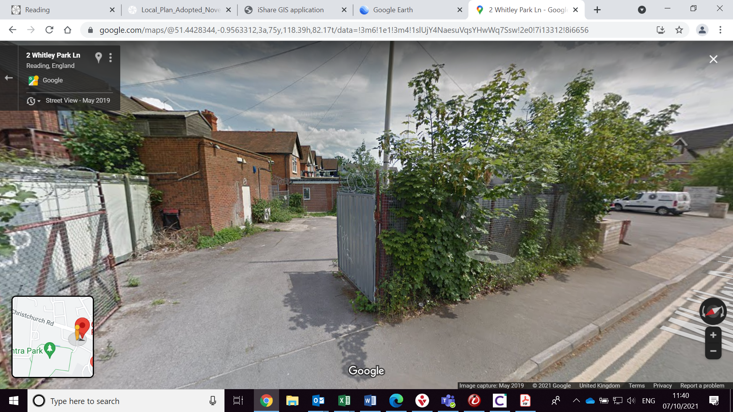
Distant view of single storey extension on which extraction equipment would be located

- Amenity of Residents
The proposed kitchen extraction equipment on the rear flat roof would be in close proximity to residential units and therefore, the following policies are relevant:

Policy CC8: Safeguarding Amenity requires developments to not “cause a detrimental impact on the living environment of existing residential properties or unacceptable living conditions for new residential properties, in terms of:
• Privacy and overlooking; • Access to sunlight and daylight; • Visual dominance and overbearing effects of a development; • Harm to outlook; • Noise and disturbance; • Artificial lighting; • Vibration; • Dust and fumes; • Smell; • Crime and safety; or • Wind..”

Policy EN16: Pollution and Water Resources require developments to not be “damaging to the environment and sensitive receptors through land, noise or light pollution..”.

The applicant submitted an acoustic assessment and odour control report along with technical specifications for the proposed plant, as listed above. These have been assessed by the Environmental Protection and Nuisance Officer and found to be acceptable subject to attaching conditions including limiting the operational hours of the equipment.

Subject to conditions, it is therefore, considered that the proposal would be acceptable and accord with policies CC8 and EN16

RECOMMENDATION:

GRANT

Conditions:
TL1 – Standard time limit 3 years
AP1 – Approved Plans
N8 – Noise Level of Plant
N16 – Hours of operation of kitchen extraction
N12 – Ventilation and extraction as specified

Informatives:
IF5 - Terms and conditions
IF1 - Positive and proactive

