
ATWORTH ARBORICULTURE LTD

Arboricultural Method Statement
Arboricultural Implications Assessment

2, Hungerford Drive,
Reading,
RG1 6JA.

Client:
Mr. Zahid.

Atworth Arboriculture Ltd, 189 Purlpit, Atworth, Wiltshire SN12 8HJ.
Vincentcainey@yahoo.co.uk 01225 708508 07970 467918
Instruction
1.0 Site: 2, Hungerford drive, Reading, RG1 6JA.

Client: Mr. Zahid

1.1 Atworth Arboriculture Ltd was instructed to supply an Arboricultural Method statement and Arboricultural Implications Assessment for the proposed development at the site above.

1.2 Local Planning Authority – Reading Borough Council

2.0 Arboricultural Method Statement Methodology.

2.1. The Arboricultural method statement provides the means by which areas of construction within or near to the Root Protection Area (RPA) of retained trees can be achieved whilst minimising the impact of construction activity on nearby trees.

2.2 This Statement is written assuming approved Preliminary Management Recommendations
(if any) to trees stated in the Tree Schedule Table have since been carried out.

2.3 The excavation of foundations for any structure on sites where trees are present may result in root damage and removal. Where root loss is likely to occur, it is important that a method of construction that minimises the impact on tree roots is utilised.

2.4 Copies of this document will be available for inspection on site.

3.0 Tree Protection Measures
3.1 Before the commencement of any works on site, protective fencing will be erected as specified by the planning conditions to be imposed. The local planning authority will be notified in writing once the fencing is in place. The position of the fencing is shown on the appended Tree Protection Plan (TPP), AA/TPP-08,02,21

3.2 The purpose of the protective fencing is to minimize damage to the tree’s roots and the soil structure surrounding them. Construction activities such as trenching, changing of levels and the storage of spoil and materials is particularly damaging to tree roots, either directly (by physical damage) or indirectly (through the destruction of nearby soil structure through compaction or ‘capping’ which inhibits further root function)
3.3 The specification of the tree protection fencing is illustrated within BS5837:2012 and is a suitable fencing design which should resist light vehicular impact and be difficult to remove casually. The British Standard also provides a more practical, less costly fencing specification which may be suitable for smaller sites. See Figure 1 and 2 below, which provides an example of both RPA protective fencing specifications, in line with BS5837:2012.
3.4 All-weather notices with the words “CONSTRUCTION EXCLUSION ZONE - NO ACCESS” should be attached securely to the barriers in prominent places.

Figure 1:
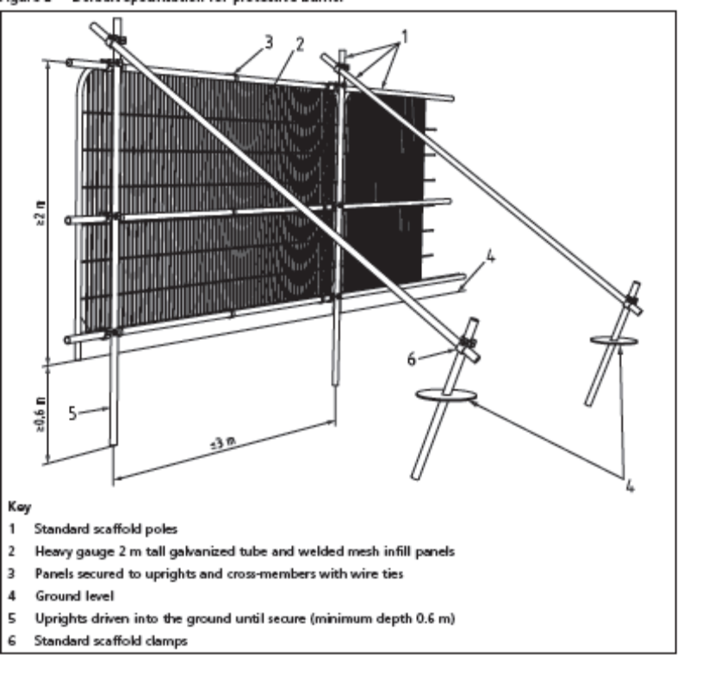
Figure 2 – suitable specifiation for smaller sites:
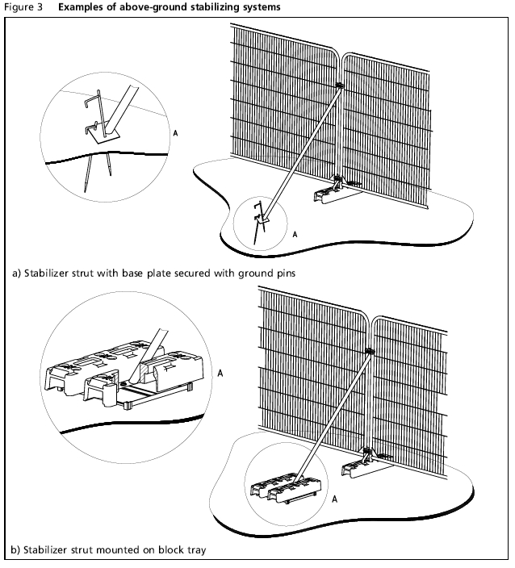

4.0 Ground protection
4.1 Ground Protection measures are to be implemented as access requirements dictate that fencing off the RPA is not appropriate. Ground protection measures which will allow foot traffic access around the footprint without causing soil compaction. Ground protection is shown as the yellow hatched area on the appended Tree Protection Plan AA/TPP-08.02.21 to be laid to the specification of a 100mm deep layer of woodchip laid on top of a geotextile membrane with side abutted scaffold boards laid on top to form a compressible layer suitable for foot traffic and pedestrian operated plant not exceeding 2t.

5.0 Works within RPA.

5.1 No works are to take place in the RPA of any tree.

5.2 Existing roots may be found during building works as 2 Leylandii trees have been removed, one of a diameter of approximately 420mm. The position is shown on the appended TPP.

Arboricultural Implications Assessment (AIA)

6.0 Above Ground Constraints

6.1 Effects of new buildings on amenity value on or near the site
The proposed development is on the footprint of 3 existing outbuildings, a summer house and 2 sheds. The proposed development will be screened from the neighbouring property, 1, Hungerford drive by the 2 trees and should have no effect on the amenity value.

6.2 Pruning and felling works.
No pruning or felling of existing trees is required to facilitate development.
7.0 Below Ground Constraints

No Services are to be routed through the RPA of any tree.

7.0 Precautionary Measures

7.1 It should be the arboriculturist’s duty to monitor site works relating to trees and where necessary take photographs to inform the LPA that the works are taking place in accordance with LPA planning conditions in relation to trees. It remains the responsibility of the LPA to enforce any breach in conditions.

7.2 Any relocated or removed fencing should be replaced as soon as is practicable (once approved works within it are complete) and once again treated as the Construction Exclusion Zone. Any excavations within the RPA that are to be backfilled should be lightly tamped and left proud. Prior to backfilling, retained roots should be surrounded with topsoil or un-compacted sharp sand (builders’ sand should not be used because of its high salt content, which is toxic to tree roots), or other loose inert granular fill, before soil or other suitable material is replaced. This material should be free of contaminants and other foreign objects potentially injurious to tree roots.

7.3 Any tree roots whilst exposed should immediately be wrapped or covered to prevent desiccation and to protect them from rapid temperature changes. Hessian sacking is recommended. Any wrapping should be removed prior to backfilling, which should take place as soon as possible.

7.4 The proposed works within the RPA may be justified by implementing soil amelioration elsewhere if this is deemed suitable. We also recommend soil amelioration as a sound and beneficial tree care strategy. Once all works within the RPA have been completed, a 50-100mm layer of 1-year (minimum) seasoned woodchip mulch should be laid down in a circle of similar size to the tree’s RPA (where practical) in order to help improve the rhizosphere and soil medium in which the tree is growing. This will help ensure the tree’s vitality for the future and minimise the adverse effects of damage to the soil structure and any root removal that may have taken place during the works.

7.5 If roots are found to be in the way during works, they may be pruned back neatly with an appropriate hand saw or bypass secateurs so long as they are below 25mm in diameter. Roots larger than this require arboriculturist advice.

7.6 No materials that are likely to have an adverse effect on tree health such as oil, bitumen or cement (including cement washings) should be stored and handled well away from the outer edge of the RPA. There will be a dedicated materials storage and preparation area. This area is shown as the hatched blue oblong on appended Tree Protection Plan AA/TPP-08.02.21

7.7 Fires on site should be avoided. When they are unavoidable, they should not be lit in a position where heat could affect foliage or branches. The potential size of fire and wind direction should be taken into account when determining its location and it should be attended at all times until safe enough to leave. Also take note of statutory litigations in force in the area before lighting fires.

7.8 No vehicles or pedestrian traffic will be allowed to enter areas once protected by fencing, unless permitted otherwise by the LPA and should be accompanied by the arboriculturist at all times.

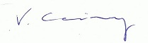
Vince Cainey BSc
8th February 2021.

