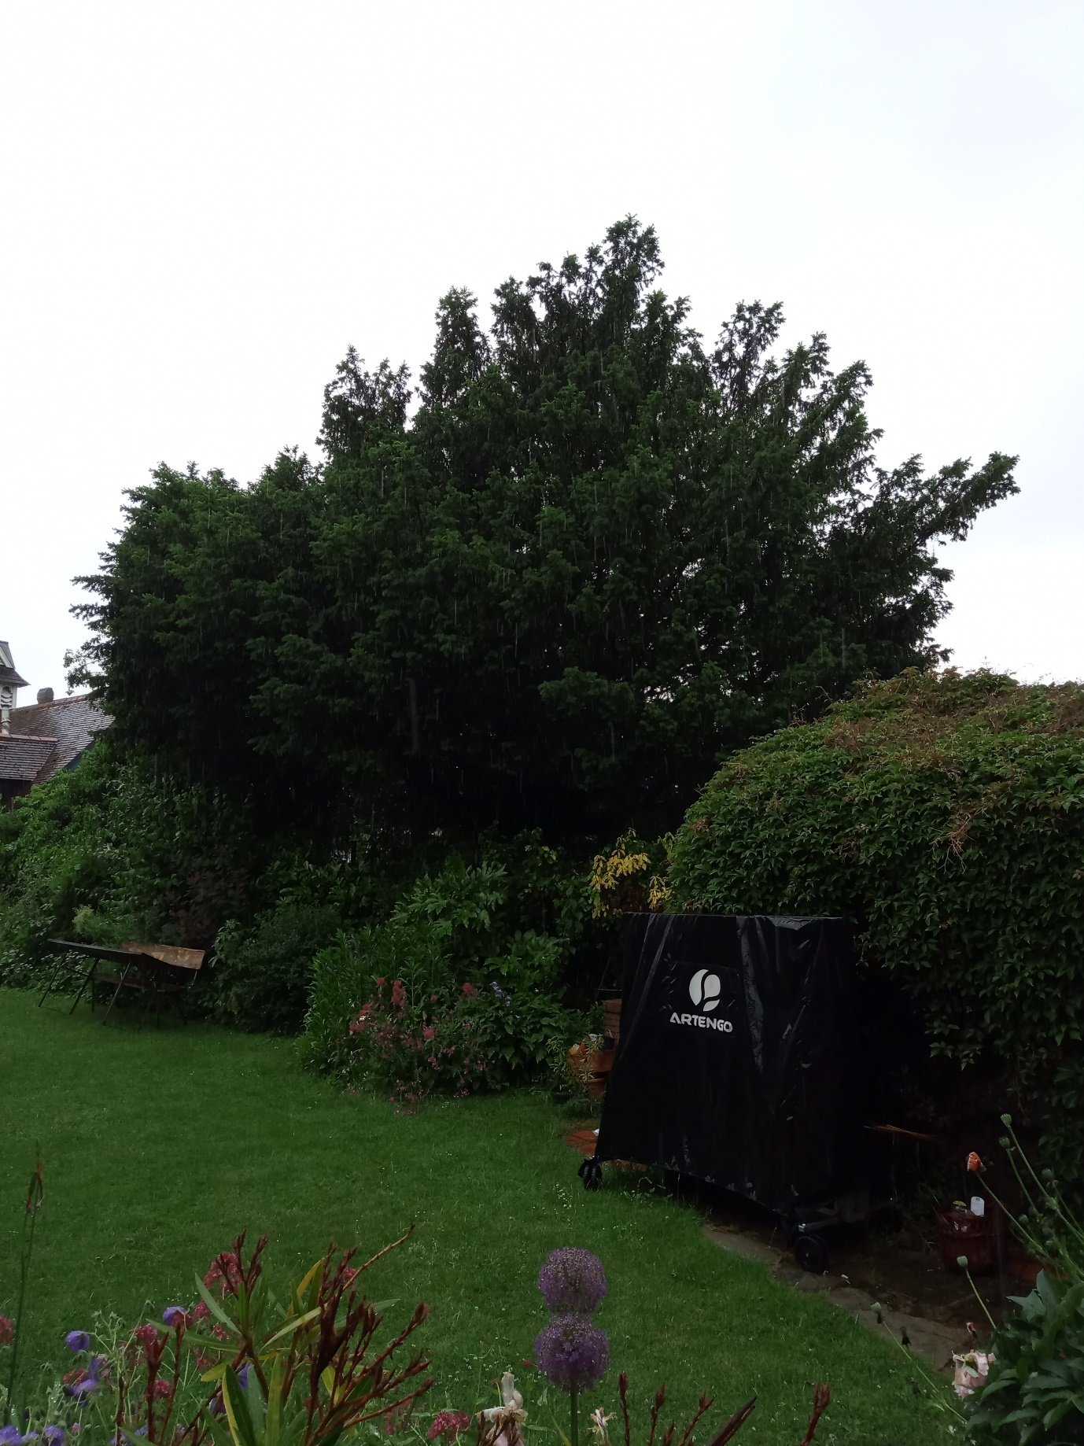
Yew - Branches overhanging garden to be pruned back to 1-1.5m from the boundary fencing, i.e. within the garden, back to suitable growing points.
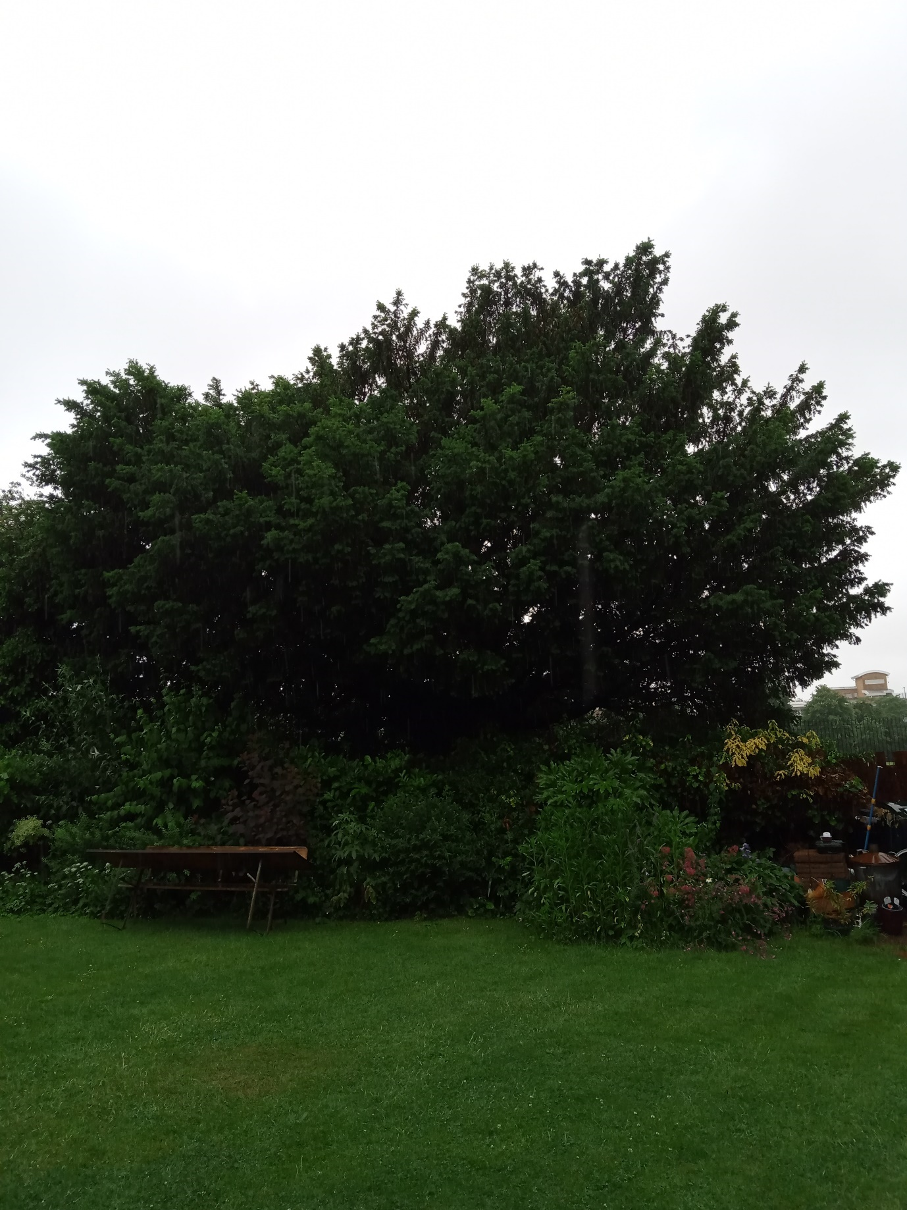
Yew - Indicative reduction / re-shaping
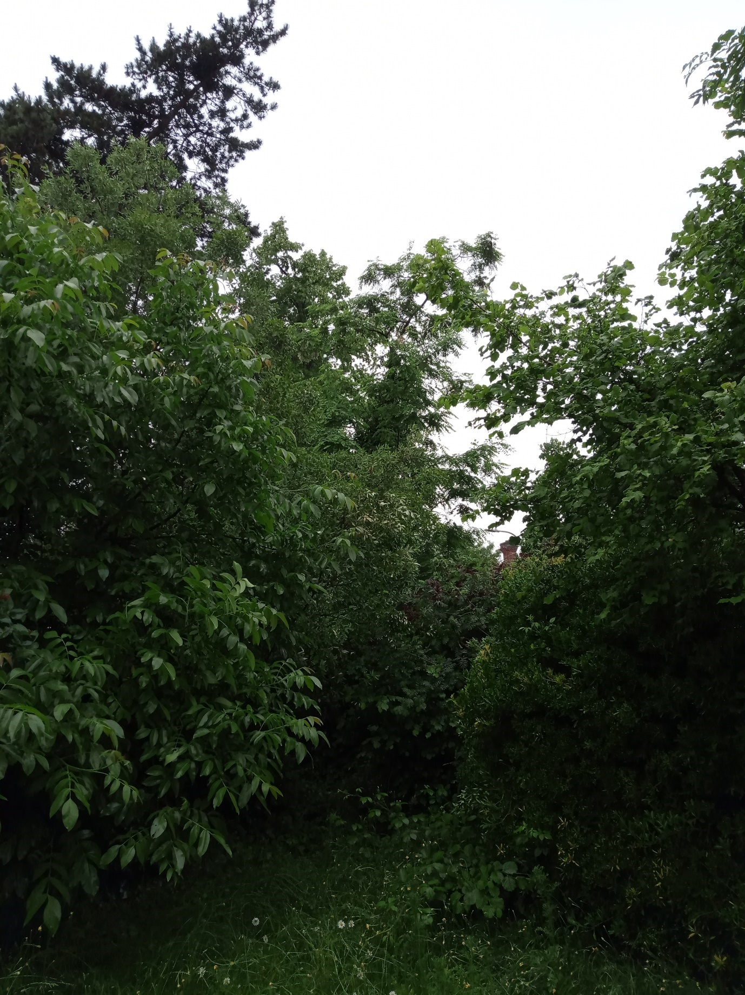
Robinia to be felled
14 Erleigh Road – 18/06/21

