DELEGATED HOUSEHOLDER APPLICATION REPORT

Ward: Tilehurst
App Ref: 211591/HOU
Address: 68 Recreation Road, Reading, RG30 4UA
Proposals: Proposed single storey rear extension and changes to fenestration following demolition of existing side conservatory
Case Officer: Chukwudi Onwudinanti
Applicant: Mr and Mrs Lawrence
Date received (valid from): 24 September 2021
Target Decision date: 19 November 2021

1. INTRODUCTION
The proposed site is a dwelling house located on the southern side of Recreation Road, close to the intersection with Blundells Road. The area comprises semi-detached dwellings of similar size.

2. PROPOSAL AND SUPPORTING INFORMATION
Proposal is for a single storey rear extension with changes to fenestration following demolition of existing side conservatory

Plans considered ( Received 24th September 2021)
Drawing No : 20-68RR-P-00.1.02 - Proposed site Location and block plans
Drawing No : 20-68RR-P-01.1.01 - Existing General Arrangement Floor Plans
Drawing No : 20-68RR-P-01.2.02 - Proposed General Arrangement Floor Plans
Drawing No : 20-68RR-P-02.1.04 - Existing & Proposed external Elevations
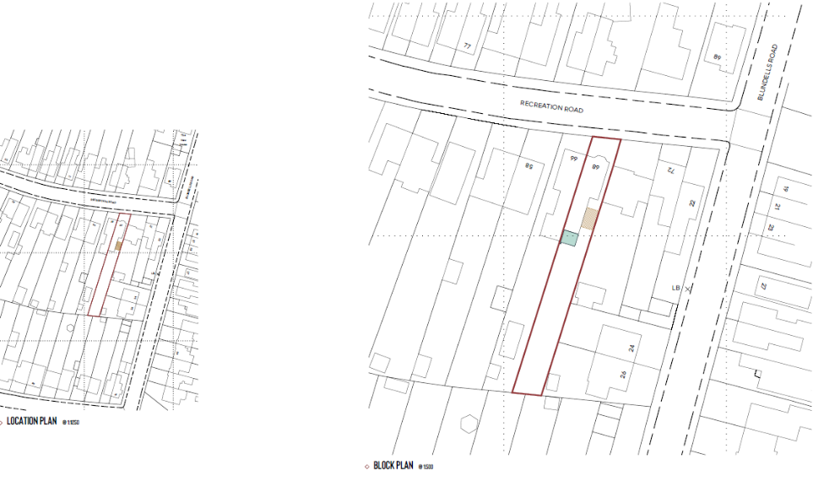

- RELEVANT PLANNING HISTORY
None

4. CONSULTATIONS

4.1 The following addresses were consulted by letter.

53 Gratwicke Road, Tilehurst, Reading, Berkshire, RG30 4TU
66 Recreation Road, Tilehurst, Reading, RG30 4UA
70 Recreation Road, Tilehurst, Reading, RG30 4UA
55 Gratwicke Road, Tilehurst, Reading, RG30 4TU

4.2 No letters of representation have been received.

Equality Act 2010:
In determining this application the Council is required to have regard to its obligations under the Equality Act 2010. However, there is no indication or evidence (including from consultation on the application) that the protected groups identified by the Act have or will have different needs, experiences, issues and priorities in relation to this particular planning application. Therefore in terms of the key equalities protected characteristics it is considered there would be no significant adverse impacts as a result of the development.

5. LEGAL AND PLANNING POLICY CONTEXT
Section 38(6) of the Planning and Compulsory Purchase Act 2004 requires that proposals be determined in accordance with the development plan unless material considerations indicate otherwise. Material considerations include relevant policies in the National Planning Policy framework (NPPF) - among them the 'presumption in favour of sustainable development'. The following local and national planning policy and guidance is relevant to this application:

National Policy
National Planning Policy Framework
National Planning Practice Guidance

Reading Borough Local Plan (2019)
CC7 (Design and the Public Realm)
CC8 (Safeguarding Amenity)
H9 (House Extensions and Ancillary Accommodation)

SPD
- A Design Guide to House Extensions SPG

6. APPRAISAL

H9 states: An extension to a house will be acceptable where it:

- Respects the character of the house in terms of scale, location, materials and design;

To assess this, the following has been considered – would the proposal:
- detract from the appearance of the original building through the use of ill-matching materials and by not fitting in with the design, scale and proportions of the original building; NO, the proposal would be for a modest rear extension inline with that at no. 66, and the materials would match existing.
- reduce the amount of usable amenity space for the property to an unacceptable degree; NO
- require the loss of trees in the garden or put significant trees at risk; NO

- Respects the character and pattern of neighbouring properties and the street as a whole in terms of scale, location, materials and design, and any important existing building line; Respects neighbour’s amenities and does not present a large blank façade to public areas.

To assess this, the following has been considered – would the proposal:
- significantly reduce the amount of daylight and sunlight enjoyed by neighbouring properties; NO, as the 45 degree check on the adjoining dwelling unit shows no daylight or sunlight negative impact.
- invade the privacy of neighbouring properties through overlooking from windows or balconies; NO, as the extension is below 4 metres, with a flat roof and the windows on the side facing the adjoining dwelling are 1 metre from the ground and not more than 2.2 metres in height.
- detract from the character of neighbouring properties through siting, excessive bulk, ill-matching materials or inconsistent design; NO
- detract from the appearance of the street or area by using ill-matched materials, glazing and detailing; NO, as the whole extension is to the rear of the dwelling.

CC8: Safeguarding Amenity states an extension to a house will be acceptable where it will not cause a significant detrimental impact to the living environment of existing or new residential properties.

To assess this, the following has been considered – would the proposal cause a significant detrimental impact to the living environment of existing or new residential properties in terms of:

- Privacy and overlooking;
- Access to sunlight and daylight;
- Visual dominance and overbearing effects of a development;
- Noise and disturbance;
- Artificial lighting;
- Vibration;
- Dust and fumes;
- Smell;
- Crime and safety.

- CONCLUSION
The proposed development has been assessed and the proposed works are considered to be in accordance with the above relevant policies and planning permission can be granted.

8. RECOMMENDATION
Grant

