DELEGATED HOUSEHOLDER APPLICATION REPORT

Ward: Redlands
App Ref: 211467/HOU
Address: 69 Alexandra Road, Reading, RG1 5PS
Proposals: Construction of glazed canopy / awning attached to the side of the house
Case Officer: Chukwudi Onwudinanti
Applicant: Mr Robert Elsie
Date received (valid from): 3 September 2021 Target Decision date: 29 October 2021

- INTRODUCTION

The development site is on a semi-detached residential dwelling located on the eastern side of Alexandria load, in a row of similar semi-detached dwelling units.

- PROPOSAL AND SUPPORTING INFORMATION

Applicant is seeking to attach a glazed canopy / awning to the side of the building, using a roof covering of glazing within coated aluminium framework over coated steel posts. The structure is 5.68m deep, 4.58m wide, overall height of 3.645m and will be within the boundaries of the existing building envelope.

Plans considered (Received 06/09/2021):
- PLA001 - Existing floor plan and elevations
- PLA002 - Proposed floor plan and elevations
- PLA003 – Location and Block plans

- RELEVANT PLANNING HISTORY

APP Ref: 010204
Proposal: Single storey rear extension and new roof to existing extension
Decision: Delegated Decision - Application Permitted.
Decision date: 14/6/2001

- CONSULTATIONS

  - The following addresses were consulted by letter.

62 Donnington Gardens, Reading, Berkshire, RG1 5LZ
Flat 1, 71 Alexandra Road, Reading, RG1 5PS
67 Alexandra Road, Reading, RG1 5PS
64 Donnington Gardens, Reading, RG1 5LZ
Flat 6, 71 Alexandra Road, Reading, RG1 5PS
Flat 5, 71 Alexandra Road, Reading, RG1 5PS
Flat 4, 71 Alexandra Road, Reading, RG1 5PS
Flat 3, 71 Alexandra Road, Reading, RG1 5PS
Flat 2, 71 Alexandra Road, Reading, RG1 5PS

  - No letters of representation have been received.

Equality Act 2010:
In determining this application, the Council is required to have regard to its obligations under the Equality Act 2010. However, there is no indication or evidence (including from consultation on the application) that the protected groups identified by the Act have or will have different needs, experiences, issues and priorities in relation to this particular planning application. Therefore, in terms of the key equalities protected characteristics it is considered there would be no significant adverse impacts as a result of the development.

- LEGAL AND PLANNING POLICY CONTEXT

Section 38(6) of the Planning and Compulsory Purchase Act 2004 requires that proposals be determined in accordance with the development plan unless material considerations indicate otherwise. Material considerations include relevant policies in the National Planning Policy framework (NPPF) - among them the 'presumption in favour of sustainable development'. The following local and national planning policy and guidance is relevant to this application:

National Policy
National Planning Policy Framework
National Planning Practice Guidance

Reading Borough Local Plan (2019)
CC7 (Design and the Public Realm)
CC8 (Safeguarding Amenity)
H9 (House Extensions and Ancillary Accommodation)
EN3 Enhancement of Conservation Areas

SPD
- A Design Guide to House Extensions SPG

- APPRAISAL

H9 states: An extension to a house will be acceptable where it:

- Respects the character of the house in terms of scale, location, materials and design;

To assess this, the following has been considered – would the proposal:
- detract from the appearance of the original building through the use of ill-matching materials and by not fitting in with the design, scale and proportions of the original building; NO
- reduce the amount of usable amenity space for the property to an unacceptable degree; NO
- require the loss of trees in the garden or put significant trees at risk; NO

- Respects the character and pattern of neighbouring properties and the street as a whole in terms of scale, location, materials and design, and any important existing building line; Respects neighbour’s amenities and does not present a large blank façade to public areas.

To assess this, the following has been considered – would the proposal:
- significantly reduce the amount of daylight and sunlight enjoyed by neighbouring properties; NO
- invade the privacy of neighbouring properties through overlooking from windows or balconies; NO
- detract from the character of neighbouring properties through siting, excessive bulk, ill-matching materials or inconsistent design; NO
- detract from the appearance of the street or area by using ill-matched materials, glazing and detailing; NO

CC8: Safeguarding Amenity states an extension to a house will be acceptable where it will not cause a significant detrimental impact to the living environment of existing or new residential properties.

To assess this, the following has been considered – would the proposal cause a significant detrimental impact to the living environment of existing or new residential properties in terms of:

- Privacy and overlooking; NO
- Access to sunlight and daylight; NO
- Visual dominance and overbearing effects of a development; NO
- Noise and disturbance; NO
- Artificial lighting; NO
- Vibration; NO
- Dust and fumes; NO
- Smell; NO
- Crime and safety. NO

EN3 Enhancement of Conservation Areas: In considering this application, in addition to internal consultation, the appraisal for the Alexandra Road Conservation Area has been considered and the activities sought to be controlled in the Conservation Area are:
- The installation of new windows and doors to the principal elevations; NO
- Alterations to the roof, including changing the roof materials and installing rooflights; NO
- Building a porch; NO
- The erection of sheds and other outbuildings; NO
- Creating an access onto the road; NO
- Building a hard standing; NO
- The erection or alteration of gates, fences or walls; NO
- Painting the exterior of a building. NO

- CONCLUSION
The proposed development has been assessed and the proposed works are considered to be in accordance with the above relevant policies and planning permission can be granted.

8.0 RECOMMENDATION
GRANT APPROVAL

9. CONDITIONS

- TL1 Standard time-limit
- AP1 Standard approved plans
- M3 Materials as specified

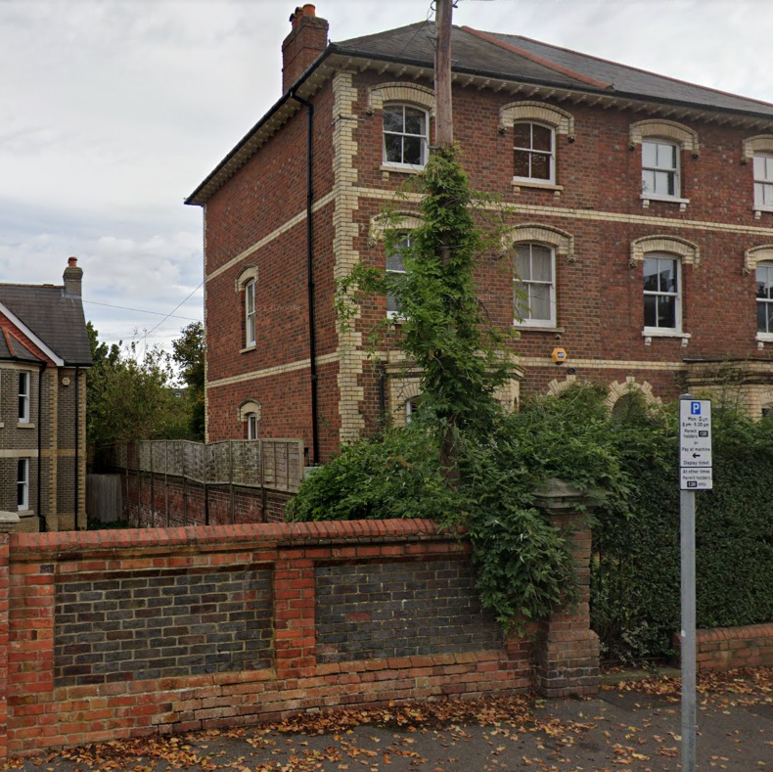

View from the road looking towards the side of the application site where the canopy/awning is to be sited

