DELEGATED APPLICATION REPORT - CERTIFICATE OF LAWFULNESS
Application No: 201805/CLE
Site Address: 539 Basingstoke Road, Reading
Proposal: Certificate of lawfulness for change of use of property from single dwelling house into 2no 1 bedroom flats (one on ground floor and one on the first floor). Original description – Conversion of property into two self contained flats.
Case Officer: Julie Williams
Target Date: 9/2/2021 - extended to 9/3/2021

SITE DESCRIPTION
The site is a mid-terrace house, possibly originally with 2 bedrooms. See plan and photo below.
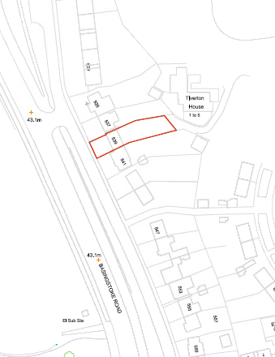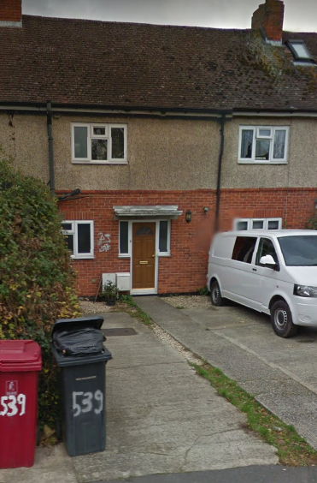
PROPOSAL
A certificate is sought to confirm that the existing use is as two self-contained 1 bedroom flats.

The NPPG provides guidance on details that must be included in each type of lawful development certificate (section 191(5) or 192(3) of the Act. Precision in the terms of any certificate is vital, so there is no room for doubt about what was lawful at a particular date, as any subsequent change may be assessed against it.

In particular a certificate for existing use must include a description of the use, operations or other matter for which it is granted regardless of whether the matters fall within a use class. But where it is within a “use class”, a certificate must also specify the relevant “class”. In all cases, the description needs to be more than simply a title or label, if future problems interpreting it are to be avoided. The certificate needs to therefore spell out the characteristics of the matter so as to define it unambiguously and with precision. This is particularly important for uses which do not fall within any “use class” (ie “sui generis” use) and in situations where there are mixed uses.
In accordance with this guidance and in view of how the site has been operated the description for the certificate has been amended, in agreement with the agent and legal advice as shown above.
PLANS SUBMITTED
Block Plan BR 539-001
Location Plan BR 539-002
Existing floor plans BR539:003
RELEVANT PLANNING HISTORY OF THE SITE
None on record
RELEVANT PLANNING POLICY AND GUIDANCE
Section 10 of the Planning and Compensation Act 1991 established a procedure that enables anyone who wishes to do so, to apply to the local planning authority to determine whether a proposed use or operation, or an existing operational development or an existing use of land, or any other matter constituting a failure to comply with any condition or limitation subject to which planning permission has been granted, is lawful, and if so, be granted a certificate to that effect.

A Lawful Development Certificate is a legal document stating the lawfulness of past, present or future development. If granted by the local planning authority, the certificate means that enforcement action cannot be carried out to the development referred to in the certificate. However, the certificate will not protect from enforcement action by the planning authority if the specified use or development is then changed 'materially' without a planning application for it.

The certificate is not a planning permission. The planning merits of the use, operation or activity in the application are not relevant. The issue of a certificate depends entirely on factual evidence about the history and planning status of the building or other land and the interpretation of any relevant planning law or judicial authority. The responsibility is on the applicant to provide evidence to support the application.

RESPONSE TO CONSULTATIONS
Legal – Legal have advised
I have considered the attached documents that you have provided. In addition I have read the Affidavit by Satinder Luthra (Owner) dated 9th December 2020.
Assessment of evidence

The Affidavit by Satinder Luthra (Owner) states that the single dwelling was converted between May to September 2007 into two flats. From July 2016 for a period of 4 years the 2 flats were occupied as separate flats. Each contacted a kitchen, bathroom, living area and bedroom.

The applicant has provided a number of tenancy agreements. These support the claim that a residential use has occurred for the relevant 4 year period, albeit with gaps. The length of these gaps i.e. one month and one week are de minimis, taking into consideration the nature of the use applied for.

In addition Gas Safety check certificates for each of the flats dated 2013, 2016 & 2020 have been provided. This further supports the claim that the property has been used as separate flats.

The evidence supporting the application needs to support the claim that the 2 flats were converted into separate self-contained dwellings at the commencement of the 4 year period. As per Gravesham Borough Council v Secretary of State for the Environment (1984) 47 P&CR 142, the LPA needs to be presented with evidence that the flats contained the facilities for day to day living and have been used as such.

The evidence provided on balance supports the application. In the absence of being made aware of any information to the contrary, the application should be granted.

Council Tax – Not aware this has been split into flats, we have this as one single dwelling which has been banded since at least 01.04.1997.
Enforcement – No records held.
Electoral Services – Data provided.

EVIDENCE SUBMITTED
The agent supplied the following supporting documents:

Supporting Statement
Affidavit by Satinder Luthra (Owner) dated 9th December 2020 and witnessed by Dexter Montague Solicitors of 105 Oxford Road.
Tenancy Agreements for Ground Floor Flat for 2016 – current day
Tenancy Agreement for First Floor Flat for 2016 – current day
Gas Safety check certificates for both flats dated 2013, 2016 & 2020.

ANALYSIS OF EVIDENCE (ASSESSMENT)
For the purposes of establishing the lawful use of the site as claimed by the applicant , the applicant must demonstrate that the two flats have been in place for 4 years leading up to the date the application is submitted, subject to no enforcement action having been taken on the property.

The relevant time period in this case is 4th December 2016 to 3rd December 2020.

The applicant has submitted evidence in the form of tenancy agreements and tenancy associated documents that cover the relevant time period. The LPA has no evidence of its own that disagrees with this evidence and Officers are therefore satisfied that the evidence provided is sufficient to show that the property has been used as claimed by this application.

Therefore it can be confirmed that the property known as 539 Basingstoke Road has been in use as a two 1 bedroom flats (Use Class C3) for more than 4 years and a Certificate can be issued to this effect.

Council tax will sort out separately with the owner how the properties are identified.

Recommendation
Grant Certificate

RECOMMENDATION
GRANT Certificate
