DELEGATED APPLICATION REPORT
Ward: Abbey
App Ref: 211181 / FUL
Address: 31 Kingsgate Street, Reading, RG1 3JR
Proposals: Single storey front extension.
Applicant: Mrs Mary Oduekun
Case Officer: Beatrice Malama
Date received (valid from): 16/07/2021 Determination date: 04/10/2021
Agreed Target Date: 11/10/2021

SITE DESCRIPTION
The proposal site is a single-story detached property located east of Kingsgate Street. The property which is currently used as a place of worship is bordered by a block of flats to the south and a carpark to the east. Facing the site across Kingsgate Street to the west is another large carpark. The area has mixed use developments of various scales, character and appearance. There are several Highrise buildings located near the site. The property is not listed nor located in a conservation area however it is within an Air Quality Management Area.
Photo 1: Existing front elevation of the site and adjoining property (block of flats) to the south
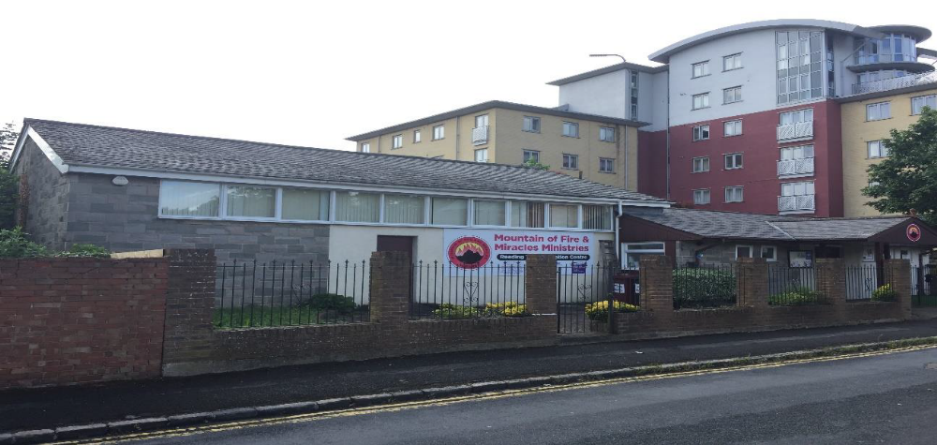
Photo 2: Northern View of the Site
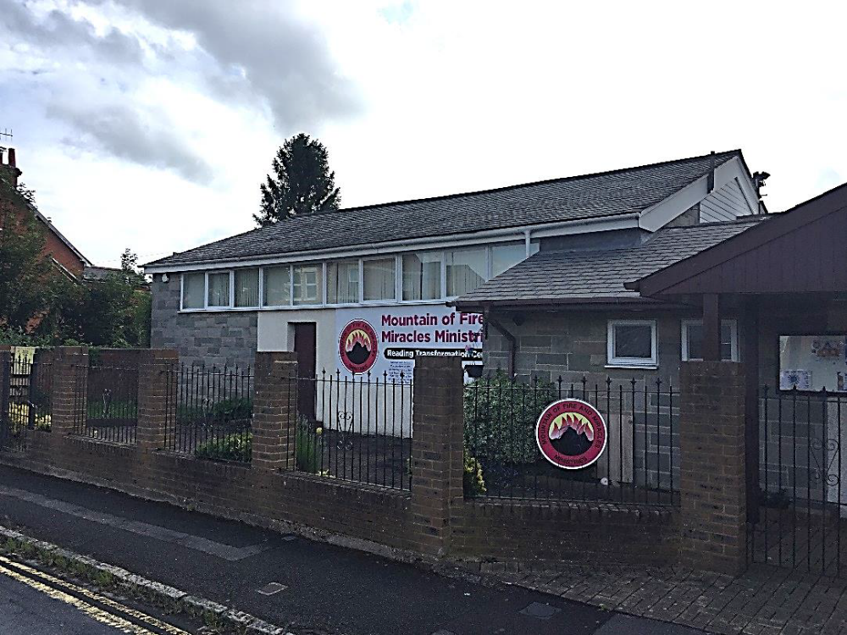
PROPOSED DEVELOPMENT
The proposed development is a single-story front extension to a church building. The proposed extension would have exterior walls and finishing materials matching the existing building and it would have a pitched roof. The proposed front extension measures 4.1m deep forward of the existing building line to the front and 5.12m wide.
Plans/documents considered:
Drawing No: 01 - Existing Ground Floor Plan
Drawing No: 02 - Existing Roof Plan
Drawing No: 04 - Existing Elevations
Drawing No: 05 - Existing Elevations
Drawing No: 06 - Existing Block Plan
Drawing No: 07 - Proposed Ground Floor Plan
Drawing No: 08 - Proposed Roof Plan
Drawing No: 10 - Proposed Elevations
Drawing No: 11 - Proposed Elevations
Drawing No: 12 – Proposed Block Plan
Site Location Plan dated 16/07/2021
Received on 16th July 2021

Planning Statement Received on 10th August 2021

RELEVANT PLANNING HISTORY
No Planning history

CONSULTATIONS
A site notice was sent to the agent on 10th August 2021 and the following addresses were consulted by letter.
20 Kingsgate Street, Reading, RG1 3JR
25 Kingsgate Street, Reading, RG1 3JR
The Pinnacle Apartments
No letters of representation were received

Equality Act 2010
In determining this application the Council is required to have regard to its obligations under the Equality Act 2010. However, there is no indication or evidence (including from consultation on the application) that the protected groups identified by the Act have or will have different needs, experiences, issues and priorities in relation to this particular planning application. Therefore in terms of the key equalities protected characteristics it is considered there would be no significant adverse impacts as a result of the development.

Relevant Planning Policy and Guidance
Section 38(6) of the Planning and Compulsory Purchase Act 2004 requires that proposals be determined in accordance with policies in the development plan unless material considerations indicate otherwise. Material considerations include relevant policies in the National Planning Policy framework (NPPF) - among them the 'presumption in favour of sustainable development'. The Development Plan for Reading relevant to the application site comprises the Reading Borough Local Plan (adopted November 2019).
The ‘National Planning Policy framework’ (‘’NPPF’’) 2019 states clearly states that its content is to be a material consideration in the determination of applications. The ‘NPPF’ states that due weight should be given to the adopted policies of the Local Plan according to their degree of consistency with the ‘NPPF’ (the closer the policies in the plan to the policies in the ‘NPPF’, the greater the weight that may be given).

National Policy
National Planning Policy Framework (2021)
National Planning Practice Guidance

Reading Borough Local Plan (2019)
CC7 Design and the Public Realm
CC8 Safeguarding Amenity
OU1 New and Existing Community Facilities

Assessment
Character and appearance
Policy CC7 (Design and the Public Realm) requires that all developments be of high design quality.
The area is characterised by properties of different types, character and scale. The proposed front extension would be single story with a design and exterior finishing materials matching the existing building. The proposed extension would be forward of the existing building line to the front however it would be in line with the existing building line of the front porch located to the southern end of the host building and would have a front gable to match the existing front porch. The roof ridgeline of the extension would be lower than the existing building allowing the primacy of the original building to be retained. The extension would mirror the existing front porch in terms of character and appearance. Whilst the extension would be visible to the public realm, as the proposal is in keeping with the character and appearance of the existing property, it would not harm the appearance of the existing property nor would it have a harmful impact on the appearance of the street. The extension therefore complies with Policy CC7.
Photo 3: Existing Front Porch
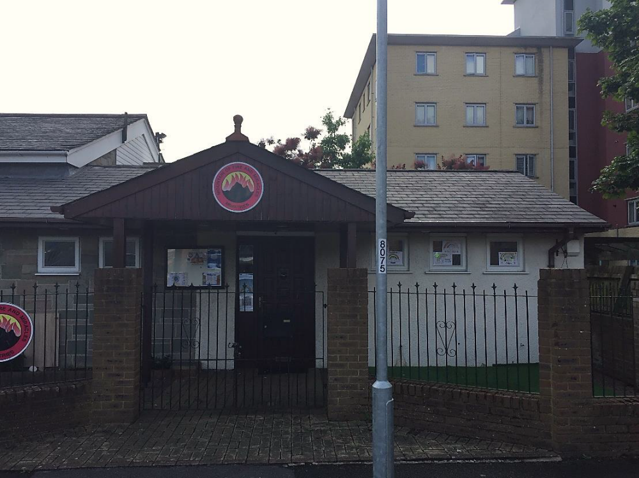

Impact on neighbouring properties
CC8 (Safeguarding Amenity) seeks to prevent development causing detrimental impact on the neighbouring properties:
The site is bordered by a multi-story building to the south and to the north is an undeveloped piece of land. To the rear of the site is a car park. The proposed extension is single story and there is adequate gap between the site and adjoining properties and/or the nearest residential properties therefore it is considered that the extension would not have detrimental impact on the living conditions of the occupants of neighbouring properties. The proposed front extension therefore complies with Policy CC8.

CONCLUSION
The proposed development is considered to be in accordance with the Reading Borough Local Plan (2019) and therefore the application is recommended for approval subject to conditions.

RECOMMENDATION
GRANT

CONDITIONS
- Time Limit (Standard) TL1
- Approved Plans Ap1
- Materials (To Match) M1

INFORMATIVES
IF5: Terms
IF6: Building Control
IF7: Complaints about construction
IF8: Encroachment

