DELEGATED HOUSEHOLDER APPLICATION REPORT

Ward: Peppard
App Ref: 211593/HOU
Address: 51 Knights Way, Reading, RG4 8RJ
Proposals: Single storey rear extension and front porch
Case Officer: Chukwudi Onwudinanti
Applicant: Mr & Mrs M Elsby
Date received (valid from): 24 September 2021
Target Decision date: 19 November 2021

1. INTRODUCTION
This development is proposed for a mid-terrace dwelling, on the eastern side of Knights Way. It is part of a series of banks of terraced buildings of similar size on both sides of the street, of the same architectural style.

2. PROPOSAL AND SUPPORTING INFORMATION
The proposal is for a Single storey rear extension and development of a front porch.

Plans considered (Received 27th September 2021)
BA0183-01a - Existing Plans and Elevations
BA0183-02 - Proposed Plans and Elevations

The agent was advised by planning officer to amend the design for the front porch aspect of the application and that aspect was amended with the submission of the following:

BA0183-02a – Proposed Plans and Elevations (Received 2nd November 2021)

The Planning Officer requested a further amendment to the roof of the proposed front porch. An amended plan was received as follows:

BA0183-02b – Proposed Plans and Elevations (Received 5th November 2021)

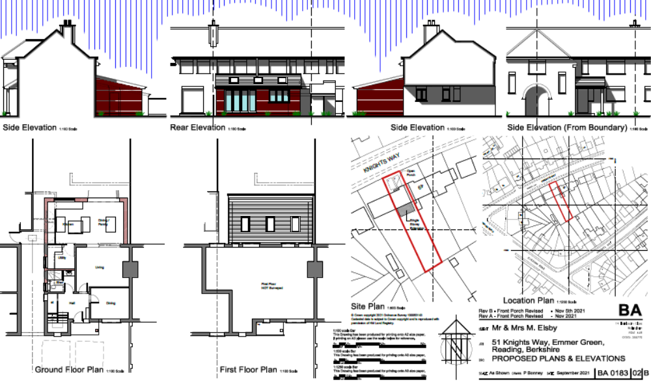

- RELEVANT PLANNING HISTORY
None

4. CONSULTATIONS

4.1 The following addresses were consulted by letter.

5 Knights Way, Emmer Green, Reading, RG4 8RJ
53 Knights Way, Emmer Green
49 Knights Way, Emmer Green, Reading, RG4 8RJ
80 Knights Way, Emmer Green, Reading, RG4 8RH

4.2 No letters of representation have been received.

Equality Act 2010:
In determining this application the Council is required to have regard to its obligations under the Equality Act 2010. However, there is no indication or evidence (including from consultation on the application) that the protected groups identified by the Act have or will have different needs, experiences, issues and priorities in relation to this particular planning application. Therefore in terms of the key equalities protected characteristics it is considered there would be no significant adverse impacts as a result of the development.

- LEGAL AND PLANNING POLICY CONTEXT
Section 38(6) of the Planning and Compulsory Purchase Act 2004 requires that proposals be determined in accordance with the development plan unless material considerations indicate otherwise. Material considerations include relevant policies in the National Planning Policy framework (NPPF) - among them the 'presumption in favour of sustainable development'. The following local and national planning policy and guidance is relevant to this application:

National Policy
National Planning Policy Framework
National Planning Practice Guidance

Reading Borough Local Plan (2019)
CC7 (Design and the Public Realm)
CC8 (Safeguarding Amenity)
H9 (House Extensions and Ancillary Accommodation)

SPD
- A Design Guide to House Extensions SPG

6. APPRAISAL

H9 states: An extension to a house will be acceptable where it:

- Respects the character of the house in terms of scale, location, materials and design;

To assess this, the following has been considered – would the proposal:
- detract from the appearance of the original building through the use of ill-matching materials and by not fitting in with the design, scale and proportions of the original building; NO, the planning officer requested that the initial design be amended to ensure the front porch design would be in keeping with the predominant design on the street scene. The rear extension is within the acceptable limits as set out in the SPD.
- reduce the amount of usable amenity space for the property to an unacceptable degree; NO, the rear extension conforms to maintaining the amenity space in the rear garden.
- require the loss of trees in the garden or put significant trees at risk; NO, no trees are affected by this proposal.

- Respects the character and pattern of neighbouring properties and the street as a whole in terms of scale, location, materials and design, and any important existing building line; Respects neighbour’s amenities and does not present a large blank façade to public areas.

To assess this, the following has been considered – would the proposal:
- significantly reduce the amount of daylight and sunlight enjoyed by neighbouring properties; NO
- invade the privacy of neighbouring properties through overlooking from windows or balconies; NO, the proposal does not have any windows or balconies facing the adjourning properties.
- detract from the character of neighbouring properties through siting, excessive bulk, ill-matching materials or inconsistent design; NO, the proposal is within acceptable scale as set out in the SPD.
- detract from the appearance of the street or area by using ill-matched materials, glazing and detailing; NO, as stated above, this concern was resolved with the amended design.

CC8: Safeguarding Amenity states an extension to a house will be acceptable where it will not cause a significant detrimental impact to the living environment of existing or new residential properties.

To assess this, the following has been considered – would the proposal cause a significant detrimental impact to the living environment of existing or new residential properties in terms of:

- Privacy and overlooking;
- Access to sunlight and daylight;
- Visual dominance and overbearing effects of a development;
- Noise and disturbance;
- Artificial lighting;
- Vibration;
- Dust and fumes;
- Smell;
- Crime and safety.

- CONCLUSION
The proposed development has been assessed and the proposed works are considered to be in accordance with the above relevant policies and planning permission can be granted.

8.0 RECOMMENDATION
Grant

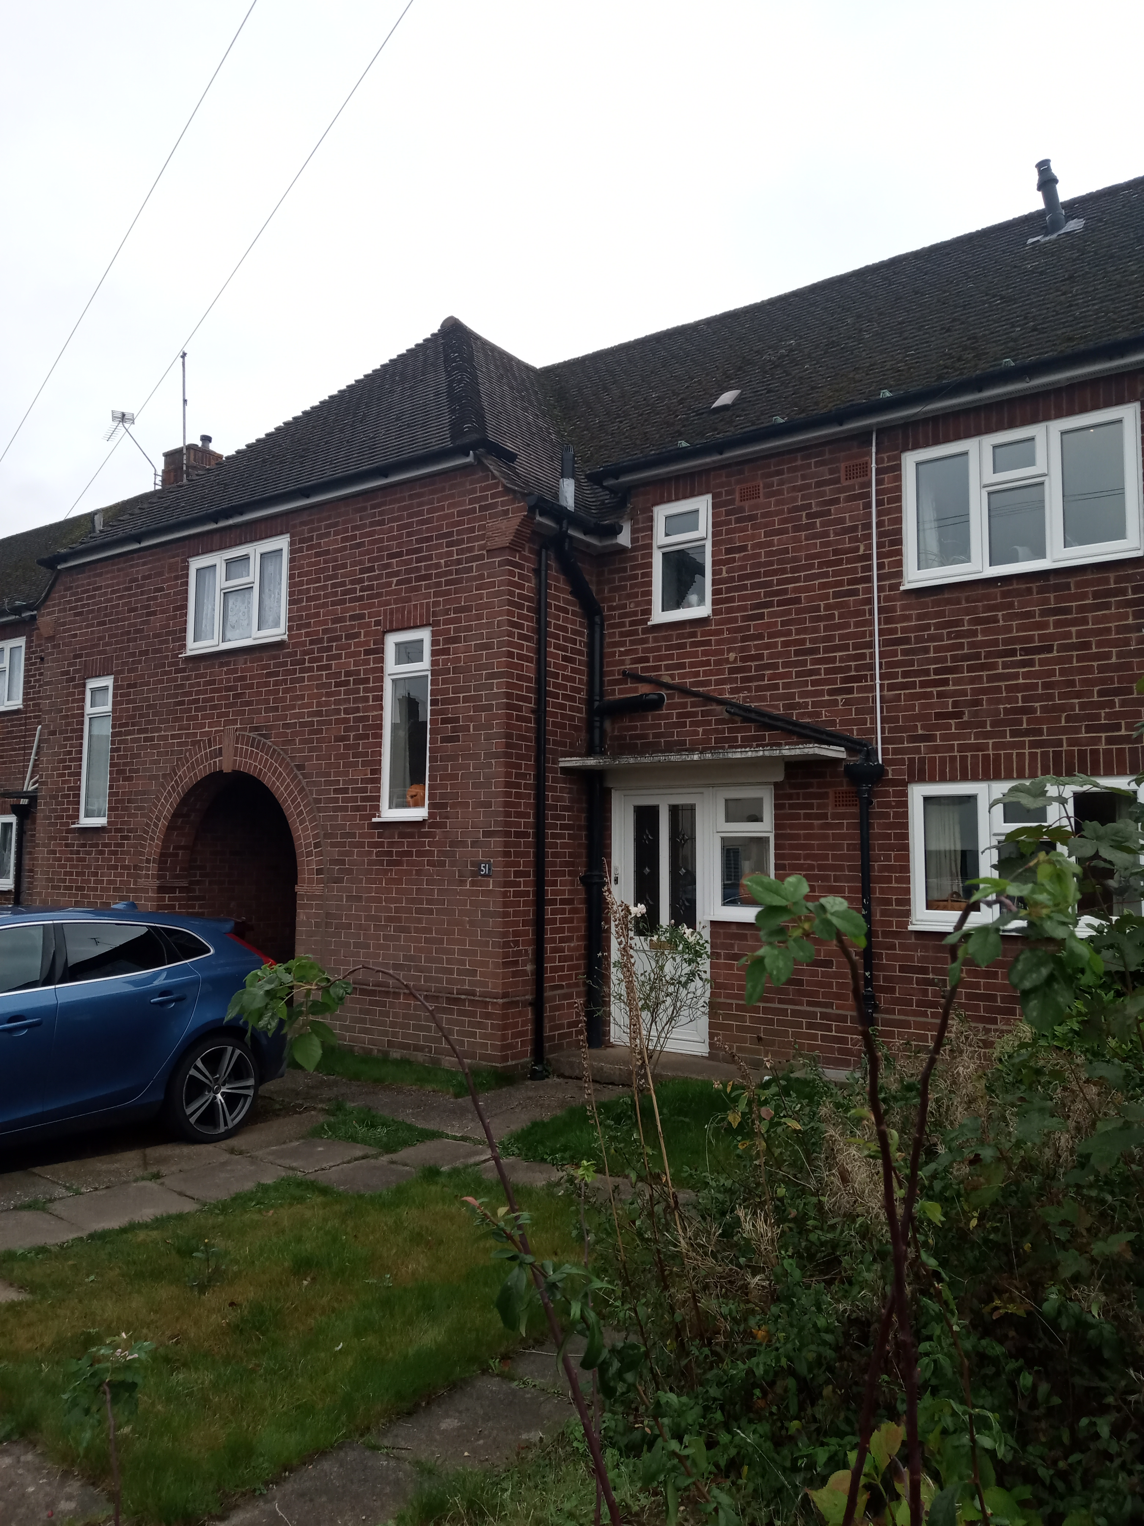
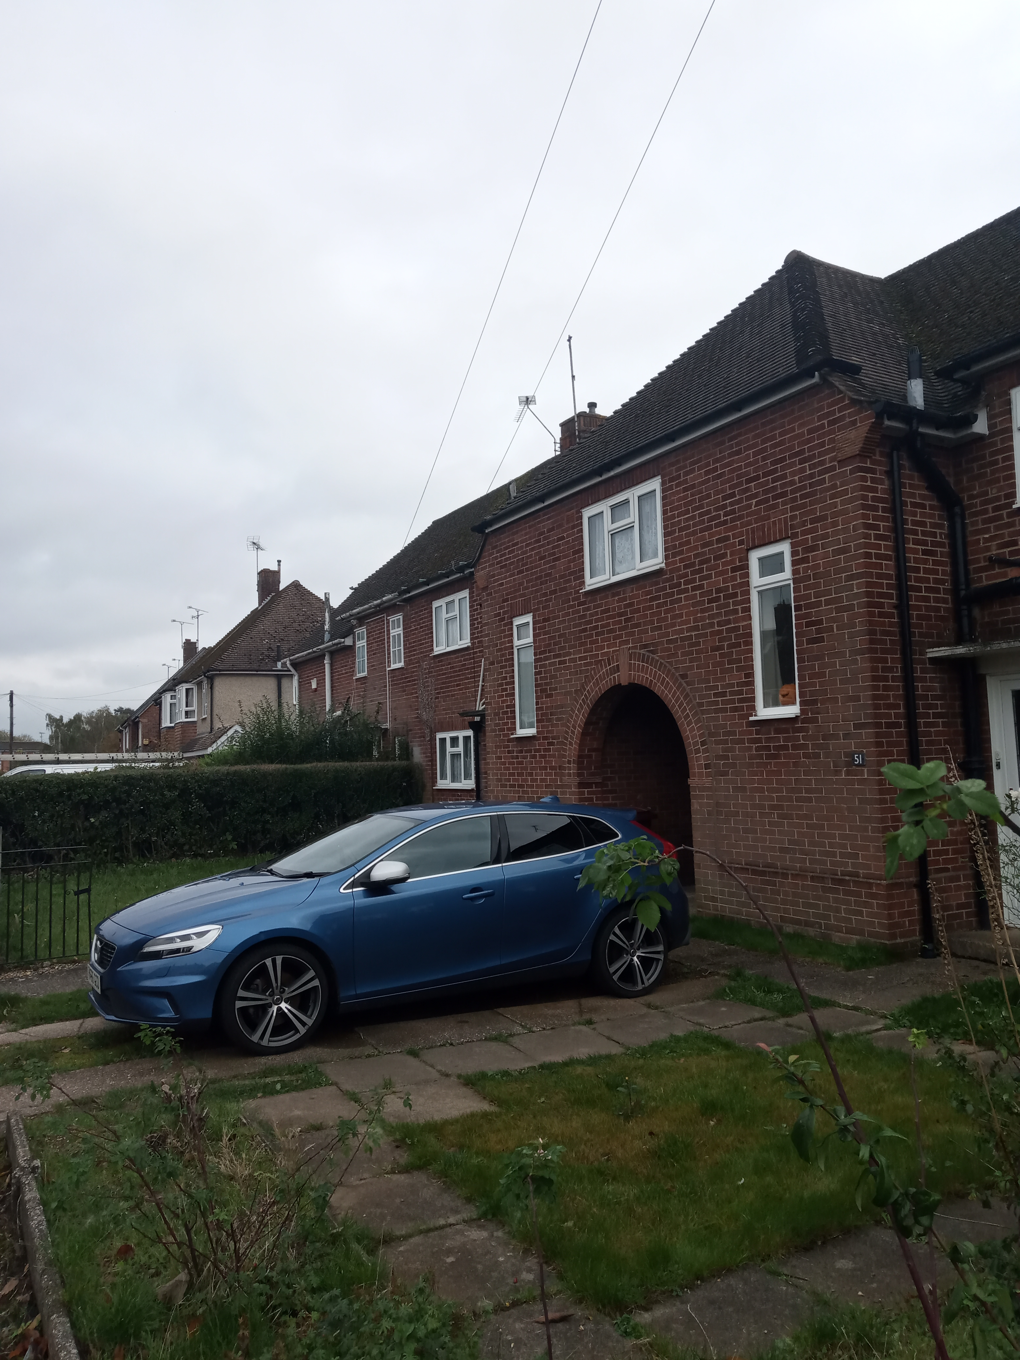

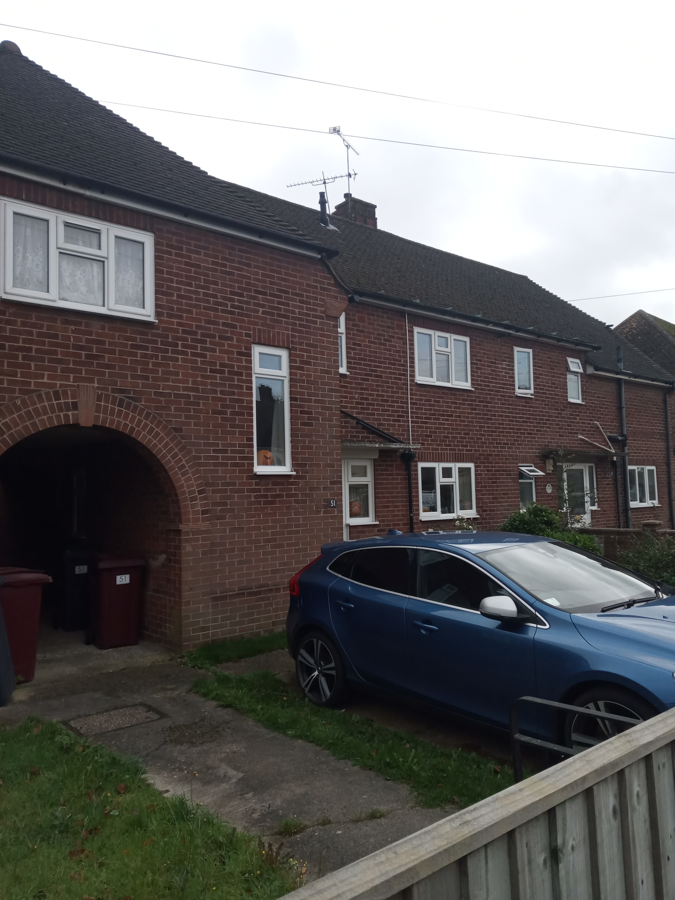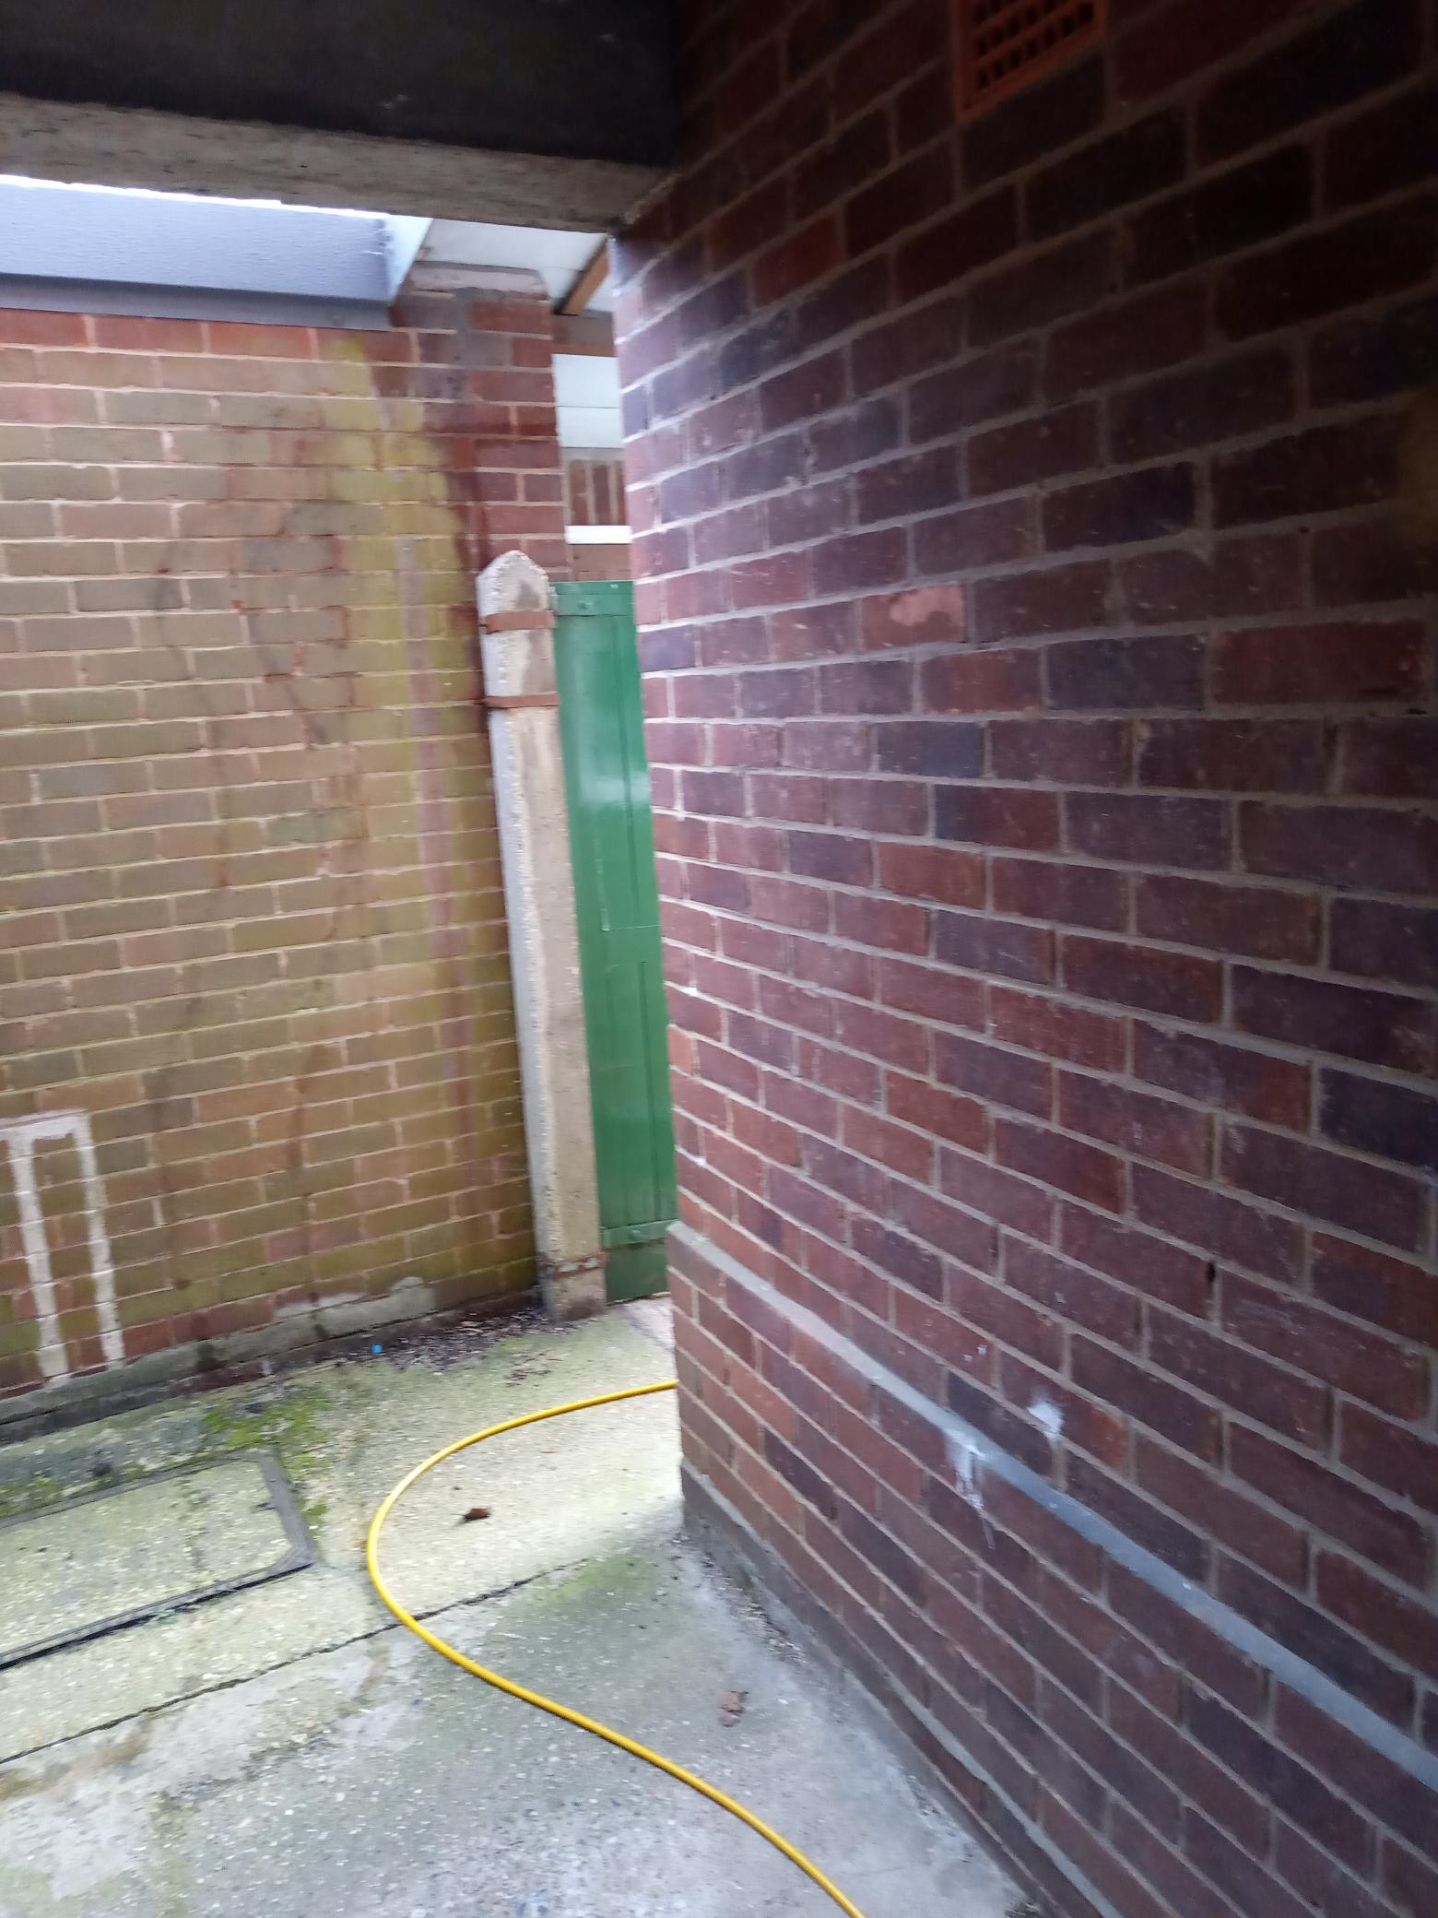

Site photos taken 03/11/2021.

