DELEGATED HOUSEHOLDER APPLICATION REPORT

Address: 72 Northcourt Avenue, Reading, RG2 7HQ
Application No: 211507/NMA
Proposal: Non material amendment to condition 3 of planning permission 201866 (Proposed loft conversion with 2 hip to gable conversions and side dormer with insertion of roof lights), to replace the proposed gable ends approved in brickwork to tile hanging.
Case Officer: Chukwudi Onwudinanti

Site Description and Surrounding Area: The application site is a detached house within a wholly residential area, at the intersection of Northcourt Avenue and Stansfield Close.

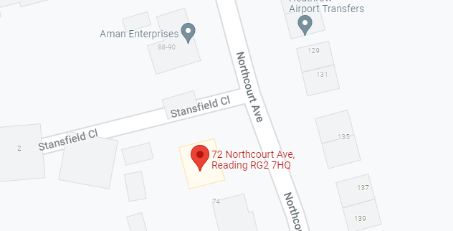

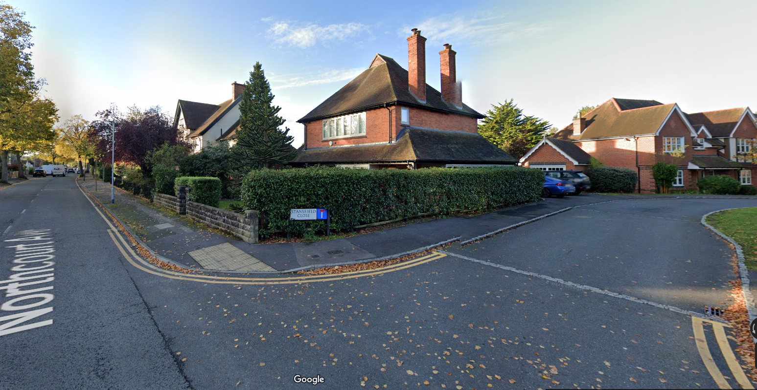

Proposal: To replace the proposed gable ends approved in brickwork to tile hanging. Applicant is proposing this due to the problematic sourcing of a skilled labour to replicate the existing house brickwork.
.

Originally Approved under 201866 Proposed under 211507

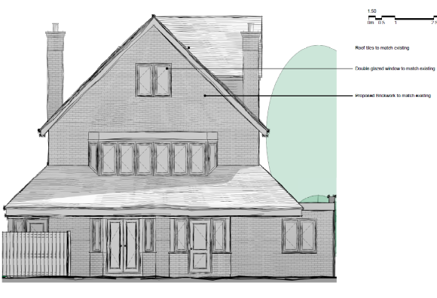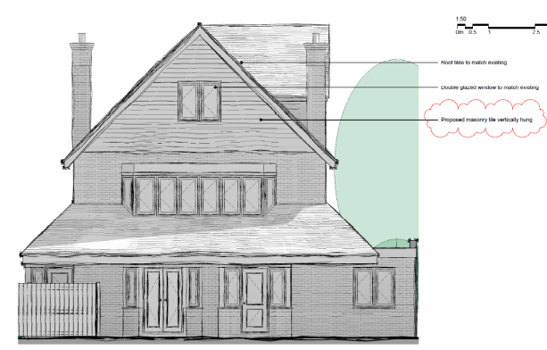

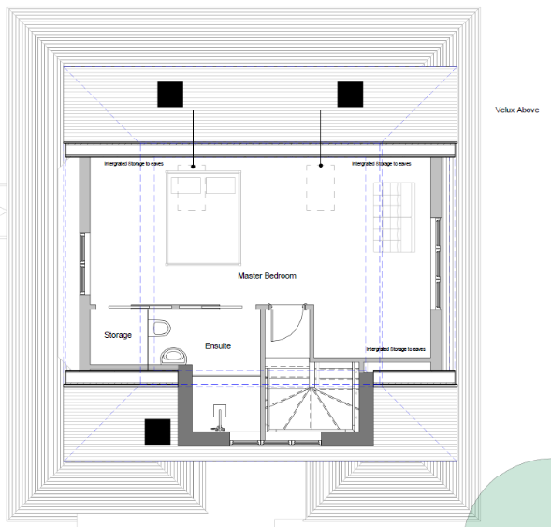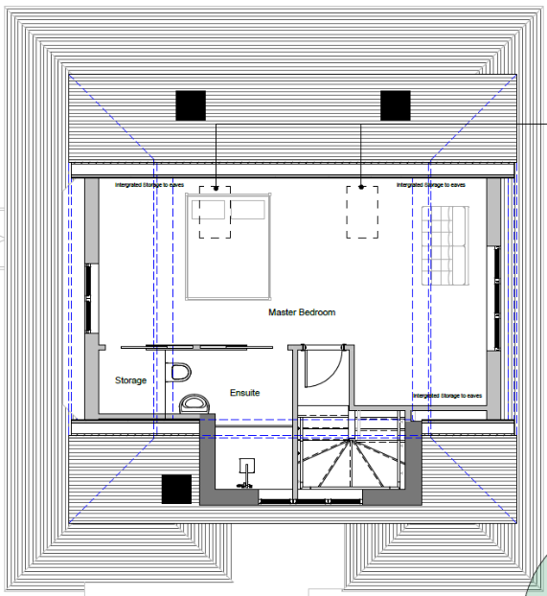

Original Plan approved under 201866/HOU | Proposed Amended Plan under 211507/NMA
Drawing no: PL12 Proposed West Elevation, received 23rd December 2020 | Drawing no: PL12 Proposed West Elevation, received 13th September 2021
Drawing no: PL15 – Proposed Loft Conversion, received 23rd December 2020 | Drawing no: PL15 – Proposed Loft Conversion, received 13th September 2021

Objections Received (Summary):
Applications under S96A are not applications for planning permission, so are not covered by the publicity requirements as set out in the DMPO.

Relevant Planning History:
Application 201866: Proposed loft conversion with 2 hip to gable conversions and side dormer with insertion of roof lights.
Received: 23rd December 2020
Approved: 26th May 2021

Discussions with the Agent:
In considering this application, the planning Officer requested of the agent, to specify the materials to be varied from the materials approved in the conditions for granting approval to prior application 210866. Material stated in the conditions for that approval was red bricks (to match existing). They responded, confirming to use as shown, Marley Plain Concrete Roof Tile Old English Dark Red or similar specified matching the corresponding façade of the other dwelling units on the street scene.

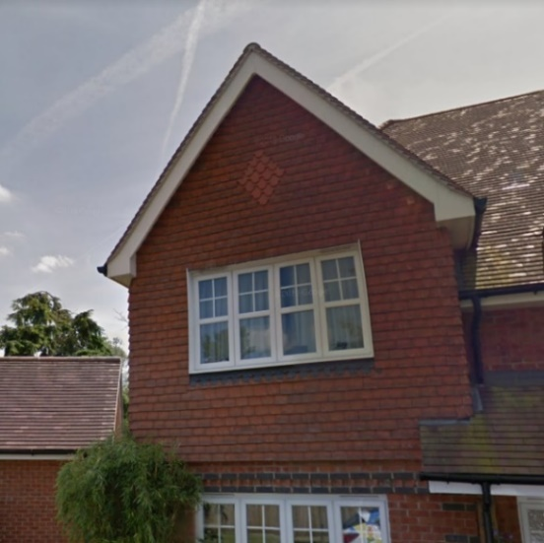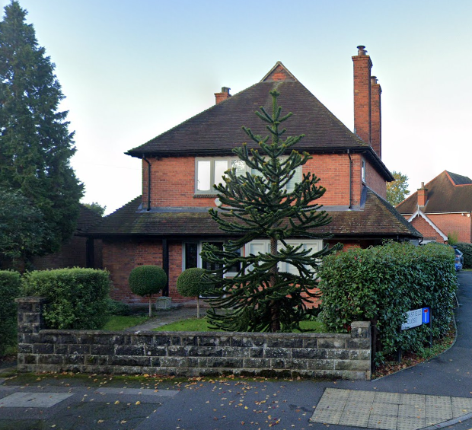

Plans Considered:

Drawing no: PL12 Proposed West Elevation, received 13th September 2021
Drawing no: PL15 – Proposed Loft Conversion, received 13th September 2021

Appraisal:
The proposed change, using Marley plain concrete roof tile (old English dark red) would have a very limited effect on the overall appearance, but not one considered to be detrimental to the overall scheme and would have no detrimental effect on residential amenity. The change would be in the context of a variety of house styles finishes across the street scene and would retain a high-quality design scheme in accordance with Policy CC7.

Conclusion:
The changes as proposed are considered to be acceptable non-material alterations to the previously approved application 201866.

3

Recommendation:
Approve non-material amendment subject to conditions. Although Section 96(A) of the Act does not allow for the original decision to be re-issued, it does allow the modification of, or imposition of, conditions. In this respect it is considered appropriate to impose an additional condition:

Condition
The plans and statements put forward by the agent hereby approved by this Non-Material Amendment (under Section 96A of the Town and Country Planning Act 1990) are as follows:

Drawing no: PL12 Proposed West Elevation, received 13th September 2021
Drawing no: PL15 – Proposed Loft Conversion, received 13th September 2021

Email from Agent to Planning Officer: Subject: FW: 211507 - Amendment to planning application 201866.

