


Planning statement supporting minor external alterations to rear elevation & creation of external balcony for Flat 5 as approval Ref. 201870

Introduction

The application relates to a three-storey building which is located on the Southern side of The Forbury, opposite the Listed St Laurence`s Church.
Forbury Gardens is located 60m to the East.
To the West is Sussex House, a former office which has been converted to residential accommodation.
One Forbury Square, an existing office block is located to the East of the application site.

The site is located within the Market Place/London Street Conservation Area.

Consent has been obtained to change the use from Class E (g) to 5 self contained flats Ref 201870 & 210502 under the Prior Notification process under Class 0.

Proposal

The proposal is to provide outside space for flat 5 by removing the rear right mono pitch roof & replacing this with a flat roof & balcony enclosure incorporating a dwarf brick wall.

The internal arrangement of this flat has also been altered as shown below to provide direct access from the living room to the outside space.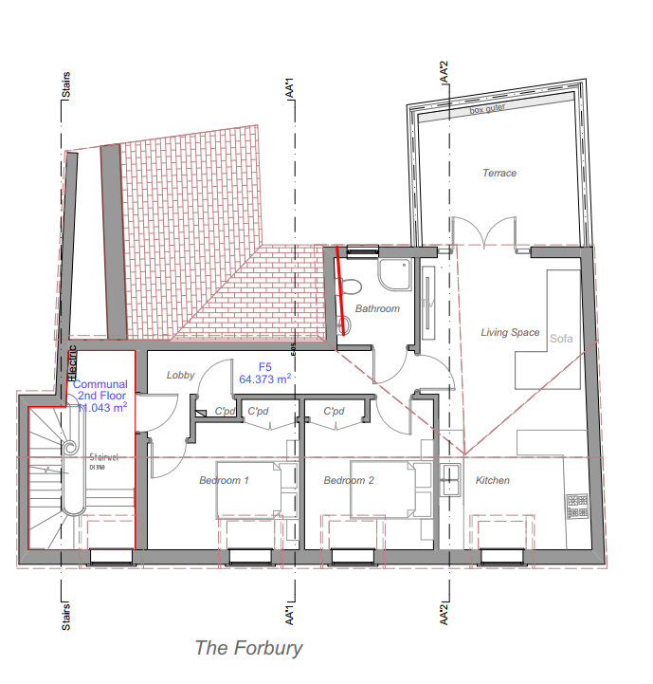

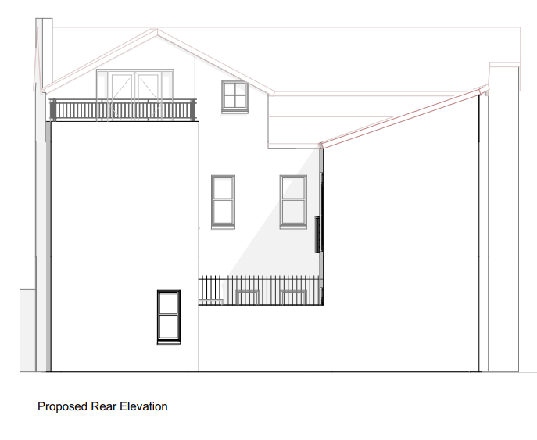

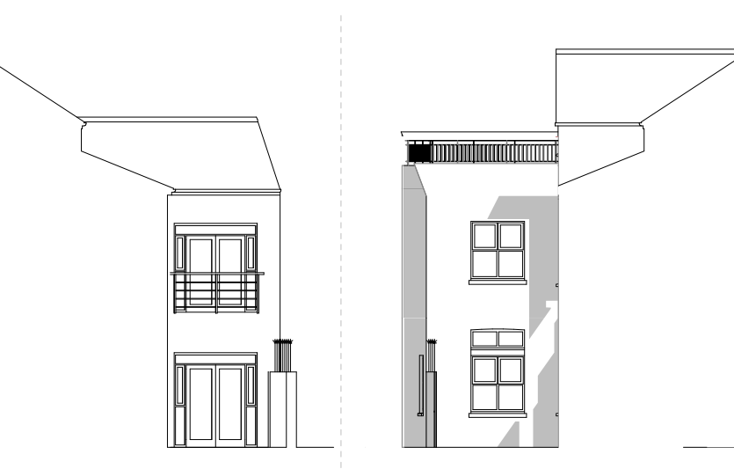

Elevations of this are shown above. There are no issues with overlooking.

On the ground & first floors to flats 1 & 3 we are proposing to replace the existing windows within the rear courtyard with French doors as shown above. The first floor will form a Juliet balcony.

All the external upvc joinery is to be replaced with timber painted flush (White) casement doors & windows apart from the existing front entrance doors which will provide a positive enhancement to the conservation area & to the application building. Details are enclosed from PanEuro Windows.

Relevant Policies

Reading Borough Local Plan 2019

CC8 Safeguarding amenity
EN16 Pollution & Water Resourses
EN18 Flooding
TR3 Traffic access & Highways related matters

Conclusion

These alterations will we believe provide a positive improvement to this building including the replacement joinery & trust this will be supported.

Chris Keen MRICS MCABE



