DELEGATED APPLICATION REPORT
Ward: Caversham
App Ref: 211415 / FUL
Address: 1A South Street, Caversham, Reading, RG4 8HY
Proposals: Replace wooden sliding sash windows for PVC replacement in the same style and colour.
Applicant: Miss Naomi Dixon
Case Officer: Beatrice Malama
Date received (valid from): 26/08/2021 Determination date: 28/10/2021

SITE DESCRIPTION
The proposal site is a three-story property on a block of ten flats located at the junction of South Street and Gosbroock Road. Located north of the site across South Street is a listed building currently used as a church. The area is predominantly commercial comprising of different types and sizes of buildings. The property is not listed and does not fall within a conservation area.
Figure 1: Western view of the site and surrounding properties
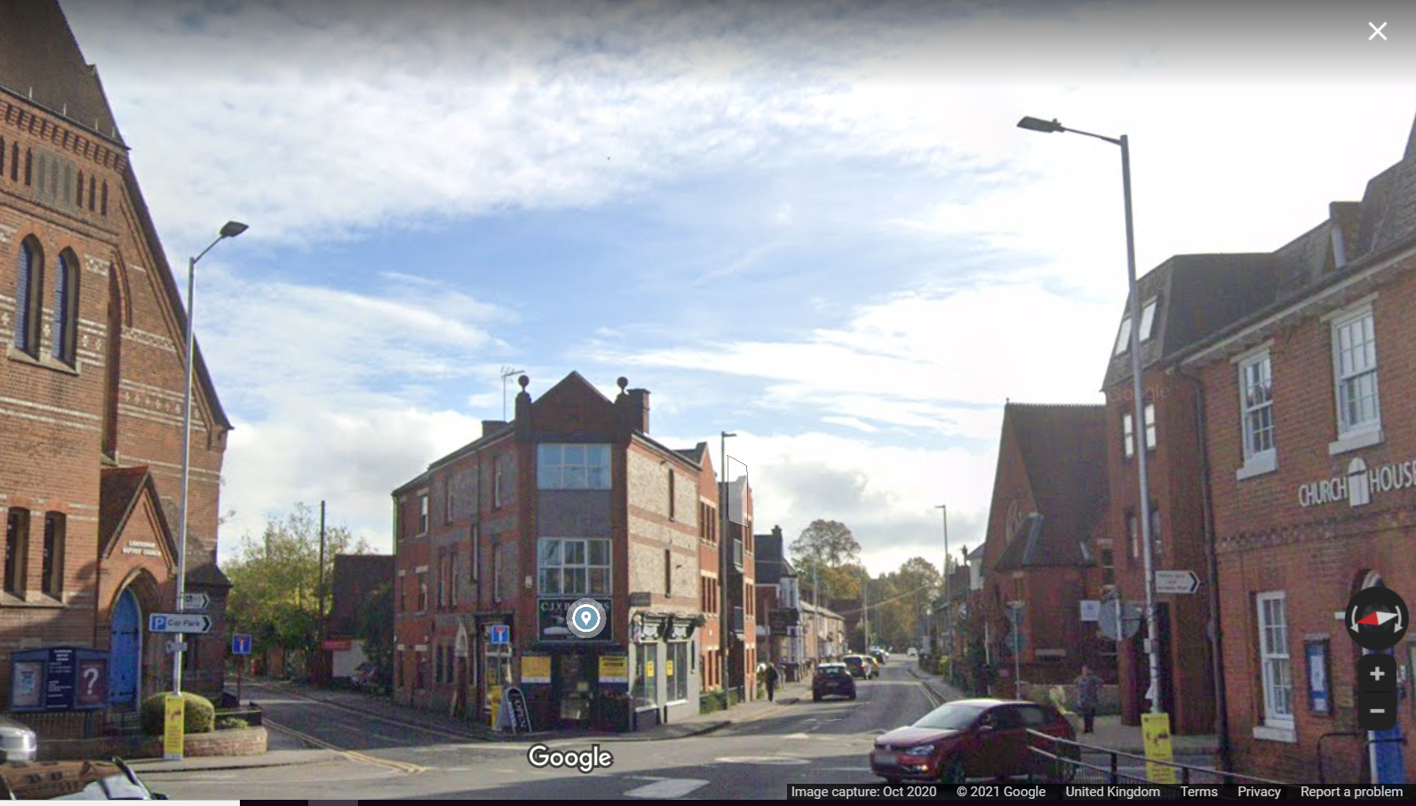
Figure 2: Existing Northern Side Elevation
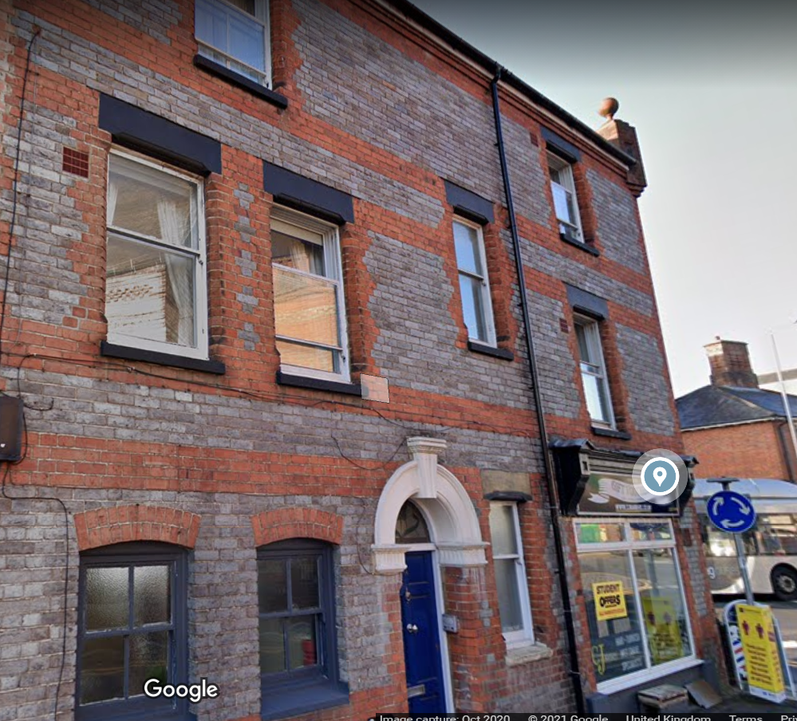

PROPOSED DEVELOPMENT
Application is sought to change the existing vertical wooden sliding windows to UPVC sliding windows. The proposed windows would be white in colour with clear glass to match the existing building.
Plans/documents considered:
Drawing No: TQRQM21245095750780 – Location Plan
Drawing No: TQRQM21245100521607 – Block Plan
Samples of proposed UPVC windows
Material specifications/purchase Order dated 25th August 2021
Received on 26th August 2021

RELEVANT PLANNING HISTORY
No Planning history

CONSULTATIONS
Internal Consultation
Conservation Urban and Design Officer – as the site is located near a listed building the Conservation and Design Officer was consulted on this application however at the time of reporting no comments were received.
A site notice was sent to the applicant on 15th September 2021 and the following addresses were consulted by letter.
3 Gosbrook Road, Caversham, Reading, RG4 8BT25
Free Church, South Street, Caversham, Reading
Flat 8, Carlingford House, 4 Gosbrook Road, Caversham, RG4 8BS
Flat 7, Carlingford House, 4 Gosbrook Road, Caversham, RG4 8BS
Flat 6, Carlingford House, 4 Gosbrook Road, Caversham, RG4 8BS
Flat 5, Carlingford House, 4 Gosbrook Road, Caversham, RG4 8BS
Flat 4, Carlingford House, 4 Gosbrook Road, Caversham, RG4 8BS
Flat 3, Carlingford House, 4 Gosbrook Road, Caversham, RG4 8BS
Flat 2, Carlingford House, 4 Gosbrook Road, Caversham, RG4 8BS
Flat 1, Carlingford House, 4 Gosbrook Roady, Caversham, RG4 8BS
No letters of representation were received

Equality Act 2010
In determining this application the Council is required to have regard to its obligations under the Equality Act 2010. However, there is no indication or evidence (including from consultation on the application) that the protected groups identified by the Act have or will have different needs, experiences, issues and priorities in relation to this particular planning application. Therefore in terms of the key equalities protected characteristics it is considered there would be no significant adverse impacts as a result of the development.

Relevant Planning Policy and Guidance
Section 38(6) of the Planning and Compulsory Purchase Act 2004 requires that proposals be determined in accordance with policies in the development plan unless material considerations indicate otherwise. Material considerations include relevant policies in the National Planning Policy framework (NPPF) - among them the 'presumption in favour of sustainable development'. The Development Plan for Reading relevant to the application site comprises the Reading Borough Local Plan (adopted November 2019).
The ‘National Planning Policy framework’ (‘’NPPF’’) 2019 states clearly states that its content is to be a material consideration in the determination of applications. The ‘NPPF’ states that due weight should be given to the adopted policies of the Local Plan according to their degree of consistency with the ‘NPPF’ (the closer the policies in the plan to the policies in the ‘NPPF’, the greater the weight that may be given).

National Policy
National Planning Policy Framework (2021)
National Planning Practice Guidance

Reading Borough Local Plan (2019)
CC7 Design and the Public Realm
CC8 Safeguarding Amenity

Assessment
In principle the proposed works to the windows could be carried out without seeking planning permission as the property is not listed and is not within a conservation area however as the proposal site is very close to a listed building it is necessary that the Local Planning Authority considers the impact of the proposed works on the existing building, nearby heritage site and the wider area. The proposal therefore will be assessed in terms character and appearance and Impact on neighbouring properties.

Character and appearance
Policy CC7 (Design and the Public Realm) requires that all developments be of high design quality.
The area is characterised by properties of different types, character and scale. The existing flat has is built of redbrick and has vertical sliding windows with wooden frames painted in white and grey. The proposed works to the windows would involve replacement of existing wooden framed windows with white UPVC. No other works to the building are proposed as such it is considered that the proposed works would not harm the character and appearance of the existing building nor would have a detrimental impact on the nearby listed building and other surrounding properties as well as the wider area. The proposal therefore complies with Policy CC7

Impact on neighbouring properties
CC8 (Safeguarding Amenity) seeks to prevent development causing detrimental impact on the neighbouring properties:
As the proposal does not include any other works to the property apart from the proposed changes to existing windows, the proposal would not have a detrimental impact on the neighbouring properties and therefore the proposed works comply with Policy CC8.

CONCLUSION
The proposed development is considered to be in accordance with the Reading Borough Local Plan (2019) and therefore the application is recommended for approval subject to conditions.

RECOMMENDATION
GRANT

CONDITIONS
- Time Limit (Standard) TL1
- Approved Plans Ap1
- Materials (AS Specified) M3

INFORMATIVES
IF5: Terms
IF6: Building Control
IF7: Complaints about construction
IF8: Encroachment

