- Extract from Historic England/Listed Buildings website

All the elements noted in this extract are still intact in the current building.

SU 7073 12/13 5128
BAKER STREET, Nos 61 to 79 (odd)
II GV
Before 1840 (shown on Edward Weller map of 1840). A formal terrace of small red brick houses set back from road. 2 storeys and basement. Stucco string under 1st floor windows. Slate roof, hipped at each end, brick ridge chimneys. 2 windows each on 1st floor, 1 on ground floor, glazing bar sashes (No 61 plate glass). 4 panel door with radiating fanlight on ground floor. 1 window and door to basement.
Listing NGR: SU7067173173

- Recent photographs of elements of the building and gardens

1 Rear garden to Belle Vue Road  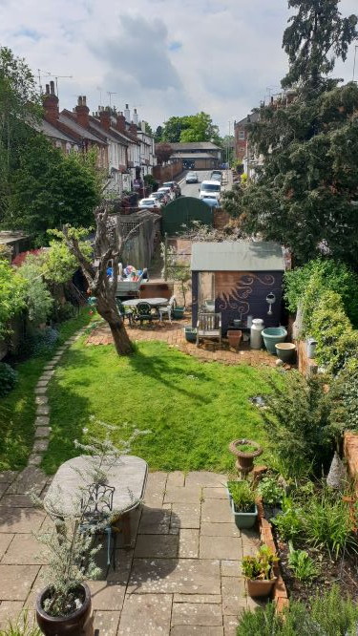 |  | 2 Brick shed at bottom of rear garden  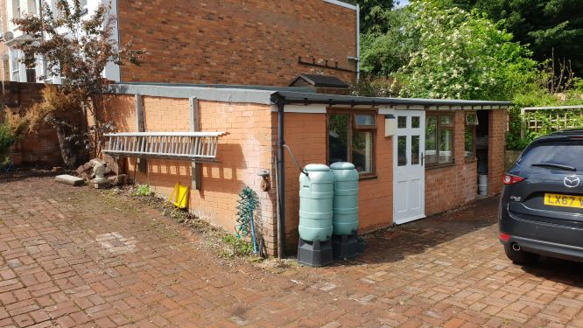
3 Rear gate giving access to Belle Vue Road  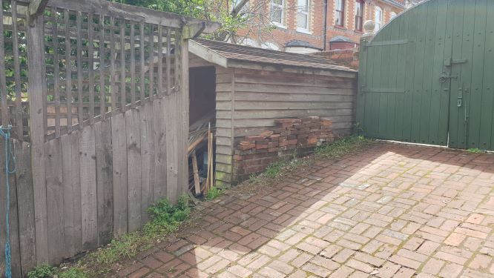 | 4 Rear view of terrace of houses  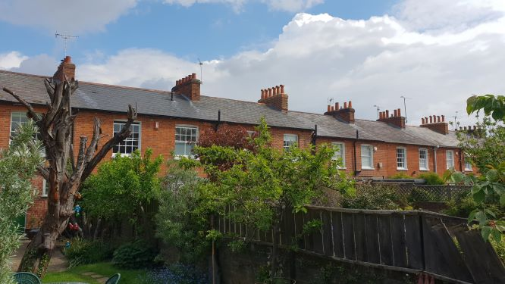
5 Rear garden  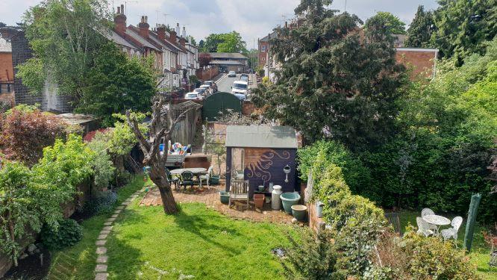 | 6 Front garden  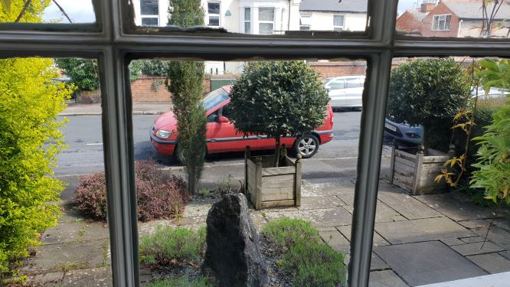
7 Kitchen in basement  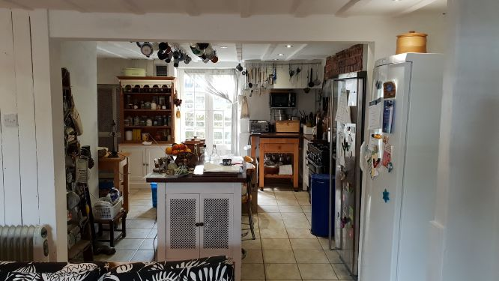 | 8 Dining area in basement  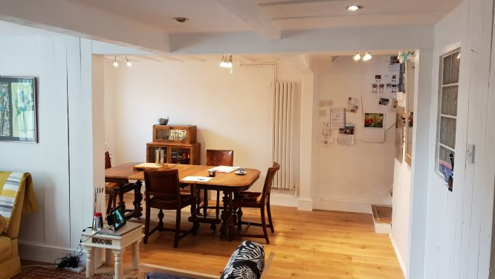
9 Front door direct to basement  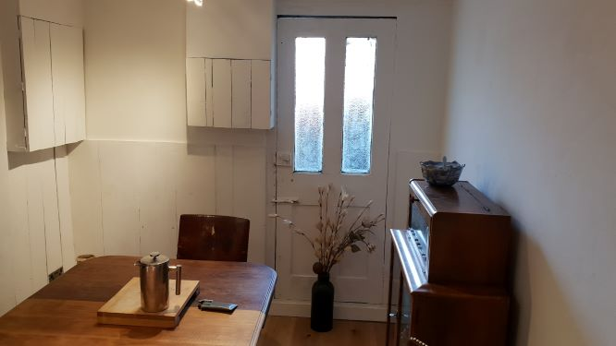 | 10 Front window in basement  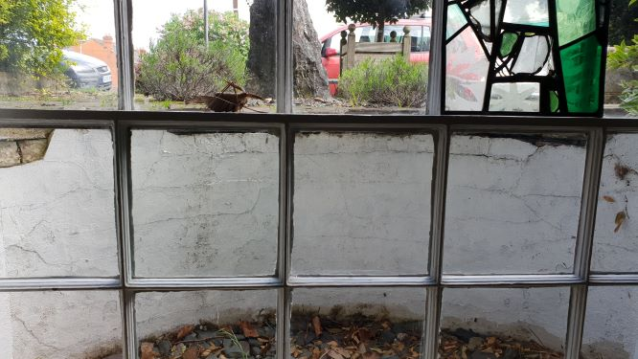
11 Seating area in basement  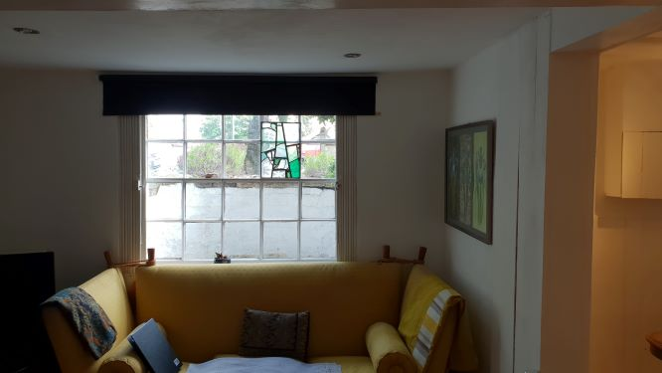 | 12 Basement ceiling detail  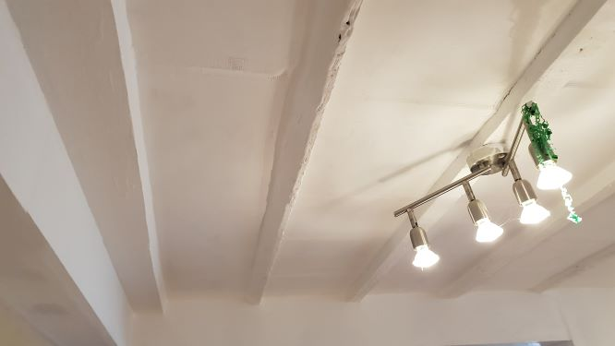
13 Stairway basement to ground floor  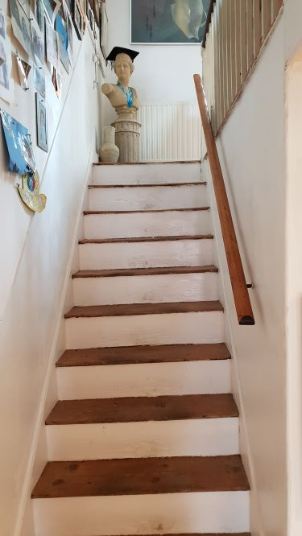 | 14 Ceiling beam ground floor reception room  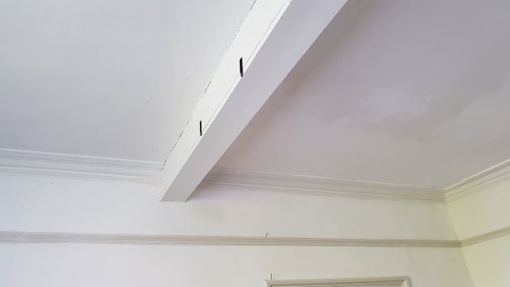
15 Cloakroom ground floor  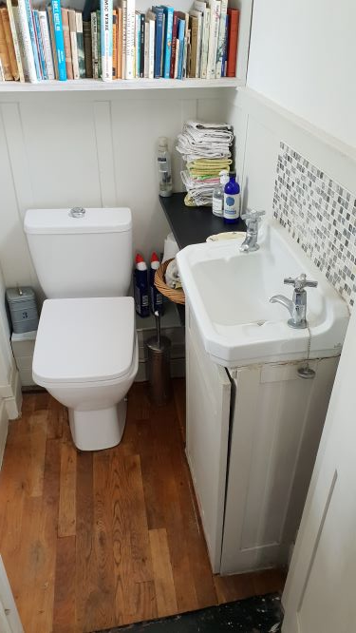 | 16 Stairway to first floor  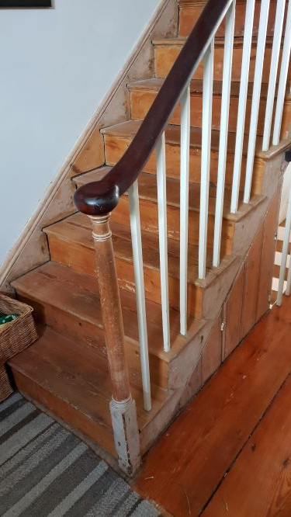
17 En-suite bathroom first floor  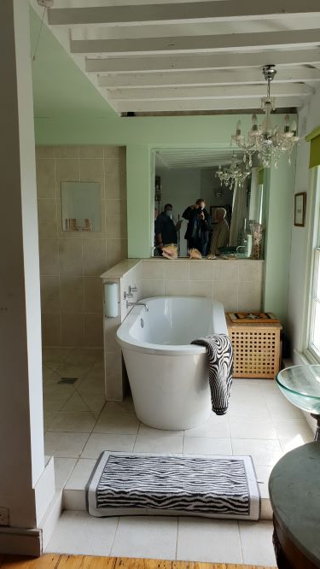 | 18 Repaired ceiling on original rafters rear bedroom  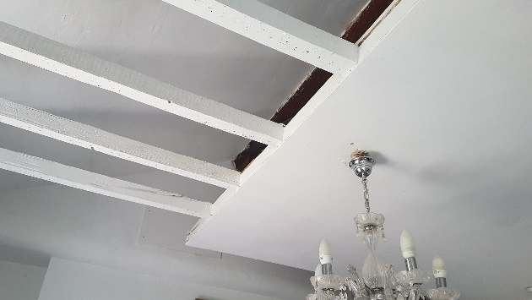
19 Metal staircase to attic floor  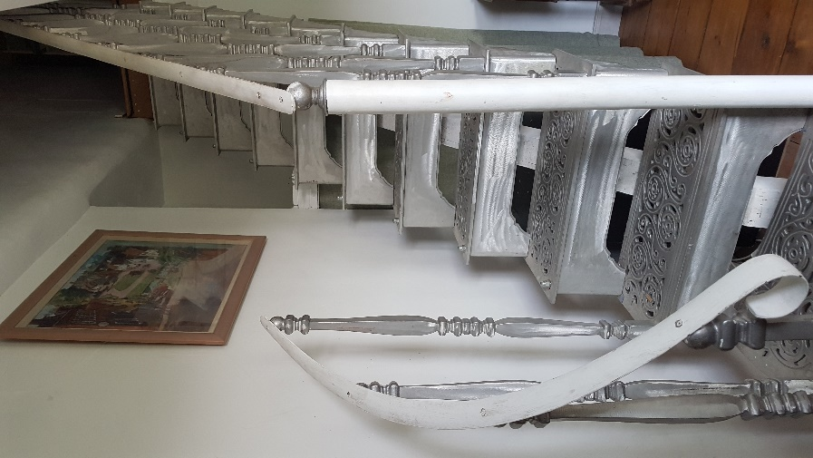 | 20 Typical ceiling detail  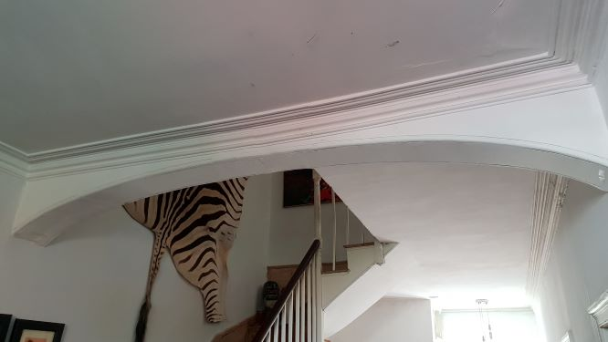
21 Typical door detail  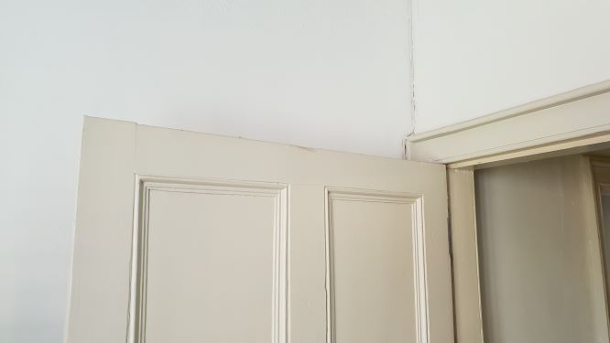 | 22 Typical door furniture  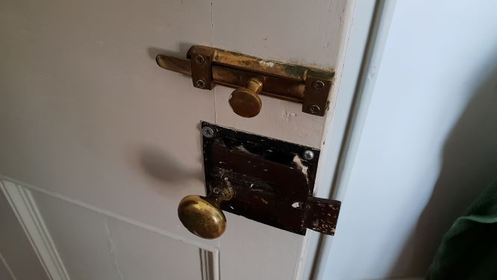
23 Typical window detail

