DELEGATED HOUSEHOLDER APPLICATION REPORT

Ward: Peppard
App Ref: 211627/HOU
Address: 47 Kiln Road, Emmer Green, Reading, RG4 8UE
Proposals: Single storey rear extension
Case Officer: Chukwudi Onwudinanti
Applicant: Mr Mohammed Arif
Date received (valid from): 29 September 2021
Target Decision date: 24 November 2021

1. INTRODUCTION
The site is located on the western side of Kiln road, in the midst of mixed style dwellings of varying sizes and scale.

2. PROPOSAL AND SUPPORTING INFORMATION
Single storey rear extension

Plans considered (Received 29th September 2021)
P2109-01 – Location Plan and Block Plan
P2109-02 – Existing Plans & Elevations
P2109-03 – Revision A (Received 5th October 2021)

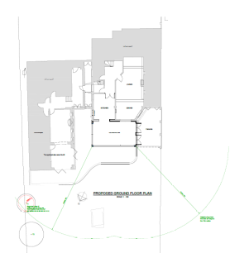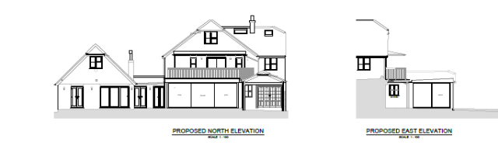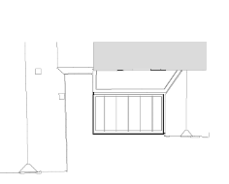

- RELEVANT PLANNING HISTORY
There have been four separate historical applications for this address between 1989 and 2009 but none is relevant to this application.

4. CONSULTATIONS
4.1 The following addresses were consulted by letter.

45 Kiln Road, Emmer Green, Reading, RG4 8UE
49 Kiln Road, Emmer Green, Reading, RG4 8UE
16 Jefferson Close, Emmer Green, Reading, RG4 8US
26 Venetia Close, Emmer Green, Reading, RG4 8UG

4.2 No letters of representation have been received.

Equality Act 2010:
In determining this application the Council is required to have regard to its obligations under the Equality Act 2010. However, there is no indication or evidence (including from consultation on the application) that the protected groups identified by the Act have or will have different needs, experiences, issues and priorities in relation to this particular planning application. Therefore in terms of the key equalities protected characteristics it is considered there would be no significant adverse impacts as a result of the development.

- LEGAL AND PLANNING POLICY CONTEXT
Section 38(6) of the Planning and Compulsory Purchase Act 2004 requires that proposals be determined in accordance with the development plan unless material considerations indicate otherwise. Material considerations include relevant policies in the National Planning Policy framework (NPPF) - among them the 'presumption in favour of sustainable development'. The following local and national planning policy and guidance is relevant to this application:

National Policy
National Planning Policy Framework
National Planning Practice Guidance

Reading Borough Local Plan (2019)
CC7 (Design and the Public Realm)
CC8 (Safeguarding Amenity)
H9 (House Extensions and Ancillary Accommodation)

SPD
- Design Guide to House Extensions SPD

6. APPRAISAL
H9 states: An extension to a house will be acceptable where it:

- Respects the character of the house in terms of scale, location, materials and design;

To assess this, the following has been considered – would the proposal:
- Detract from the appearance of the original building through the use of ill-matching materials and by not fitting in with the design, scale and proportions of the original building; NO, the proposal is to the rear of the dwelling, sits within the existing envelope of the original building and subsequent extensions and is not visible from the street in any direction. The extension is to be constructed of transparent glass and is within a height of 3m.
- Reduce the amount of usable amenity space for the property to an unacceptable degree; NO, the new extension has no significant impact on the usable amenity space.
- Require the loss of trees in the garden or put significant trees at risk; NO

- Respects the character and pattern of neighbouring properties and the street as a whole in terms of scale, location, materials and design, and any important existing building line; Respects neighbour’s amenities and does not present a large blank façade to public areas.

To assess this, the following has been considered – would the proposal:
- Significantly reduce the amount of daylight and sunlight enjoyed by neighbouring properties; NO, the extension is not near any boundaries with any adjoining dwellings and is below 3m in height, so will have no impact on any neighbours.
- Invade the privacy of neighbouring properties through overlooking from windows or balconies; NO
- Detract from the character of neighbouring properties through siting, excessive bulk, ill-matching materials or inconsistent design; NO
- Detract from the appearance of the street or area by using ill-matched materials, glazing and detailing; NO, the whole extension is to the rear of the dwelling.

CC8: Safeguarding Amenity states an extension to a house will be acceptable where it will not cause a significant detrimental impact to the living environment of existing or new residential properties.

To assess this, the following has been considered – would the proposal cause a significant detrimental impact to the living environment of existing or new residential properties in terms of:

- Privacy and overlooking;
- Access to sunlight and daylight;
- Visual dominance and overbearing effects of a development;
- Noise and disturbance;
- Artificial lighting;
- Vibration;
- Dust and fumes;
- Smell;
- Crime and safety.

- CONCLUSION
The proposed development has been assessed and the proposed works are considered to be in accordance with the above relevant policies and planning permission can be granted.

8.0 RECOMMENDATION
Grant

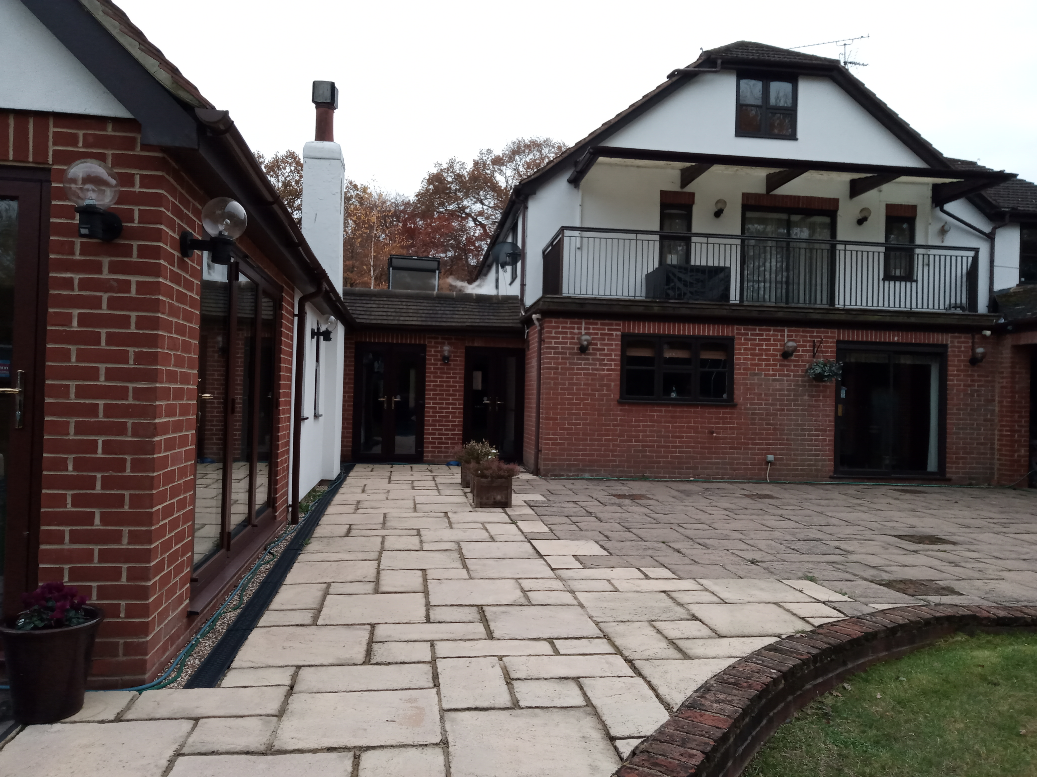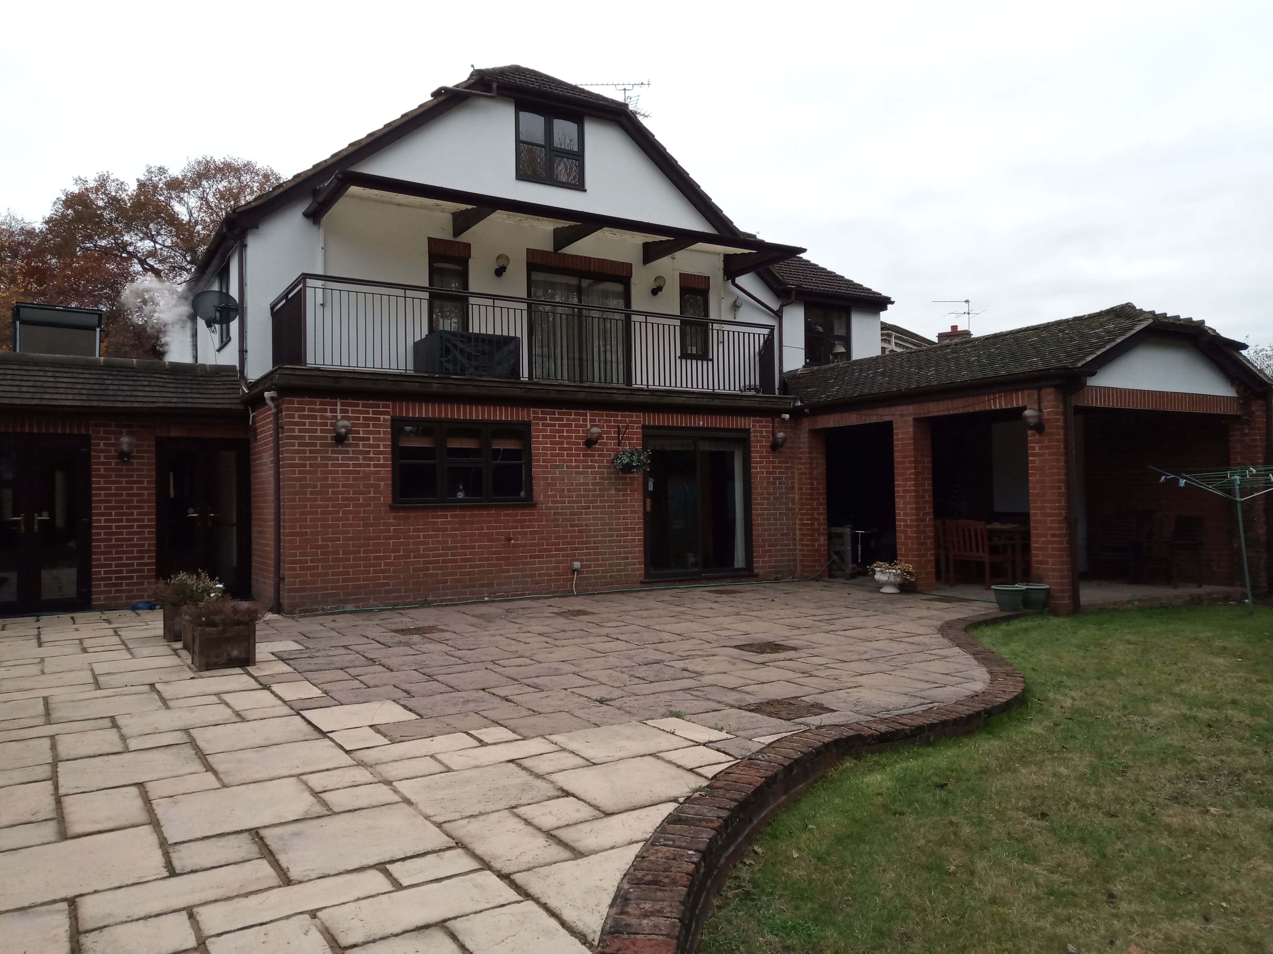

Site Photos taken on 15th November 2021.

